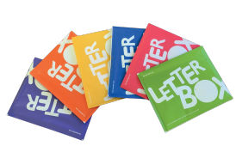
Feedback form for Letterbox Club 2019-2020, 2020-2021

Over the last 6 months, your child has been sent Letterbox Club parcels – we’d really like to know what you think about them! Once completed please return this from to the office.
How did your child react to receiving Letterbox Club parcels?
Wow, excited, desperate to open it, happy, couldn’t wait to see what was inside.
Excited, loved it, happy, intrigued, thrilled, shared straight away, amazed
What did your children think about the contents?
Stationery:
loved it liked it okay didn’t really like it didn’t like it at all
86% 14%
89% 11%
Number games:
loved them liked them okay didn’t really like them didn’t like them at all
57% 29% 14%
Books:
loved them liked them okay didn’t really like them didn’t like them at all
86% 14%
What did your child enjoy most about receiving letterbox Club?
The excitement of what’s inside, games and books, the book in the final parcel, teddy, Paddington bear book.
Activities and reading, new books, the games, each letter box parcel was jam packed with lovely, useful equipment and sensory bits.
What are your favourite things?
Finger teddy, Paddington bear book, calculator and animal anthology, all of it, books and stationary.
Everything, the pen/pencils and books and dice game, books, resources, games, variety of books from joke to more
Did you spend time with your child looking through and engaging with the games and books?
Yes No
86% 14%
100%
Could you please tell me a little about what you enjoyed doing together:
Child wanting to read books, the money games, playing the games and interacting together, games, reading the books and playing with finger puppets, maths games.

Do you and your child do anything differently as a result of receiving Letterbox Club parcels?
Yes No
43% 57%

In general do you think Letterbox Club has had an impact on you and your child in any of the following ways?
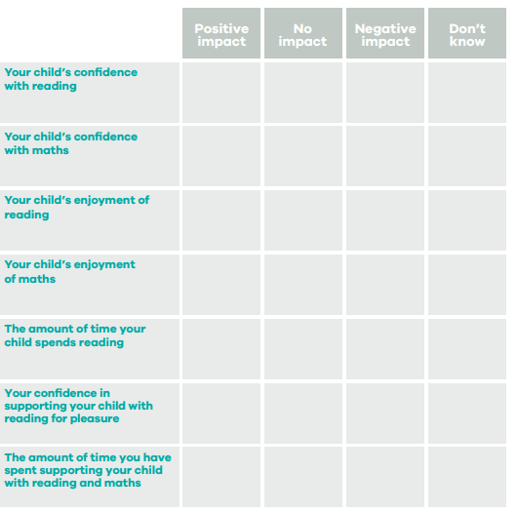
5 1 1

4 2 1

6 1

5 1 1

4 3

6 1

6 1

2020-2021
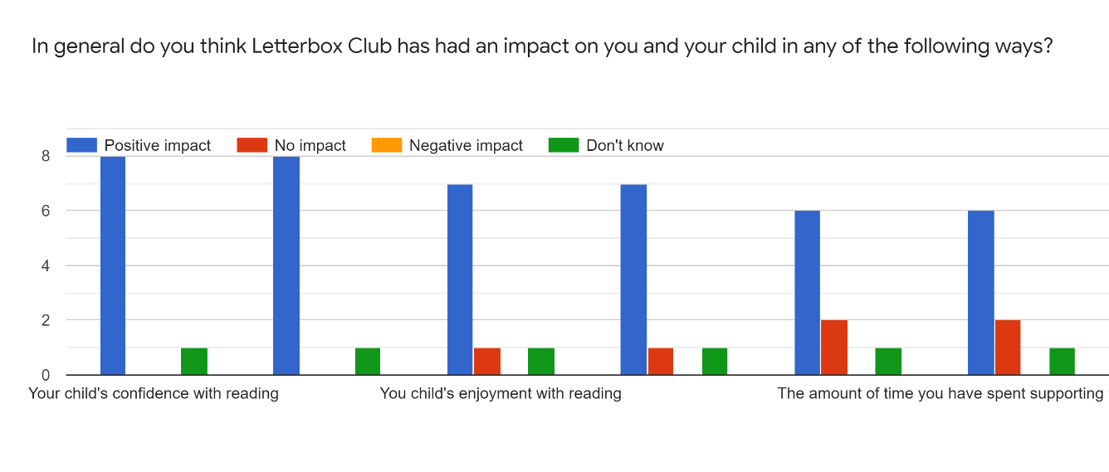
Anything else you would like to add:
Helped with reading and also impact on confidence, made her feel special and someone cared to make her a parcel.
Thank you for giving us the opportunity to be part of Letterbox Club.
Many thanks for including us.
Thank you, we have really enjoyed receiving the parcels.
We all love them
Letterbox is amazing. Thank you all so much.
X really enjoyed receiving the parcels and his confidence grew especially with maths as he enjoyed using the counters and playing the games. These gave me and him more of a chance of doing something just the two of us which I think he enjoyed as well. The packs had a good selection of items and a great idea. Thank you.
Y has been totally thrilled with each parcel. Grinning from ear to ear. We love them! Thank you ☺️
I think they are brilliant and we loved them.
THANK YOU FOR YOUR TIME

