SWANS, SWIFTS & DOVES - SUMMER 2024– 1st half term
PIRATES

Personal Social and Emotional Development  - Circle time games.  - Relationships – activities using stories, puppets/role play.  - Value – Friendship  - Fair and unfair situations  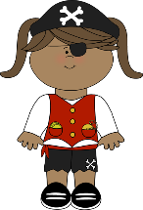  - Build constructive and respectful relationships. | Communication and Language  - Articulate their ideas and thoughts in well-formed sentences when sharing Learning Logs and Show and Tell items.  - Connect one idea or action to another using a range of connectives.  - Listen to and talk about stories to build familiarity and understanding.  - Role-play situations e.g. Dressing up as a pirate  - Learning to talk like a pirate and use pirate phrases |  | Physical Development  - Develop the foundations of a handwriting style, which is fast, accurate and efficient.  - Use their core muscle strength to achieve a good posture when sitting at a table or on the floor.  - Form lower-case and capital letters correctly.  - Gymnastics Unit 2  - Cooperate and solve problems Unit 2  - Further develop and refine a range of ball skills including: throwing, catching, kicking, passing, batting and aiming.  - Develop confidence, competence, precision and accuracy when accuracy when engaging in activities that involve a ball.  - Develop their small motor skills so that they can use a range of tool competently, safely and confidently to create a pirate ship.
Literacy  - Listen to pirate stories e.g. Pirates Love Underpants, The Pirates Next Door, The Pirates of Scurvy Sands, The Night Pirates, Pirates in Pyjamas, Ten Little Pirates  - Sequence stories.  - Write labels, lists, sentences and speech bubbles.  - Label a pirate map and a pirate ship.  - Create a pirate character.  - Write a speech bubble for a pirate character.  - Read and spell high frequency words.  - Segment sounds in simple words and blend them together.  - Re-read what they have written to check that it makes sense.  - Write short sentences with words with known sound letter correspondences using a capital letter and full stop.  - Write a pirate story.  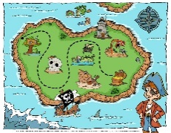  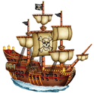 | Mathematics  - Building numbers beyond 10  - Build and identify numbers to 20 using a range of resources including using two 10 frames.  - Counting patterns beyond 10  - Recognise that the numbers 1 to 9 repeat after every full 10.  - Count on and back beyond 10. Count on and back from different starting points.  - Say what comes before or after a given number.  - Matching, rotating and manipulating shapes  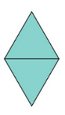  - Select and rotate shapes to fill a given space. Match arrangements of shapes. Use positional language to describe where shapes are in relation to one another.  - Adding more and taking away using objects and quantities  - Number songs and stories  - Composing and decomposing shapes – combining and breaking up shapes  - Use first, then, now to create mathematical stories. | Understanding the World  - History of real pirates  - Growing beans in order to survive on a pirate island  - Caring for pets and finding out about their life cycles e.g. parrots, cats, dogs and rats  - Comparing different places –a pirate island, Ampthill and Antarctica  - Investigating floating and sinking  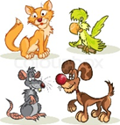  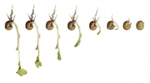 |  | Expressive Art and Design  - Listening attentively, moving to and talking about music, expressing their feelings and responses.  - Exploring and engaging in music making and dance, performing solo or in groups.  - Music – Big Bear Funk  - Learn rhymes, poems and songs.  - Big Bear Funk  - Hickory Dickory Dock  - ABC Song  - Twinkle Twinkle Little Star  - Head, Shoulders, Knees and Toes  - If You’re Happy and You Know It  - The Wheels On The Bus  - Baa Baa Black Sheep  - Row, Row, Row Your Boat  - The Hokey Cokey  - Exploring high sounds and low sounds using voices.  - Design and create a ship using junk materials.  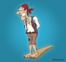  - Create a parrot and a mermaid/merman.
RE
- Why is Easter special to Christians?
- Say why Easter is a special time for Christians.
- Discuss their Easter holiday.
Computing
- Learning that information can be retrieved from books, computers and mobile digital devices.
- Log in and open 2Paint.
- Type name using a capital letter (shift key/caps lock).
- Change pen colour and size.
- Draw a flag, ship and island using shapes.

