APRIL NEWSLETTER
March 2024
Dear Parents/Carers,
Welcome to our latest newsletter. These newsletters are sent out on a monthly basis to keep you informed about what is happening in school. If you ever want to contribute an ‘article’ or suggest information that should be on the newsletters, I would be delighted to hear about them.
Please note events that are underlined and in italics are new or amended since the previous newsletter.
Thursday 28th March - Easter Craft Activity morning - come in and join us for a crafty morning (9 - 10:10 (YFS/Y1/Y3) and 9 - 10:30 (Y2/Y4) (more details to follow), Easter Hunts at school, Eco Challenge ends (PTA), Break up for the Easter Holidays

Easter Holidays 29th March - 14th April 2024 - Premier Holiday Camp on site (some spaces are still available)

Monday 15th April - ALL Children back to school - NO INSET DAY
Wednesday 17th April – 5 Year Old’s Oral Health survey in school, 2:45 pm - Parent Volunteer session (sign up below using the Google Form), Year 3 to Celtic Harmony
Monday 22nd April – FS Vision Screening, Jacqueline Ross (HT Alameda) in to take assembly, Finance and Premises Governors’ meeting at 6:30pm
Tuesday 23rd April – Co2 safety sessions from Hazard Alley – to Penguin Class
Wednesday 24th April – Year 3 Faith Tour, Co2 safety sessions from Hazard Alley – to Robin Class
Thursday 25th April - Co2 safety sessions from Hazard Alley – to Greenfinch Class
Friday 26th April – Transfer Festival for Y4 children at Alameda
Wednesday 1st May – Condover Hall Visit for Year 4
Thursday 2nd May – Condover Hall Visit for Year 4, KS2 playground markings updated
Friday 3rd May – Condover Hall Visit returns, PTA Happy’s Circus event from 5pm (see Classlist App for more details)
Monday 6th May – BANK HOLIDAY MONDAY – school closed
Tuesday 7th May – Bikeability – Year 4 (more details to follow)
Wednesday 8th May – Bikeability – Year 4 (more details to follow)
Thursday 9th May - PTA Meeting, 7:30pm at Wingfield Club
Monday 13th May – Golf festival (rescheduled) some Year 4 children
Wednesday 15th May - FS visit to Ampthill Library (am
Friday 17th May – Cricket festival some Year 4 children
Wednesday 22nd May - Year 2 trip to Roald Dahl Museum - Penguin and Robin Classes
Thursday 23rd May - Year 2 trip to Roald Dahl Museum - Greenfinch Class
Friday 24th May – Break up for May Half term today

May half term holidays 27th May – 31st May 2024 - Premier Holiday Camp on site

Monday 3rd June – All children back at school – NO INSET DAY, ‘Bounce’ sessions for each class begin today, Year 4 multiplication tables checks begin in June
Tuesday 4th June - Bounce sessions for some classes
Wednesday 5th June - 9am Inclusion Coffee Morning (Transition) - more information to follow, Athletics festival for some Y3 children
Thursday 6th June - 80th anniversary of D-day - special assembly with the Town Crier and Royal British Legion Standard bearer
Monday 10th June - Phonics screening begins for Y1 children, Year 4 will begin some GL testing for transfer to middle schools
Wednesday 12th June - Year 3 badminton
Thursday 13th June - Greenfinch and Penguin Class to Marston Vale, Ladybirds Sports afternoon on the field, 6:30pm - New Intake Meeting for September 2024 children (main hall)
Friday 14th June - Robin Class to Marston Vale
Saturday 15th June - PTA Summer Fayre - more information to follow
Monday 17th June - Y2 friendship letters out for classes in Y3
Wednesday 19th June - Ladybirds AGM
Monday 24th June - Year 2 friendship letters deadline today, Athletics festival for some Y2 children
Wednesday 26th June - Sports Morning at Russell - more details to follow
Monday 1st July - Curriculum, Learning and Standards Meeting at 6:30pm
Thursday 4th July - Letters out re new classes and teachers for September
Friday 5th July - Transition Day - Y4 to middle schools, Class swap morning at Russell, new intake 2024 ‘stay and play’ morning
Saturday 6th July - Ladybirds Summer Fayre
Monday 8th July - Full Governors’ Meeting at 6:30pm
Tuesday 9th July - 2:15 pm and 6pm Year 4 Performance to parents
Wednesday 10th July - Year 3 badminton coaching
Friday 12th July - Reports home today
Monday 15th July - Sunflower Competition Winners announced, 2:30pm - Open afternoon - more information to follow
Tuesday 16th July - FS visit to the farm, 9:15 am Year 4 Leavers’ assembly to the parents, 1:30 - 3:30pm Year 4 Leavers’ Party
Friday 19th July - Final day of school - summer holidays begin

More detailed information on the above events will follow in due course

Aviary Club - breakfast and after school club parents:
Please check your inboxes for a very important email with a link to a Google form on 28/3/24. This Google form needs to be completed by Friday 19th April with your requirements for before/after school club places for September 2024 onwards please. We do appreciate that you may not have all the information about your shifts etc. at this point, but in order to guarantee places, we need to plan staffing this far in advance. Please be aware that requests received after this date may not be possible to accommodate. After Friday 19th April, we need to offer places to our very large new intake parents too so as you can see, time is of the essence. If you do not receive this email by the end of the day on Thursday 28th March, please contact the Aviary. Thank you for your support. We appreciate this is a very precious and important resource for parents and we continue to try to meet the enormous range of needs of all our parents.

Resilience and wellbeing:
Following on from her talk at our Wellbeing and Resilience workshop back in February, Karen Potter (Russell parent and Resilience Coach) is starting a Parents’ Support group.

Karen says, “If you’re a parent who feels like you’re trying your best but it’s never quite good enough then this Parent Support group is designed for you. Starting at the end of April, I will coach you and a small group of other parents through a 6-week training programme which incorporates weekly group coaching as well as access to the Positive Intelligence app. Positive Intelligence uses breakthrough, research-based tools to strengthen the part of your brain that serves you and quieten the part that sabotages you - leading to a more positive mindset and less stress. If you want to feel calmer and better able to cope with the daily challenges that life brings (especially as a parent) then get in touch to find out more.

You can start exploring Positive Intelligence by taking their free saboteur assessment here: https://www.positiveintelligence.com/saboteurs/ , email me at karenpottercoaching@gmail.com or follow me on my Instagram or Facebook pages @Karen Potter Coaching to find out more.”
Please also see attached.
A plea:
Can we please ask for your support in not using our toilets before and after school unless it is absolutely necessary? The beginning and end of the day are the busiest times for our office staff and foyer area, but they are also the only times that the staff can use the toilet as they are with children the rest of the day. Thank you so much for your support with this.

PTA AGM and new team:
It was a very emotional PTA AGM this year as we said ‘goodbye’ to two wonderful Co-Chairs - Lindsay Birtles and Jo Budge. The governors and I would like to thank them and the whole committee (most of whom are staying on - thank you!) and the band of volunteer parents that have helped with events over the past 12 months. School has benefitted over the years from many tens of thousands of pounds of equipment (including Trim-trails, shelters, FS play equipment, outdoor gym equipment, toilet refurbishments to name a few!)that we simply would not be able to afford otherwise. An enormous thank you to our PTA! Thankfully, we now have a new Chair in Kristina Smith and new Vice Chair in Aaron Dagley to lead us into the next 12 months of exciting events and fundraisers. Once again, thank you to both the PTA committee and all the parent volunteers who make the events possible (such as the recent, highly successful, discos) - we really appreciate it!

School Improvement Partner and Local Authority Visits to school:
Over the last few weeks, a local authority advisor, school improvement partner and several governors undertook several learning walks at Russell. This was to check on the school’s ability to challenge all children in their learning and to ensure that high standards of learning were continuing. They were all very impressed by what they saw and praised the ‘expert’ staff and incredible behaviour at Russell. We were delighted! A feedback summary is below:
Overall summary of progress to date
The school continues to drive towards excellence by using clear and well-conceived development plans. The school is on track to meet these objectives and where areas for further improvement have been identified these relate to embedding practice and sharing the best examples of quality first teaching with new staff as they join the school.

Book Fair and Design an egg competition:
Thank you for your support with the book fair. We received over £300 of commission for school – all of which has already been ‘turned into’ books for the children – thank you so much.
Thank you also for the INCREDIBLE ‘egg’ designs. The effort and enthusiasm, as well as the imagination and exceptionally high quality of entrants, was evident again this year. So many designs had moving parts and even electrics! Highly impressive. Watch this space for photos to be updated with this year’s entrants: https://www.russell-lower.co.uk/website/easter_egg_competition/647787
Easter Egg Design Competition
Winners - 2024
Well done to everyone; the entries were amazing and we found it incredibly hard to judge the winners. All entries received a prize!
Swans | Fynn and Bea
Doves | Harrison and Patrick H
Swifts | Adaline and George D
Owls | Millie T and Henry C
Wrens | Imogen and George H
Puffins | William and Violet
Penguins | Darcy and Matias
Robins | Ashton and Olivia
Greenfinch | Elena and Bianka S
Blackbirds | Leon and Violet H
Nightingales | Joseph and Teddy P
Goldfinch | Sienna and Freddie
Woodpeckers | Elsie and William
Starlings | Eva G and Billy W
Kingfishers | Edward P and Ralph
Well done everyone!
Eco Schools and Green Flag
Can you help us keep our school Green Flag by being mindful of not having your car’s engine idling? Together we can cut emissions around Russell quickly! Thank you for your support.
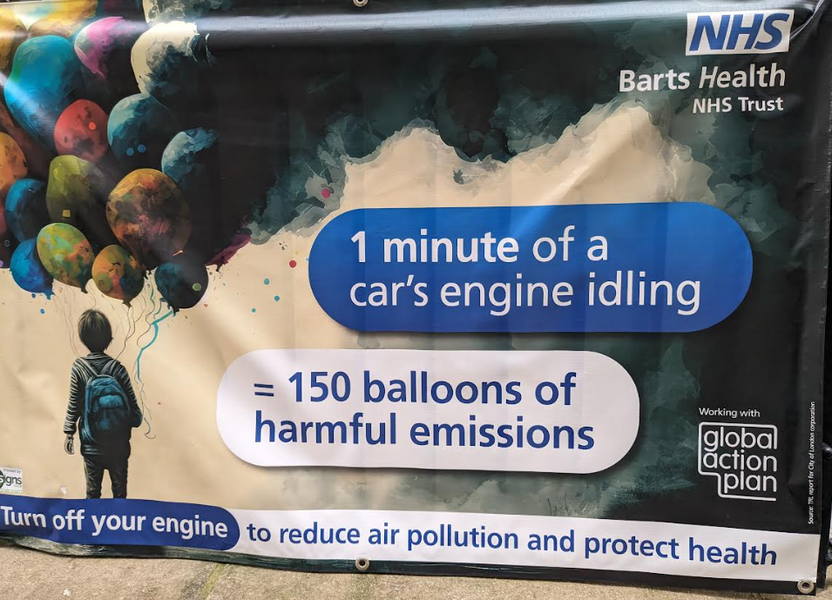

Reminder - Parent Volunteer session - Wednesday 17th April at 2:45pm:
If you would like to volunteer to help in school, but have never attended a volunteer session or completed your DBS check (disclosures and barring check), please sign up here for our next volunteer session: https://forms.gle/1CsNJbhUba1FHhTHA

Is your child interested in music? Want to find out more?
Please see the attached and below, a poster about Saturday Music School.

Reminder - Term dates 2024/2025:
Please find on the website: https://www.russell-lower.co.uk/website/term_dates_events__galleries/543714 our agreed term dates for 2024/25. These have been agreed with all lower and middle schools in Ampthill, Flitwick and Maulden.
Russell Lower School Values:
Each half term, we teach the children about a different value. We then have a weekly ‘values’ assembly where we celebrate the demonstration of this value. The values this coming term coming will be:

Summer 1: Friendship

PE and festivals news:
We are super excited to have lots of things planned for next half terms linked to PE and sport at Russell. It really is a half term for year 4 with a whole year group transfer festival at Alameda, a golf festival and also a cricket festival - they will certainly be busy! We will also be offering free (funded as part of our offer with Redborne School Sport Partnership) Bikeability sessions to all year 4 children. This is a great opportunity for the children to develop their confidence and cycle skills and we hope as many children as possible will take part.
We can also now reveal that we have plans in place to update our KS2 playground markings in May. The last time these were updated was around 8 years ago and we cannot wait to see our plans come to life and support our children in becoming even more active during our break and lunchtimes. Don’t worry KS1, there are future plans for your playground too.
Community events:
Please see below and attached.
FREE EASTER FUN!
Children who are entitled to income related free school meals have access to 2 days holiday provision (Including a trip to the theatre) and a hot meal on the 2nd and 3rd April.
The Ampthill days will be based at Alameda Middle School and will have a pirate theme. Day one will be filled with fantastic pirate activities and games and day two will be a coach trip to the theatre to see ‘Grooving with Pirates’ an animated and live-action mystical, magical, nautical, musical adventure which follows three pirate friends on a dangerous mission to find some treasure! A tale of friendship, loyalty and a magic chest.
BOOK your child’s FREE space NOW… https://fullhouse.org.uk/current-show/creative-buzz-2/

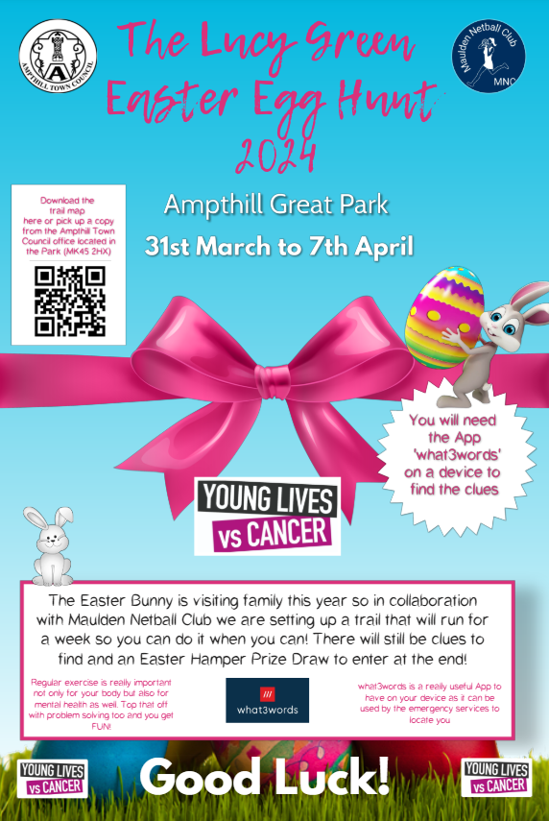

Back by Popular demand - Children's Maytime Celebrations morning - Early May Bank Holiday May 6th
Pre-booking asap is essential, as numbers are limited. All funds raised will go towards Ampthill Mayor, Cllr Susan Clinch’s Charities which are Young Minds and Bedfordshire Down's Syndrome Support Group.
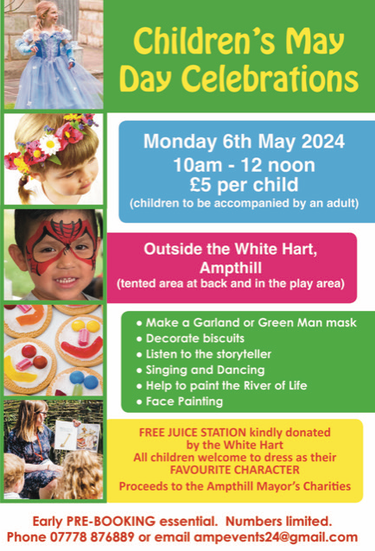
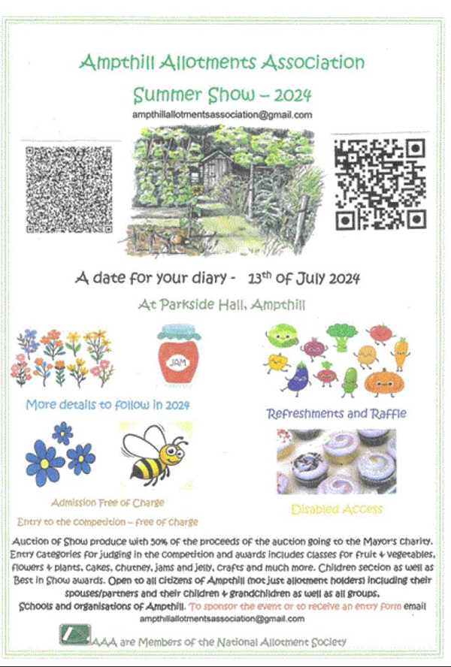

And finally:
Thank you for taking the time to read this newsletter and for all your on-going support this term. Wishing you all a very Happy Easter!
Many thanks and kind regards,
Nicki Walker
Headteacher

