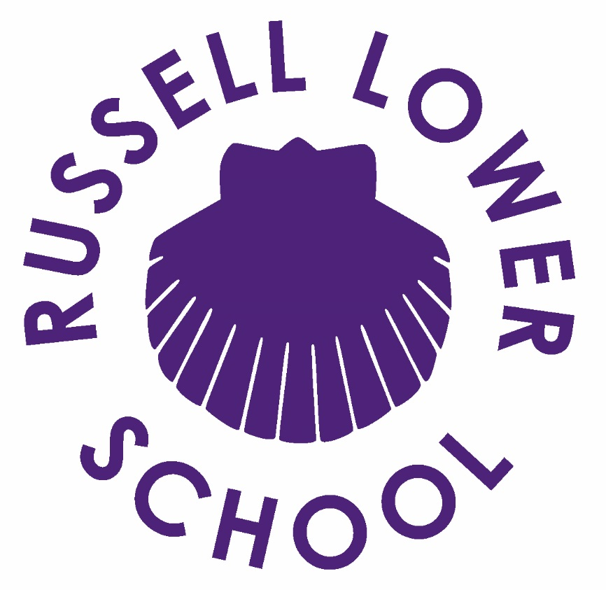

Safety Information for Visitors

Safety Information for Visitors
We hope that your visit will be enjoyable, informative and safe.
Please help us by reading and complying with the guidance contained in this leaflet, which is intended to ensure both your health and safety and that of our staff and children whilst you are at Russell Lower School.
If you have any questions after reading this, please do not hesitate to ask a member of staff to help you.
Security and Safeguarding
All visitors and contractors coming in to the school must report to Reception. If you do not have valid, official ID, or a reason for visiting you WILL NOT be allowed on site.
Please sign in and collect a visitor lanyard. Please make sure your lanyard is clearly visible to staff and students at all times. Most visitors will not work with students alone. If you are working unsupervised with students, the office staff will ask you to produce your DBS certificate or details thereof, together with proof of identification, ie. Passport or driving licence. Without this you may not be granted access.
You must sign in on each occasion you visit the school.
Please sign out at the end of your visit and return the Visitor lanyard.
Safeguarding Guidance for Visitors to the School
Adults visiting or working on the school site play an important part in the life of the school. You can play a part in keeping students safe whilst working at, or visiting, the school by observing the following guidelines:
- Do not initiate verbal or physical contact with students unless it is appropriate and a part of the agreed reason for your visit.
- Do not give any personal information to students, such as your mobile number or address.
- If you have any concerns that a student may be at risk of harm, report it immediately to the senior designated person for child protection (DSL), Sarah Knight, who can be contacted via the main school office.
- Do not discuss your concerns with the student, and do not carry out an investigation.
- If a student makes a disclosure to you, do not promise confidentiality. Explain that you will need to talk to someone else. Inform the designated senior person for child protection (Sarah Knight) of your concerns immediately.
- For further guidance, the school’s Safeguarding and Child Protection policy can be found on the school website.
We all have a duty to safeguard children.
If you have any concerns about a child’s welfare or anything that you see, hear or become aware of whilst visiting our school please see:
Sarah Knight (DSL), Nicki Walker, Headteacher and Deputy DSL or Louise Bunney, Deputy DSL and Deputy Headteacher. You can also contact the CBC safeguarding team directly: 0300 300 8585 or NSPCC: 0808 800 5000
These details and staff photos are also on safeguarding posters around the school.
If you have a concern about a member of staff, or an adult in our school you can contact: Nicki Walker (Headteacher) or LADO 0300 300 4825 / 0300 300 8142
Photographs
Visitors are prohibited from taking photographs whilst on the school site.
Fire & Evacuation
If you hear the alarm you must leave the building by the nearest exit
Go to either assembly point (Nearest playground) and ensure that you are recorded present by the administration staff.
Do not take any personal risks.
You must not re-enter the building until told it is safe to do so.
First Aid
If you have any medical needs please inform office staff upon arrival. If you need first aid or feel unwell whilst you are on site, please go to the Medical Room near the school office.
Health & Safety
Contractors must ensure that they are fully conversant with the safety rules and regulations to be observed by contractors working on site. As a visitor to our school it is essential that you follow any health and safety guidelines that may apply. This includes the current Covid restrictions which will be explained to you as you sign in. By complying with these rules, you will assist us in meeting the requirements of the Health & Safety at Work Act 1974.
Smoking
Russell Lower School operates a no smoking policy. Please do not smoke anywhere on the school site.
Use of mobile phones
Please note that the use of mobile phones is not permitted whilst around students. If you need to make/receive a phone call please do so from the offices or upstairs.

