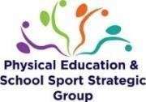
Evidencing the use of the PE and Sport Premium funding: Action plan and Impact Review
The DfE Vision for the Primary PE and Sport Premium

ALL pupils leaving primary school physically literate and with the knowledge, skills and motivation necessary to equip them for a healthy, active lifestyle and lifelong participation in physical activity and sport.

The funding has been provided to schools to make additional and sustainable improvements to the quality of PE and sport they offer. This means that you should use the funding to:
- develop or add to the PESSPA activities that your school already offer
- build capacity and capability within the school to ensure that improvements made now will benefit pupils joining the school in future years
Schools need to ensure impact against the following 5 Key Indicators:
- Increased confidence, knowledge and skills of all staff in teaching PE and sport
- Engagement of all pupils in regular physical activity
- The profile of PE and sport is raised across the school as a tool for whole school improvement
- Broader experience of a range of sports and physical activities offered to all pupils
- Increased participation in competitive sport

It is a statutory requirement of Ofsted, under their Common Inspection Framework, to ensure that information on the use of the Primary PE and Sport Premium and the impact it has had on pupils PE and sport participation and attainment is available on the school website by 31st July 2023. Schools also have a responsibility to publish on their website the % of pupils who achieve the expectation for swimming by the end of Year 6.
You should not use your funding to:
- employ coaches or specialist teachers to cover planning preparation and assessment (PPA) arrangements - these should come out of your core staffing budgets
- teach the minimum requirements of the national curriculum – apart from top-up swimming lessons after pupils’ completion of core lessons
- fund capital expenditure

Academic Year: | 2022-2023
Funding Allocation: | £16,000 school  £10pp years 1-4
Total | £19,490
Predicted Spend: | £19,244
Contingency | £246

PE and Sport Premium Action Plan
Indicator 1: Increased confidence, knowledge and skills of all staff in teaching Physical Education and Sport |  |  | Percentage of total allocation: %
Intent | Implementation | Allocated funding | Anticipated outcomes
For staff confidence, knowledge and skills to increase/develop in teaching Physical Education and Sport. | Join the Redborne School Sport Partnership (SSP). This provides support for local schools including professional development for teachers and entry into all local school festival and transition events.  - 2 x YST Twilight Workshops during the year  - Practical Real PE showcase event  - Teach Active Workshop  - Primary Cricket workshop  - Primary Rugby workshop  - Primary Tennis workshop  - Shooting Stars (Girls Football) training  National PE & School Sport Awards & National Programmes  Access to YST membership level 2  Access to online resources, topical updates, exclusive offers, discounts and priority access to YST National PE & School Sport Awards & National Programmes – used for resources and staff training  Nationally recognised badge of excellence for PE and school sport. | Within the £3,150 to join RSSP | Current staff/PE lead to increase skillset and confidence in order to provide high quality sessions that pupils engage well with.
For staff confidence, knowledge and skills to increase/develop in teaching Physical Education and Sport. | Badminton delivery day, including:  - 5 hours delivery  - Athlete assembly  - Follow up visit  1 day of Curriculum delivery in a chosen sport to suit your  school in any of the following sports:  - Basketball  - Cricket  - Dance  - Rugby Union  - Dance | Within RSSP offer
Further develop the skillset/confidence of the PE lead. | PE co-ordinator to attend the PE conference in March 2022 or any other relevant training. | £175 | For the PE lead to feel confident in their role and be able to support and guide others in improving PE and physical activity across the school.
Further develop the skillset/confidence of the PE lead. | 2 x Cluster networking meetings provided by RSSP | Within RSSP offer
Staff to gain experience in teaching a new physical activity – cultural dance | Cultural dance- Bhangra workshop. Highly skilled coaches to teach one PE lesson alongside staff and then offer lunchtime/twilight CPD to share new techniques and planning strategies | £1050 | Staff to have updated teaching and learning techniques to use when teaching specific physical activity. Staff to be confident in their own ability.
Indicator 2: The engagement of all pupils in regular physical activity |  |  | Percentage of total allocation: %
Intent | Implementation | Allocated funding | Anticipated outcomes
Encourage more physical activity during lunchtimes for all pupils through use of Sports Leaders. | With the support of RSSP training, Sports Leaders to lead lunchtime games for all pupils on rotation throughout the week. | Within the £3,150 to join RSSP | Sports ambassadors to enjoy the training and gain skills to enable them to work with and initiate sports activities with pupils in all year groups of the school at lunchtimes including offering personal challenges.
School to be well resourced in order to support regular physical activity – curricular, extra-curricular and lunchtime. | Staff to make the PE lead aware of any gaps in resources or additional resources required in order to support regular physical activity within curriculum lessons, extra-curricular clubs and breaktimes.  PE lead to source appropriate recourses according to the need within school. | £1000 | All pupils to be able to participate in high quality PE lessons/physical activity with safe, high quality resources.
Least active pupils/COVID recovery within school to have access and opportunity to attend extra-curricular clubs to increase their physical activity. | Autumn term audit to discover least active pupils in school.  Pupils to be offered a school-funded club to attend later in the year.  Find out if all PPG/SEND pupils are in at least one club over the year. If this is not the case, offer a club to them. | £3,500 for the year  £700 per ½ term (30 places) – Aut 2 to Summer 2 | The least active/vulnerable pupils within school to have been identified and offered the opportunity to attend a club. This will hopefully prove to be a positive experience for the pupils and they will look to attend in the future.
Year 3 pupils to be aware of basic safety factors when scooting. | Scootability to be offered to all Year 3 pupils as they did not receive the sessions last year due to covid. | £300 | Pupils will develop confidence with an active travel method to get to school  Pupils enjoy being active and are more active more of the time
Year 4 pupils to be aware of basic safety factors when riding a bike. | Level 1 Bikeability to be offered to all Year 4 pupils | Within RSSP offer  Booked for 9th and 10th May 2023 | Pupils will learn to:  - control and master their bikes in a space away from traffic  - prepare themselves and their bike for cycling  - get on and off their bike without help  - start off, pedal and stop with control  - pedal along, use gears and avoid objects  - look all around and behind, and control the bike  - share space with pedestrians and other cyclists
Year 2 pupils to be aware of basic safety factors when scooting. | Scootability to be offered to all Year 2 pupils | £ 300 | Pupils will develop confidence with an active travel method to get to school  Pupils enjoy being active and are more active more of the time

Indicator 3: The profile of PE and Sport is raised across the school as a tool for whole school improvement |  |  | Percentage of total allocation: %
Intent | Implementation | Allocated funding | Anticipated outcomes
RSSP community day | Aimed towards family development in order for them to experience and value the importance of physical activity outside of the school day – linked to Active 30:30 agenda  I kind of see a workshop filled day (possibly a weekend) where families would be encouraged to come onto the school site to partake in fun and exciting physical activities/sports in a means of getting them motivated and enthused with some activity.  Activities being targeted towards sports clubs/leisure activities that families could access in the local vicinity post event - if we could get some clubs involved that would be great! A real community event with Russell at the heart of it | £2800 | Children/families to be more active outside of the school environment.
Understanding around health and wellbeing (including diet) to be raised across the school as a tool for whole school improvement. | Purchase seeds/seedlings for each class so they are able to grow simple vegetables such as potatoes, carrots and onions. They will then be able to use this produce in healthy eating lessons with a link to physical health.  To arrange for a gardener to come in and speak to the pupils about growing their own food. | £200 | Pupils to understand how diet can influence healthy lifestyles.  Pupils to gain enjoyment and success from growing their own produce.  Pupils to be more aware of where their food comes from and the health benefits of freshly grown food.
Continued celebration of sporting and physical activity success across the school so pupils feel a sense of pride and community. | Pupils who attend festivals through RSSP awarded certificates/medals presented in our whole school assemblies in order to raise the profile of PE.  Certificates to be displayed on main PE board. | Within RSSP offer | The profile of PE, Sport and Physical Activity is raised across the school through whole school celebration and pupils feel proud of their achievements.
Sports Leaders to have a high profile within all key stage playgrounds and across the school and support peers in working towards their personal best. | With the support of RSSP training, Sports Leaders to lead lunchtime games for all pupils on rotation throughout the week.  Y4 Sports Ambassador training programme  - Including Log Books/Pin Badges  - 10 x Sports Ambassador T-Shirts for the 2022/23 cohort  - Support for Sports Ambassadors to deliver an intra school  - festival  Focus on leaders encouraging peers to complete the ‘personal challenges’ – link to KI5.  A display board dedicated to the Sports Leaders and their achievements as well as a board dedicated to PE across the school. | Within RSSP offer | Physical activity to be prominent across all times of the school day included outside of PE lessons.  Pupils to be able to see and celebrate their improvements and success.  Sports Leaders to feel valued and a sense of pride carrying out their role.
A greater number of pupils to achieve the expected standard of swimming by the end of KS2. | Year 3 pupils to attend swimming lessons beyond the core offer in year 4.  Breakdown of KS2 swimming outcomes into 2 years’ worth of smaller steps rather than the core year 4 lessons alone (PE milestone document) should ensure that more pupils achieve the expected swimming KS2 milestones before they leave year 4. | £2000 | Pupils to have water confidence before their curriculum lessons in year 4.  Pupils’ swimming skills are increased  Pupils’ water confidence is increased  Pupils’ activity levels are increased
Indicator 4: Broader experience of a range of sports and activities offered to all pupils |  |  | Percentage of total allocation: %
Intent | Implementation | Allocated funding | Anticipated outcomes
Pupils to be able to experience a broader range of sports/physical activity. | Through RSSP pupils to attend local school games events where there are a range of sport/physical activities for pupils to take part in including SEND/inclusion events. | Within RSSP offer | For pupils to have fun and feel part of a team.  Pupils to experience ‘new’ sports/physical activity in order to enthuse and motivate including our disadvantaged pupils.  Pupils to be inspired to try a new sport.
Pupils to be able to experience a broader range of sports/physical activity. | Create a new extra-curricular offer with Premier Sport including funding for Autumn 2 and Spring 1 for all children. | Within £3500 above | Pupils to experience ‘new’ sports/physical activity in order to enthuse and motivate including our disadvantaged pupils.  Pupils to be inspired to try a new sport.
Pupils to experience new physical activity. | Bhangra and cultural dance workshop. Highly skilled coaches to teach one PE lesson alongside staff.  British values focus on PE. 16th, 17th and 18th January. | In above £1050 cost | For pupils to have fun.  Pupils to experience a new ‘traditional’ physical activity, develop new skills, and possibly seek pursuing this outside of school hours.  To add to pupil’s cultural capital via PE.
Pupils to experience new physical activity. | Irish dance workshop. Highly skilled coaches to teach one PE lesson alongside staff.  British values focus on PE. 13th , 14th and 15th March | £1597 | For pupils to have fun.  Pupils to experience a new ‘traditional’ physical activity, develop new skills, and possibly seek pursuing this outside of school hours.  To add to pupil’s cultural capital via PE.
Pupils to experience new physical activity. | World cup dance workshop. Highly skilled coaches to teach one PE lesson alongside staff.  . 16th, 17th and 18th November | £1597 | For pupils to have fun.  Pupils to experience a new ‘traditional’ physical activity, develop new skills, and possibly seek pursuing this outside of school hours.  To add to pupil’s cultural capital via PE.
Pupils to experience new physical activity which is also promotes school value of ‘The right to be included.’ | Wheelchair Basketball event.  All pupils and staff to partake in wheelchair basketball. Highly skilled coaches to teach one PE lesson alongside staff. | £1575- booked for various dates | For pupils to have fun.  Pupils to experience a new ‘traditional’ physical activity, develop new skills, and possibly seek pursuing this outside of school hours.  To add to pupil’s cultural capital via PE.
Indicator 5: Increased participation in competitive sport |  |  | Percentage of total allocation:
Intent | Implementation | Allocated funding | Anticipated outcomes
All pupils in year 4 to attend a transition event and 1 additional event  All pupils in year 3 to attend at least one event  All pupils in year 2 to attend at least one event.  A selection of year 1 pupils to attend an event. | Join the Redborne School Sport Partnership (SSP). This provides support for local schools including professional development for teachers and entry into all local school festival and transition events.  Pupils are given the opportunity to attend a range of festivals and transition events.  PLAY  - KS1 Multi Skills Festival  - Y3/4 Paralympic Festival  - Year 1 – 4 Dance Festival  - Y3/4 Badminton  DEVELOP  - KS1 Cricket  - Y3/4 Basketball  - Y3/4 Tennis  - Y3/4 Tag Rugby  COMPETE  - KS1 Kurling  - Y3/4 Sportshall Athletics  - Y3/4 QuadKids Athletics  - Y3/4 Kwik Cricket  - Y3/4 Swimming | Within RSSP offer | Pupils experience interschool sports festivals and therefore will be more confident to put themselves forward for these in the future.

PE and Sport Premium Impact Review
Academic Year: | 2022-2023
Funding Allocation: | £16,000  £10pp
Total | £19,490
Actual spend: | Spent £19,731.19

Indicator 1: Increased confidence, knowledge and skills of all staff in teaching Physical Education and sport |  |  |  | Percentage of total allocation:
 |  |  |  | 6% excluding RSSP
Intent | Implementation | Actual Cost | Impact | Sustainability and suggested next steps
For staff confidence, knowledge and skills to increase/develop in teaching Physical Education and Sport. | Join the Redborne School Sport Partnership (SSP). This provides support for local schools including professional development for teachers and entry into all local school festival and transition events.  - 2 x YST Twilight Workshops during the year  - Practical Real PE showcase event  - Teach Active Workshop  - Primary Cricket workshop  - Primary Rugby workshop  - Primary Tennis workshop  - Shooting Stars (Girls Football) training  National PE & School Sport Awards & National Programmes  Access to YST membership level 2  Access to online resources, topical updates, exclusive offers, discounts and priority access to YST National PE & School Sport Awards & National Programmes – used for resources and staff training  Nationally recognised badge of excellence for PE and school sport. | Within the £3,150 to join RSSP | All festivals entered this year have been attended and resources used when and as needed to support PE and sport school wide.  Attendees for festivals are chosen in an inclusive manner rather than for winning. | Improved capabilities within the school that will benefit pupils in years to come.  As a school, we will continue to be a member of RSSP and be involved in all that they have to offer.
For staff confidence, knowledge and skills to increase/develop in teaching Physical Education and Sport. | Badminton delivery day, including:  - 5 hours delivery  - Athlete assembly  - Follow up visit  1 day of Curriculum delivery in a chosen sport to suit your  school in any of the following sports:  - Basketball  - Cricket  - Dance  - Rugby Union  - Dance  - Other | Within the £3,150 to join RSSP | Year 3 badminton support - unfortunately these sessions did not happen due to staff illness within RSSP.  Year 4 athletics support in the summer term  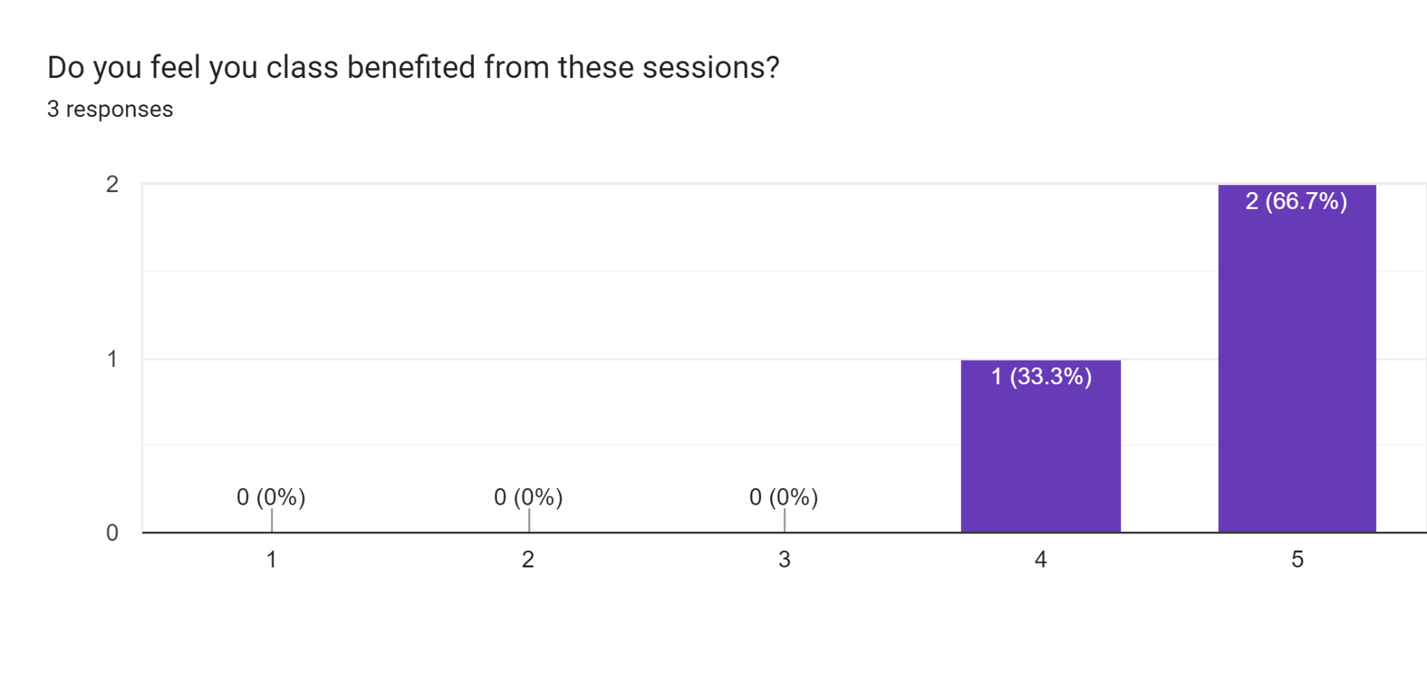  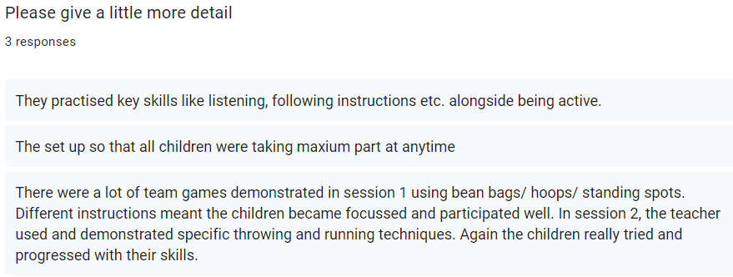  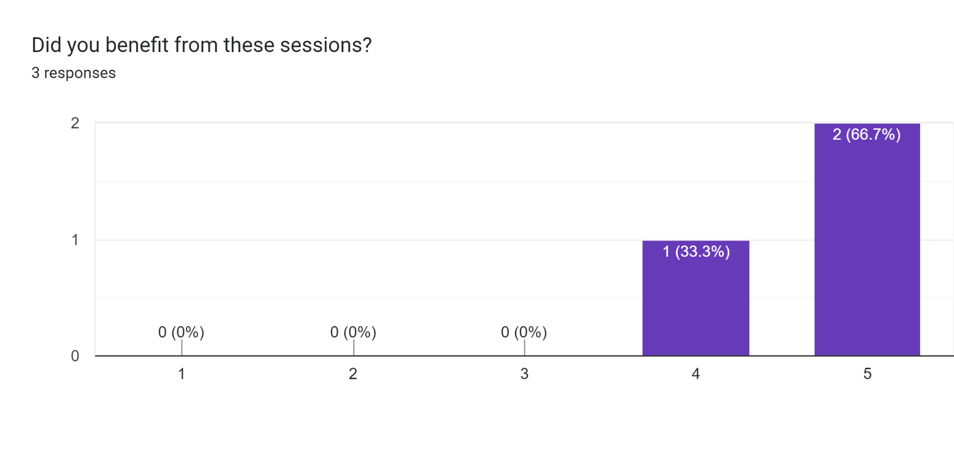  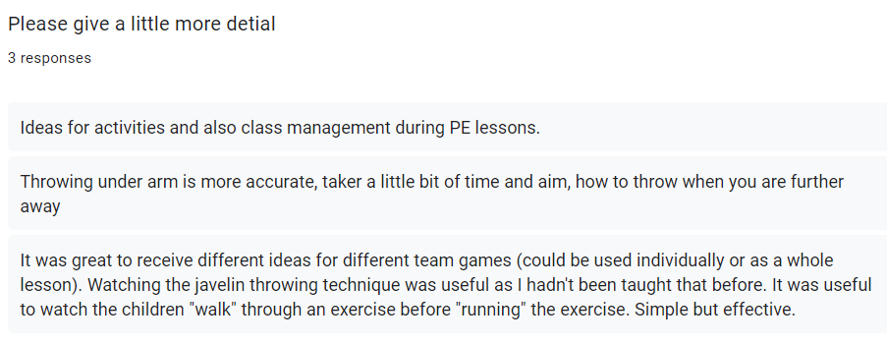 | Improved capabilities within the school that will benefit pupils in years to come.
Further develop the skillset/confidence of the PE lead. | PE co-ordinator to attend the PE conference in March 2022 or any other relevant training. |  | For the PE lead to feel confident in their role and be able to support and guide others in improving PE and physical activity across the school.  Not attended due to being on mat leave | Improved capabilities within the school that will benefit pupils in years to come.
Further develop the skillset/confidence of the PE lead. | 2 x Cluster networking meetings provided by RSSP | Within the £3,150 to join RSSP | For the PE lead to feel confident in their role and be able to support and guide others in improving PE and physical activity across the school.  Virtual meetings were attended where new ideas were explored the main one being a new PE planning tool. Nothing has been implemented due to Ofsted and the move over to a new assessment tool where outcomes need to be inputted. | Improved capabilities within the school that will benefit pupils in years to come.
Staff to gain experience in teaching a new physical activity – cultural dance | Cultural dance- Bhangra workshop. Highly skilled coaches to teach one PE lesson alongside staff and then offer lunchtime/twilight CPD to share new techniques and planning strategies | £1050 | Staff felt these sessions were valuable particularly in terms of cultural capital for the children.  In terms of CPD there was limited opportunity due to timings however all class teachers were present in the class sessions.  It was useful to see the structure and pace of the sessions and how much progress the children made within the sessions.

Indicator 2: The engagement of all pupils in regular physical activity |  |  |  | Percentage of total allocation:
 |  |  |  | 30% excluding RSSP
Intent | Implementation | Actual Cost | Impact | Sustainability and suggested next steps
Encourage more physical activity during lunchtimes for all pupils through use of Sports Leaders. | With the support of RSSP training, Sports Leaders to lead lunchtime games for all pupils on rotation throughout the week. | Within the £3,150 to join RSSP | Training took place on 17th October 2022 for 10 year 3 and 10 year 4 pupils.  100% enjoyed the training  85% felt the training would help them to lead other children in being active with 15% not sure  Some of the things the children felt they had learnt included how to motivate and encourage children to join in, some new activities and games to play, how to be a good role model, they need good communication skills to work with the younger children.  During the Spring term meetings took place with the PE lead focussing on the sports leader booklet however these were limited due to the PE lead being in class.  During the Summer term the sports leaders have been on all three playgrounds supporting with games and activities being played. By the summer term they were fully independent in setting up the activities and leading them in their pairs/small groups. | Children enjoy and are enthusiastic about sport, creating a positive sporting culture within school. Children also have a good understanding of health and well-being  Pupils to disseminate skills further down the school.  Within summer term year 4 to buddy up with year 3 to coach.
School to be well resourced in order to support regular physical activity – curricular, extra-curricular and lunchtime. | Staff to make the PE lead aware of any gaps in resources or additional resources required in order to support regular physical activity within curriculum lessons, extra-curricular clubs and breaktimes.  PE lead to source appropriate recourses according to the need within school. | £541.21 – RR goals and balls for whole school use | These resources are used by Russell Raiders football club at the weekends but are also used each lunchtime by KS2 children. The children are on a rota for the week and enjoy their football days. | PE resources within school continue to improve year after year, allowing teachers to deliver the PE curriculum effectively and allowing lunchtime supervisors and after school club workers to deliver other sports activities.  Equipment is kept all together in a safe place. It is maintained and therefore will be used for many years to come.
Least active pupils/COVID recovery within school to have access and opportunity to attend extra-curricular clubs to increase their physical activity. | Autumn term audit to discover least active pupils in school.  Pupils to be offered a school-funded club to attend later in the year.  Find out if all PPG/SEND pupils are in at least one club over the year. If this is not the case, offer a club to them. | Autumn 2 £2,070  Spring 1 £1725  Total £3795 | Autumn term least active identified:  Have never been to a sports club in school KS1 42%, KS2 25%  Have never been to a sports club in or out of school KS1 19%, KS2 4%  Autumn 2 uptake  Have never been to a sports club in school KS1 31%, KS2 24%  Have never been to a sports club in or out of school KS1 26%, KS2 38%  Spring 1 uptake  Have never been to a sports club in school KS1 24%, KS2 20%  Have never been to a sports club in or out of school KS1 29%, KS2 13%  11 different children took up a club in KS1 and 3 in KS2.  8 children re-joined a club in KS1 and 7 in KS2.  By the end of the spring term:  KS1 47% of children who had never been to a sports club in school had attended at least one. 46% who had never been to a sports club in or out of school had attended at least one club.  KS2 31% of children who had never been to a sports club in school had attended at least one. 37% who had never been to a sports club in or out of school had attended at least one club.  Average 39% and 42% uptake  We will now offer remaining children the opportunity to attend some dodgeball sessions (won in a competition) in the Summer term. | As a school, we shall continue to support our least active/vulnerable pupils and allow equal opportunities.
Year 3 pupils to be aware of basic safety factors when scooting. | Scootability to be offered to all Year 3 pupils as they did not receive the sessions last year due to covid. Booked 6th February 2023 | £300 | Pupils enjoyed the sessions and felt they had learnt something new.  I learnt how to scoot around. I learnt how to jump using a scooter. I learnt how to ride a scooter without putting my foot down to turn. I learnt how to disco on a scooter. I learnt how to scoot over a ramp. I learnt it isn't a big deal if you fall over.  They felt we offered the sessions for the following reasons:  To be fitter. To be more confident and courageous. To get us more active. To learn how to ride a scooter. To have fun! To encourage us to ride our scooters to school. To follow our value and be courageous. To give children the opportunity to ride a scooter who do not have one at home | Skills that pupils will be able to use once they have left Russell and develop further should they wish.  To continue to fund this programme through main school budget if required.
Year 4 pupils to be aware of basic safety factors when riding a bike. | Level 1 Bikeability to be offered to all Year 4 pupils | Within RSSP offer  Booked for 9th and 10th May 2023 | 90% of pupils said they enjoyed the session  80% felt the sessions had somewhat improved their confidence  66% felt the sessions had somewhat developed their skills  The children said the following about the sessions:  we had a really fun time, it inspired me to do more cycling, I loved it because it developed my skills | Skills that pupils will be able to use once they have left Russell and develop further should they wish.  To continue to fund this programme through main school budget if required.
Year 2 pupils to be aware of basic safety factors when scooting. | Scootability to be offered to all Year 2 pupils | £ 300 | Pupils enjoyed the sessions and felt they had learnt something new.  Different games How to balance  How to go onto 2 wheels instead of 3.  They felt we offered the sessions for the following reasons:  To learn how to keep fit  To learn new skills  To test how good we are on 2 wheel and 3 wheel scooters and how to balance. | Skills that pupils will be able to use once they have left Russell and develop further should they wish.  To continue to fund this programme through main school budget if required.
Indicator 3: The profile of PE and Sport is raised across the school as a tool for whole school improvement |  |  |  | Percentage of total allocation:
 |  |  |  | 28% excluding RSSP and
Intent | Implementation | Actual Cost | Impact | Sustainability and suggested next steps
RSSP community day | Aimed towards family development in order for them to experience and value the importance of physical activity outside of the school day – linked to Active 30:30 agenda  I kind of see a workshop filled day (possibly a weekend) where families would be encouraged to come onto the school site to partake in fun and exciting physical activities/sports in a means of getting them motivated and enthused with some activity.  Activities being targeted towards sports clubs/leisure activities that families could access in the local vicinity post event - if we could get some clubs involved that would be great! A real community event with Russell at the heart of it | £2699.85 | Due to other school pressures this would not have been possible to have organised. Therefore, KS1 home activity packs (including a number of items such as beanbags, balls, tennis rackets etc. were purchased for all KS1 children and sent home with some links to activities that could be completed at home to encourage families to be active at home.  Parent feedback:  83% of parents felt the packs would help their children become MORE active outside of home.  99% said they would use the pack to do some physical activity with their children.  Some feedback comments included:  Great excite with the sports pack - straight into garden using. Kids already do obstacle course building - this has increased their interest. Great idea, thank you.  My child is very excited about the activity pack and embraces outdoor time more then before  Thank you so much, we love the resources and my child was very excited to use them and show us all things they do in PE. We will definitely be using them a lot in the garden.  This is a fantastic initiative to support children who perhaps aren't able to access clubs that increase their level of physical activity. We are very lucky at Russell to have great resources and our family is fortunate enough to be in a position to send our children to sports clubs etc.  A very good idea providing this activity pack but most important is parents to understand the necessity and importance of physical activities for children and not to forget taking time and spend it with our children, from our busy schedules. | Children/families to be more active outside of the school environment.
Understanding around health and wellbeing (including diet) to be raised across the school as a tool for whole school improvement. | Purchase seeds/seedlings for each class so they are able to grow simple vegetables such as potatoes, carrots and onions. They will then be able to use this produce in healthy eating lessons with a link to physical health.  To arrange for a gardener to come in and speak to the pupils about growing their own food. | There was no cost to this element as funding was provided through the Tesco grant scheme | The feedback indicated that children enjoyed growing their own produce. Many felt that doing so helped them to understand where food comes from and how it is produced particularly some of the less familiar foods such as radishes. Comments included:  I know plants are very helpful to the environment, I've learnt the progress of them and how it starts to grow, how it starts to turn into our food  A high % of children said they would like to continue growing veg/fruit next year too.  A high % of children would also like to grow fruit and veg at home after experiencing this at school.  Additional comments included:  We've enjoyed trying to eat new things including radishes. We learnt plants need a lot of water and sunlight to grow quickly.  We like watering the plants and we are learning about plants in science | Investment made in vegetable beds/planters that will provide pupils with the opportunity to use this equipment for a number of years before needing to be replaced.  Pupils also have a good understanding of health and well-being.
Continued celebration of sporting and physical activity success across the school so pupils feel a sense of pride and community. | Pupils who attend festivals through RSSP awarded certificates/medals presented in our whole school assemblies in order to raise the profile of PE.  Certificates to be displayed on main PE board. | Within RSSP offer | All children from year2 to 4 have an opportunity to take part in an inter school festival.  These festivals are then celebrated in assembly through the awarding of a certificate.  Children take pride in representing their school. | Children enjoy and are enthusiastic about sport, creating a positive sporting culture within school.
Sports Leaders to have a high profile within all key stage playgrounds and across the school and support peers in working towards their personal best. | With the support of RSSP training, Sports Leaders to lead lunchtime games for all pupils on rotation throughout the week.  Focus on leaders encouraging peers to complete the ‘personal challenges’.  A display board dedicated to the Sports Leaders and their achievements as well as a board dedicated to PE across the school. | Within RSSP offer | During the Summer term the sports leaders have been on all three playgrounds supporting the games and activities being played. By the summer term they were fully independent in setting up the activities and leading them in their pairs/small groups. | Children enjoy and are enthusiastic about sport, creating a positive sporting culture within school.  Children also have a good understanding of health and well-being
A greater number of pupils to achieve the expected standard of swimming by the end of KS2. | Year 3 pupils to attend swimming lessons beyond the core offer in year 4.  Breakdown of KS2 swimming outcomes into 2 years’ worth of smaller steps rather than the core year 4 lessons alone (PE milestone document) should ensure that more pupils achieve the expected swimming KS2 milestones before they leave year 4.Year 3 pupils to attend swimming lessons beyond the core offer in year 4.  The breakdown of KS2 swimming targets into 2 years’ worth of lessons rather than the core year 4 lessons alone (PE milestone document) should ensure that more pupils achieve the expected swimming KS2 milestones before they leave year 4. | Swimming sessions - £1041.13  Coach - £900 | 91% of pupils said they enjoyed the sessions.  67% said the sessions developed their water confidence to some level.  70% said the sessions developed their skills.  The children made the following comments about the lessons:  - would like more and longer  - more fun activities  - I enjoyed using the floats  - they helped me improve  - I really enjoyed the sessions  The pupils will receive their curriculum requirement for swimming next year with us and will then be assessed in their middle schools. | Pupils are more confident and competent swimmers for use in later life. Due to the middle school not providing swimming as part of the curriculum, we felt this ‘additional’ swimming was an excellent use of the premium.  Moving forward assessment data to be completed by school/swimming lesson staff.
Indicator 4: Broader experience of a range of sports and activities offered to all pupils |  |  |  | Percentage of total allocation:
 |  |  |  | 36% excluding RSSP and club costs from above
Intent | Implementation | Actual Cost | Impact | Sustainability and suggested next steps
Pupils to be able to experience a broader range of sports/physical activity. | Through RSSP pupils to attend local school games events where there are a range of sport/physical activities for pupils to take part in including SEND/inclusion events. | Within RSSP cost | All festivals and events have been attended.  Pupils are given the opportunity to attend a range of festivals and transition events.  PLAY  - KS1 Multi Skills Festival – Autumn year 2  - Y3/4 Paralympic Festival – Spring year 3  - Y3/4 Badminton - Spring year 3  DEVELOP  - KS1 Cricket – Summer year 2  - Y3/4 Basketball – Autumn year 3  - Y3/4 Tennis – Summer year 4  - Y3/4 Tag Rugby – Spring year 4  COMPETE  - KS1 Kurling – Spring year 2  - Y3/4 Sportshall Athletics – Autumn year 4  - Y3/4 QuadKids Athletics – Summer year 3. Placed 5th and 6th  - Y3/4 Kwik Cricket – Summer year 4  - Y3/4 Swimming – Spring year 4. Russell 3rd, Russel 2 9th  Year 4 transfer event in Summer term | As a school we will continue to be a member of RSSP and be involved in all that they have to offer.
Pupils to be able to experience a broader range of sports/physical activity. | Create a new extra-curricular offer with Premier Sport including funding for Autumn 2 and Spring 1 for all children. | Within £3795 above | Bold clubs are new this year  Autumn 2  KS1  Paralympic - 19  World Cup football – 27  Gymnastics - 26  KS2  Paralympic - 14  Badminton - 25  World Cup football – 27  Spring 1  KS1  Basketball/netball - 28  Gymnastics - 26  Hockey - 20  KS2  Basketball - 26  Hockey - 21  Table tennis – 23  Moving forwards we would like to offer further variety through clubs such as those below following from a pupil survey:  Kurling  Lacrosse  Tri golf  Volleyball  Athletics  Archery  Fencing | Pupils to experience ‘new’ sports/physical activity in order to enthuse and motivate including our disadvantaged pupils.  Pupils to be inspired to try a new sport.
Pupils to experience new physical activity. | Bhangra and cultural dance workshop. Highly skilled coaches to teach one PE lesson alongside staff.  British values focus on PE. | £1050 | 90% of children enjoyed the sessions  89% of children felt they learnt something new  Some of the things they felt they learnt were:  Movements (clapping and shoulder moves). The dance was from The Punjab region of India  Chaffa which is a dance move, that they have an arm movement to show happiness and they used a stick with a red flag which makes the dance cool  I learnt how to do a Bhangra dance. I learnt Bhangra dance uses your shoulders a lot! I learnt you count 1, 2, 3, 4 in Bhangra dance. I learnt in Bhangra dance you have to have a HUGE smile! I learnt that Bhangra dance is really fun! I learnt how to dance with a 'randanna' which was a silk flag. I learnt how to dance with prop - long stick with silk flags attached.
Pupils to experience new physical activity. | Irish dance workshop. Highly skilled coaches to teach one PE lesson alongside staff.  British values focus on PE. 13th , 14th and 15th March | £1597 | 81% of pupils said they enjoyed the sessions.  66% of pupils felt they had learnt something new.  Some of the things they felt that had learnt included:  Places around the world that celebrate St. Patrick's Day New dance style Traditional and modern Irish Dance Styles Dancing with arms at your side  I learnt how to Irish dance. I learnt Irish dancing is a lot of fun. I learnt Irish dancing keeps you fit and healthy.  The kissing gallops, dancing not using arms  Spinning around, kicking feet together, going across and in together with my leg, going sideways and leftways (sic) and jumping.
Pupils to experience new physical activity. | World cup football dance workshop. Highly skilled coaches to teach one PE lesson alongside staff.  16th, 17th and 18th November | £1597 | 87% of children enjoyed the sessions  86% of children felt they learnt something new  Some of the things they felt they learnt were:  A new dance routine  Learnt about Brazilian dance  Working with others  Learning a dance from another country  Samba moves  Learnt about a beat of 4 or a beat of 8 in most dances  Flamenco clapping sequence, lots of different hand shapes, keeping in time  I learnt how to be a dancer, I learnt how to do the Samba, I learnt how to shimmy, I learnt what Samba means, I learnt the rhythm of the Samba (1, 2, 123).  Then children had a good understanding that we were doing the sessions now as the World Cup is about to begin.
Pupils to experience new physical activity which is also promotes school value of ‘The right to be included.’ | Wheelchair Basketball event.  All pupils and staff to partake in wheelchair basketball. Highly skilled coaches to teach one PE lesson alongside staff. | £1710  £525 paid Nov  £525 paid Feb | 99% of the children enjoyed the sessions as well as all the adults who took part.  100% of children felt they learnt something new  Some of the things they felt they learnt were:  How to get into a wheelchair How to move it in different directions  I learnt people who use a wheelchair can still play sport. I learnt people who use a wheelchair can still have fun. I learnt how to sit on a wheelchair safely. I learnt people who use a wheelchair can still play the sports I play. I learnt people who use a wheelchair can still play basketball.  How people in wheelchairs play basketball. What it was like to be disabled. You don't need to dribble the ball in wheelchair basketball. What it was like from their perspective, how it felt and how they lived. How to use a wheelchair.  How to play wheelchair basketball. If you don't score, it doesn't matter. How hard it is to shoot. That it takes a lot of teamwork to pass the ball around. To not be afraid and have fun. That it's very hard to do sports in a wheelchair.  93% think they now understand a little more what it is like to play a sport with a disability?
Indicator 5: Increased participation in competitive sport |  |  |  | Percentage of total allocation:
 |  |  |  | 16% of sports premium for RSSP buy in
Intent | Implementation | Actual Cost | Impact | Sustainability and suggested next steps
All pupils in year 4 to attend a transition event and 1 additional event  All pupils in year 3 to attend at least one event  All pupils in year 2 to attend at least one event.  A selection of year 1 pupils to attend an event. | Join the Redborne School Sport Partnership (SSP). This provides support for local schools including professional development for teachers and entry into all local school festival and transition events.  Pupils are given the opportunity to attend a range of festivals and transition events.  PLAY  - KS1 Multi Skills Festival  - Y3/4 Paralympic Festival  - Year 1 – 4 Dance Festival  - Y3/4 Badminton  DEVELOP  - KS1 Cricket  - Y3/4 Basketball  - Y3/4 Tennis  - Y3/4 Tag Rugby  COMPETE  - KS1 Kurling  - Y3/4 Sportshall Athletics  - Y3/4 QuadKids Athletics  - Y3/4 Kwik Cricket  - Y3/4 Swimming | Within RSSP | Pupils have experienced interschool sports festivals across the year.  Autumn 2021:  - KS1 Multi Skills Festival – Autumn year 2  - Y3/4 Basketball – Autumn year 3  - Y3/4 Sportshall Athletics – Autumn year 4  Spring 2022:  - Y3/4 Paralympic Festival – Spring year 3  - Y3/4 Badminton - Spring year 3  - KS1 Kurling – Spring year 2  - Y3/4 Tag Rugby – Spring year 4  - Y3/4 Swimming – Spring year 4. Russell 3rd, Russel 2 9th  Summer 2022:  - KS1 Cricket – Summer year 2  - Y3/4 Tennis – Summer year 3  - Y3/4 QuadKids Athletics – Summer year 3. Placed 5th and 6th  - Y3/4 Kwik Cricket – Summer year 4  - Year 4 transfer event in Summer term | Pupils enjoy and are enthusiastic about sport, creating a positive sporting culture within school.  Pupils may be inspired to pursue outside of school.  Children experience interschool sports festivals and therefore will be more confident to put themselves forward for these in the future.  To allocate funding to be part of RSSP (bespoke package tailored to our needs) if needed in the future.

Financial Year | Budget | Actual Spend | Key Impact for each year
2019 - 2020 | £ 23,590 | £ 23,194 | COVID 19 year  - We could see the impact of the year 3 additional swimming from the previous as Year 4 children had much better competitive swimming results at the inter-school competition with Team 2 coming first.
2020 - 2021 | £19,460 | £19,350.04 | Another COVID 19 year  - Increased engagement of pupils in regular physical activity
2021 - 2022 | £19,589.96 |  | Another COVID 19 year  - Children were finally able to attend interschool events in person rather than just virtually during Summer term 2022.
2022 – 2023 | £19,490 | £19,731.19 | - Lots of cultural capital and enrichment activities this year including Irish dancing, world cup dance, bhangra dance and wheelchair basketball. The wheelchair basketball was an excellent opportunity for both staff and child and we will be looking to

Summary of key plans for 2022- 2023 | Summary of key achievements for 2022-2023 | Summary of key plans for 2023-2024
• To broaden community links and achieve the platinum sports award.  • To continue to offer cultural capital and enrichment opportunities linked to physical education, sport and physical activity whilst developing teaching knowledge and understanding and confidence.  • To continue to target the least active and vulnerable groups.  • To support staff in providing more cross curricular links which involve the outdoors and physical activity.  • To support staffs QFT in continuing to develop the PE curriculum focussing on physical activity, mental health and wellbeing. | - Due to the Sports premium being extended into next year we instead prioritised the activity of KS1 by purchasing individual take home PE kits. We have the Platinum sports award for a second year  - Lots of cultural capital and enrichment activities this year including Irish dancing world cup dance, bhangra dance and wheelchair basketball. The wheelchair basketball was an excellent opportunity for both staff and child and we will be looking to  - Two half terms of free clubs offered to both KS1 and 2 to encourage participation. A competition that we won provided us with some dodgeball sessions, these were offered free to remaining least active children.  - KS2 staff have received CPD around athletics via RSSP. | - To continue with inclusivity and enrichment activities such as wheelchair basketball  - To consider the development of some of the field into a MUGA (multi-use games area) so that outdoor sports can be taught throughout the year and to offer more physical space during break times.  - Continued buy in to RSSP in order to access intra and inter festivals  - To further develop active 30:30

Signed off by |  | Date
PE Lead | L Bunney | November 22 July 23
Headteacher | N Walker | November 22 July 23
Governor | R Gallagher | November 22 July 23

