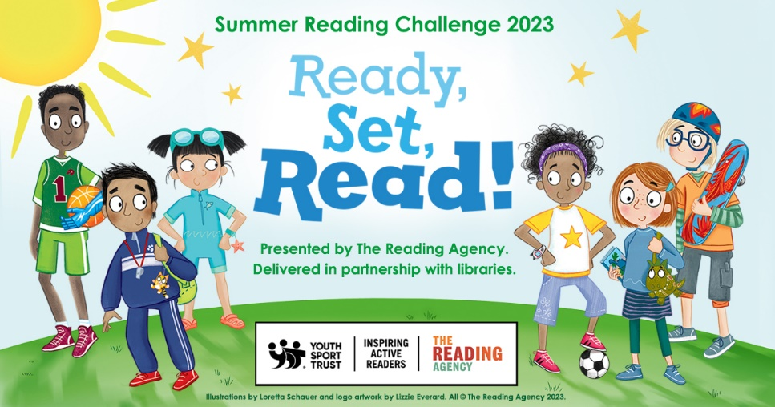

The Summer Reading Challenge is an annual challenge run jointly by The Reading Agency and public libraries. This year the challenge is Ready, Set, Read, with a theme of Sports & Games.
It runs Friday 21st July to Saturday 9th September 2023.
The Summer Reading Challenge aims to keep children’s minds and bodies active over the summer break. Children are encouraged to read whatever they like for the challenge, recognising the importance of reading for pleasure in increasing empathy and improving well-being, as well as in children’s educational success.
The Challenge
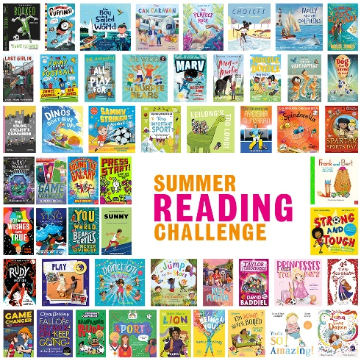
- Children must be members of the library service. Join the library here or go to your local library.
- The challenge invites children to read any six library books or more during the summer holidays.
- Children can borrow books or read our e-books, magazines and audiobooks available from our Virtual Library
- Families can sign up for the challenge at any library, at any stage in the summer from Friday 21st July.
- Children are awarded a certificate and a medal for reading 6 books.
- Children completing the challenge (6 books) will be entered into a lucky dip at their library for the chance to win a £50 lego voucher.

Events
We are thrilled to have Matt Oldfield, co-author of Ultimate football heroes series and winner of the 2020 Children's Sports Book of the Year for Unbelievable football series at Flitwick, Sandy and Toddington Libraries on Thursday 31st August.
Happy Little Yogi. An introduction to yoga for 4-11 year olds where the children practise balance, flexibility and creativity.
Game On! Join local artist Kaye Mahoney, as she captains a team of young participants to create an interactive table-top sports game complete with players... the goal is to build it AND then play on it, all in an hour!
Details of locations, dates, times and tickets available from all libraries, from mid-June.
Further details of all activities will become available: www.centralbedfordshire.gov.uk/summer-reading-challenge

