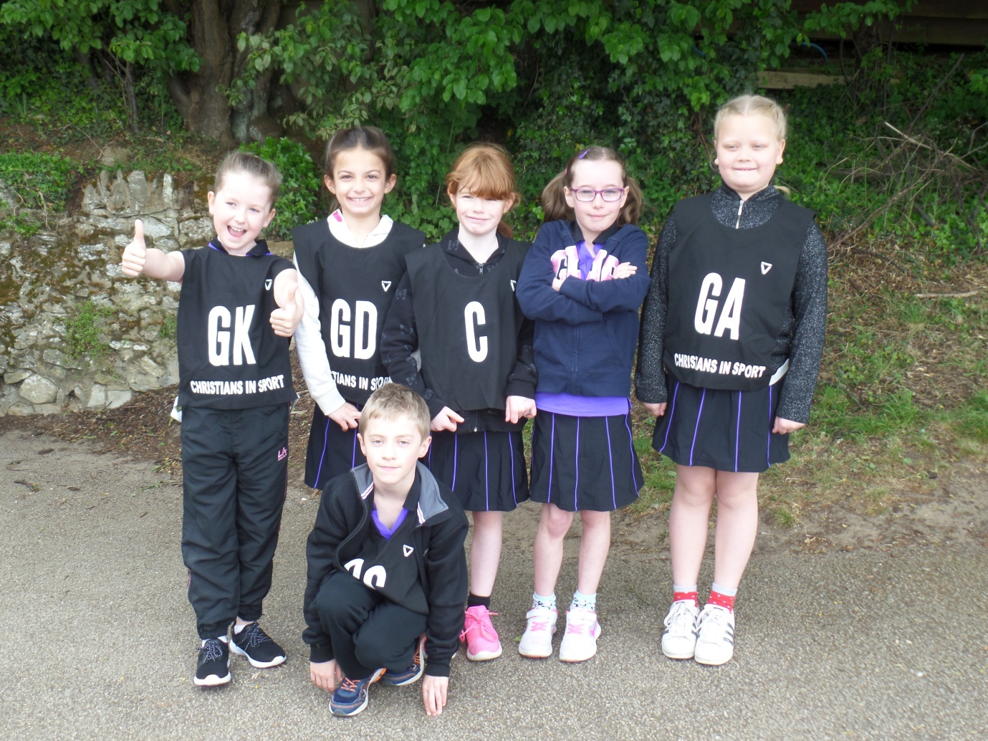

Russell Diamonds Yr 4 Netball

Maulden Lower School Tournament

With just two sessions of summer training under their belts 6 bold Russell Diamonds players braved a slightly chilly May day to play in their first ever tournament.
The tournament featured 6 teams from the local area with each team playing the others once. The games were 7 minutes long and the players rotated positions after each game so that everyone played in every position. With many of the other players away with the Brownies this weekend it was up to Imogen Harrison, Rosie Byrne, Grace Lewis, Imogen Thomas, Rahda Greenslade (back row L-R) and Nathaniel Bottoms (front) to represent Russell.
The first game was against Westoning Warriors who proved to be a very experienced side. Sadly Nathaniel (GS) and Radha (GA) barely got a touch on the ball as Russell tried very hard to get the ball out of the defending third. Imogen Harrison was the player of the game as she bravely tried to prevent Westoning scoring. (5-0 to Westoning)
The second game was against the equally experienced Harlington Blue and again Russell struggled to get the ball out of the defending third. A brave performance from Nathaniel as GK against much taller players made him the player of this game. (9-0) Harlington.
In the third game Russell found their feet and began to move the ball and themselves more freely. When Imogen Thomas found herself with a scoring opportunity she put a superb ball through the hoop to give Russell their first tournament goal (to much cheering from the parents and the coach ). Much to everyone’s delight Imogen managed to score an almost identical goal moments later and Russell got a win! Imogen T was the player of the game, just beating out Grace with some great defensive work. (2-1 to Russell)
Russell faced Wilstead in the 4th game and looked much more confident and didn’t let their heads drop as Wilstead took the lead. Rosie (GA) was her usual active self and made some great interceptions to try to keep Russell in the game. Sadly Wilstead’s defence was too strong and neither Rosie or Grace (GS) could find the chance to score. Rosie was the player of the game.
Facing a Maulden team, Maulden Blue, for the first time Russell we keen to get back to winning ways. Imogen H (C) used the ball well to work into the D where Imogen T (GA) and Rahda (GS) had good efforts that didn’t quite hit the target. Rahda, who seemed to come alive in this game, found her space and movement which made her the player of the game. (3-0)
Another Maulden team, Maulden Magic, were the final opposition for Russell. The team had improved with each game and it was a shame not to come away with more wins and more points but the whole squad gave their all. Another strong performance from Imogen H made her my player of the tournament. Maulden, with just a little more experience than Russell won the last game 3-0.
It was always going to be tough ask to compete when we are so recently back to training but all the players did themselves proud. They listened, learnt and improved which is all a coach can ask for. With more time before our next tournament we will continue to improve and get more confidence boosting wins.
Well done to everyone who played, the parents who could come to support and Maulden Lower School (especially Mrs Milligan) for inviting us to play.

