**APPLICATION FOR LEAVE OF ABSENCE FOR YOUR CHILD DURING TERM TIME**

**As a parent or carer, please complete this form and return it to the school office AT LEAST SIX WEEKS before the date when you want the period of absence to start**. Please see our Attendance Policy on the school website: www.russell-lower.co.uk

**Student’s Full Name: ……………………………………………………… Date of Birth: ………………………..**

**Class: ………………….**

**Period of absence for ………. days from: ………………… to: …………………………...** (inclusive)

**Reason for Absence** (if request is for a family holiday, please explain the exceptional circumstances why it **MUST** be in term time, if required please attach additional sheets with evidence from your employer)

**Name: ……………………………….…………………. Relationship to student: …………..………………...**

**Signed: ………………………………………….………………………. Date: ………………………...**

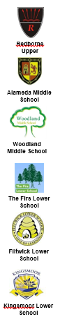

Please indicate if your child has siblings in any of our Redborne Partnership schools

The Firs Russell Maulden Alameda

Templefield Kingsmoor Flitwick Woodland

Redborne

**Sections below to be completed by school staff only**

**Current Attendance ……………..% Previous holidays checked**

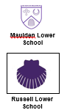

**Decision Regarding Request For Leave Of Absence In Term Time**

Number of days requested:- ………………………………….

Absence request authorised

Absence request unauthorised

Absence request can be partly authorised

Reason for decision (if appropriate) ………………………………………………………………………………

Signed:- ………………………………………………………………………………….. Deputy/Head Teacher

**Please note:** Amendments to the 2006 regulations which were enacted in September 2013, removed all references to family holidays and extended leave as well as to the threshold of 10 school days. The amendments make it clear that headteachers may not grant **any** leave of absence during term time unless there are **exceptional circumstances**. For further information contact Andrew Copperwheat, Access and Inclusion Service, on 0300 300 6291.

