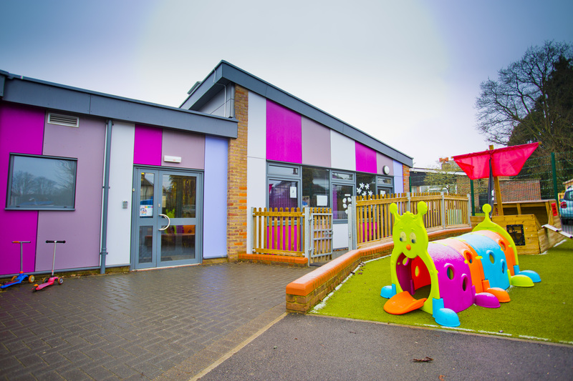My school is closed.

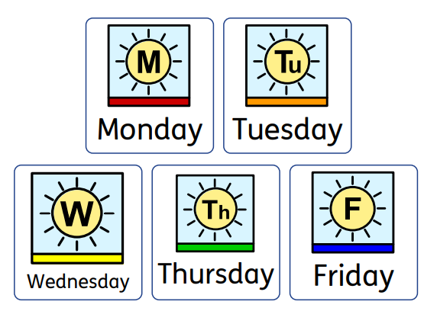

Most children go to school on these days.

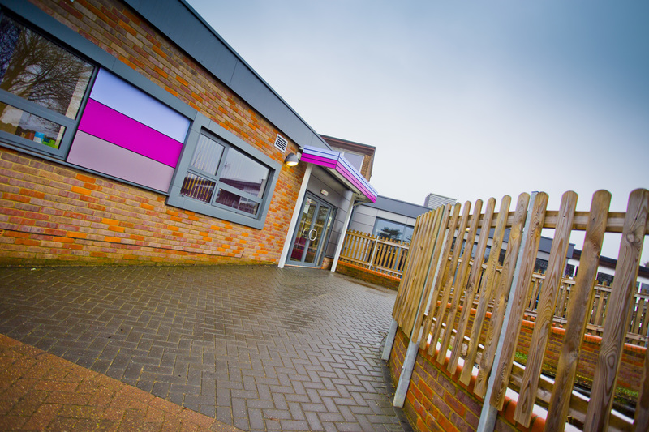
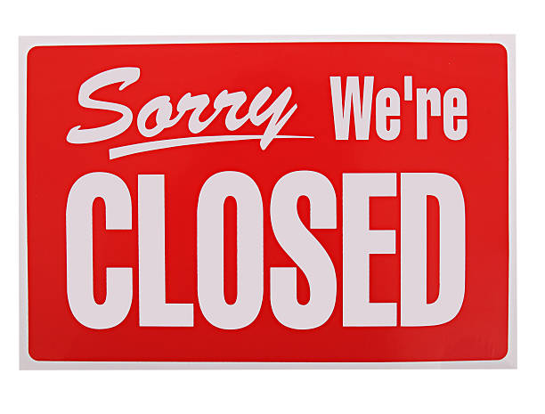
To help keep us all safe from Coronavirus Russell Lower School is now closed to most children.

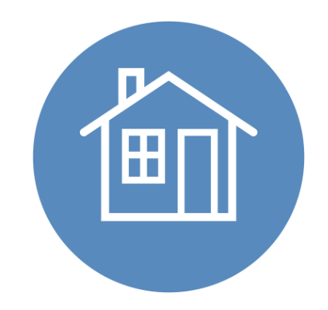
I will stay at home.

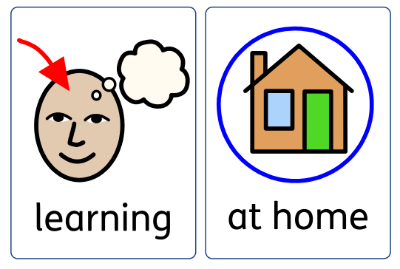
My teacher has given my parents or carers some learning for me to do at home.
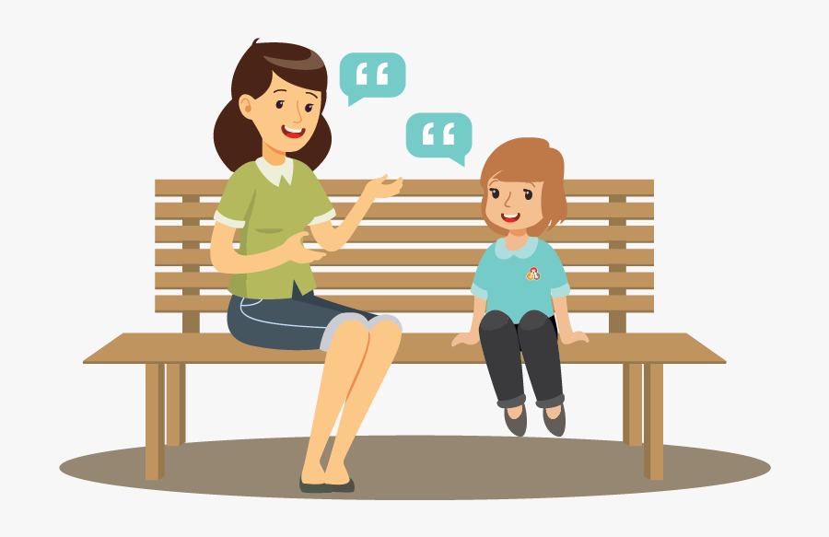My parents or carers will tell me when it’s time to go back to school.

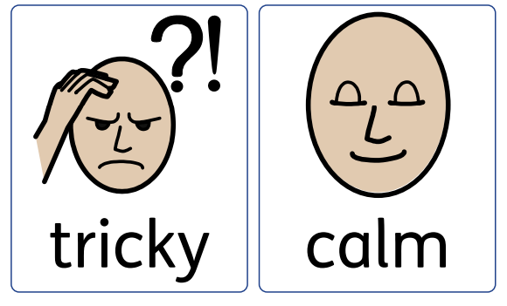

This change in my routine can feel tricky, I’ll do my best to stay calm.

