SWANS, SWIFTS & DOVES - SPRING 2024 – 2nd half term
ARE WE NEARLY THERE YET?

Personal Social and Emotional Development  - Circle time games.  - Good to be me – activities using stories and songs.  - Feeling good about myself.  - Feeling loved and cared for.  - Value – Responsibility and Cooperation  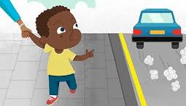  - Know about and talk about different factors that support their overall health and wellbeing: Being a safe pedestrian. | Communication and Language  - Articulate their ideas and thoughts in well-formed sentences when sharing Learning Logs and Show and Tell items.  - Connect one idea or action to another using a range of connectives.  - Listen to and talk about stories to build familiarity and understanding.  - Role-play situations e.g. Dressing up as police officers, firefighters etc. |  | Physical Development  - Develop the foundations of a handwriting style, which is fast, accurate and efficient.  - Use their core muscle strength to achieve a good posture when sitting at a table or on the floor.  - Form lower-case and capital letters correctly.  - Speed, Agility and Travel – combine different movements with ease and fluency. Progress towards a more fluent style of moving, with developing control and grace.  - Dance – perform recognised actions to music. Copy, repeat and perform basic actions to music.  - Develop their small motor skills so that they can use a range of tool competently, safely and confidently to create a vehicle.
Literacy  - Listen to stories e.g. What the Ladybird Heard, PC Ben  - Sequence stories.  - Non- fiction books about occupations.  - Write labels, lists, factual sentences and speech bubbles.  - Read and spell high frequency words.  - Segment sounds in simple words and blend them together.  - Re-read what they have written to check that it makes sense.  - Write short sentences with words with known sound letter correspondences using a capital letter and full stop.  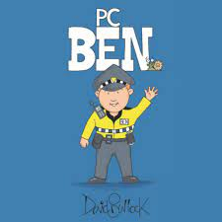  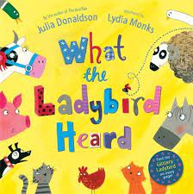  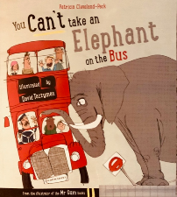 | Mathematics  - Representing 9 and 10, ordering numerals to10, composition of 9 and 10.  - Building, matching and printing with 3D shapes.  - Naming and describing cones, cubes, cuboids, cylinders, spheres and triangular prisms.  - Exploring repeating patterns.  - Ten in the Bed song.  - Counting back from 10, comparing numbers within 10, making 10.  - Building 9 and 10  - Understand the ‘one more than/one less than’ relationship between consecutive numbers.  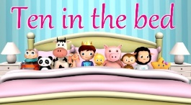  - Select, rotate and manipulate shapes to develop spatial reasoning skills. | Understanding the World  - Draw information from a simple map.  - Explore the natural world around them.  - Understand that some places (Kings Arms Garden and St Andrews Church) are special to members of the community. |  | Expressive Art and Design  - Listening attentively, moving to and talking about music, expressing their feelings and responses.  - Exploring and engaging in music making and dance, performing solo or in groups.  - Music – Our World  - Learn rhymes, poems and songs.  - Old Macdonald  - Incy Wincy Spider  - Baa Baa Black Sheep  - Row, Row, Row Your Boat  - The Wheels On The Bus  - The Hokey Cokey  - Exploring high sounds and low sounds using voices.  - Design and create a model using junk materials.
RE
- Why is Easter special to Christians?
- Recognise and retell stories connected with the celebration of Easter.
- Say why Easter is a special time for Christians.
- Talk about ideas of new life in nature.
- Recognise some symbols Christians use during Holy week, e.g. palm leaves, cross, eggs etc. and make connections with signs of new life in nature.
- Talk about some ways Christians remember these stories at Easter.
Computing
- Learning that information can be retrieved from books, computers and mobile digital devices.
- Log in and open 2Paint.
- Type name using a capital letter (shift key/caps lock).
- Draw a vehicle using shapes.

