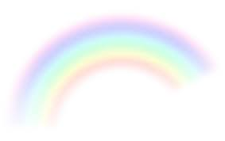
I am happy

Close your eyes and imagine a huge rainbow in front of you. You can see red, yellow, orange, pink, blue, green and purple. You can’t help but smile looking at it, the colours are so bright and beautiful. You decide you want to walk over it. You are full of excitement as you climb the rainbow, you look down and see the colours moving under you. You can’t wait to see where the rainbow leads. As you look around you can see trees and birds all around you. You feel full of joy and happiness. When you get to the top you sit down ready to slide to the bottom. As you slide down you feel the wind in your face and see the colours all around you. You feel so happy.

As you get to the end of the rainbow think about what you see. It’s the most magical place you have ever seen and fills you with happiness to be there.

When you are ready have a big stretch and open your eyes.

