**NOVEMBER NEWSLETTER**

November 2024

Dear Parents/Carers,

Welcome to our November newsletter. These newsletters are sent out on a monthly basis to keep you informed about what is happening in school. If you ever want to contribute an ‘article’ or suggest information that should be on the newsletters, I would be delighted to hear about them.

*Please note events that are underlined and in italics are new or amended since the previous newsletter.*

**Tuesday 12th November –** Y4 Samba drumming workshops, 1:15 – Kingfisher WW1 walks

**Wednesday 13th November –** 1:15pm Woodpecker WW1 walk

**Thursday 14th November –** PTA meeting, Wingfield Club, 7:30pm

**Friday 15th November –** Children in Need Day – ‘Be SPOTACULAR’ (spotty non-uniform day – more

information to follow), Year 3 Paralympic festival (am)

**Monday 18th November –** Anti-bullying week, UK Parliament week, CLS Governors meeting at 6:30pm

**Tuesday 19th November –** Y4 Samba drumming

**Wednesday 20th November –** Year 4 tag rugby festival (am)

**Thursday 21st November** - KS2 Open the Book Assembly

**Monday 25th November –** Santa Challenge begins

**Tuesday 26th November –** Samba drumming to parents in Y4 (see previous emails for timings)

**Wednesday 27th November** - Foundation Stage Maths Workshop to parents at 9:15am, KS1 and 2 Maths workshop to parents at 2:30pm – see below to sign up

**Thursday 28th November –** 9:30 am -New Intake Meeting – Foundation Stage September 2025

**Friday 29th November –** 9amInclusion coffee morning for parents – please see below

**,**PTA ‘Mistletoe Mingle’ straight after school (more details to follow)

**Saturday 30th November** - Ladybirds Christmas Bazaar (see below) **and Sunday 1st December –** St Andrew’s Christmas Tree Festival, with the choir singing ( Sunday afternoon *at 1:30pm*) – more details to follow

**Monday 2nd December -**  Full Governors Meeting 6:30 pm

**Tuesday 3rd December –** Year 1 visits to the Methodist Church

***Wednesday 4th December -*** *1:20 - Violin assembly to KS1 and 2*

**Friday 6th December** - Christmas activity morning with parents (9 – 10:15 am), Christmas Jumper non-uniform day – more details to follow, Ladybird concert in the main hall (pm)

**Monday 9th December -** FS Nativity to the school

**Tuesday 10th December** - 9:30am, FS Performance to Parents, Churches Together choir performance at the park (TBC - more details to follow), Flu immunisations (more information to follow)

**Wednesday 11th December** - 9:30 FS performance to nurseries, Christmas Lunch day, FS Nativity to parents at 2:15pm (more information to follow)

**Thursday 12th December** - Year 2 performances to parents (show 1 at 2:15pm, show 2 at 5:45pm) more details to follow, 2 x Y1 classes and 3 x FS classes visit Elfridges

**Friday 13th December** - 1 x Y1 Class and Y2, Y3 and Y4 Elfridges visits

**Monday 16th December –** Y1 Superheroes day (more details to follow)

**Tuesday 17th December –** Theatre visits - *Year 4(am), Year 1 (pm)* - The King’s Polar Bear

**Wednesday 18th December** - Theatre Visits - *Year 3 (am), Year FS (pm)* - The King’s Polar Bear

**Thursday 19th December –** Theatre Visits - *(Y2 am)* - The King’s Polar Bear

**Friday 20th December -** Last day of the school term, break up for Christmas today

**CHRISTMAS HOLIDAY Monday 23rd DECEMBER – Tuesday 7th JANUARY 2025**

**Monday 6th January 2025 – INSET Day – SCHOOL CLOSED TO ALL CHILDREN**

**Tuesday 7th January 2025 –** ALL children back to school today, *Year 3 Faith Tour, all children complete Network Hands this week*

**Wednesday 8th January 2025** - Vision Screening for FS children

**Thursday 9th January 2025 –** 9:30 - extra New Intake Meeting due to overwhelming demand, 2:45pm – Parent Volunteers in School Induction sessions, (more information to follow)

**More detailed information on the above events will follow in due course**

**Building work update:**

As many of you will have noticed, thankfully the scaffolding and site disruption due to the leaking roof in Year 4 has now gone. Thank you for your support and patience whilst this work was completed. We still have some minor repair work to complete on the inside of the building, but it is great that, hopefully at least, the roof now will not leak!

**Big thank you for your support:**

Thank you for your support with recent fundraising. We are proud to have been able to support Olympic Athletes, The Royal British Legion and Children in Need over the last term. I want to pass on huge thanks to our Governors, volunteers such as Maggie and PTA members such as Kristina who have supported us so much before and after school, in all weathers, to make this possible. Thank you all for your generous support.

**Parent Helpers next volunteer session - Thursday 9th January at 2:45pm:**

If you haven’t volunteered in school before, but would like to, we would love to see you at our next volunteer information session coming up in January(see calendar above) – please sign up using the following Google Form and then just turn up - thank you!

<https://forms.gle/AZyZs4hcA88Mhan1A> Everyone MUST attend an induction session, but only if you have not attended one already and MUST have a DBS in place before volunteering with the children.

**Aviary club charges – price increase from January 2025:**

Unfortunately, we are having to increase the charge for using The Aviary before and after school club from January. We are simply unable to sustain the rising costs of staffing, energy, consumables and food within the existing pricing structure. The new price will be £5.50 per hour. Thank you for your understanding. We would like to remind you that this facility is to enable parents to work; it is not for ‘play dates’ or general ‘childcare’ etc. This is important as we have reached capacity in most sessions and run waiting lists. We need to support working parents who have no alternative support as a priority. Thank you again for your support.

**Accident in school:**

Please be aware that if your child has a visible mark or significant injury as a result of a slip, trip or some sort of accident at school we will always try our very best to get a medical note emailed out to you on that day. Alternatively, a teacher will speak to you, or we will call you directly. Slips, trips etc. that do not result in visible marks or significant injury will not result in notification by medical note/email, conversation with the teacher or telephone call. However, if you ever have any concerns about an injury that you feel was acquired at school, please do not hesitate to contact us and it will be fully investigated to ensure our procedures have been correctly followed. Thank you for your support.

**Inclusion Coffee Morning:**

Everyone is welcome! The theme is: Behaviour as communication (including ‘masking’) - Friday 29th November, 9 - 10 am - just turn up!

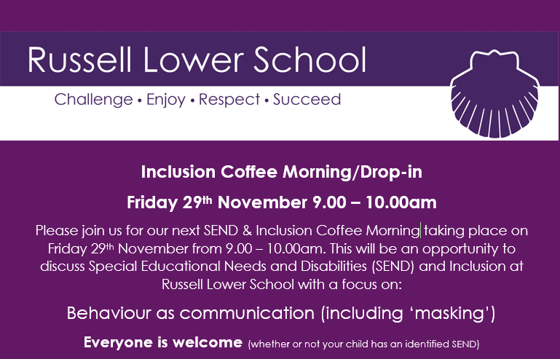

**Maths Workshops for parents:**

Maths is not taught how it used to be! Would you like to come and hear how we teach it and how you can further support your children at home? If so, please sign up using these simple Google Forms:

Foundation Stage Maths Workshop for parents – 9:15am – 10am, Wednesday 27th November

<https://forms.gle/nfrXPuNJpmaU2NDz6>

KS1 and KS2 Maths Workshops for parents – 2:30pm – 3:15pm, Wednesday 27th November

<https://forms.gle/T8795MdtJ8WTVSWW7>

**REMINDER - School admissions to Foundation Stage in September 2025 and Middle Schools**

It’s that time of year again! Even though the children have only just started in their new year group, you need to make your applications now:

**Children born between 01/09/20 and 31/08/21 are due to start school in September 2025.**

Parents/carers need to make an application to CBC **by 15 January 2025**, **even if their child attends a nursery/pre-school on the school site.** All the information you will need regarding your Starting School 2025 application is available on the CBC website (see hyperlink below).

**Year 4 parents,** please bear in mind that applications for **Middle School are also needed within the same timescales i.e. before 15th January 2025. Please note: this will not just happen automatically.**

[School admissions | Central Bedfordshire Council](https://www.centralbedfordshire.gov.uk/info/5/school_admissions)

**Russell Lower School Values:**

Each half term, we teach the children about a different value. We then have a weekly ‘values’ assembly where we celebrate the demonstration of this value. The value this coming half term is:

**Autumn 2**: Peace

**PE and festivals news:**

Many congratulations to Russell Raiders Hurricanes who defeated the older Maulden Magpies team 3-0 in their final last weekend. It was wonderful to hear just how well the team played, but also the spirit in which they played. Well done. Everyone is very proud of you all!

In school this half term, some of our Year 3 children will be attending a Paralympic Festival and our 4 children have a tag rugby festival. Good luck to everyone. If your child is chosen to take part in one of the up-coming festivals you will be notified and additional information will be given.

We have also completed a review of last year’s sports premium spending and its impact and have also added the document for this year outlining how we intend to spend this year’s money. Please take a look over the next few weeks at our plans to further improve PE and sport across Russell Lower: <https://www.russell-lower.co.uk/sports_premium>

**Community information and events:**

Please see below

**And finally:**

Thank you for taking the time to read this newsletter and for all your support during the last month.

Many thanks and kind regards,

Nicki Walker

Headteacher

**Community information and events:**

**Wrap Up**

Do you have any coats or ski clothing that are no longer required?

Wrap Up UK is a project that Ampthill and District Rotary Club are supporting.

If you are able to donate a Winter Coat or Ski Clothing in good condition to help the homeless, please bring it to school and place it in the receptacle in the office foyer. Thank you.





