**RUSSELL LOWER SCHOOL**

**Teaching and Learning Policy**

**Spring 2025 - 2028**



**CONTENTS**

|  |  |
| --- | --- |
|  | **Page Number** |
| Vision |  |
| Aims and Purpose | 1 |
| Planning | 1 |
| Differentiation, adaptive teaching and scaffolding | 3 |
| Marking and Feedback | 5 |
| Assessment, recording and reporting | 5 |
| Learning environment and organisation | 5 |
| Celebration | 6 |
| Monitoring and evaluation | 6 |
| Home Learning | 6 |
| Links with other policies | 7 |
| **Appendices** |  |
| Role and Responsibilities | 8 |
| Teaching and Learning strategies - Rosenshine’s Principles of Effective Instruction’ and the EEF’s ‘Great Teaching Toolkit | 11 |
| Questioning and feedback | 12 |
| Differentiation, adaptive teaching and scaffolding strategies commonly used in classrooms | 12 |
| Learning environment checklist | 13 |

**Vision**

At Russell, we educate the whole child. Our vision is:

* To **challenge** and inspire children to become intellectually curious
* To ensure children are happy, safe and **enjoying** their education.
* To be proud, confident and **respectful**
* To work together to ensure every child can **succeed** and exceed expectations

Our teaching and learning policy is devised around these four key statements.

Aims and Purpose

The aim of this policy is to ensure the highest possible level of progress and attainment for **all** children within an ambitious, broad and balanced curriculum, designed to give children the knowledge and cultural capital they need to succeed in life. Everyone in the Russell Lower School community has the **‘Right to Learn’**.

The curriculum lies at the heart of education. At Russell Lower School, we are a knowledge-engaged school, where knowledge underpins and enables the application of skills and we develop both. Our whole school curriculum also incorporates the development of life skills such as resilience, a growth mind-set and perseverance, alongside our school values and four Russell Rights. See our [curriculum policy](https://www.russell-lower.co.uk/school_policies) for more information.

By adopting a whole school approach to teaching and learning across our school, we aim to ensure **consistency** of teaching and learning in each classroom and enable teachers to teach as effectively as possible. This is achieved by creating a strong, shared vision and ethos, ensuring accountability and creating learning within school so best practice can spread quickly. We look for ‘visible consistencies’ in all we do and ‘how’ we are. See appendix 1 for roles and responsibilities.

At Russell Lower School we use ‘Rosenshine’s Principles of Effective Instruction’, the EEF’s ‘Great Teaching Toolkit’ and Teaching Walk Thrus as our guiding models. This has enabled us to identify a set of classroom strategies which teachers employ creating an environment conducive to effective learning. See appendix 2 for more detail.

Our further aims include:

* set **high expectations and a positive climate** characterised by respectful interactions. All children should be held to high standards of behaviour. Good whole-school behaviour management is achieved through our culture of inclusion, Theraputic Thinking, Emotional Coaching and a Growth Mindset approach. Our [Behaviour Policy](https://www.russell-lower.co.uk/behaviour_at_russell_lower_school) is consistent and fairly and rigorously applied. The expectations run through the school culture, leadership, and child and teacher behaviours.
* provide a **high quality,** **knowledge-rich curriculum**. At Russell we support children in knowing more and remembering more. We use approaches that help children integrate new knowledge into the long-term memory and make connections that foster understanding.
* provide **inclusive quality first teaching** in all areas of the school. This is achieved by drawing upon research-based approaches, with proven impact such as those mentioned above, with necessary adaptions**.** In some cases, additional personalised provision is available that is tailored to an individual’s specific needs
* provide **effective learning environments** to support and facilitate pupils learning
* develop **lifelong skills** and give children the skills they require to become effective **lifelong learners**. Enabling children to become confident and interested learners, actively engaged in their own learning including that beyond the core curriculum such as personal, social, healthy lifestyles and emotional skills including developing children’s self-respect and respect for the cultures and values of others
* pupils being **prepared for the next stage** of their education and learning journey.

Planning

At Russell Lower School our curriculum is built around [core themes](https://www.russell-lower.co.uk/website/russell_lower_school_themes_/437829) and is based on:

* the [Early Years Foundation Stage Statutory framework](https://www.gov.uk/government/publications/early-years-foundation-stage-framework--2) (2024)
* the [National Curriculum](https://www.gov.uk/government/collections/national-curriculum) (September 2014)

It is delivered using a variety of approaches and resources depending on the nature of the subject being taught and the needs of the children. For more details please refer to the separate [curriculum pages](https://www.russell-lower.co.uk/website/subject_areas/451369) on the school’s website.

Learning is defined as a change in long-term memory. We therefore need to use approaches that help children integrate new knowledge into the long-term memory and make connections that foster understanding.

Retention of knowledge will not happen if the working memory (short term) is overloaded. This suggests organising learning in small chunks which do not need too much memory capacity (4 – 5 things maximum) works best. The concepts below taken from ‘Teaching Walk Thurs’ are a vehicle to support the review and planning of units of learning across Russell Lower.

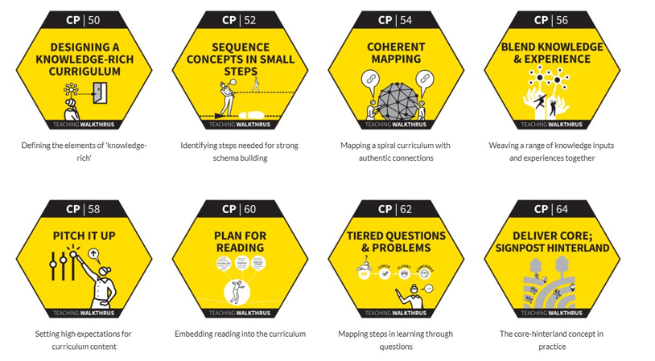

Our curriculum is designed to enable all children to acquire relevant subject knowledge which underpins the application of skills. We have a clear learning sequence across the school, outlined in our subject syllabuses/long term plans, which ensures progression in each subject, enabling powerful learning as children build on and link to previous learning supporting them in acquiring depth as they ‘know more and remember more’.

Our subject syllabuses contain the relevant EYFS Early Learning Goals (See our [EYFS policy](https://www.russell-lower.co.uk/foundation_stage_curriculum) for information on how our early years curriculum is delivered) and National Curriculum requirements for the subject. Each syllabus contains a unit overview with links to medium term plans. This is followed by our assessment criteria for each year group. For more detail on our planning elements see our [curriculum policy](https://www.russell-lower.co.uk/our_curriculum) and [EYFS policy](https://www.russell-lower.co.uk/foundation_stage_curriculum).

Non-negotiables around planning/lessons and teaching at Russell Lower.

|  |  |
| --- | --- |
| **Planning/lessons** | **Teaching** |
| **Clear and concise learning** objectives taught through **accurate and precise subject knowledge** | **Therapeutic Thinking /Emotional Coaching** strategies to support great behaviour for learning and mutually **respectful** relationships |
| **Spaced, repetitive practice** where knowledge is rehearsed for short periods over a longer period of time | **High expectations** in everything we do |
| Planned **activities that focus precisely on the intended learning** and help pupils remember important subject knowledge | Teachers asking a variety of **deep open questions**, and using a **range of questioning techniques**, to establish children’s understanding such as ‘how do you know?’ ‘justify’ or ‘explain’ See appendix 3 |
| Have well planned **success criteria**, which is revisited throughout the lesson, to support the children in understanding the expectations of the lesson and working towards the outcome in order to demonstrate the learning objective | **Less teacher talk** and fewer words on Lynx slides – less is more |
| New material presented in **small steps**, with teachers ensuring that each step is mastered before moving on | Teachers **model clearly**, using equipment, visual and/or other aids to show children how to solve problems. This includes **modelling of thinking** aloud while demonstrating, and use of ‘prompts’ to scaffold children temporarily as needed |
| All groups of **learners are challenged** appropriately in lessons, including the needs of pupils with SEND. See [SEND policy.](https://www.russell-lower.co.uk/send_at_russell_lower_school) | Teachers **check all children’s understanding linking directly to the learning objective** in a variety of ways such as ‘Pose, Pause, Pounce, Bounce’ or random/targeted questioning (eliminating hands up) and provide regular reviews of learning throughout the lesson |
| **Purpose** to the teaching and learning, where possible linked to real life events. Use of visits and visitors to enrich the curriculum is valued and these are used throughout the school to widen children’s experiences and support learning across a range of subject areas | Give **sufficient time for practice** (first guided, then independent) |
| A **daily review** of previous learning using **retrieval practice** strategies such as Flashback 4 | **Live marking and feedback** throughout the lesson, and ensure children ‘act’ upon it |
| **Key vocabulary**, explicitly teaching and using it in every lesson | Teachers **refer to individual children’s work** during lessons to illustrate examples of good practice and successful use of success criteria |
| Children have a **high rate of success**, with enough mistakes to show that they are being challenged | **Confident** teachers have a clear understanding of subject knowledge and setting objectives |
| **Enjoyable and engaging lessons** to support motivation and enthusiasm | **Interactive** teaching, pupil’s contributions are encouraged, expected and extended |
| Provide **different levels of challenge** built upon prior learning. | Well-paced for all learners. With a focus on progression and success for all. |

Differentiation, adaptive teaching and scaffolding

Teaching and learning at Russell will take the backgrounds, needs and abilities of all pupils into account. We will differentiate or adapt learning to cater to the needs of all of our pupils

* **Differentiation** is the adaptation of planning, activities and methods of teaching to ensure every pupil can learn, be challenged and progress from their starting point and individual needs.
* **Scaffolding** is where the activity is supplemented with additional resources and/or instruction so that pupils can access the learning.

Where scaffolding is provided and a pupil is unable to access the learning, and therefore progress, the task must be differentiated.

Differentiation is not always planned as a result of academic ability/attainment; it may be due to preferred learning styles and needs.

What do we need to know in order to differentiate and scaffold effectively?

1. What is the core objective of the lesson?

2. What is the pupil’s starting point in relation to the learning objective?

3. What are the pupil’s strengths and needs?

In order to differentiate and scaffold effectively, teachers will consider pupils’ Zone of Proximal Development:

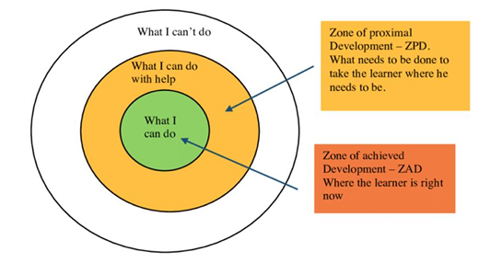

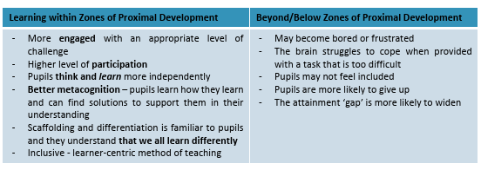

Considering Zones of Proximal Development allows teachers to effectively plan and adapt the learning content, process, product or learning environment in order to best suit individual needs. When considering the area of content, we plan teaching and learning around the Bloom’s Taxonomy model.

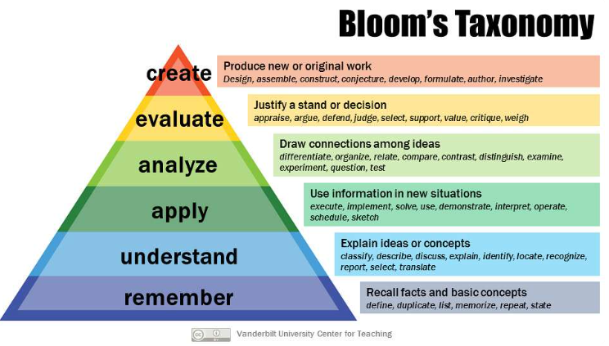

So that we always have the highest possible expectations of individual learners and so they can demonstrate what they can do, understand and achieve, teachers will adapt the curriculum according to individual needs by:

* teaching strategy - focus on the vital role that teacher’s play in facilitating learning and removing the barriers to learning
* learning needs - visual, aural, kinaesthetic
* pace - time allocated for adjusted task
* content - adapt what you want the children to learn or how they gain access to knowledge, skills and understanding
* task - allocate different tasks to achieve same goal
* outcome - what the child expected to produce
* scaffolding - writing frames, word lists, visual timetables relevance;
* resources - accessible, appropriate and supportive including use of technology
* extension – additional challenge and depth of learning
* peer group support - buddies, group work, peer tutoring teacher/adult support - effective deployment to support learning
* feedback - teachers give individual feedback and set individualised goals and targets

See appendix 4 for some examples of strategies commonly used in classrooms. In some cases, additional support might be offered through working with our Inclusion Lead. Additionally, advice is sought from relevant external support agencies when and where the need demands it. See our [SEND policy and information report for more information.](https://www.russell-lower.co.uk/send_at_russell_lower_school)

Marking and feedback

Feedback will clearly explain to pupils what they’re doing well and what they need to do next to continue to improve their work. See [marking and feedback policy.](https://www.russell-lower.co.uk/our_curriculum)

Assessment, recording and reporting

At Russell Lower School we see assessment as an integral part of teaching and learning, and it is inextricably linked to our curriculum. We use 3 broad overarching forms of assessment:

* day-to-day in-school formative assessment
* in-school summative assessment
* nationally standardised summative assessments including:
  + Reception baseline assessment framework (RBA) within the first 6 weeks of a pupil starting reception
  + Early Years Foundation Stage (EYFS) profile at the end of reception
  + Phonics screening check in year 1 in June (pass/fail with a follow up in Year Two for those children who do not meet standard)
  + National Curriculum tests (non-statutory) and teacher assessments at the end of Key Stage 1 (year 2) in May
  + Year 4 multiplication tables checks in June

Formative assessment procedures are used to assess the knowledge, skills and understanding of pupils during lessons and to provide immediate additional challenge, support or scaffolding where this is needed as well as being used to identify gaps in learning and misconceptions so these can be addressed without delay resulting in continued progress. This information is then used to plan lessons or remediation to improve children’s learning.

Summative assessment is more useful for general quality control and to provide a picture of how well a child, or group, has performed over time. Teachers will usually make use of end of half term/term and unit assessments. Teachers will assess children using Insight. This will be used to regularly inform parents about their child’s progress. See [assessment, recording and reporting policy](https://www.russell-lower.co.uk/assessment).

Learning environment and organisation

The learning environment is key in supporting children’s academic performance and wellbeing at Russell Lower. At Russell Lower we believe that all areas should be calm, well organised learning spaces. See [behavior curriculum](https://www.russell-lower.co.uk/behaviour_at_russell_lower_school) for more information. A well cared for and organised learning area and school can make pupils feel that they want to achieve as well as supporting them in doing so. Pupils will be taught how to access resources (with growing impendence) and respect the learning environments and whole school environment.

All areas of the learning environment will be planned for, including, where appropriate, the outside areas, in order to ensure opportunities for a range of practical activities, which will develop appropriate knowledge, skills and understanding linked to the curriculum. To ensure a sense of consistency across the school we have learning environment checklists in place. See appendix 5.

**Early Years**

Activities are planned for both inside and outside (main playground and smaller terrace space) environments. Across the day, children have the freedom to move between the different environments and access a variety of learning opportunities. The learning environments at Russell Lower are divided into a variety of different areas such as: role play, book corner, writing area, computer, creative, sand, water, construction, small world, puzzles and many other cross curriculum learning areas.

These areas are carefully arranged to encourage quiet areas and more active areas within the learning environment. Children are encouraged to become independent learners and to take some responsibility for initiating their own lines of enquiry and investigation.

**Celebration**

At Russell Lower success is celebrated through displays and recognition such as:

* Each child is given an opportunity to have work displayed during the school year
* Class rewards and incentives
* ‘Gold Certificate’ awards are given weekly to celebrate individual academic or behavioural achievement.
* ‘Values Certificate’ awards are given weekly to celebrate individual achievement towards demonstrating the value of the half term.
* ‘Headteacher Awards’ are given to pupils in each class for achieving their personal best in an area of learning.

Monitoring and evaluation

We monitor teaching and learning in Russell Lower to make sure that all of our pupils make the best possible progress from their starting points.

Pupils’ work is monitored and moderated regularly in each of the core curriculum areas by the subject leaders, Deputy and/or Headteacher.

So that the SLT know the strengths and areas to develop in the school we follow a monitoring and evaluation cycle each term:

1. Assessment Week (Data Deadline on the following Friday)
2. Pupil Progress Meetings with SLT (Following this: Update Provision Maps)
3. Parents’ Evenings (Reporting to parents)
4. Monitor Teaching and Learning (Learning Walks – environment and learning in classrooms, Work Scrutiny, Pupil Interviews, Walk Thurs and Instructional Coaching)
5. Feedback to teachers and staff/Implementation of Provision Map strategies
6. Governor/SIP Meetings/Update

See Performance Management Policy.

Home learning

Home Learning supports the development of independent learning skills and is used to reinforce classwork as well as to consolidate and/or extend learning. Students have opportunities and experiences outside of school that are equally important in developing and enriching their lives and so we shall give careful consideration to ensuring homework remains well-balanced across the school.

Each year group publishes a grid outlining the expectation of home learning activities at the beginning of each year. Timings and frequency are included. This is emailed to parents/carers. See [home learning policy.](https://www.russell-lower.co.uk/home_learning_policy)

Links with other policies

This policy links with the following policies and procedures:

* Behaviour policy
* Curriculum policy
* Early Years Foundation Stage (EYFS) policy
* SEND policy and information report
* Marking and feedback policy
* Home-school agreement
* Assessment, recording and reporting policy
* Performance management policy
* Equality information and objectives

**Appendix 1 – Roles and responsibilities**

Teaching and learning at Russell Lower is a shared responsibility, and everyone in our school community has an important role to play.

Teachers

As experts in teaching and learning, teachers take the lead when meeting the needs of all children, including those with lower ability, higher ability (see excellence for all policy), Pupil Premium, SEND (see SEND policy) and those children identified via Pupil Progress Meetings and assessments/data as needing to make the most or accelerated progress. Therefore, in lessons, it is the teacher, not the LSA, who will predominantly work with these children, ensuring that their progress is at least as good as their peers.

Teachers at Russell Lower will:

* Follow the expectations for teaching and professional conduct as set out in the [Teachers’ Standards](https://www.gov.uk/government/publications/teachers-standards)
* Know pupils well and adapt support to meet their individual learning needs
* Provide a challenging and stimulating curriculum designed to encourage all children to reach the highest standard of achievement
* Recognise and be aware of the needs of each individual child according to ability and aptitude
* Ensure that learning is progressive and continuous
* Be good role models, punctual, well prepared and organised
* Keep up-to-date with educational issues
* Establish links with the local community to prepare pupils for the opportunities, responsibilities and experiences of life
* Actively engage parents/carers in their child’s learning through conversations and open mornings, including clearly communicating the purpose of home learning via letters and the website
* Update parents/carers on pupils’ progress at least termly and produce a mid-year and end of year written report on their child’s progress
* Use agreed assessment for learning strategies. See assessment policy
* Use timely effective marking and feedback as required. See marking and feedback policy
* Meet the expectations set out in our curriculum, behavior, marking and feedback and assessment policies as well as any other relevant policies

**Support staff**

Support staff at Russell Lower will:

* Support teaching and learning with flexibility and resourcefulness
* Use timely effective marking and feedback as required
* Engage in providing inspiring lessons and learning opportunities
* Feedback observations of pupils to teachers
* Ask questions to make sure they’ve understood expectations for learning
* Identify and use resources to support learning
* Have high expectations
* Demonstrate and model themselves as learners
* Meet the expectations set out in our curriculum, behavior, marking and feedback and assessment policies as well as any other relevant policies.

Subject/phase leaders

Subject/phase leaders at Russell Lower will:

* Help to create well-sequenced, broad and balanced curriculum plans that build knowledge and skills
* Sequence lessons in a way that allows pupils to make good progress from their starting points
* Use their budget effectively to resource their subject, providing teachers with necessary resources for learning
* Drive improvement in their subject/phase, working with teachers to identify any challenges
* Moderate progress across their subject by, for example, systematically reviewing progress against a range of evidence and reviewing qualitative and quantitative performance data
* Improve on weaknesses identified in their monitoring activities
* Create and share clear intentions for their subject
* Encourage teachers to share ideas, resources and good practice
* Meet the expectations set out in our curriculum, behavior, marking and feedback and assessment policies as well as any other relevant policies.

Senior leaders

Leadership is crucial to good learning and teaching.

Research has found (Ofsted 2019) that Instructional leaders are most effective. They have a pedagogical and curricular vision and expertise. An instructional leader promotes common approaches to factors such as teaching and behaviour management (see behaviour policy) in the school, monitors teaching, and makes sure that professional development (CPD) focuses on teaching and learning.

Senior leaders at Russell Lower will:

* Have a clear and ambitious vision for providing high-quality, inclusive education to all
* Celebrate achievement and have high expectations for everyone
* Hold staff and pupils to account for their teaching and learning
* Plan and evaluate strategies to secure high-quality teaching and learning across the school
* Manage resources to support high-quality teaching and learning
* Provide support and guidance to other staff through coaching and mentoring
* Input and monitor the impact of continuing professional development (CPD) opportunities to improve staff’s practice and subject knowledge
* Promote team working at all levels through paired Walk Thurs and Instructional Coaching
* Address underachievement and intervene promptly
* Meet the expectations set out in our curriculum, behavior, marking and feedback and assessment policies as well as any other relevant policies

Pupils

Pupils at Russell Lower will:

* Meet expectations for good behaviour for learning at all times, respecting the Russell Rights – the right to learn, be happy, be included and be safe
* Take responsibility for their own learning, and support the learning of others
* Attend all lessons on time and be ready to learn, with any necessary equipment for the lesson
* Be curious, ambitious, engaged and confident learners
* Understand how to improve (with the support of the adults in class)
* Put maximum effort and focus into their work
* Complete home learning activities as required
* Meet the expectations set out in home learning letters and the behavior policy

Parents and carers

Parents and carers of pupils at Russell Lower will:

* ensure that their child attends school regularly, punctually, well-rested and in good health
* Ensure that their child arrives at school wearing the correct uniform and bringing necessary equipment;
* Value learning
* Encourage their child as a learner
* providing support for the discipline within the school and for the teacher’s role
* Participate in discussions about their child’s progress and attainment
* Communicate promptly with school to discuss matters which affect a child’s happiness, progress and behaviour
* Provide resources as required to support learning
* Encourage their child to take responsibility for their own learning
* Support and give importance to home learning. See home learning policy.
* Support the work of individual education plans or targets s and becoming actively involved in the implementation of any support programme
* Allow their child to become increasingly independent as they progress throughout the school

Governors

Governors at Russell Lower school will:

* Monitor that resources and funding are allocated effectively to support the school’s approach to teaching and learning
* Monitor the impact of teaching and learning strategies on pupils’ progress and attainment
* Monitor the effectiveness of this policy and hold the headteacher to account for its implementation
* Make sure other school policies promote high-quality teaching, and that these are being implemented

**Appendix 2 Teaching and learning strategies**

To ensure the highest possible levels of progress and attainment for all the children who attend Russell Lower School, it is essential that there is a shared understanding of what constitutes highly effective learning and the highly effective teaching that enables this to occur. We aim to use research-based approaches, with proven impact.

As curriculum lies at the heart of education, and subject knowledge lies at the heart of the curriculum, then it follows that teachers need solid knowledge: content knowledge and understanding of the subjects they teach. As well as this, they need to know how to teach that particular subject (pedagogical knowledge), and more generally how to teach effectively. At Russell Lower School we use ‘Rosenshine’s Principles of Effective Instruction’, the EEF’s ‘Great Teaching Toolkit’ and Teaching Walk Thrus as our guiding models.

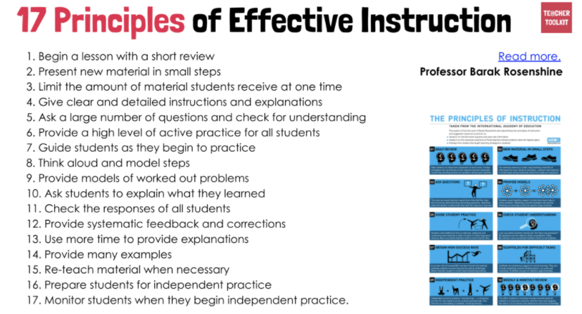

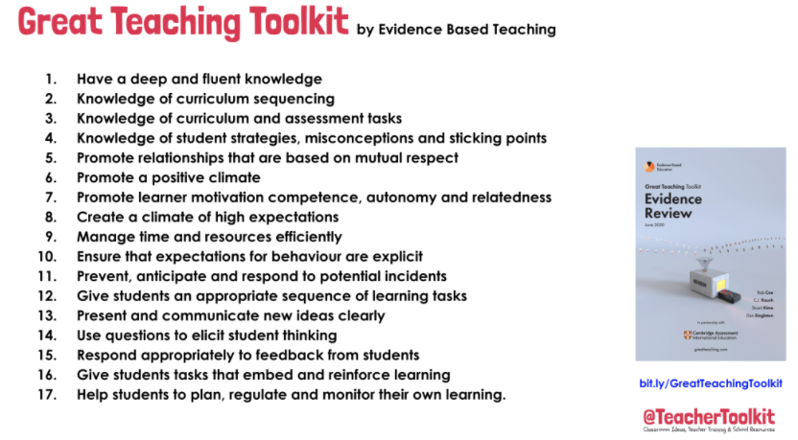

**Appendix 3 Questioning and feedback**

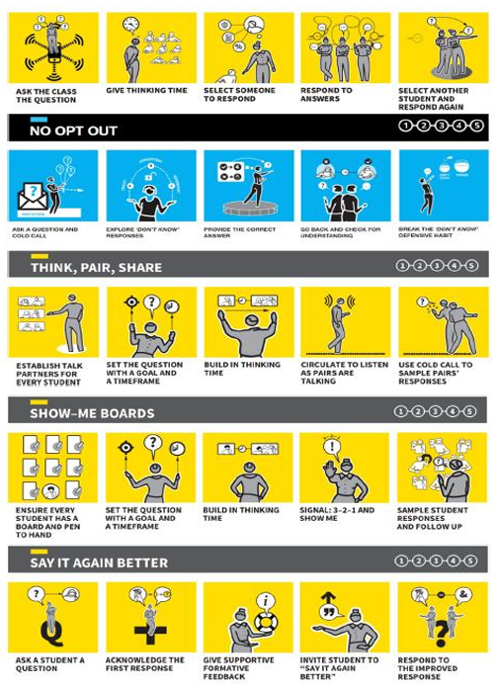

Appendix 4 Differentiation, adaptive teaching and scaffolding strategies commonly used in classrooms

* Visual timetables/displays
* Three levels of ‘differentiated task’ for all lessons.
* Personalised spellings/number bonds/times tables for all children.
* Individual reading progress for all children from Foundation stage (not group reading)
* Now/next
* Tray systems
* Button timers/Egg Timers
* Writing slopes
* Ergonomic pencils/pencil grips/variety of writing tools
* Use of ICT – Sound buttons, IPADS, Computer suites.
* Adapted tasks – cloze procedures
* Provisions – Switch On reading, writing, handwriting
* Maths pre-teach/support, Third Space Tutoring
* 5-minute phonics
* Phonics intervention
* Speech and Language – Lift off to language, Individualised SALT.
* Enlarged fonts/texts/test materials
* Coloured backgrounds
* Pictorial resources
* Seating positions
* Staff support
* Precision teaching

Appendix 5 – Learning environment checklist

Year group environment checklists can be found here:

<https://drive.google.com/drive/folders/1or-fjGcAw7UuglnwcLwJsgZ2H50mPoQh>