**MAY NEWSLETTER**

May 2025

Dear Parents/Carers,

Welcome to our latest newsletter. These newsletters are sent out on a monthly basis to keep you informed about what is happening in school. If you ever want to contribute an ‘article’ or suggest information that should be on the newsletters, I would be delighted to hear about them.

*Please note events that are underlined and in italics are new or amended since the previous newsletter.*

**Thursday 22nd May -** KS2 Open the Book Assembly, Year 2 visits to the Roald Dahl Museum

**Friday 23rd May -** Year 2 visits to the Roald Dahl Museum, *Taking Care of Yourself Workshop (CBC), 9 - 10:15am, main hall .* Break up for half term

**May Half Term Holiday - 26th May - 30th May 2025, with Premier Holiday Camps Monday to Thursday**

**Monday 2nd June -** Everyone back to school - **NO** INSET DAY

**Wednesday 4th June -** Year 3 Quad Kids Festival for some children (am)

**Friday 6th June -** 9am Inclusion Coffee Morning - Neurodiversity

**Monday 9th June -** Year 3 visit to Celtic Harmony, *Phonics screening in Year 1*

***Tuesday 10th June -*** *Group Photos (whole school today)*

**Thursday 12th June -** 6:30pm **-** New Intake Meeting for FS 2025, Drumming Assembly

**Friday 13th June -** 2pm Ladybirds Sports Day on Russell’s field, Father’s Day gifts out

***Monday 16th June -*** *Friendship**Letters home re FS and Y2 classes as they go into Y1 and Y3 (see more information below)*

***Tuesday 17th June -*** *Year 1 Seaside Day*

**Wednesday 18th June -** 6:30pm - Ladybirds AGM at Russell

**Friday 20th June -** Ladybirds birds of prey display (pm) - Russell field

**Saturday 21st June -**Russell Lower School PTA Summer Solstice Ball at the Cross Keys in Pulloxhill

**Tuesday 24th June -** Year 2 Cricket Festival for some children

**Wednesday 25th June -** Russell’s Sports Morning with PTA refreshments (am)

**Thursday 26th June -** KS1 Open the Book assembly

**Thursday 3rd July -** KS2 Open the Book assembly, *No Technology morning (link Climate Action Plan)*

**Friday 4th July -** Middle School Transition Day (Y4 to Alameda/Woodlands etc.), also Russell ‘Class Swap’ morning and Stay and Play sessions for new FS 2025 children

**Saturday 5th July -** Ladybirds’ Summer Fayre at Russell

**Monday 7th July -** 6:30pm Governors’ Meeting

**Tuesday 8th July -** Year 2 to Marston Vale *(Greenfinch/Penguin)*, Year 4 Performance to Parents (2:15pm and 6pm)

**Wednesday 9th July -** Year 2 to Marston Vale*(Robin)*

**Thursday 10th July -** Choir to summer concert at Alameda - afternoon (rehearsal) and early evening (performance) *See below for more details*

**Friday 11th July -** Sunflower Competition ends, **Ampthill’s Big Tent Weekend** - 11th/12th/13th July - lots more information to follow

**Monday 14th July -** 2:30pm Russell Open Afternoon

**Tuesday 15th July -** Foundation Stage Visit to Herrings Green Farm, 9:15 - Year 4 Leavers’ Assembly to parents, 1:30 - 3:30pm - Year 4 Leavers’ Party

***Wednesday 16th July - 9:15- Summer Reading Challenge Assembly by Ampthill Library***

**Friday 18th July -** Children break up for summer holidays

**Summer Holidays - Premier Holiday Camps for the first 4 weeks of the holidays**

**More detailed information on the above events will follow in due course**

**Year 2 SATs, Year 4 multiplication checks and GL tests; and Year 1 Phonics screening:**

Although Year 2 SATs are no longer statutory, at Russell we continue to administer these low key ‘quizzes’ alongside our other assessments, as recommended by the local authority. We have always taken a low-key approach to these and the children genuinely seem to love them! We will also continue to report the outcomes to parents alongside the summer report.

Year 1 Phonics screening remains statutory and we will be administering this during w/c 9th June. Please note that it is essential that all Year 1 children are in school that week.

For Year 4, both the statutory ‘Multiplication checks’ and the transitional GL (progress tests for middle school) will also take place mainly during w/c 9th June. Again, these are low key and often practised so the children will barely notice! However, if you want to support your child from home to ‘peak’ in these skills at just the right time, phonics and multiplication/division knowledge practice would be perfect leading up to and during w/c 9th June! Thank you for your support. Again, we will need all Year 4 children in school that week please and we will be reporting outcomes to parents again in the end of year reports.

**Aviary Update:**

Thank you for supporting us with our planning and staffing of Aviary in September by providing us with your childcare needs in the new term/year. Confirmation of places in September went out on Wednesday 21st May. If for any reason you do not receive an email and you are expecting to, please contact us as soon as possible after this date. Thank you.

**FS and Year 2 Friendship Letters (16th June)**

As always, we will be sending letters home for all Year 2 children so that they can tell us of children they would like to be in class with in Year 3, as we ‘mix’ the classes between KS1 and KS2 (Y2 and Y3). The teachers will then use this information to create 3 balanced classes to go into Year 3 with. You will be notified of which class your child will be in on 3rd July, which is the day before the class swap day so there is no time to worry at all before meeting their new class and teacher. This year, we have also decided to take the same approach in Foundation (Swan, Swift and Dove Class). On the same day as Year 2, a ‘friendship’ letter will come home for you to complete with your child. Again, on 3rd July, you will learn of their new class and teacher, just before the class swap day on 4th July. We have never mixed between Foundation and Year 1 before, but feel it would be highly beneficial this year due to the mix of children in the current three classes. Thank you for your support.

**Inclusion Coffee Morning - Friday 6th June - come and join us!**

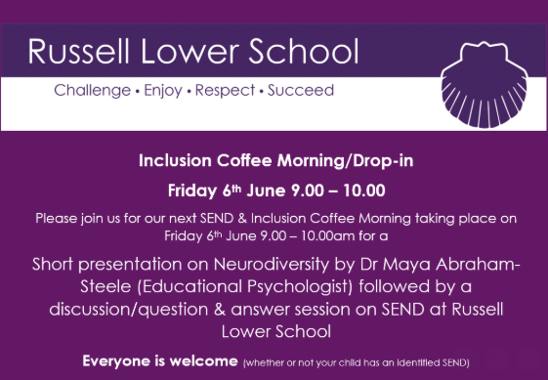

**Sports Day:**

Please see below information about our sports morning. We look forward to seeing as many of you as possible!

**SPORTS DAY MORNING - WEDNESDAY 25th JUNE**

We would like to invite you along to our Sports Day on Wednesday 25th June (weather permitting)

This year the format will be as follows:

**Foundation and KS1 (Years R, 1 & 2)**

Sports Events 9.30 am – 10.30 am

**KS2 (Years 3 & 4)**

Sports Events 10.45 am – 11.45 am

Refreshments will be available throughout the morning in the main hall

(Kindly provided by PTA)

Once the scores are in, we will award the Sports Day Trophy to the house with the most points in an assembly

**Your child should come to school in their PE kit on the day please.**

Your child may either wear their purple PE top or a T Shirt in their house colour could be worn instead

(Beech – Blue, Oak – Red, Sycamore – Green, Willow – Yellow)

We also have coloured bibs in school so please do not worry

As your child will be outside much of the morning, please also provide a water bottle, sun hat and apply sunscreen before school.

May we remind you that any photographs/videos taken must be for your own personal use only and NOT shared on any social media sites. Thank you.

**Parents: as you arrive, please go straight to the school field at the correct time. A sign on the back of a chair will show you which ‘station’ the children will be starting at. Please wait at your child’s class start point (around the long edges of the marked grid).** The children will come out with their class teachers and rotate around all the stations (clockwise as you look at the field with your back to the school building), spending a few minutes at each.

**Please arrive via the main entrance and leave via the KS2 gate entrance (A&F Motors end)** promptly after the event. Prolonged farewells only unsettle the children for the rest of the day. Thank you.

We look forward to seeing you! Fingers crossed for at least dry weather…

**Reminder - Being prepared for any weather:**

Can we please ask you to ensure that your child has a filled, named water bottle, named peaked cap/wide brimmed hat and a named raincoat (not big winter coat please) in school every day? Equally, if at all possible can you please apply sunscreen to your child before they come to school as this will save an awful lot of difficulty for them as we cannot apply it for children? Thank you.

**Ampthill Library - Summer Reading Challenge:**

The challenge is open to children of any age and reading level, whether they are free readers or sharing stories with a grown up, sibling etc. This year's reading challenge is called Story Garden and celebrates the connection between reading and nature. You can find more information about the aims and objectives of the Summer Reading Challenge via the Reading Agency website: [https://readingagency.org.uk](https://readingagency.org.uk/)

Please also see the attached (to email) flyer for May half term.

**Russell Choir Performance in the build up to the Big Tent weekend:**

On **Thursday 10th July** The Alameda Summer Concert will be taking place under a big tent on the Alameda School field. There will be art, music and dance students from Alameda, as well as choirs and musicians from Maulden, The Firs and ***our very own Russell School Choir.***

Tickets: Tickets are £5 plus a booking fee and are available using the following link:

[Click here to buy tickets](https://www.trybooking.com/uk/82036)

We would encourage as many people as possible to walk to this event to prevent congestion in the town. Please do not park at Parkside for this event. If you require disabled parking, please contact the Alameda School Office.

Gates open: **Entry will be through gates from the Alameda Walk opposite the school at 17:00 and you are welcome to bring your chair/ picnic blanket in to set up your view of the stage between 17:00 and 18:00. You can bring food and drink to the event, but we would ask that you don’t bring any glass or knives onto site. There will be refreshments available from the Alameda PTA on the evening.**

**Performance: 18:00- 19:30**

**We are really looking forward to it and hope you can join us!**

**Exciting NHS Children’s Behaviour Workshop for Parents/Carers:**

Thank you to all the parents (from many different schools) who came and attended this workshop. The slides are now available on the website here: <https://www.russell-lower.co.uk/nhs-behaviour-workshop>

# **A couple of pleas please:**

Please can you ensure that you drop your children at the classroom door, not just on the school site. We have some instances of children ‘appearing’ at classroom doors without adults as they drop off younger siblings. Please accompany all your children. Thank you for your support.

**Russell Lower School Values:**

Each half term, we teach the children about a different value. We then have a weekly ‘values’ assembly where we celebrate the demonstration of this value. The values this coming term coming will be:

**Summer 1**: Trust

**Summer 2:** Tolerance

**PE and festivals news:**

We are pleased to confirm that all Premier clubs for summer 2 will continue to be fully funded through the use of our sports premium meaning that you have been able to sign up to them **for free**! If you have been successful in gaining a place, you will already have been notified.

We are very excited about the upcoming makeover of the KS1 playground. We have now confirmed the plan and date for the new playground markings that will be laid over the summer holiday break. Here’s a sneaky peek of the design that will be in place come September 2025.

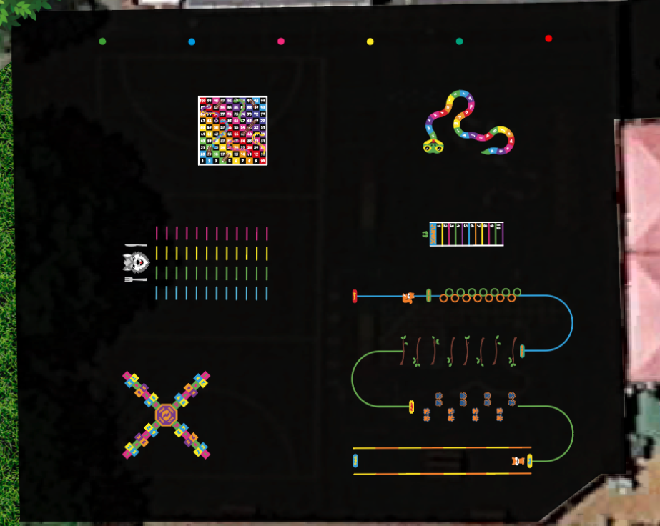

**Very busy summer term:**

As you will see from the calendar, the summer term is the busiest of the school year! Please bear with us as there will be an awful lot to communicate with you about! We try our best to do this in a timely manner, but apologise if we fall short on occasion. It is not for the want of trying! Thank you for your understanding.

**Online Safety/ESafety update:**

As part of our Online Safety Policy and procedures, we aim to reinforce the importance of children being safe online, both at school and out of school. In each newsletter we will be using one-page poster guides from National Online Safety to highlight areas that we think are relevant to our children and families, helping you to keep up-to-date with what's going on in the world of online safety. We hope that this will help you gain the confidence and skills to have age-appropriate, informed discussions with children to keep them safe, healthy and resilient to life beyond the school gates.

**May - What parents need to know about age ratings (see poster attached to the email)**

**Community events:**

Please see lots of exciting opportunities and activities **below.**

**And finally:**

Thank you for taking the time to read this newsletter and for all your on-going support. Have a wonderful half term holiday.

Many thanks and kind regards,

Nicki Walker

Headteacher

**Ampthill vs Cancer 5k:**

We are reaching out to invite Russell Lower School families to be a part of something truly special this summer. On Sunday, 29th June the Ampthill community will come together for the first-ever *Ampthill vs Cancer 5K*—an event designed not only to raise vital funds for local cancer charities, but to bring our town closer together through solidarity and hope.

While the event is open to everyone, we are especially excited to invite your students to participate in the **Golden Hare Mile**—a fun, family-friendly race where children (aged 12 and under) can run, jog, or walk in honour of a loved one or simply to show support. This special event is inspired by the legendary treasure hunt from the book *Masquerade*, which once led to the discovery of a golden hare right here in Ampthill Park.

In addition to the Golden Hare Mile, we also have a full 5K race for adults and family members. But it’s not just about running—it's about coming together as a community to support three amazing charities that help our neighbours and loved ones who are battling cancer:

* **The Primrose Car Service** (part of Bedford Hospital Charity & Friends) offers free transport for local cancer patients to Addenbrooke’s Hospital and is run by a team of volunteers.
* **Willen Hospice** provides comfort and care for those with terminal illnesses.
* **Addenbrooke’s Charitable Trust,** which is the cancer hub for our region,supports pioneering cancer research and life-saving treatments.

Every step taken during this event will help fund these vital services.

We would love your support in spreading the word to pupils and their families. **Attached** is a flyer about the Ampthill vs Cancer event, and the Golden Hare Mile that provides more information about the event. We kindly ask if you can share it with parents and carers via school communications.

The Golden Hare Mile is a wonderful way for children to get active, and be part of a cause that will make a real difference in the lives of local families affected by cancer. It’s also a great way to inspire a sense of community and solidarity in our next generation.

We hope your school can be part of this exciting, meaningful event.

As a team of volunteers putting this event on, we are open to any suggestions in raising awareness for this event amongst your pupils and their families. We would welcome the opportunity for one of our team to come in to the school to meet with a member of your team to discuss this further, and the possibility of an event in school for all children to take part in the lead up to the main event.

Here is our website: [Ampthill vs Cancer – Run, Walk, Support](https://ampthillvscancer.co.uk/)

Thank you for your time and support.

