**JUNE NEWSLETTER**

June 2025

Dear Parents/Carers,

Welcome to our latest newsletter. These newsletters are sent out on a monthly basis to keep you informed about what is happening in school. If you ever want to contribute an ‘article’ or suggest information that should be on the newsletters, I would be delighted to hear about them.

*Please note events that are underlined and in italics are new or amended since the previous newsletter.*

+**Tuesday 24th June -** Year 2 Cricket Festival for some children

**Wednesday 25th June -** Russell’s Sports Morning with PTA refreshments (am)

**Thursday 26th June -** KS1 Open the Book assembly

**Thursday 3rd July -** KS2 Open the Book assembly, No Technology morning (link Climate Action Plan) *Children will find out new classes at the end of the day*

**Friday 4th July -** Middle School Transition Day (Y4 to Alameda/Woodlands etc.), also Russell ‘Class Swap’ morning and Stay and Play sessions for new FS 2025 children

**Saturday 5th July -** Ladybirds’ Summer Fayre at Russell

**Monday 7th July -** 6:30pm Governors’ Meeting

**Tuesday 8th July -** Year 2 to Marston Vale (Greenfinch/Penguin), Year 4 Performance to Parents (2:15pm and 6pm)

**Wednesday 9th July -** Year 2 to Marston Vale(Robin)

**Thursday 10th July -** Choir to summer concert at Alameda - afternoon (rehearsal) and early evening (performance) See below for more details

**Friday 11th July -** Sunflower Competition ends, **Ampthill’s Big Tent Weekend** - 11th/12th/13th July - lots more information to follow

**Monday 14th July -** 2:30pm Russell Open Afternoon

**Tuesday 15th July -** Foundation Stage Visit to Herrings Green Farm, 9:15 - Year 4 Leavers’ Assembly to parents, 1:30 - 3:30pm - Year 4 Leavers’ Party

**Wednesday 16th July -** 9:15- Summer Reading Challenge Assembly by Ampthill Library

**Friday 18th July -** Children break up for summer holidays

**Summer Holidays - Premier Holiday Camps for the first 4 weeks of the holidays**

**More detailed information on the above events will follow in due course**

**September staff update:**

We are currently planning our staffing for September; the details will be finalised soon. However, staffing will remain very stable going forward. We are very sad to tell you that both Mrs Leach and Mrs Beirne will be leaving Russell this summer simply because they were covering maternity positions here. I think we can all agree that we have been incredibly lucky to have them both here and that they have been truly fantastic teachers for our children: the data shows us this (the children have made such great progress!) but also the strong relationships that they have both formed with both children and staff too. We will really miss Mrs Leach and Mrs Beirne and would like to thank them both and wish them all the very best in their future endeavours. In addition, the wonderful Mrs Jochacy will be leaving us this year having decided not to return from her third maternity leave, but to spend more time at home with her young family. Mrs Jochacy has been an outstanding teacher over her many years at Russell and we will miss her greatly, that said we completely understand her reasoning and wish her and her family all the very best in the future. Mrs Jochacy has promised to keep in touch and still do some teaching at Russell now and then too. We look forward to it!

The teaching team for next academic year will be:

**Foundation Stage:**

Mrs Brown – Swan Class (FS lead)

Ms Leung – Swift Class

Mrs Lyons – Dove Class

**Year 1:**

Mrs Rogers – Owl Class

Mrs Cox - Puffin Class

Ms Meyern (Monday, Tuesday, Wednesday) Mrs Salih (Thursday, Friday) – Wren Class

**Year 2:**

Mrs Coles – Penguin Class

Mrs Johnson – Greenfinch Class

Mrs Hitchings – Robin Class (KS1 Lead)

**Year 3:**

Mrs Ruddick – Goldfinch Class

Ms Gallagher – Blackbird Class

Ms Lara Lyons – Nightingale Class

**Year 4:**

Mrs Willis (formerly Miss Walker who taught in Year 3) – Woodpecker Class

Mrs Moffat – Starling Class

Mrs Tuck – Kingfisher Class (KS2 Lead)

We are so lucky to have such an experienced, talented and stable teaching team, especially at a time when so many other schools are really struggling to recruit. We are in for another great year!

The children will spend a morning with their new class teacher on Friday 4th July. An email will come home on Thursday 3rd July, letting you know who this will be. We deliberately only send it the day before so that any possible anxiety and worry is minimised. If your child should come home concerned, please reassure them: all the teachers at Russell are lovely and they will soon ‘settle in’ and they will definitely be with some of their friends (even if they are in Foundation Stage or Y2 who will be ‘mixed’ as they move on this year). Thank you.

**Open ‘Afternoon’ - Monday 14th July, from 2:30pm:**

As there is not a parents’ evening in the summer term, we like to create the opportunity for parents to come into school and look at their children’s books/folders and classrooms, and to ask any questions you may have about your child’s end of year report (which will come out to you on Friday 11th). We are very much looking forward to seeing as many of you as possible as the children love it!

This will be taking place on Monday 14th July this year. From 2:30pm, parents are invited to come into their child’s class and look at their books/folders and classrooms with them. Once you have finished looking you may take your child(ren) home early. **Please arrive via the school office/reception door and make your way to your child’s classroom. You are free to leave when you want to but please just ensure that you notify the class teacher that you are taking your child home so that we can sign them out.**

Can we also kindly request that you bring a bag/carrier bag with you on this day as you will be able to take your child’s books, folders and other work home with you to save the children struggling with them later in the week.

If you cannot make it into school on Monday 14th July, please do not worry. If you would kindly send a sturdy carrier bag into school on Tuesday 15th July we will package your child’s books up for you and send them home.

We hope you can join us and look forward to seeing you in school.

**Reminder - Term dates 2025/2026:**

Please find on the website: <https://www.russell-lower.co.uk/term_dates> our agreed term dates for 2025/26. These have been agreed with all lower and middle schools in Ampthill, Flitwick and Maulden.

**Reminder: Sports Day:**

Please see below information about our sports morning. We look forward to seeing as many of you as possible!

**SPORTS DAY MORNING - WEDNESDAY 25th JUNE**

We would like to invite you along to our Sports Day on Wednesday 25th June (weather permitting)

This year the format will be as follows:

**Foundation and KS1 (Years R, 1 & 2)**

Sports Events 9.30 am – 10.30 am

**KS2 (Years 3 & 4)**

Sports Events 10.45 am – 11.45 am

Refreshments will be available throughout the morning in the main hall

(Kindly provided by PTA)

Once the scores are in, we will award the Sports Day Trophy to the house with the most points in an assembly

**Your child should come to school in their PE kit on the day please.**

Your child may either wear their purple PE top or a T Shirt in their house colour could be worn instead

(Beech – Blue, Oak – Red, Sycamore – Green, Willow – Yellow)

We also have coloured bibs in school so please do not worry

As your child will be outside much of the morning, please also provide a water bottle, sun hat and apply sunscreen before school.

May we remind you that any photographs/videos taken must be for your own personal use only and NOT shared on any social media sites. Thank you.

**Parents: as you arrive, please go straight to the school field at the correct time. A sign on the back of a chair will show you which ‘station’ the children will be starting at. Please wait at your child’s class start point (around the long edges of the marked grid).** The children will come out with their class teachers and rotate around all the stations (clockwise as you look at the field with your back to the school building), spending a few minutes at each.

**Please arrive via the main entrance and leave via the KS2 gate entrance (A&F Motors end)** promptly after the event. Prolonged farewells only unsettle the children for the rest of the day. Thank you.

We look forward to seeing you! Fingers crossed for at least slightly cooler weather…

**A couple of pleas:**

* Please can you check that we have your up to date mobile number and email address - thank you
* Please can ‘temporary’ tattoos be removed before school? Thank you
* Please can you help us ensure that chewing gum does not come into school? Thank you
* Please remind children to dismount scooters and bikes once they are on the school site before and after school. We had a very nasty accident last week involving one of our youngest children.

Thank you for your support with these things. We really appreciate it.

**Clearing Parent Pay before the summer please:**

Please could all parents check their Parent Pay accounts before the end of the school year on 18th July? It is particularly important that we go into the new year with any debts cleared. Thank you. **Please note that we are unable to guarantee places at the Aviary Club for any children whose parents’ Parent Pay account is in arrears.** Thank you so much for your support.

**Reminder: Ampthill Library - Summer Reading Challenge:**

The challenge is open to children of any age and reading level, whether they are free readers or sharing stories with a grown up, sibling etc. This year's reading challenge is called Story Garden and celebrates the connection between reading and nature. You can find more information about the aims and objectives of the Summer Reading Challenge via the Reading Agency website: [https://readingagency.org.uk](https://readingagency.org.uk/)

**Reminder: Russell Choir Performance in the build up to the Big Tent weekend:**

On **Thursday 10th July** The Alameda Summer Concert will be taking place under a big tent on the Alameda School field. There will be art, music and dance students from Alameda, as well as choirs and musicians from Maulden, The Firs and ***our very own Russell School Choir.***

Tickets: Tickets are £5 plus a booking fee and are available using the following link:

[Click here to buy tickets](https://www.trybooking.com/uk/82036)

We would encourage as many people as possible to walk to this event to prevent congestion in the town. Please do not park at Parkside for this event. If you require disabled parking, please contact the Alameda School Office.

Gates open: **Entry will be through gates from the Alameda Walk opposite the school at 17:00 and you are welcome to bring your chair/ picnic blanket in to set up your view of the stage between 17:00 and 18:00. You can bring food and drink to the event, but we would ask that you don’t bring any glass or knives onto site. There will be refreshments available from the Alameda PTA on the evening.**

**Performance: 18:00- 19:30**

**We are really looking forward to it and hope you can join us!**

**Russell Lower School Values:**

Each half term, we teach the children about a different value. We then have a weekly ‘values’ assembly where we celebrate the demonstration of this value. The values this half term is:

**Summer 2:** Tolerance

**PE and festivals news:**

We have had another fantastic year for physical activity and sport at Russell and are extremely proud to announce that all this hard work has resulted in us retaining the **Platinum School Games Mark** that was awarded to us last year. This is an **amazing achievement** and demonstrates all the **hard work** that Russell puts into PE and physical activity on a daily basis.

Please visit the school website to read the review of our sports premium spend to see where the money has gone and the impact it has had. <https://www.russell-lower.co.uk/website/sports_premium/520526>. If you have any ideas or suggestions on future use of the sports premium (years 1 to 4) please contact the school office who will pass your ideas on to Mrs Bunney.

**Online Safety/ESafety update:**

As part of our Online Safety Policy and procedures, we aim to reinforce the importance of children being safe online, both at school and out of school. In each newsletter we will be using one page poster guides from National Online Safety to highlight areas that we think are relevant to our children and families, helping you to keep up-to-date with what's going on in the world of online safety. We hope that this will help you gain the confidence and skills to have age-appropriate, informed discussions with children to keep them safe, healthy and resilient to life beyond the school gates.

**June - Setting boundaries around gaming (see poster attached to the email)**

**The summer holidays are coming:**

We do understand the ‘gap’ that can arise when school staff are not available during the summer holidays. To help bridge this gap, the Mental Health Support Team (who work with us during term time) are pleased to offer the **2025 drop-in service** for families and young people throughout the summer.

**Please note: this is *not* a mental health crisis service**, but rather an opportunity for families and young people to seek advice and support with issues that may arise over the summer break.

Below is a poster with full details on how to access the service.

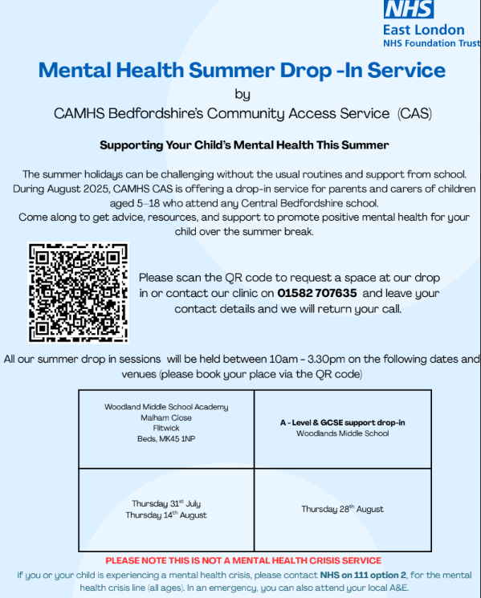

**Community events:**





For Tickets click  [here](https://ampthillbtw.co.uk/#event-dates)

**Could you help?**

The Ampthill Big Tent is happening from **11th–13th July**, and we’d love your help to make it amazing!

Thanks to those of you who have already made contact.

Whatever time you can give, we’ll take it (and love you for it!).

If you’re available to lend a hand (even for just an hour or two! ), between 4pm and 11pm Friday and/or Saturday and on Sunday between 11a.m. and 6pm, please let us know by going to  [volunteer with us](https://ampthillbtw.co.uk/volunteer-with-us/) or by emailing us at info@ampthillbtw.co.uk

Many thanks from the ABTW Team

Please see lots of exciting opportunities and activities **below.**

**And finally:**

Thank you for taking the time to read this newsletter and for all your on-going support.

Many thanks and kind regards,

Nicki Walker

Headteacher



