**JULY NEWSLETTER**

July 2025

Dear Parents/Carers,

Welcome to our latest newsletter. These newsletters are sent out on a monthly basis to keep you informed about what is happening in school. If you ever want to contribute an ‘article’ or suggest information that should be on the newsletters, I would be delighted to hear about them.

*Please note events that are underlined and in italics are new or amended since the previous newsletter.*

**Friday 18th July -** Children break up for summer holidays

**Summer Holidays - Premier Holiday Camps for the first 4 weeks of the holidays**

***Wednesday 3rd September*** *– Year 1, 2, 3 and 4 children return to school, Home Visits for new foundation stage children begin*

***Monday 8th September*** *- Y3 visit to Celtic Harmony*

***Wednesday 10th Septembe****r – Half of new foundation stage children start school*

***Thursday 11th September*** *– All foundation stage children in school*

***Wednesday 17th September*** *– Mental Health support team working with Year 1, Parents Evening letter out*

***Thursday 18th September*** *– New Intake Meeting for Foundation Stage (2026)*

***Friday 19th September*** *- 9:15- 10am, Swan, Swift and Dove Class reading/Phonics and writing workshop for parents - join us for coffee! Flu immunisations*

***Monday 22nd September*** *– Harvest Assembly TBC*

***Tuesday 23rd September*** *- New Intake Meeting (FS 2026) at 9:30am*

***Thursday 25th September -*** *Y2 Trip to Whipsnade*

***Friday 26th September*** *- Anxiety around school attendance - parent workshop 9 - 10am, Mental Health Schools Team*

***Monday 6th October*** *– Parents’ Evening 3:45pm to 7pm*

***Tuesday 7th October*** *– Parents’ Evening 3:45pm to 6:30pm*

***Wednesday 8th October*** *– New Intake Meeting (FS 2026) at 9:30am*

***Monday 20th October*** *– Finance and Resources Governors’ Meeting, 6:30pm*

***Friday 24th October*** *– Break up for half term*

**More detailed information on the above events will follow in due course**

**Open ‘Afternoon’**

Thank you so much to all of you for joining us for our Open Afternoon this week - the children loved showing you their work - and going home early, of course!

**Russell Leavers:**

As the academic year comes to an end it is always sad to say goodbye to the Year 4s as they move on to Alameda or indeed to other schools. Year 4 has been a super year group, full of wonderful, caring children. As I said in the Leavers’ Assembly, I am really going to miss them. The children have been fantastic Russell Rights role models all year, and I wish them all the very best in the future. Come back and see us – we would love to know how you get on! I would also like to take this opportunity to say goodbye to some of our Year 4 parents, some of whom have their youngest child leaving Russell, and we realise we will be losing you too! Thank you for the huge contribution you have made: so many PTA events and fundraising, classroom support, helping on trips etc. Simply, thank you: we are really going to miss your incredible support!

**PTA:**

I would just like to take this opportunity to say an enormous thank you to **Kristina Smith** and the entire PTA for being absolutely brilliant this year. Anyone who attended the incredible Summer Solstice ball will know exactly what I mean! It is not easy finding the time to support school - they have all been simply amazing this year again in so many ways! Thank you ALL so much for all you do! Please see below for just some of their recent achievements (and thank you for your generosity too):

The **Summer Solstice Ball** raised £6,743

The **Big Tent Weekend** raised £2,566

So far this year the PTA (and our generous parents) have raised a total of **£11,600.**

Thank you for all your support with all things PTA and in particular to those of you who attended the ball and contributed your time to support events.

**Walking to and from school:**

Year 4 have done a brilliant job getting themselves to and from school safely this half term: a really important skill to learn before heading off to middle school. Please can you remind all the children about taking care when walking to and from school in September, and indeed when they are around and about in Ampthill over the summer holidays. Thank you.

**Medication:**

All medication and inhalers will be sent home today. Please return any necessary medication to the office in September and complete a new consent form. Thank you.

**Free training and courses – for parents too:**

Does your child suffer from anxiety? Is it sometimes about coming to school? Come to this. Please just turn up on the day – this will be good! See below for details.



**Russell Raiders update - Please see update from our wonderful Russell Raiders coaches:**

**Foundation:**

For our Foundation year group, we started Saturday morning sessions just before Christmas, really getting into the swing of things after Christmas and running all the way through until the end of June. For many, this was their first experience of football, and it’s been genuinely amazing to see how much they’ve managed to develop in such a short space of time. The focus has all been about fun, with sessions made up of football-themed games, basic drills, and the odd mini-match thrown in. This approach will continue next year with organised matches vs other schools starting in year 2. With approximately 25 children registered (boys and girls), we’ve consistently averaged ~15 for each week and would welcome any new players! Please contact Zoe Barlow for more details russellraiders24@gmail.com

**Year 2:**

The year 2's completed their first seasons of competitive matches and we are pleased to say they did the school proud. They have improved their skills, made new friends and worked extremely hard whilst representing Russell Lower School. They have listened to their coaches, been respectful to their teammates and most importantly, had lots of fun. Just a few highlights include magnificent goals from Adam Doran, endless running and enthusiasm from Max Ashman and Harmaani Lagah, with plenty of passion and determination shown by George Jarmin and Arthur James.

The season ended with a trophy presentation in which Ivy Wilson won supporters' player of the season and Henry Prior won the players' player award. This was followed by an epic water pistol fight involving 550 water balloons and plenty of wet coaches and kids. Bring on next season!

**Year 4:**

This year saw the year 4’s move from 5 aside to 7 aside football. With 33 children we ran 3 teams (Thunder, Lightning, and Hurricanes), 2 playing as U9 sides against other school teams from the local area, and one team playing up a year as U10’s. Some highlights from the season to mention: a magnificent effort from the Hurricanes (playing as U10’s) winning the county cup, in a knockout competition played over several weeks. Lightning playing in the top U9 mini-league and enjoying some fantastic battles against arch-rivals the Firs, including a last-minute winner against them in our final ever game. And Thunder showing great character and grit in a number of comeback situations over the season. It now marks the end of their Russell Raiders journey and it’s been fantastic to see how they’ve developed over the last 5 years. Good luck in your next footballing chapter boys!

**Reminder - Term dates 2025/2026:**

Please find on the website: <https://www.russell-lower.co.uk/term_dates> our agreed term dates for 2025/26. These have been agreed with all lower and middle schools in Ampthill, Flitwick and Maulden.

**Clearing Parent Pay before the summer please and school meal prices:**

Please could all parents check their Parent Pay accounts before the end of the school year on 18th July? It is particularly important that we go into the new year with any debts cleared. Thank you. **Please note that we are unable to guarantee places at the Aviary Club for any children whose parents’ Parent Pay account is in arrears.** Thank you so much for your support. Apologies in advance, but we have been notified that school meal prices (from Y3 onwards as they are free before this) will have to rise **from £2.60 to £2.70 in September** – sorry! On a superb note, just this week, the kitchen retained its **5 Star Hygiene** rating AGAIN! Well done to the kitchen staff!

**Reminder: Ampthill Library - Summer Reading Challenge:**

The challenge is open to children of any age and reading level, whether they are free readers or sharing stories with a grown up, sibling etc. This year's reading challenge is called Story Garden and celebrates the connection between reading and nature. You can find more information about the aims and objectives of the Summer Reading Challenge via the Reading Agency website: [https://readingagency.org.uk](https://readingagency.org.uk/) Please see attached (June newsletter) for the summer activities at the library.

**Russell Choir Performance in the Big Tent:**

On Thursday last week, the choir were absolutely spectacular as they performed alongside other local schools in the opening sequence of the ‘Big Tent Event’. Congratulations and well done to the entire choir - they literally made adults weep with their emotive renditions.

Later that weekend, Russell Lower School also excelled itself with its Eco Sculpt entry by winning the schools’ category - a huge thank you and well done to Mrs Coles and the School Council!

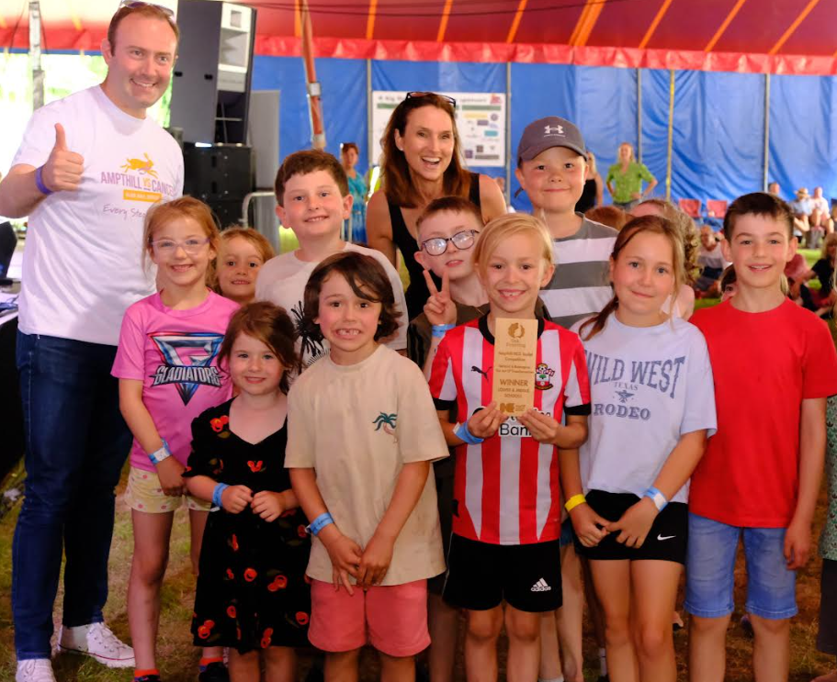

**Russell Lower School Values:**

Each half term, we teach the children about a different value. We then have a weekly ‘values’ assembly where we celebrate the demonstration of this value. The values this half term is:

**Summer 2:** Tolerance

**Autumn 1:** Respect

**PE and festivals news:**

We have had another fantastic year for physical activity and sport at Russell and are extremely proud to announce that all this hard work has resulted in us retaining the **Platinum School Games Mark** that was awarded to us last year. This is an **amazing achievement** and demonstrates all the **hard work** that Russell puts into PE and physical activity on a daily basis.

Please visit the school website to read the review of our sports premium spend to see where the money has gone and the impact it has had. <https://www.russell-lower.co.uk/website/sports_premium/520526>. If you have any ideas or suggestions on future use of the sports premium (years 1 to 4) please contact the school office who will pass your ideas on to Mrs Bunney.

**Online Safety/ESafety update:**

As part of our Online Safety Policy and procedures, we aim to reinforce the importance of children being safe online, both at school and out of school. Please keep children safe online by knowing what they are accessing ‘digitally’ and limiting screen time too. These top tips may help:

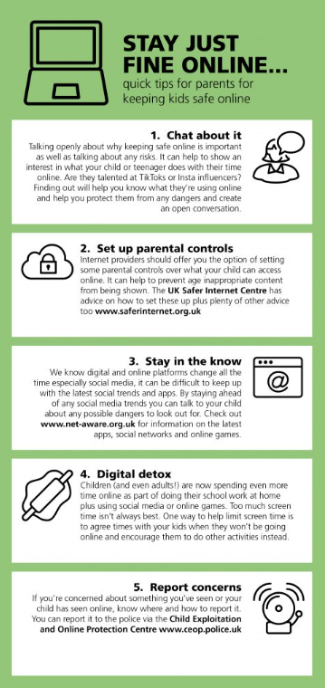

**The summer holidays are coming:**

We do understand the ‘gap’ that can arise when school staff are not available during the summer holidays. To help bridge this gap, the Mental Health Support Team (who work with us during term time) are pleased to offer the **2025 drop-in service** for families and young people throughout the summer.

**Please note: this is *not* a mental health crisis service**, but rather an opportunity for families and young people to seek advice and support with issues that may arise over the summer break.

Below is a poster with full details on how to access the service.

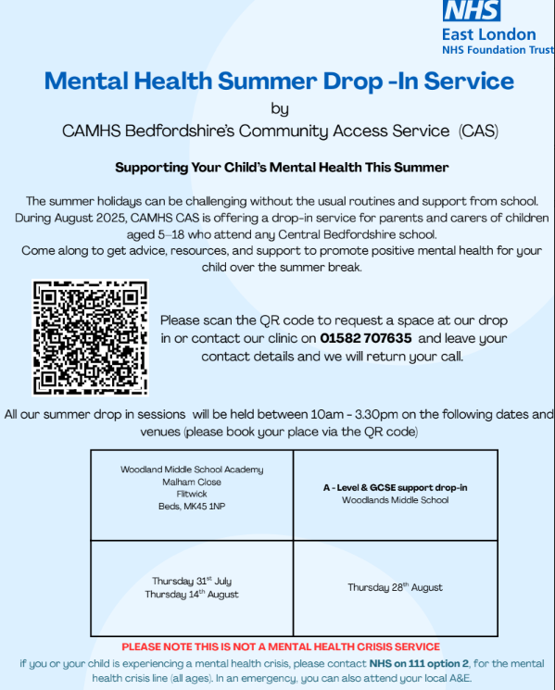

**Community events:**

Please see below the final paragraph.

**And finally:**

Thank you very much for taking the time to read this newsletter, **all** your support this year and all the wonderful summer gifts and messages myself and the staff have been so generously and thoughtfully given over the last week.

It has been another incredibly busy year, but incredibly successful too. I would like to thank everyone for their incredible support again throughout the year: from our brilliant academic results to the 65th Birthday Celebrations, Summer Solstice Ball and Big Tent Weekend, and everything in between! The ***whole*** Russell community (children, staff and parents) has yet again, been truly phenomenal, and created such a great partnership for the children.

I hope you and your family have a wonderfully restful and safe summer holiday and I look forward to seeing (nearly) everyone again in September. Happy holidays to you all!

Many thanks and kind regards,

Nicki Walker

Headteacher



