Pupil premium strategy statement – Russell Lower School (3 year plan for 2023/2024, 2024/2025, 2025/2026)
This statement details our school’s use of pupil premium (and recovery premium) funding to help improve the attainment of our disadvantaged pupils.
It outlines our pupil premium strategy, how we intend to spend the funding in this academic year and the outcomes for disadvantaged pupils last academic year.

School overview
Detail | Data
Number of pupils in school | 446
Proportion (%) of pupil premium eligible pupils | 6% 26
Academic year/years that our current pupil premium strategy plan covers (3 year plans are recommended) | 2023/2024, 2024/2025, 2025/2026
Date this statement was published | September 2023
Date on which it will be reviewed | July 2023
Statement authorised by | Nicki Walker  Headteacher
Pupil premium lead | Louise Bunney/Sarah Knight  Deputy Head Inclusion Lead
Governor / Trustee lead | Francesca Crowther lead for disadvantaged pupils

Funding overview
Detail | Amount
Pupil premium funding allocation this academic year (financial year based on Oct 22 census) | £46,090
Recovery premium funding allocation this academic year (based on Oct 22 census) | £4,350
Pupil premium (and recovery premium*) funding carried forward from previous years (enter £0 if not applicable)  *Recovery premium received in academic year 2021 to 2022 can be carried forward to academic year 2022 to 2023. Recovery premium received in academic year 2022 to 2023 cannot be carried forward to 2023 to 2024. | £0
Total budget for this academic year  If your school is an academy in a trust that pools this funding, state the amount available to your school this academic year | £50,440

Part A: Pupil premium strategy plan

Statement of intent
At Russell Lower School as of 2021-2022 we have adopted the RADY (raising the attainment of disadvantaged youngsters) approach. It is our intent to:
raise expectations;
raise awareness;
raise aspirations;

in order to close gaps between our disadvantaged pupils and their non-disadvantaged peers both in terms of attainment and holistic opportunities and experiences through focusing on equity not equality.

RADY Pledge
Our school pledges to take the following steps as part of the implementation of RADY to provide an equitable approach, resulting in improved outcomes for disadvantaged youngsters:
- An uplift will be applied for all disadvantaged youngsters at the start of the phase of education so that, if all children reach their increased target, attainment will be equalised by the end of the phase of education, and we can diagnose and address gaps in knowledge, skills and understanding at the earliest opportunity
- RADY will form the Golden Thread through the existing school development plan, resulting in all leaders driving RADY through their respective areas which will help to ensure that RADY becomes a sustainable approach that is embedded into the school culture
- We will work to achieve proportional representation for disadvantaged youngsters in all aspects of school life by the end of the first year of implementation so that our disadvantaged youngsters are challenged in lessons and engaging in wider experiences outside of the classroom that will develop their skills to be successful in life
- From the end of 2021-2022 all colleagues within the school will understand what RADY is and be able to articulate what we are doing as a school to increase the attainment of our disadvantaged youngsters.

Research states that disadvantaged pupils have been disproportionately affected by the pandemic. In order to address this our strategy is integral to wider school plans and our SDP ‘golden threads’ for whole school improvement. We understand that by developing evidence-based practices (which we have been focussing on for several years now) that support our disadvantaged pupils we will also be enhancing staff skills and provisions for all pupils.

At Russell Lower high-quality teaching is at the heart of everything we do, with a focus on areas in which disadvantaged pupils require the most support. This is proven to have the greatest impact on closing the disadvantage attainment gap and at the same time will benefit the non-disadvantaged pupils in our school.

We also continue to make use of targeted support for those who are not making good progress, or those who have been disproportionately impacted by the effects of the pandemic. We consider carefully the links between structured small group interventions to classroom teaching and the curriculum and use high quality evidence based provisions to support our pupils.

We are constantly mindful of the wider strategies we use and ensure they relate to the most significant non-academic challenges to success in school, including attendance, behaviour, and social and emotional support, which also may negatively impact upon academic attainment.

We believe accurate early identification of need and knowing our pupils well is key in supporting our disadvantaged pupils to make good progress and achieve high attainment in all subject areas. For this reason, teachers carry out PP passports within the first two weeks of pupils returning to school and appropriate support/provisions are identified and set up by the end of the third week back in September.
We also believe engagement of our PP/vulnerable families is key and continue to develop our communication with these families whilst being mindful to protect these families from any kind of stigmatisation or stereotyping. We invite them to contribute (via Your thoughts questionnaire) to influence the provision their children receive so that it has the greatest impact on raising attainment.

Through robust diagnostic assessment carried out by Phase Leaders, the Inclusion Lead (PP lead), the Deputy Head (PP strategy lead) and the Headteacher supported by LSAs and class teachers during half termly PP meetings/Pupil Progress Meetings (PPMs) we are able to ensure our approach to supporting our disadvantaged pupils is responsive to common challenges and individual needs.

We worked with Challenging Education (Louise Blackburn) during 2021/22 and 2022/23 to implement RADY approaches. We will be continuing with this into 2023/24.

Challenges
This details the key challenges to achievement that we have identified among our disadvantaged pupils. These will be our focuses for the next three years (2023/24, 2024/25 and 2025/26).
Challenge number | Detail of challenge
1 | Attendance  Internal monitoring shows that by June 2023 our PP attendance was 94.5% vs non-PP of 95%  (National of 93.7% for all pupils’ years 1 to 6).  June 23 our PP persistent absence (PA) was at 12.9% reducing from 17% in October 22. Non-PP PA was at 10% in June 23 resulting in a gap of -2.9%.  (National of 17.7% for all pupils’ years 1-6)  Although all the figures above are positive in terms of our PP children it has taken considerable work and monitoring to reduce this gap and without the continuation of this we fear it could increase again, particularly the PA %. All evidence indicates that absenteeism negatively impacts attainment and progress.
2 | Attainment  Internal and external assessments and observations indicate that writing and maths attainment among PP pupils is below that of non-PP.
  June 23 | PP ARE+ | Non PP | Sum gap | Gap with SEND removed for both groups
  Reading | 88 (87 June 22) | 89 | -1 | +1
  Writing | 61 (55 June 22) | 82 | -21 | -15
  Maths | 76 (69 June 22) | 87 | -11 | -4
3 | Lower level of phonics on entry to school  Assessments, observations, and discussions with pupils suggest disadvantaged pupils generally have greater difficulties with phonics on entry to Russell than their peers. This negatively impacts their development as readers.
4 | Language and vocabulary skills  Assessments, observations, and discussions with pupils indicate underdeveloped oral language skills and vocabulary gaps among many disadvantaged pupils. These are evident from Reception through to KS2 and in general, are more prevalent among our disadvantaged pupils than their peers.
5 | Resilience - emotional wellbeing (to include proportional representation)  Our assessments (including SDQs, observations and discussions with pupils and families) indicate that resilience is low in many of our disadvantaged children which has been further impacted by the partial school closures during the COVID-19 pandemic, this is true also for many of our Non-PP pupils.  This lack of resilience towards learning and social factors is significantly impacting the overall progress of our children.  During the academic year 2022/23 31% of the children accessing Pastoral support were disadvantaged.

Intended outcomes
This explains the outcomes we are aiming for by the end of our current strategy plan, and how we will measure whether they have been achieved.
Intended outcome | Success criteria
Improved Attendance  To achieve and sustain improved attendance for all pupils, particularly our disadvantaged children. | Improved and sustained high attendance by 2025/26 demonstrated by:  - Attendance for all to be >97% with no more than a 1% gap between PP and non-PP. 95% year 1, 96% year 2 and 97% year 3  - Persistent absence to be <8% (ideally down to <3%) for all children and close the gap (2.9%) between PP and non-PP PA.
Improved Writing Attainment  Improved writing attainment among disadvantaged pupils from 61% July 23 and narrow the gap of 21%  July 23 no SEN disadvantaged attainment was 75% compared to no SEN other attainment 89%  Gap of 14% | Writing outcomes in 2025/26 show that 85% of disadvantaged pupils meet the expected standard  Writing outcomes in 2025/26 show that 85% of no SEN disadvantaged pupils meet the expected standard with a continued narrowing of the gap.
Improved Maths attainment  Improved maths attainment among disadvantaged pupils from 76% July 23 and narrow the gap of 11%  July 23 no SEN disadvantaged attainment was 87% compared to no SEN other attainment 94%  Gap of 7% | Maths outcomes in 2025/26 show that 85% of disadvantaged pupils meet the expected standard  Maths outcomes in 2025/26 show that 85% of no SEN disadvantaged pupils meet the expected standard with a continued narrowing of the gap. vt
Improved phonics attainment among disadvantaged pupils. | KS1 phonics outcomes in 2025/26 show that more than 95% of disadvantaged pupils (minus SEND) meet the expected standard.
Improved oral language skills and vocabulary among disadvantaged pupils. | Assessments and observations indicate significantly improved oral language among disadvantaged pupils. This is evident when triangulated with other sources of evidence, including engagement in lessons, book scrutiny and ongoing formative assessment.
Improved Resilience  SDP2 - To build a resilient school community, to ensure children, parents, staff and governors have the skills they need to be successful and thrive. | School has moved from an entirely well-being pastoral model to a resilience model resulting in improved wellbeing by 2025/26 demonstrated by:  - qualitative data from student voice, student and parent surveys and teacher observations demonstrating an improved attitude to all areas but in particular learning  - quantitative data from SDQs/SHEU  - a sustained increase in participation in enrichment activities, particularly among disadvantaged pupils - proportional representation  - Attendance improves further from the position at the end of the year 2022/23 (overall and PA)  - The SHEU survey demonstrates improvements in resilience, as does the well-being governor and staff, child and parent questionnaires  - More children attend the Y4 residential in 2024 without huge intervention from the SLT

Activity in this academic year (2023/24)
This details how we intend to spend our pupil premium (and recovery premium) funding this academic year to address the challenges listed above. This is linked to the menu of approaches.

Teaching (for example, CPD, recruitment and retention)
Budgeted cost: £ £14,000
Activity | Evidence that supports this approach | Challenge number(s) addressed and menu of approaches
OFSTED objective  Continue to develop teachers’ subject knowledge so that they focus specifically on the subject knowledge that curriculum leaders intend children to learn.  CPD around QFT and the T&L toolkit to ensure:  - Teachers have secure subject knowledge in all subjects (as judged in observations)  - Each lesson focused on specifically the subject knowledge that the subject syllabus intends (as judged in observations)  - Teachers plan activities that help pupils remember important subject knowledge  - Children achieve well in all subject areas  - The gap between boys and girls writing and reading continues to narrow  - The gap between disadvantaged and non-disadvantaged children’s writing and reading continues to narrow | Evidence indicates that high quality teaching is the most important lever schools have to improve pupil attainment, including for disadvantaged pupils. Schools should focus on building teacher knowledge and pedagogical expertise, curriculum development, and the purposeful use of assessment. In some cases, this may include the selection of high-quality curriculum materials, or investment in the use of standardised assessments. EEF | 2  HQT 1
SDP1 (linked to OFSTED objective)  To further develop the English curriculum at Russell so that outcomes continue to improve for all children, but particularly in boys and disadvantaged children’s writing  CPD and monitoring around Talk for Writing principles and research around the Simple view of writing and novice to expert writing. | Supporting continuous and sustained professional development (PD) on evidence-based classroom approaches is important to develop the practice of teachers in your setting. The content of PD should be based on the best available evidence. Effective PD is likely to require a balanced approach that includes building knowledge, motivating teachers, developing teacher techniques, and embedding practice. EEF | 2,3,4  HQT 2
Production of year group writing TAF statements and greater opportunity for cross year group moderation with consideration of producing writing exemplars.  We will fund teacher release time to embed key elements of guidance in school and to access CPD. | Accurate assessment provides reliable insights into the specific strengths and weaknesses of each pupil to help ensure they receive the correct additional support through interventions or teacher instruction:  Standardised tests | Assessing and Monitoring Pupil Progress | Education Endowment Foundation | EEF | 2  HQT 1
Continued enhancement of our maths teaching and curriculum in line with DfE and EEF guidance. | The impact of mastery learning approaches is an additional five months progress, on average, over the course of a year.  The DfE non-statutory guidance has been produced in conjunction with the National Centre for Excellence in the Teaching of Mathematics, drawing on evidence-based approaches:  Maths_guidance_KS_1_and_2.pdf (publishing.service.gov.uk)  The EEF guidance is based on a range of the best available evidence:  Improving Mathematics in Key Stages 2 and 3 | 2  HQT 2
Training for all teaching staff to ensure assessment is accurate and consistent across the school and in all areas this will include:  - CPD around the new assessment tool (insight)  - Rewritten policy  - Governor training  - Updated pupil progress template to ensure SLT are ‘digging deeper’ | Accurate assessment provides reliable insights into the specific strengths and weaknesses of each pupil to help ensure they receive the correct additional support through interventions or teacher instruction:  Standardised tests | Assessing and Monitoring Pupil Progress | Education Endowment Foundation | EEF | 2,3,4  HQT 1
OFSTED objective  Research and training in preparation for purchase a DfE validated Systematic Synthetic Phonics programme to ensure our books are even more closely matched to our children's phonics ability resulting in children being able to read better and therefore write better. | Phonics approaches have a strong evidence base that indicates a positive impact on the accuracy of word reading (though not necessarily comprehension), particularly for disadvantaged pupils:  Phonics | Toolkit Strand | Education Endowment Foundation | EEF | 2,3,4  HQT 2,5
Embedding dialogic activities across the school curriculum. These can support pupils to articulate key ideas, consolidate understanding and extend vocabulary.  We will purchase resources and fund ongoing teacher training and release time. | There is a strong evidence base that suggests oral language interventions, including dialogic activities such as high-quality classroom discussion, are inexpensive to implement with high impacts on reading:  Oral language interventions | Toolkit Strand | Education Endowment Foundation | EEF | 2,3,4  HQT 1, 2, 5

Targeted academic support (for example, tutoring, one-to-one support, structured interventions)
Budgeted cost: £27,000
Activity | Evidence that supports this approach | Challenge number(s) addressed and menu of approaches
Additional high quality phonics sessions targeted at disadvantaged pupils who require further phonics support | Phonics has a positive impact overall (+5 months) with very extensive evidence and is an important component in the development of early reading skills, particularly for children from disadvantaged backgrounds.  Targeted phonics interventions have been shown to be more effective when delivered as regular sessions over a period up to 12 weeks:  Phonics | Toolkit Strand | Education Endowment Foundation | EEF | 2,3,4,5  TAC 1,2,4
Offer high quality maths, reading, writing and SPaG provisions (SO, tutoring and LSA provisions) in order to narrow the gap between disadvantaged and others in school | Pupils may require targeted academic support to assist language development, literacy, or numeracy. Interventions should be carefully linked to classroom teaching and matched to specific needs, whilst not inhibiting pupils’ access to the curriculum.  - EEF small group tuition +4 months  - 1:1 tuition/small group work and personalised learning results in a +5 months gain EEF  DfE research has found that disadvantaged pupils have been worst affected by partial school closures, and that the attainment gap has grown as a result of national lockdowns. | 2,3,4,5  TAS 1, 2, 3, 4
Further embed a programme to improve listening, narrative and vocabulary skills for disadvantaged pupils who have relatively low spoken language skills - NELI/communication cookbook/CPD via private S&L therapist | On average, oral language approaches have a high impact on pupil outcomes of 6 months’ additional progress.  Oral language interventions can have a positive impact on pupils’ language skills. Approaches that focus on speaking, listening and a combination of the two show positive impacts on attainment:  Oral language interventions | EEF (educationendowmentfoundation.org.uk) | 2,4,5  TAS 2
Monitor adaptations (activity and resources) and provisions being made to meet the specific needs of disadvantaged pupils with SEND | Disadvantaged pupils with SEND have the greatest need for excellent teaching. Specific approaches to support these pupils may include explicit instruction, cognitive and metacognitive strategies, scaffolding, flexible grouping, and the targeted use of technology. Supporting resources:  • The EEF guidance report on Special Educational Needs in Mainstream Schools includes 5 evidence based recommendations to support pupils with SEND. | 2,3,4  TAS 3

Wider strategies (for example, related to attendance, behaviour, wellbeing)
Budgeted cost: £10,000
Activity | Evidence that supports this approach | Challenge number(s) addressed and menu of approaches
Embedding principles of good practice set out in the DfE’s Improving School Attendance advice and Working Together 2022  This will involve continuing to dedicate time to monitor attendance and work with parents to ensure this is high for PP children | The DfE guidance has been informed by engagement with schools that have significantly reduced levels of absence and persistent absence.  Clear evidenced link between attendance and attainment. NfER briefing for school leaders identifies addressing attendance as a key step. | All  WS 1
SDP 2  The resilience model being communicated with all stakeholders via INSET/workshops/lessons/assemblies/newsletters and daily practice in order to move school on from an entirely well-being pastoral model to a resilience model | Evidence from the EEF’s Teaching and Learning Toolkit suggests that effective SEL (social emotional learning) can lead to learning gains of +4 months | All  WS 1
To continue to support and encourage parental engagement through:  - an open door policy with the SLT  - embedding the SEND/PP/PS parents café/workshops to support parental engagement  - a range of parent workshops  - offering appropriate extended provision | Parental engagement has a positive impact on average of 4 months’ additional progress.  Levels of parental engagement are consistently associated with improved academic outcomes. Practical approaches, such as supporting shared book reading, or tailoring positive communications about learning, can prove actionable for schools. Supporting resources:  • The EEF Toolkit has a strand on parental engagement.  • The EEF guidance report on ‘Working with Parents to Support Children’s Learning’ offers practical approaches and insights for communicating and supporting parents.  The EEF states ‘Developing a holistic understanding of the needs of pupils, and strategies to support those needs, will require consistent and purposeful engagement with parents and families.’  There is some evidence that providing free, universal, before-school breakfast clubs can benefit pupils, by preparing children for learning or supporting behaviour and school attendance. | All  WS 1,2,4,5,6
Continued focus on proportional representation across the school such as school council, sports leaders, extra-curricular clubs, music lessons etc.  Consider allocating places rather than offering - need to turn down rather than sign up | EEF evidence indicates that when pupils take pride and engage in wider aspects of school life socially, they achieve well as they are more settled.  Improving behaviour in schools  Extracurricular activities are an important part of education in its own right. These approaches may increase engagement in learning, but it is important to consider how increased engagement will be translated into improved teaching and learning. Supporting resources:  - The EEF Toolkit has a strand on arts participation. | All  WS 1,2,3
Sign up to initiatives such as Letterbox club in order to support parental engagement. | Feedback from previous years of use of Letterbox club and the positive impact this has had on children and parental engagement/support at home. | 2,3,4  WS 3

Total budgeted cost: £ £51,000

Part B: Review of the previous academic year
Outcomes for disadvantaged pupils

2022/23
Over 2022-2023 we saw a slight decline in the numbers of PP children from 36 to 31 (43 the previous year). This number remained stable over the year. By the end of the academic year, 35% of our disadvantaged pupils were also on the SEN register. 55% of our PP children were boys and 73% of the SEND PP children were boys. This contributed to the difficulty in narrowing gaps for boys.
Despite our previous strategies (pre pandemic) being effective in narrowing the gaps as evidenced by our 2019 data whereby we had successfully narrowed attainment gaps in reading (-7%), Writing (-14%) and Maths (-14%) the outcomes we aimed to achieve over the last three years through our strategies have not been fully realised. However, we have been extremely successful in continuing to reduce these again following the huge impact of the pandemic:
 | June 2019 | June 2021 | Diff 19 - 21 | July 2022 | Diff  19 - 22 | July 2023 | Diff  19 - 23
 | PP ARE+ | PP ARE+ |  | PP ARE+ |  | PP ARE+
Reading | 80% | 61% | -19% | 87% | +7% | 88% | +8%
Writing | 65% | 44% | -21% | 55% | -10% | 61% | -4%
Maths | 68% | 55% | -13% | 69% | +1% | 76% | +8%
This means that we are now exceeding attainment outcomes from pre-pandemic times in reading and maths and are only 4% behind in writing.
Foundation Stage GLD June 2022 was 0% (but only 2 children). PP FS GLD June 23 was 75% (3/4)
Whole school PP reading ARE (87% July 22, 88% July 2023) 22% (23%) more than the LA KS1 average (55%) for 2019 FSM analysis (pre covid)

Whole school PP writing ARE (55% July 2022, 61% 2023) 8% (14%) more than the LA KS1 average (47%) for 2019 FSM analysis (pre covid)

Whole school PP maths ARE ( 69% July 2022, 76% July 2023) 14% (21%) more to the LA KS1 average (55%) for 2019 FSM analysis (pre covid)

Whole school reading gap between PP and other is -2% 2022 (-1% 2023) less than the LA KS1 average (-25%) for 2019

Whole school writing gap between PP and other is -24% 2022 (-21% 2023) less than the LA KS1 average (-27%) for 2019

Whole school maths gap between PP and other is -15% 2022 (-11% 2023) less than the LA KS1 average (-24%) for 2019

Phonics
Year 1 – 89% (91% 2022) of children passed the phonics screening – 75% of PP (100% 2022) children passed, 89.5% (90.5% 2022) of non-PP children passed. The difference was two new boys who started Russell in Y1 and were very weak. They both did not pass.
Year 2 – 97% passed (92% 2022) – 100% of PP (75% of PP in 2022) children passed, 96% (94% 2022) of non-PP children passed.
Whole school attendance was an issue in 21/22 due to huge absence from Covid-19 all year. It was then very difficult again in 22/23 due to lowered immunity and term time holidays. We continue to monitor the attendance of all children very carefully, but specifically PP PA attendance as it was very high:
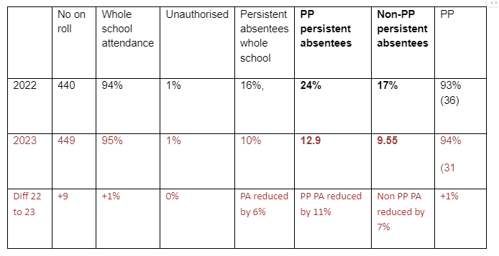

Further information (optional)
Additional activity
Our pupil premium strategy has been supplemented by additional activity that has not been funded by pupil premium or recovery premium. That included:
- utilising the DfE grant to train a senior mental health lead. The training we have selected focuses on the training needs identified through the online tool: developing our understanding of our pupils’ needs, giving pupils a voice in how we address wellbeing, and supporting more effective collaboration with parents.
- In addition, we trained two mental health first aiders
Planning, implementation, and evaluation
In planning our new pupil premium strategy, we evaluated why activity undertaken in previous years had not had the degree of impact that we had expected. We also commissioned a pupil premium review in Autumn 2021-2022 to get an external perspective, and continue to work with the RADY programme. Both these had very positive reviews and the recommendation was to do ‘more of the same’ in 2022/23 as we had successfully closed gaps in reading (-1%), narrowed the gap in Maths (-11%), but still needed to work on writing, which had been the most significantly impacted area during Covd-19.
We triangulated evidence from multiple sources of data including assessments, engagement in class, book scrutiny, feedback from parents, pupils and teachers in order to identify the challenges faced by disadvantaged pupils.
We looked at a number of reports, studies and research papers and attended CPD courses around effective use of pupil premium, focussing on areas such as; developing an evidence based PP strategy; the impact of disadvantage on education outcomes and how to address challenges to learning presented by socio-economic disadvantage. We also looked at studies about the impact of the pandemic on disadvantaged pupils.
We used the EEF’s implementation guidance to help us develop our strategy, particularly the ‘explore’ phase to help us diagnose specific pupil needs and work out which activities and approaches are likely to work in our school. We will continue to use it through the implementation of activities.
We have put a robust evaluation framework in place for the duration of our three-year approach and will adjust our plan over time to secure better outcomes for pupils.

The PP strategy has been written with the ‘Using Pupil Premium for School Leaders’ document and the Menu of approaches. These have been referenced in the document using the following codes:
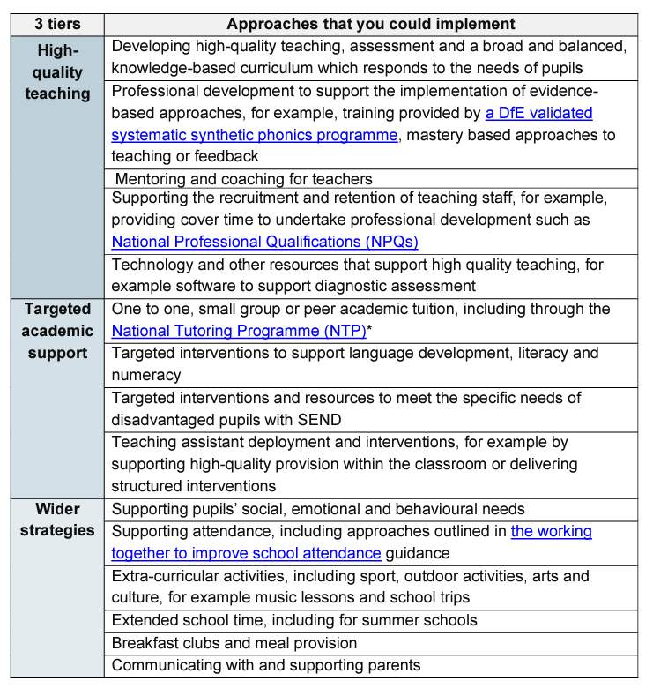
HQT 1

HQT 2

HQT 3
HQT 4

HQT 5
TAS 1

TAS 2

TAS 3

TAS 4

WS 1

WS 2

WS 3
WS 4
WS 5
WS 6

