DECEMBER NEWSLETTER
December 2025
Dear Parents/Carers,
These newsletters are sent out on a monthly basis to keep you informed about what is happening in school. If you ever want to contribute an ‘article’ or suggest information that should be on the newsletters, I would be delighted to hear about them.
Please note events that are underlined and in italics are new or amended since the previous newsletter.
Monday 15th December - Year 1 superheroes day
Tuesday 16th December - Year 4 visit the Theatre (am), Year 1 visit the Theatre (pm)
Wednesday 17th December - Year 3 visit the Theatre (am), Foundation Stage (Swan/Doves/Swifts) visit the Theatre (pm), Violin Assembly at 1:20pm - main hall
Thursday 18th December - Year 2 visit to the Theatre (am), Year 4 choir visits to local care homes (pm), Samba drumming to parents - Kingfisher 9:30am, Starlings 10:30am, Woodpecker 11:30am
Friday 19th December - Rotakids ‘break the rules day’, Santa will be visiting all of our classrooms, break up for Christmas holidays
CHRISTMAS HOLIDAYS

Monday 5th January 2026 - INSET DAY - school CLOSED for staff training
Tuesday 6th January 2026 - Children return to school after the Christmas break
Wednesday 7th January 2026 - Year 3 Faith Tour, Foundation Stage Vision Screening
Thursday 8th January 2026 - Mental Health Schools Team in to support Year 1 children and staff with emotion coaching, Y3 swimming begins (and every Thursday for 6 weeks)

More detailed information on the above events will follow in due course

Headteacher handover:
Mr Young enjoyed another great visit to school last Thursday and this Friday - he loved the questions that the children had prepared and was impressed with everyone and everything! He cannot wait to be here now, thank you for making him feel so welcome already! He already feels very settled and very much part of the community.

School attendance:
Please can you help us by getting to school on time each day? We need children to be on site by 8:50am so we can have them settled in their seats for the register by 8:55am. Yesterday, we had 14 ‘late’ children and this meant that the office staff spent a long time delivering children to classrooms rather than getting on with their usual jobs. Thank you in advance.
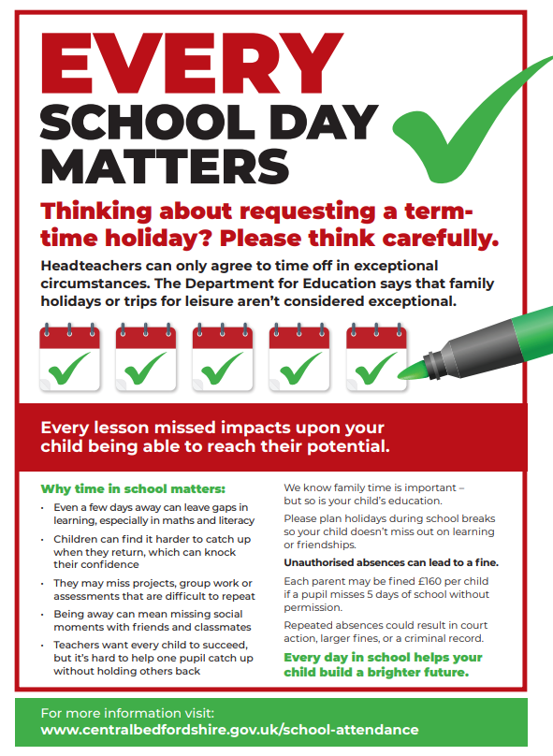

Governor Vacancy
Thank you for the huge response to our plea for a new governor at Russell. We are excited at the interest in this role and the calibre of people. We have been able to successfully appoint a new range of governors with specific skills that our school will benefit from - thank you to everyone who expressed their interest. Governors details will be updated and shared soon.

Reminder Term Dates 2026/27:
These are now on the school website. Thank you for not booking holidays in term time. We really appreciate it.

Big thank you for your support:
Thank you for your support with recent fundraising. We are proud to have been able to support The Royal British Legion (£555.75) and Children in Need (£1356.18!)very recently. In addition, a huge thank you to Gemma, Vicky and Hannah and their children in particular, for hosting a ‘Colourful Bake Sale’ after school recently for the Abilities Foundation books. They raised a whopping £276 which will provide us with many copies of wonderfully inclusive books for the library and the Nest. These are incredible donations. Simply a HUGE thank you!

Foundation Stage and Year 2 performances to parents:
Thank you for your incredible support attending our FS and Y2 performances – you really did pack the house out! There was standing room only (and not much of that!), to see the children’s shows. They were absolutely buzzing with excitement and their faces lit up when they saw you all. Thank you for all your support, including learning lines and songs.

Christmas Jumper Day/Father Christmas Visit and ‘Elfridges’:
Thank you for all your support over the last week or so. It was a lot of fun! We enjoyed (or will have!) eight opportunities to get parents into school (three x Year 4 Samba performances, two x Year 2 Performances and two x Foundation Stage Nativities) as well as having a brilliant Christmas Lunch on Wednesday, and Christmas Jumper Day/Christmas Craft Activity morning on the previous Friday (which turned out to be our biggest ever!), with a wonderful visit to 'Elfridges' for many children too. What a busy time!
We cannot thank the PTA Elves enough for giving up their days to deliver such amazing Christmas magic and fun at Elfridges again this year! The children were filled with awe and wonder at the transformation of the library. If there was any doubt, they now definitely believe in the magic of Christmas! A HUGE thank you to everyone involved.

Christmas Tree Festival 2025 - update:
On the weekend of 6th and 7th of December St Andrew’s Church held their Christmas Tree Festival. Russell Lower School’s tree was there with our ‘Traditional Christmas’ inspired decorations,
as were our brilliant choir with Ms Gallagher. The choir was simply brilliant: they were phenomenal and sounded so good, even in the huge church. Thank you to all the parents and children who came to support us - especially in the middle of your Sundays. Once again, Russell scooped the ‘Overall Winner’ at the festival - thank you so much to you all for your support and all the votes for the tree. We really appreciate it.

Santa Challenge:
Our target was to get to Lapland 2,027 miles away. We are delighted to announce that Russell Lower School made it all the way to Lapland (and home again!) completing many more miles than they needed to - well done! News of the scooter winner will follow shortly!

Mental health support team:
Please see the poster below for the latest workshops for parents.

Inclusion Coffee morning on Friday 23rd January 2026 at 9.15am
As part of our participation in the national PINS project (Partnership for Inclusion of Neurodiversity in Schools), we are delighted to welcome the SNAP Parent Carer Forum back to Russell Lower School in the second of three parent coffee mornings .
This will be an opportunity to share your parent carer experience, and that of your child. Full details to follow in January.
Please indicate your intention to attend using the very brief Google form attached (this ensures that we purchase sufficient coffee, tea and biscuits!!)
https://forms.gle/8xwfoyPXerZMnqdm9

Safeguarding
During term time, you can discuss any concerns you may have about a child with the Russell Safeguarding team in person, by telephone on 01525 755664 or via the dedicated safeguarding email address: safeguarding@russell-lower.co.uk
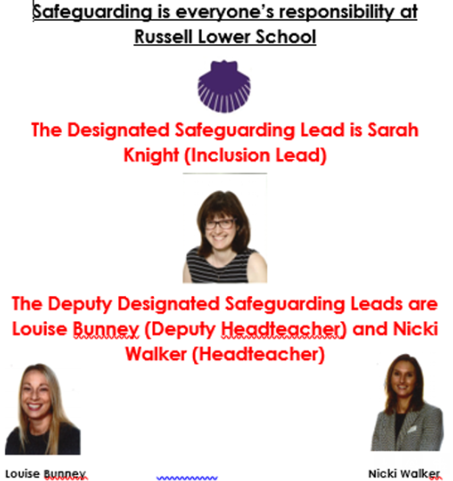
Mr Young will assume the role of DDSL in January.
When school is closed, if you think a child you know is being harmed or at risk of being harmed, please contact the Integrated Front Door on 0300 300 8585, who you can talk to about your concerns.
They will give you advice or may investigate the circumstances. All child protection calls are treated in confidence and you don't need to give your details.
Alternatively, visit the Safeguarding Bedfordshire website: https://www.safeguardingbedfordshire.org.uk/report-a-concern/report-a-concern-about-an-adult-or-a-child
Everyone has a responsibility to protect children from harm.
Thank you.

REMINDER - School admissions to Foundation Stage in September 2026 and Middle Schools
It’s that time of year again! Even though the children have only just started in their new year group, you need to make your applications now:

Children born between 01/09/21 and 31/08/22 are due to start school in September 2026.
Parents/ carers need to make an application to CBC by 15 January 2026, even if their child attends a nursery/pre-school on the school site. All the information you will need regarding your Starting School 2026 application is available on the CBC website (see hyperlink below).
Year 4 parents, please bear in mind that applications for Middle School are also needed within the same timescales i.e. before 15th January 2026. Please note: this will not just happen automatically.
School admissions | Central Bedfordshire Council

Russell Lower School Values:
Each half term, we teach the children about a different value. We then have a weekly ‘values’ assembly where we celebrate the demonstration of this value. The value next half term is:
Spring 1: Sharing and Caring

PE and festivals news:
Well done to all the children who have taken part in festivals this term, they have been an absolute credit to the school demonstrating both the Russell and RSSP values. Next half term year 3 will begin their swimming lessons, some of year 4 will attend a sportshall athletics event and some of year 2 will attend a dance event. We wish all those taking part the very best of luck! The year 4 Sports Leaders will also begin supporting the rest of the schools in achieving physically active lunchtimes, they can’t wait to get started!

Russell Raiders Update:
Russell Raiders Year 4s - now in their final year of Russell Raiders, and wow, what an improvement we have seen in everyone involved since starting back on the school field over 3 years ago. Now playing competitive matches at 7 a side, we have had some great results against some good teams. This year group always does the school proud with their hard work, respect, teamwork work and respect shown towards the other teams and each other. Great work - keep it up and have a great Christmas!

Some excellent performances so far this season from the Year 3s. Including a winning goal from George H with the last kick of the game against GP United. Seven goals from Heath Warwick in the win against Silsoe Lower School and Arthur M scoring the winning goal away against Oakley are just a few of the highlights in the squad's impressive start to the season. The squad are playing as a team with Alby M always full of energy, Avy dedicated to his defending and Seb always working hard. They are all learning and developing their skills, proudly representing their school across the local area and at training.

The Year 1s have continued their footballing development journey. Our sessions on Saturday mornings are focused on fun, football-themed games, to build their skills of passing, shooting, and dribbling. Plus, the all-important mini-match to finish!
We did take a squad of 10 to a tournament during the October half-term, our very first taste of matches against other teams. A great morning of matches with bags of effort, lots of enthusiasm, and a positive attitude on display from of our children. They played with smiles on their faces all morning, with the smiles getting even wider with a medal around their necks at the end.
For anyone interested in joining our sessions on Saturday morning, please email russellraiders24@gmail.com for more info

For any parents in Foundation, Russell Raiders is a parent-led football program. It would be great to get something set up for our newest year group, and the first critical step is coach recruitment. If any mums, dads, uncles, aunties, grandparents, etc are interested in exploring this further and volunteering some of their time, then please email russellraiders24@gmail.com, and we can have a chat.

Finally, a massive well done to all children who have represented Russell Lower School in training or at matches, you've done us proud. Thank yous to the teams of coaches who make it happen and our touchline supporters for braving the elements!

Community events/news:
Please see below, including attached ‘What's On information from Ampthill Library’
And finally:
Thank you for taking the time to read this newsletter and for all your support over the decade that I have been at Russell. I really appreciate all the messages and gifts that you have flooded me with - I have been truly overwhelmed and deeply touched. Thank you all and please forgive me if I am unable to thank you all individually this time - I think it might be impossible!
‘Letting go’ of my role at Russell and saying goodbye has been the hardest thing that I have ever had to do. Russell runs right through me and I have lived and breathed it for over 10 years as the Headteacher, and nearly 20 years as a parent too: I will grieve for a very long time for all the children, staff, parents and wider community that I will miss dearly. A huge heart-felt thank you to you all - my time at Russell and with you all has been the absolute best; I could not have asked for more and I am so delighted to be leaving school in Mr Young and ‘Team Russell’s’ very capable, safe hands. All the very best of wishes to you all in the future.
Merry Christmas and a happy, healthy 2026 to one and all!
With love, many thanks and kind regards,
Nicki Walker
Headteacher

