NOVEMBER NEWSLETTER
November 2025
Dear Parents/Carers,
These newsletters are sent out on a monthly basis to keep you informed about what is happening in school. If you ever want to contribute an ‘article’ or suggest information that should be on the newsletters, I would be delighted to hear about them.
Please note events that are underlined and in italics are new or amended since the previous newsletter.
Monday 17th November - Anti-bullying and UK Parliament Week, Curriculum, Learning and Standards Governors’ meeting at 6:30pm
Thursday 20th November - Open the Book assembly for KS1
Friday 21st November - Mr Young in school (am) and on the ‘gate’ with Mrs Walker in the morning, Inclusion Coffee Morning (more information to follow), Y2 multiskills festival (am) for some children, 3:30pm Parents’ Cake Sale after school
Sunday 23rd November - Park Run - Key Stage 1 (Y1 and Y2) Challenge (more information below)
Monday 24th November - Santa Challenge begins, Young poets week, Antibullying week
Wednesday 26th November - Foundation Stage Maths workshop to parents - 9:15am, main hall, KS1 and 2 Maths workshops to parents, 2:30 - 3:15pm, Year 4 Science enrichment (pm) with Alameda at Russell
Thursday 27th November - New Intake meeting (Foundation Stage September 2026) - 9:30am
Friday 28th November - Y4 WW1 enrichment day, PTA Mistletoe Mingle, 3:30 - 4:15pm (KS1 playground and Nathan’s Garden), Mr Young in school (pm) and joining us for Mistletoe Mingle
Sunday 30th November - Park Run - Key Stage 2 (Y3 and Y4) Challenge (more information to follow)
Tuesday 2nd December - Year 4 Financial Education sessions
Wednesday 3rd December - Year 3 festival for some children (More information to follow), PTA Santa Sleigh in Flitwick
Thursday 4th December - Open the Book assembly, KS2, Mr Young in school all day, Ladybirds Concert to parents in main hall 1:30 - 3pm
Friday 5th December - Christmas jumper and activity morning - come in and join us until 10am!
Saturday 6th and Sunday 7th December - St Andrew’s Christmas Tree Festival all weekend - our Y4 choir will be performing on Sunday lunchtime - please save the day!
Monday 8th December - Full governors meeting, 6:30pm
Tuesday 9th December - Foundation Stage Nativity to parents at 9:30am - more information to follow
Wednesday 10th December - Christmas lunch day, Foundation Stage Nativity to parents at 2:25pm (and then the children can go home)
Thursday 11th December - PTA Elfridges begins, Year 2 Christmas Performance to parents at 2:15pm and 5:45pm (children can go home following performances)
Friday 12th December - PTA Elfridges continues
Tuesday 16th December - Year 4 visit the Theatre (am), Year 1 visit the Theatre (pm)
Wednesday 17th December - Year 3 visit the Theatre (am), Foundation Stage (Swan/Doves/Swifts) visit the Theatre (pm), Violin Assembly at 1:20pm - main hall
Thursday 18th December - Year 2 visit to the Theatre (am), Year 4 choir visits to local care homes (pm), Samba drumming to parents - Kingfisher 9:30am, Starlings 10:30am, Woodpecker 11:30am
Friday 19th December - Rotakids ‘break the rules day’ - more information to follow, break up for Christmas holidays
CHRISTMAS HOLIDAYS

Monday 5th January 2026 - INSET DAY - school CLOSED for staff training
Tuesday 6th January 2026 - Children return to school after the Christmas break
Wednesday 7th January 2026 - Year 3 Faith Tour, Foundation Stage Vision Screening
Thursday 8th January 2026 - Mental Health Schools Team in to support Year 1 children and staff with emotion coaching

More detailed information on the above events will follow in due course

Staff update:
I am delighted to share with you some exciting news. Both Mrs Lyons (Dove Class) and Mrs Willis (Woodpecker Class) are expecting their second children around Easter time/early in the summer term. We are very excited for them and their families and have already written to their classes to inform them of next steps. We will keep everyone fully updated as we progress with recruitment after Christmas.

Russell Recharge:
Thank you for asking about the Russell Recharge - we are so pleased to hear that the children are sharing this and using it at home too.
A Russell Recharge is an opportunity built into every class's timetable at least once a day for 2 minutes of calm and breathing. It is scientifically proven to work to calm, help regulate and ‘flip the switch’ from any ‘fight/flight or freeze’ responses to ‘calm, rational, thinking’ responses. We teach children this daily, whether they need it or not, so that when they do need it, it has become natural.
This is the slide we use in class as we breathe slowly, in and out, as we trace up and down our fingers.
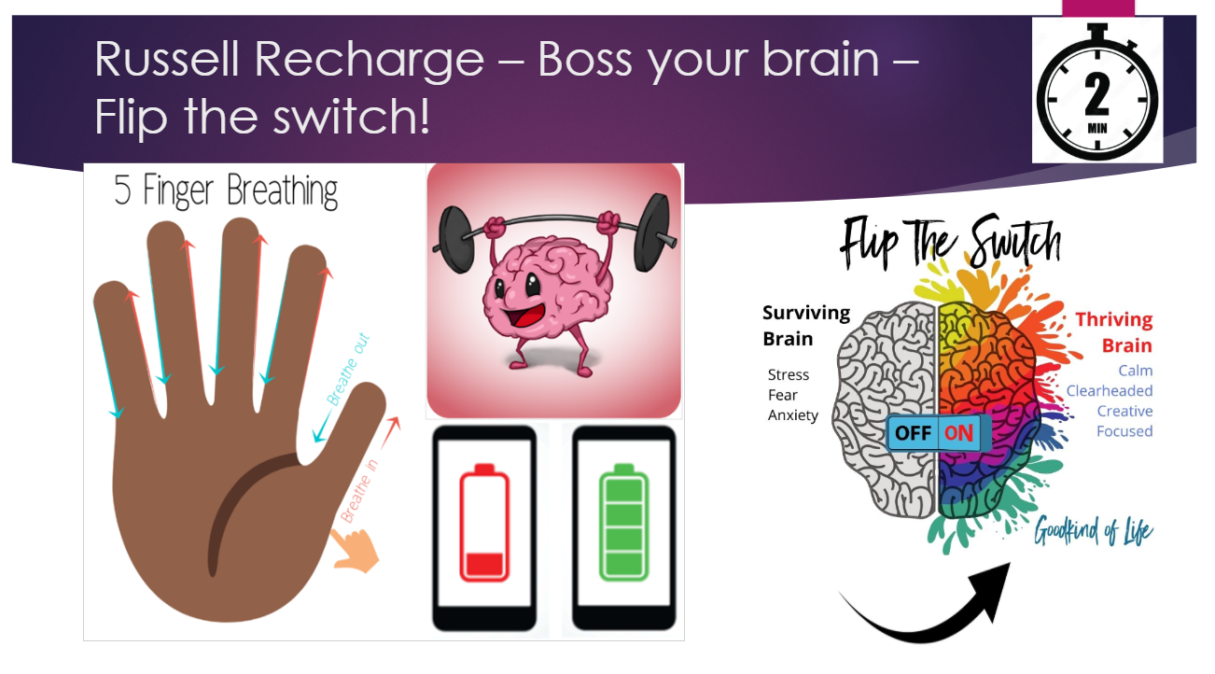
We introduced this in the classrooms back in the academic year 23/24 with this slide:
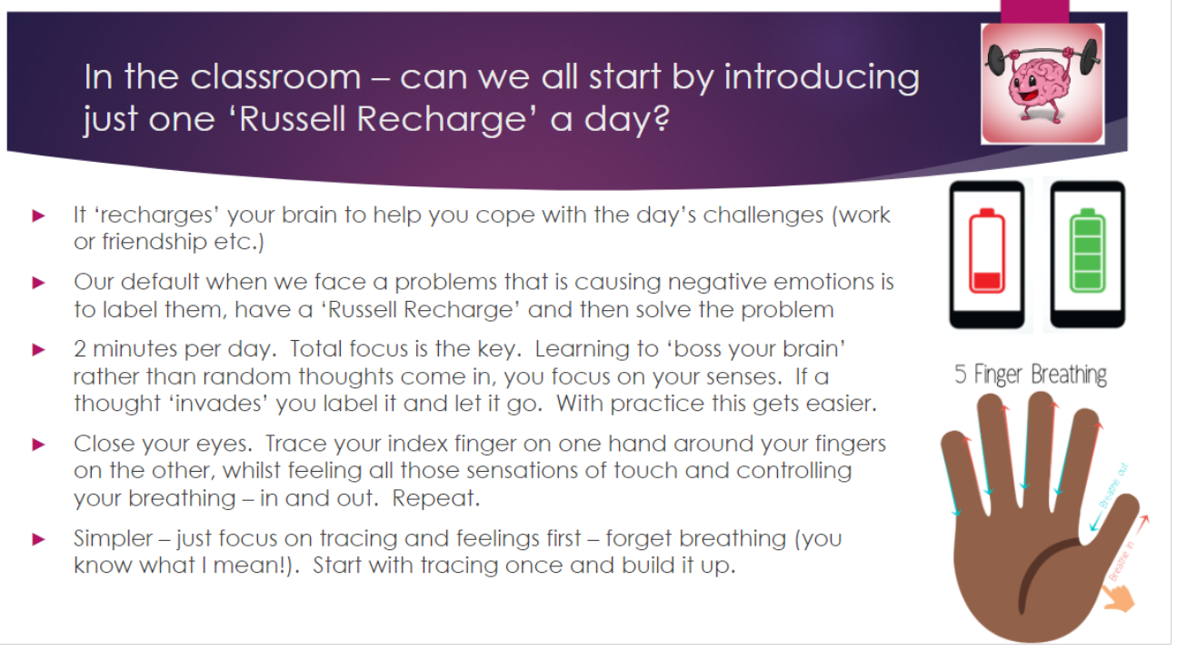
It has been a revelation and taught all of the children skills for life. It works for adults too - do try it yourself. Thank you for all your support.

A plea!
As you know, we get out in all weathers at Russell. Can we please ask that all children bring a coat to school every day and that all coats have a hood please? We do stay out in all but torrential downpours and exceptionally cold weather.

Governor Vacancy
Thank you for the huge response to our plea for a new governor at Russell. We are excited at the interest in this role and the calibre of people. As soon as we have more information, we will update you further.

Accidents in school:
Please be aware that if your child has a visible mark or significant injury as a result of a slip, trip or some sort of accident at school we will always try our very best to get a medical note emailed out to you on that day. Alternatively, a teacher will speak to you, or we will call you directly. Slips, trips etc. that do not result in visible marks or significant injury will not result in notification by medical note/email, conversation with the teacher or telephone call. However, if you ever have any concerns about an injury that you feel was acquired at school, please do not hesitate to contact us and it will be fully investigated to ensure our procedures have been correctly followed. Thank you for your support.

Reminder Term Dates 2026/27:
These are now on the school website. Thank you for not booking holidays in term time. We really appreciate it.

Inclusion Coffee morning on Friday 21st November at 9.15am
This term's Inclusion Coffee morning will take a slightly different format to previous events.

As part of our participation in the national PINS project (Partnership for Inclusion of Neurodiversity in Schools), we are delighted to welcome the SNAP Parent Carer Forum to Russell Lower School to introduce SNAP Parent Carer Forum, the PINS project, as well as the 6C’s framework. This will be an opportunity to share your parent carer experience, and that of your child. Full details on the poster attached.
Please indicate your intention to attend using the very brief Google form attached (this ensures that we purchase sufficient coffee, tea and biscuits!!)
https://forms.gle/NRMc68b5qmrLRLrV6

Maths Workshops for parents:
Maths is not taught how it used to be! Would you like to come and hear how we teach it and how you can further support your children at home? If so, please sign up using these simple Google Forms:
Foundation Stage Maths Workshop for parents – 9:15am – 10am, Wednesday 26th November
https://forms.gle/g4teiMrQc3EwoGjt8
KS1 and KS2 Maths Workshops for parents – 2:30pm – 3:15pm, Wednesday 26th November
https://forms.gle/rEuz6o3hE7KTo1j76

Big thank you for your support:
Thank you for your support with recent fundraising. We are proud to have been able to support The Royal British Legion and Children in Need very recently. I want to pass on huge thanks to our Chair of Governors, Mariella Cook and Governor, Amy Beeken and Lucienne Mann who have supported us so much before and after school, to make this possible. Thank you all for your generous support.

Headteacher update:
I have had the pleasure of talking to Mr Young a lot over the last few weeks and planning times when he can visit school. You will see from the calendar above several opportunities for him to visit school to meet children, staff, parents and have a comprehensive handover too. We are really looking forward to seeing lots more of Mr Young, he really does seem perfect for our school community! Do come and say hello if you see us on the gate together: the first date for this is anticipated to be Friday 21st November.
REMINDER - School admissions to Foundation Stage in September 2026 and Middle Schools
It’s that time of year again! Even though the children have only just started in their new year group, you need to make your applications now:

Children born between 01/09/21 and 31/08/22 are due to start school in September 2026.
Parents/ carers need to make an application to CBC by 15 January 2026, even if their child attends a nursery/pre-school on the school site. All the information you will need regarding your Starting School 2026 application is available on the CBC website (see hyperlink below).
Year 4 parents, please bear in mind that applications for Middle School are also needed within the same timescales i.e. before 15th January 2026. Please note: this will not just happen automatically.
School admissions | Central Bedfordshire Council

Russell Lower School Values:
Each half term, we teach the children about a different value. We then have a weekly ‘values’ assembly where we celebrate the demonstration of this value. The values this half term is:
Autumn 2: Thoughtfulness

PE and festivals news:
This half term we are very excited to be taking part in the Santa Challenge between the 24th November and 5th December. This is a virtual race where every active travel journey your child makes, such as walking, cycling, or scooting to school, counts as a step closer to Santa in Lapland. The more active journeys you complete, the closer we get to reaching Santa’s home! All journeys will be recorded in school. Children who take part will have the opportunity to win a brand new scooter! More details to follow shortly.
We have also completed a review of last year’s sports premium spending and its impact and have added the document for this year outlining how we intend to spend this year’s money. Please take a look over the next few weeks at our plans to further improve PE and sport across Russell Lower: https://www.russell-lower.co.uk/sports_premium

Community events/news:
Please see below
And finally:
Thank you for taking the time to read this newsletter and for all your ongoing support.
Many thanks and kind regards,
Nicki Walker
Headteacher

