JANUARY 2026 NEWSLETTER
Dear Parents/Carers,
Welcome to our January newsletter. These newsletters are sent out on a monthly basis to keep you informed about what is happening in school. If you ever want to contribute an ‘article’ or suggest information that should be on the newsletters, I would be delighted to hear about them.
Upcoming events
Tuesday 13th January- Year 4 SportsHall Athletics (Henlow Academy) 1pm-4.30pm
Thursday 15th January- School Census Day (Please see below), parent volunteer session please sign up via this link: https://forms.gle/TyqWKjYMj4vhp7879
Monday 19th January Mock Phonics Screening, Sports Leaders Assembly
Thursday 22nd January 7.30pm PTA Meeting at the Wingfield Club all welcome
Friday 23rd January Inclusion Coffee Morning 9.15am-10.15am (details below), Parents Evening Slots open 7am
Monday 26th January Drumba sessions for all, Keith Hatton (Author) to visit Year 4
Tuesday 27th January Drumba sessions for all
Wednesday 28th January Parents Evening closes at 6pm
Monday 2nd February CHUMS Shine Bright week, National Storytelling week
Thursday 5th February Year 2 Dance Festival (Redbourne) for some children, you will be contacted if your child is due to attend
Friday 7th February Spring Report out to parents, CHUMS Shine Bright Non Uniform Day
Monday 9th and Tuesday 10th February Foundation Stage Height, Weight and Hearing Tests
Monday 9th and Tuesday 10th February Parents Evening
Friday 13th February Last Day of Spring 1 Half term
Half term Holiday- Monday 16th February- Friday 20th February
Monday 23rd February- Start of Spring 2 half term, children return to school

I wanted to write to you at the end of my first week as Headteacher to say thank you for the wonderfully warm welcome I have received. It has been an absolute pleasure to meet so many of you, and I have been struck by the genuine sense of community that exists here at Russell Lower School.
The children, especially considering the weather, have been fantastic, and I have thoroughly enjoyed getting to know them, visiting classrooms, and seeing the excellent learning taking place across the school. The staff have been incredibly supportive in helping me settle in, and I am genuinely excited about working alongside such a dedicated team.
I am very much looking forward to getting to know all of our families better and working together to ensure that every child at Russell Lower School continues to thrive. This promises to be a busy half term with lots going on, and it is exciting to see how the children flourish this term.
Please come and say hello when you see me around school. I will be outside at the beginning and end of the day as often as possible, and I look forward to meeting you all.
Please see below for a few updates and matters to draw to your attention
Best wishes
Glenn Young
Cold Weather
As the cold weather continues, please ensure your child comes to school each day with a warm coat, hat, gloves, and scarf. It's essential that all items are clearly labelled with your child's name, as this helps us reunite lost property with its owner much more quickly. Children often remove their outdoor clothing during playtime or PE, and unnamed items can be difficult to return. We want to make sure your child stays warm and comfortable throughout the school day, especially during outdoor breaks and activities.Thank you for your cooperation in keeping our pupils warm and well this winter.

Attendance and winter bugs:
Please be aware that it has been made clear to us by the DfE and CBC that schools should continue maintaining high attendance expectations and refer parents to NHS guidance to know when a child is too ill for school. Pupils should not miss school on a precautionary basis and can normally attend school with a cough or cold, unless they have a fever or diarrhoea/vomiting. Thank you for your support with our attendance policy.

Pharmacy First:
Think ‘Pharmacy First’ for Earache (children aged 1-17), Sore throat (over 5s), Infected insect bites (over 1s), Impetigo (over 1s). GP practices are busy and it can be difficult to get a same-day GP appointment. When your child is off sick from school with any of the above conditions, by going straight to your local pharmacy you can have a consultation with a trained clinical professional and receive advice and even medication if it is needed, meaning they could be on the road to recovery and back at school as soon as possible.
For more information, speak with your local community pharmacy. To find your nearest pharmacy, see: Find a pharmacy - NHS

School Meals Census:
Next Thursday is School Census Day as Mrs Walker would have previously explained, the census and number of pupils having a ‘hot meal’ has a direct link to our school funding. Please can we ask for your support, and have as many children as possible have a hot meal on this day- it really does make such a positive impact for all our children, and we thank you in advance for your support! Last year it was 88%, it would be amazing to get as close to a 100% as possible.

Russell Lower School Values:
Each half term, we teach the children about a different value. We then have a weekly ‘values’ assembly where we celebrate the demonstration of this value. The values this term are:
Spring 1: Sharing and Caring
Spring 2: Responsibility and Cooperation

Safeguarding
During term time, you can discuss any concerns you may have about a child with the Russell Safeguarding team in person, by telephone on 01525 755664 or via the dedicated safeguarding email address: safeguarding@russell-lower.co.uk

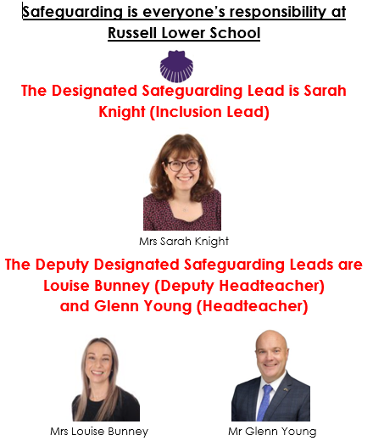
When school is closed, if you think a child you know is being harmed or at risk of being harmed, please contact the Integrated Front Door on 0300 300 8585, who you can talk to about your concerns.
They will give you advice or may investigate the circumstances. All child protection calls are treated in confidence and you don't need to give your details.
Alternatively, visit the Safeguarding Bedfordshire website: https://www.safeguardingbedfordshire.org.uk/report-a-concern/report-a-concern-about-an-adult-or-a-child
Everyone has a responsibility to protect children from harm.
Thank you.

Inclusion/PINS coffee morning - Friday 23rd January 2026
Our second of three PINS coffee mornings will take place on Friday 23rd January 2026 at 9.15am. We’d love to see as many parents as possible to enjoy a drink/biscuits and to share your views on our SEND provision. All attendees on this date will receive a paper copy of the ‘Supporting your Neurodiverse Child booklet’, which is full of helpful information.
To give us an idea of numbers, please indicate your intention to attend via this short google form:
https://forms.gle/C2hYsnDLnB4KN1qs6
Parent training sessions are also being offered as part of this project on subjects including Understanding ADHD, Autism, PDA, Understanding Challenging behaviour, supporting sensory difficulties at home, supporting the morning transition, dyslexia. Full details will be on the Russell website https://www.russell-lower.co.uk/parent_carer_workshops__events
Managing Children’s Digital Lives:
Please find below a document from the Children’s Commissioner – A Guide For Parents On Managing Children’s Digital Lives:
What I wish my parents or carers knew: A guide for parents on managing children’s digital lives.

Community Safety - Survey From Central Beds Council
As part of the Community Safety Partnership, Central Beds Council are very interested in how safe parents feel and what the main issues are in and around Ampthill. Your help in completing this short survey would be appreciated: https://safercentral.org/community-safety-survey/
