A story about the Russell Lower trip to Condover Hall

On Wednesday 29th April I will come to school as usual, but I will not be wearing school uniform.
I will bring a suitcase with clothes in it for two nights away. I will bring them to the school hall with my parents.
I will have some pocket money in a named envelope or plastic bag (no more than £10) which Mrs Knight will look after for me.
If I take any medicines, Mrs Bremner and Mrs Wolf will look after these for me and make sure that I get them when I need them.
Once I have done this, I will say goodbye to my parents and go to my classroom for the register as usual.
I will be going on holiday with my friends and teachers from school.
We will go on a coach. I can sit with my friends.
I can bring a small ‘day bag’ on the coach for my packed lunch (which will all be disposable) and perhaps something small to do/play with on the coach.
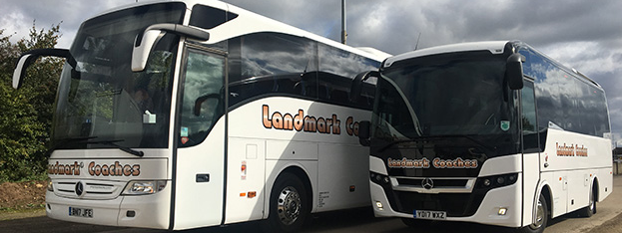
After about 1 and a half – 2 hours and when it is lunchtime we will stop at a service station and I will eat my packed lunch with my friends.
Everyone will have the chance to go to the toilet too.
Then we will have a short coach journey (20-25 minutes)to Condover Hall.
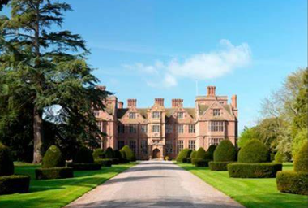
When we arrive, we will meet our Condover team leaders. We will either go to our accommodation block, where there are lots of rooms for the children and teachers to sleep in or put our cases somewhere safe whilst we have a quick tour and they make sure our rooms are ready.

This is when I will find out who I am sharing a room with and who is in my activity group (usually 10 -12 children).
There will be at least one Russell teacher and one Condover teacher with my group.

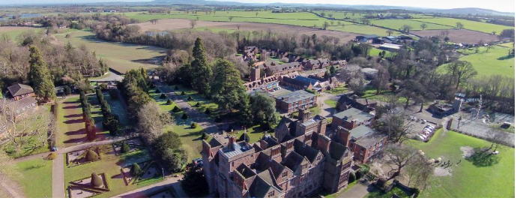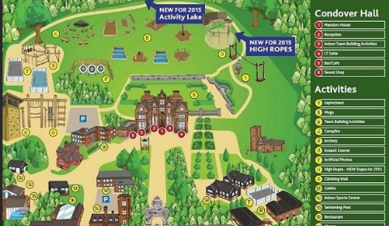
My teachers will tell me which room I will sleep in. I will have a bunk bed. There is a shower and toilet in each bedroom that I can use.
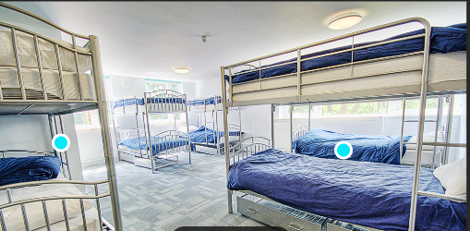
The names of the children will be on the door.
The teachers rooms are nearby and the names of the teachers will be on the door.
I can ask for help if I need it.
Then we will go with our activity group to do our first activity. This could be fencing, buggy building, archery, climbing or abseiling or something else fun. My teachers will help me to join in if I want to. It will be fun. 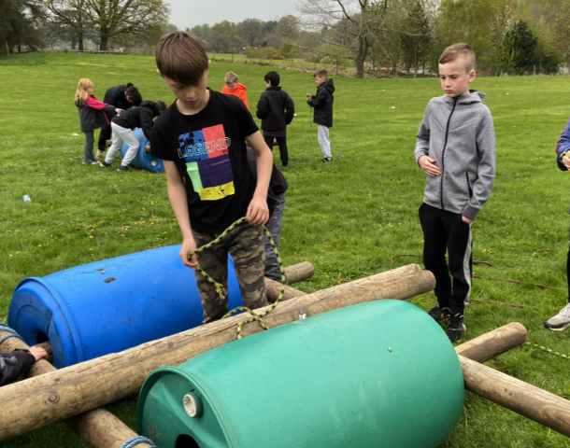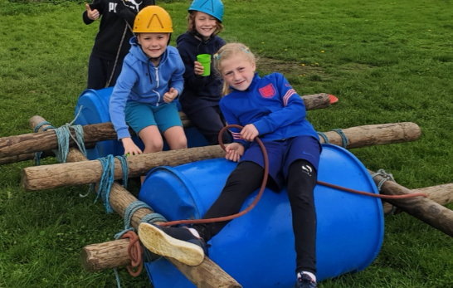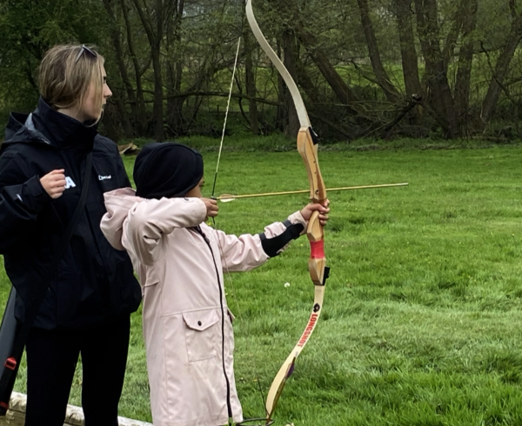
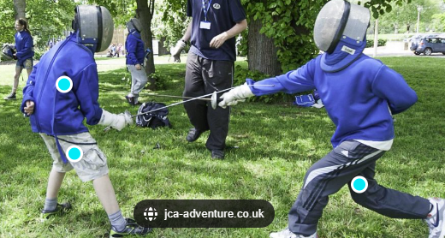
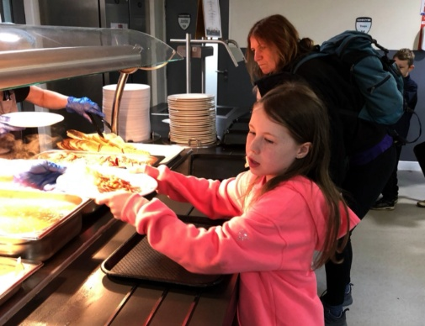
After the activity, we may have a little bit of time back in our bedrooms, before we will go to the restaurant for dinner. I can choose what I would like to eat. It is buffet style. The food is great.

After dinner, the whole of Russell Year 4 will have an evening activity. At 8.30pm this will finish and we will go back to our bedrooms.
We might have a wash or shower before we get into our pyjamas.
We will have a late night feast, eating our favourite snack from home.
Then it will be time to clean our teeth and get into bed.
Our teachers will make sure that everyone can get to sleep.
In the morning, we will get up, clean our teeth, perhaps have a wash or shower and get dressed. Our teachers will make sure everyone is awake and ready.
Then we all go for breakfast in the restaurant. There will be lots to choose from including things like porridge, pancakes, bacon, sausage, eggs, or baked beans as well as toast, cereals and fruit.
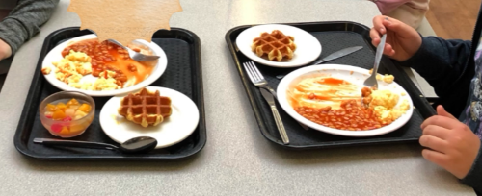

Then we will do two more fun activities.
Then it will be lunchtime in the restaurant.
We will do two more activities and then after dinner we will have another evening activity.
We will sleep well on Thursday night. We will be very tired.
On Friday morning after breakfast we will put our luggage somewhere ready to go on the coach and have one more activity with our group.
Then we will have our final lunch in the restaurant, go to the toilet, collect our luggage and then get onto the coach for the journey home. We will get home at the end of school on Friday and have a lovely long weekend to enjoy with our families.
I’m excited about Condover and know it will be fun!

