Russell Lower School Behaviour Policy – Autumn 2025 - Autumn 2028

- Aims and Philosophy
At Russell Lower School, we value all members of our community and aim to help our children to be good citizens of the future. We work hard to provide a supportive environment, where children are helped to make positive behaviour choices through a carefully planned system that clearly identifies rights, rules, responsibilities and consequences.

We understand that, although at times we must address behaviour, we must also keep every child’s self-esteem intact; positive attitudes and respect for others are therefore valued and all staff lead by example. At Russell Lower School, we adopt a ‘therapeutic’ approach. (See Appendix 1).

All members of the school community have a vested interest in developing high standards of behaviour across the school. Establishing and maintaining high standards of behaviour is not only vital in ensuring that teachers can deliver the curriculum, but also plays a critical role in ensuring that the school is a safe environment for all pupils in which they can learn and reach their full potential.

School leaders and governors need to maintain the high standards of behaviour if the education standards of the school are to be maintained and improved.

Teachers need focused and enthusiastic children if their teaching is to have any impact.

Parents want children who feel safe and happy in school with teachers who are focused on supporting their learning and not having their attention drawn away by poor behaviour. Children like to have clear boundaries with rewards and consequences applied equitably, appropriately and consistently.

At Russell Lower School we achieve the following through adopting the Emotion Coaching principles and practice. Emotion coaching enables children and young people to manage their own behaviour through helping them to name and understand the different emotions they experience, why they occur, and how to handle them.

This policy aims to:
- Create a positive culture that promotes excellent behaviour, ensuring that all pupils have the opportunity to learn in a calm, safe and supportive environment
- Establish a whole-school approach to maintaining high standards of behaviour that reflect the values of the school
- Outline the expectations and consequences of behaviour
- Provide a consistent approach to behaviour management that is applied equitably to all pupils
- Define what we consider to be unacceptable behaviour, including bullying and discrimination

2. Legislation, statutory requirements and statutory guidance
This policy is based on legislation and advice from the Department for Education (DfE) on:
- Behaviour in schools: advice for headteachers and school staff 2024
- Searching, screening and confiscation: advice for schools 2022
- The Equality Act 2010
- Keeping Children Safe in Education
- Suspension and permanent exclusion from maintained schools, academies and pupil referral units in England, including pupil movement
- Use of reasonable force in schools
- Supporting pupils with medical conditions at school
- Special Educational Needs and Disability (SEND) Code of Practice
- Sharing nudes and semi-nudes: advice for education settings working with children and young people
In addition, this policy is based on:
- Section 175 of the Education Act 2002, which outlines a school’s duty to safeguard and promote the welfare of its pupils
- Sections 88 to 94 of the Education and Inspections Act 2006, which requires schools to regulate pupils’ behaviour and publish a behaviour policy and written statement of behaviour principles, and gives schools the authority to confiscate pupils’ property
- DfE guidance explaining that maintained schools must publish their behaviour policy online

3. Definitions
Misbehaviour is defined as:
- Disruption in lessons from detrimental behaviour, in corridors between lessons, and at break and lunchtimes
- Non-completion of classwork or homework
- Poor attitude
- Incorrect uniform
Serious misbehaviour is defined as:
- Repeated breaches of the school rules, usually with dangerous behaviour
- Any form of bullying
- Sexual violence, such as rape, assault by penetration, or sexual assault (intentional sexual touching without consent)
- Sexual harassment, meaning unwanted conduct of a sexual nature, such as:
  - Sexual comments
  - Sexual jokes or taunting
- Online sexual harassment, such as unwanted sexual comments and messages (including on social media), sharing of nude or semi-nude images and/or videos (including pseudo-images, which are computer-generated images that otherwise appear to be a photograph or video), or sharing of unwanted explicit content
- Vandalism
- Theft
- Fighting
- Smoking
- Racist, sexist, homophobic or discriminatory behaviour
- Possession of any prohibited/banned items. These are:
- Knives or weapons, including toy versions
- Alcohol
- Illegal drugs
- Stolen items
- Tobacco and cigarette papers
- E-cigarettes or vapes/lighters/matches
- Fireworks
- Pornographic images
- Mobile phones – except in the summer term of Year 4with explicit parental/teacher permission and then handed in for the duration of the school day
- Any article a staff member reasonably suspects has been, or is likely to be, used to commit an offence, or to cause personal injury to, or damage to the property of, any person (including the pupil)

4. Bullying
Bullying is defined as the repetitive, intentional harming of 1 person or group by another person or group, where the relationship involves an imbalance of power.
At Russell Lower School we teach the children that it is any unwanted, upsetting behaviour that occurs ‘Several Times On Purpose’ (STOP).
Bullying is, therefore:
- Deliberately hurtful
- Repeated, often over a period of time
- Difficult to defend against
Bullying can include:
TYPE OF BULLYING | DEFINITION
Emotional | Being unfriendly, excluding, tormenting
Physical | Hitting, kicking, pushing, taking another’s belongings, any use of violence
Prejudice-based and discriminatory, including:  - Racial  - Faith-based  - Gendered (sexist)  - Homophobic/biphobic  - Transphobic  - Disability-based | Taunts, gestures, graffiti or physical abuse focused on a particular characteristic (e.g. gender, race, sexuality)
Sexual | Explicit sexual remarks, display of sexual material, sexual gestures, unwanted physical attention, comments about sexual reputation or performance, sharing of nude or semi-nude images and/or videos (including pseudo-images, which are computer-generated images that otherwise appear to be a photograph or video), or inappropriate touching
Direct or indirect verbal | Name-calling, sarcasm, spreading rumours, teasing
Cyber-bullying | Bullying that takes place online, such as through social networking sites, messaging apps, gaming sites, devices or via images, audio, video, or written content generated by artificial intelligence (AI)

Please see our Anti-bullying policy for more information.

5. Roles and responsibilities
5.1 The governing board
The governing board is responsible for:
- Reviewing and approving the written statement of behaviour principles (appendix 1)
- Reviewing this behaviour policy in conjunction with the headteacher
- Monitoring the policy’s effectiveness
- Holding the headteacher to account for its implementation
5.2 The headteacher
The headteacher is responsible for:
- Reviewing this policy in conjunction with the governing board
- Giving due consideration to the school’s statement of behaviour principle (appendix 1)
- Approving this policy
- Ensuring that the school environment encourages positive behaviour
- Ensuring that staff deal effectively with poor behaviour
- Monitoring that the policy is implemented by staff consistently with all groups of pupils
- Ensuring that all staff understand the behavioural expectations and the importance of maintaining them
- Providing new staff with a clear induction into the school’s behavioural culture to ensure they understand its rules and routines, and how best to support all pupils to participate fully
- Offering appropriate training in behaviour management, and the impact of special educational needs and disabilities (SEND) and mental health needs on behaviour, to any staff who require it, so they can fulfil their duties set out in this policy
- Ensuring this policy works alongside the safeguarding policy to offer pupils both sanctions and support when necessary
- Ensuring that the data from the behaviour log is reviewed regularly, to make sure that no groups of pupils are being disproportionately impacted by this policy (see section 13.1)
5.3 Staff
Staff are responsible for:
- Creating a calm and safe environment for pupils
- Establishing and maintaining clear boundaries of acceptable pupil behaviour
- Implementing the behaviour policy and curriculum consistently
- Communicating the school’s expectations, routines, values and standards through teaching behaviour and in every interaction with pupils
- Modelling expected behaviour and positive relationships
- Providing a personalised approach to the specific behavioural needs of particular pupils
- Considering the impact of their own behaviour on the school culture and how they can uphold school rules and expectations
- Recording behaviour incidents promptly (see appendix 3 for a behaviour log)
- Supporting and challenging pupils to meet the school’s expectations
The senior leadership team (SLT) will support staff in responding to behaviour incidents.
5.4 Parents and carers
Parents and carers, where possible, should:
- Get to know the school’s behaviour policy and reinforce it at home where appropriate
- Support their child in adhering to the school’s behaviour policy
- Inform the school of any changes in circumstances that may affect their child’s behaviour
- Discuss any behavioural concerns with the class teacher promptly
- Take part in any pastoral work following misbehaviour (for example, attending reviews of specific behaviour interventions)
- Raise any concerns about the management of behaviour with the school directly, while continuing to work in partnership with the school
- Take part in the life of the school and its culture
The school will endeavour to build a positive relationship with parents and carers by keeping them informed about developments in their child's behaviour and the school’s policy, and working in collaboration with them to tackle behavioural issues.
5.5 Pupils
Pupils will be made aware of the following:
- The expected standard of behaviour they should be displaying at school
- That they have a duty to follow the behaviour policy
- The school’s key rules and routines, including the Russell Rights and Values
- The rewards they can earn for meeting the behaviour standards, and the consequences they will face if they don’t meet the standards
- The pastoral support that is available to them to help them meet the behaviour standards
Pupils will be supported to meet the behaviour standards and will be reminded.
Pupils will be supported to develop an understanding of the school’s behaviour policy and wider culture.
Pupils will be asked to give feedback on their experience of the behaviour culture to support the evaluation, improvement and implementation of the behaviour policy.
Extra support will be provided for pupils who are new arrivals.

6. School behaviour curriculum
Russell Lower School has a Behaviour Curriculum (Appendix 1) which is explicitly taught and explains how pupils are supported to show valued behaviours.
Pupils are expected to:
- Uphold the Russell Rights and values
- Behave in an orderly and self-controlled way
- Show respect to members of staff and each other
- In class, make it possible for all pupils to learn
- Move quietly around the school
- Treat the school buildings and school property with respect
- Wear the correct uniform at all times
- Accept sanctions when given
- Refrain from behaving in a way that brings the school into disrepute, including when outside school or online
Where appropriate and reasonable, adjustments may be made to routines within the curriculum to ensure all pupils can meet behavioural expectations in the curriculum.
6.1 Mobile phones
Mobile phones are not allowed in school, except in the summer term of Year 4with explicit parental/teacher permission and then handed in for the duration of the school day

7. Responding to behaviour
7.1 Classroom management
Teaching and support staff are responsible for setting the tone and context for positive behaviour within the school using the Russell Rights and Values, Behaviour Curriculum, Class Rules and Charters and this Behaviour Policy.
They will:
- Create and maintain an orderly and organised, stimulating environment that encourages pupils to be engaged and independent
- Follow the behaviour curriculum and display the Russell Rights and their own classroom rules (including for wet playtimes)
- Develop a positive relationship with pupils, which includes:
  - Greeting pupils in the morning
  - Establishing clear routines/rules
  - Communicating expectations of behaviour in ways other than verbally
  - Highlighting and promoting good behaviour
  - Concluding the day positively and starting the next day afresh
  - Having a positive plan for dealing with low-level disruption
  - Using positive reinforcement
  - Communicating effectively with other staff and parents to ensure consistency and a ‘joined up’ approach
7.2 Safeguarding
The school recognises that changes in behaviour may be an indicator that a pupil is in need of help or protection.
We will consider whether a pupil’s misbehaviour may be linked to them suffering, or being likely to suffer, significant harm.
Where this may be the case, we will follow our child protection and safeguarding policy, and consider whether pastoral support, an early help intervention or a referral to children’s social care is appropriate.
Please refer to our child protection and safeguarding policy for more information.
7.3 Responding to good behaviour
When a pupil’s behaviour meets or goes above and beyond the expected behaviour standard, staff will recognise it with positive recognition and reward. This provides an opportunity for all staff to reinforce the school’s culture and ethos.
Positive reinforcements and rewards will be applied clearly and equitably to reinforce the routines, expectations and norms of the school’s behaviour culture.
Positive behaviour will be rewarded frequently. For example, with:
- Verbal praise
- Stickers
- Communicating praise to parents/carers via a phone call or written correspondence
- Certificates or special assemblies
- Positions of responsibility, such as monitors, school councillors etc.
7.4 Responding to misbehaviour
When a pupil’s behaviour falls below the standard that can reasonably be expected of them, staff will respond in order to restore a calm and safe learning environment, and to prevent recurrence of misbehaviour.
Staff will endeavour to create a predictable environment by always challenging behaviour that falls short of the standards, and by responding in a consistent, equitable and proportionate manner, so pupils know with certainty that misbehaviour will always be addressed.
De-escalation techniques, including the use of pre-arranged scripts and phrases, can be used to help prevent further behaviour issues arising.
All pupils will be treated equitably under the policy, with any factors that contributed to the behavioural incident identified and taken into account.
When giving behaviour sanctions, staff will also consider what support could be offered to a pupil to help them to meet behaviour standards in the future.
The school may use 1 or more of the following sanctions in response to unacceptable behaviour:
- A verbal reminder of the expectations of behaviour
- Loss of privilege at break or lunchtime
- Expecting work to be completed at home, or at break or lunchtime
- Loss of privileges at other times – for instance, the loss of a responsibility
- A ‘repair’ activity, such as tidying a classroom
- Referring the pupil to a senior member of staff
- Email or phone call home to parents/carers
- Agreeing a behaviour or sticker chart/contract with frequent reporting to parents/SLT
- Removal of the pupil from the classroom
- Suspension
- Permanent exclusion, in the most serious of circumstances
Personal circumstances of the pupil will be taken into account when choosing sanctions, and decisions will be made on a case-by-case basis, but with regard to the impact on perceived fairness and appropriateness.
7.5 Reasonable force
Reasonable force covers a range of interventions that involve physical contact with pupils. All members of staff have a duty to use reasonable force, in the following circumstances, to prevent a pupil from:
- Causing disorder
- Hurting themselves or others
- Damaging property
- Committing an offence
Incidents of reasonable force must:
- Always be used as a last resort
- Be applied using the minimum amount of force and for the minimum amount of time possible
- Be used in a way that maintains the safety and dignity of all concerned
- Never be used as a form of punishment
- Be recorded and reported to parents/carers
When considering using reasonable force, staff should, in considering the risks, carefully recognise any specific vulnerabilities of the pupil, including SEND, mental health needs or medical conditions.
At Russell Lower School, we have a number of Team Teach trained adults who can be called upon for support. Please discuss this with the Inclusion Lead.
7.6 Searching and confiscation
Searching and confiscation is conducted in line with the DfE’s latest guidance on searching, screening and confiscation.
Confiscation
Any prohibited items (listed in section 3) found in a pupil’s possession as a result of a search will be confiscated. These items will not be returned to the pupil.
We will also confiscate any item that is harmful or detrimental to school discipline. These items will be returned to pupils after discussion with senior leaders and parents/carers, if appropriate.
Searching a pupil
Searches will only be carried out by a member of staff who has been authorised to do so by the headteacher, or by the headteacher themselves.
An authorised member of staff can carry out a search without another member of staff as a witness if:
- The authorised member of staff carrying out the search reasonably believes there is risk that serious harm will be caused to a person if the search is not carried out as a matter of urgency; and
- It is not reasonably practicable for the search to be carried out in the presence of another member of staff
When an authorised member of staff conducts a search without a witness, they should immediately report this to another member of staff, and make sure a written record of the search is kept.
If the authorised member of staff considers a search to be necessary, but not required urgently, they will seek the advice of the headteacher, designated safeguarding lead (or deputy) or pastoral member of staff who may have more information about the pupil. During this time the pupil will be supervised and kept away from other pupils.
A search can be carried out if the authorised member of staff has reasonable grounds for suspecting that the pupil is in possession of a prohibited item or any item identified in the school rules for which a search can be made, or if the pupil has agreed.
An appropriate location for the search will be found. Where possible, this will be away from other pupils. The search will only take place on the school premises or where the member of staff has lawful control or charge of the pupil, for example on a school trip.
Before carrying out a search the authorised member of staff will:
- Assess whether there is an urgent need for a search
- Assess whether not doing the search would put other pupils or staff at risk
- Consider whether the search would pose a safeguarding risk to the pupil
- Explain to the pupil why they are being searched
- Explain to the pupil what a search entails – e.g. “I will ask you to turn out your pockets and remove your scarf”
- Explain how and where the search will be carried out
- Give the pupil the opportunity to ask questions
- Seek the pupil’s co-operation
If the pupil refuses to agree to a search, the member of staff can give an appropriate behaviour sanction.
If they still refuse to co-operate, the member of staff will contact the headteacher/DSL or DDSL to try to determine why the pupil is refusing to comply.
The authorised member of staff will then decide whether to use reasonable force to search the pupil. This decision will be made on a case-by-case basis, taking into consideration whether conducting the search will prevent the pupil harming themselves or others, damaging property or causing disorder.
The authorised member of staff can use reasonable force to search for any prohibited items identified in section 3.
The authorised member of staff may use a metal detector to assist with the search.
An authorised member of staff may search a pupil’s outer clothing, pockets, possessions, drawer or bags.
‘Outer clothing’ includes:
- Any item of clothing that isn't worn wholly next to the skin or immediately over underwear (e.g. a jumper or jacket being worn over a t-shirt)
- Hats, scarves, gloves, shoes or boots
Searching pupils’ possessions
Possessions means any items that the pupil has or appears to have control of, including:
- Drawers
- Bags
A pupil’s possessions can be searched for any item if the pupil agrees to the search. If the pupil does not agree to the search, staff can still carry out a search for prohibited items (listed in section 3) and items identified in the school rules.
An authorised member of staff can search a pupil’s possessions when the pupil and another member of staff are present.
If there is a serious risk of harm if the search is not conducted immediately, or it is not reasonably practicable to summon another member of staff, the search can be carried out by a single authorised member of staff.
Informing the designated safeguarding lead (DSL)
The staff member who carried out the search should inform the DSL without delay:
- Of any incidents where the member of staff had reasonable grounds to suspect a pupil was in possession of a prohibited item as listed in section 3
- If they believe that a search has revealed a safeguarding risk
All searches for prohibited items (listed in section 3), including incidents where no items were found, will be recorded in the school’s safeguarding system.

Informing parents/carers
Parents/carers will always be informed of any search for a prohibited item (listed in section 3). A member of staff will tell the parents/carers as soon as is reasonably practicable:
- What happened
- What was found, if anything
- What has been confiscated, if anything
- What action the school has taken, including any sanctions that have been applied to their child

Support after a search
Irrespective of whether any items are found as the result of any search, the school will consider whether the pupil may be suffering or likely to suffer harm and whether any specific support is needed (due to the reasons for the search, the search itself, or the outcome of the search).
If this is the case, staff will follow the school’s safeguarding policy and speak to the designated safeguarding lead (DSL). The DSL will consider whether pastoral support, an early help intervention or a referral to children’s social care is appropriate.
Strip searches
The authorised member of staff’s power to search outlined above does not enable them to conduct a strip search (removing more than the outer clothing) and strip searches on school premises shall only be carried out by police officers in accordance with the Police and Criminal Evidence Act 1984 (PACE) Code C.
Before calling the police into school, staff will assess and balance the risk of a potential strip search on the pupil’s mental and physical wellbeing and the risk of not recovering the suspected item.
Staff will consider whether introducing the potential for a strip search through police involvement is absolutely necessary, and will always ensure that other appropriate, less invasive approaches have been exhausted first.
Once the police are on school premises, the decision on whether to conduct a strip search lies solely with them. The school will advocate for the safety and wellbeing of the pupil(s) involved. Staff retain a duty of care to the pupil involved and should advocate for pupil wellbeing at all times.
Communication and record-keeping
Where reasonably possible and unless there is an immediate risk of harm, before the strip search takes place, staff will contact at least 1 of the pupil’s parents/carers to inform them that the police are going to strip search the pupil, and ask them whether they would like to come into school to act as the pupil’s appropriate adult. If the school can’t get in touch with the parents/carers, or they aren’t able to come into school to act as the appropriate adult, a member of staff can act as the appropriate adult (see below for information about the role of the appropriate adult).
The pupil’s parents/carers will always be informed by a staff member once a strip search has taken place. The school will keep records of strip searches that have been conducted on school premises, and monitor them for any trends that emerge.
Who will be present
For any strip search that involves exposure of intimate body parts, there will be at least 2 people present other than the pupil, except in urgent cases where there is risk of serious harm to the pupil or others.
One of these must be the appropriate adult, except if:
- The pupil explicitly states in the presence of an appropriate adult that they do not want an appropriate adult to be present during the search, and
- The appropriate adult agrees
If this is the case, a record will be made of the pupil’s decision and it will be signed by the appropriate adult.
No more than 2 people other than the pupil and appropriate adult will be present, except in the most exceptional circumstances.
The appropriate adult will:
- Act to safeguard the rights, entitlements and welfare of the pupil
- Not be a police officer or otherwise associated with the police
- Not be the headteacher
- Be of the same sex as the pupil, unless the pupil specifically requests an adult who is not of the same sex or it is impossible to get someone of the same sex at that time
Except for an appropriate adult of a different sex if the pupil specifically requests it, no one of a different sex will be permitted to be present and the search will not be carried out anywhere where the pupil could be seen by anyone else.
Care after a strip search

After any strip search, the pupil will be given appropriate support, irrespective of whether any suspected item is found. The pupil will also be given the opportunity to express their views about the strip search and the events surrounding it.
As with other searches, the school will consider whether the pupil may be suffering or likely to suffer harm and whether any further specific support is needed (due to the reasons for the search, the search itself, or the outcome of the search).
Staff will follow the school’s safeguarding policy and speak to the designated safeguarding lead (DSL). The DSL will consider whether, in addition to pastoral support, an early help intervention or a referral to children’s social care is appropriate.
Any pupil(s) who have been strip searched more than once and/or groups of pupils who may be more likely to be subject to strip searching will be given particular consideration, and staff will consider any preventative approaches that can be taken.
7.7 Off-site misbehaviour
Sanctions may be applied where a pupil has misbehaved off-site when representing the school. This means misbehaviour when the pupil is:
- Taking part in any school-organised or school-related activity (e.g. school trips)
- Travelling to or from school
- Wearing school uniform
- In any other way identifiable as a pupil of our school
Sanctions may also be applied where a pupil has misbehaved off-site, at any time, whether or not the conditions above apply, if the misbehaviour:
- Could have repercussions for the orderly running of the school
- Poses a threat to another pupil
- Could adversely affect the reputation of the school
Sanctions will only be given out on school premises or elsewhere when the pupil is under the lawful control of a staff member (e.g. on a school-organised trip).
7.8 Online misbehaviour
The school can issue behaviour sanctions to pupils for online misbehaviour when:
- It poses a threat or causes harm to another pupil or member of staff
- It could have repercussions for the orderly running of the school
- It adversely affects the reputation of the school
- The pupil is identifiable as a member of the school
Sanctions will only be given out on school premises or elsewhere when the pupil is under the lawful control of a staff member.
7.9 Suspected criminal behaviour
If a pupil is suspected of criminal behaviour, the school will make an initial assessment of whether to report the incident to the police.
When establishing the facts, the school will endeavour to preserve any relevant evidence to hand over to the police.
If a decision is made to report the matter to the police, a member of SLT will make the report.
The school will not interfere with any police action taken. However, the school may continue to follow its own investigation procedure and enforce sanctions, as long as it does not conflict with police action.
If a report to the police is made, the designated safeguarding lead (DSL) will make a tandem report to children’s social care, if appropriate.
7.10 Zero-tolerance approach to sexual harassment and sexual violence
The school will ensure that all incidents of sexual harassment and/or violence are met with a suitable response, and never ignored.
Pupils are encouraged to report anything that makes them uncomfortable, no matter how ‘small’ they feel it might be.
The school’s response will be:
- Proportionate
- Considered
- Supportive
- Decided on a case-by-case basis
The school has procedures in place to respond to any allegations or concerns regarding a child’s safety or wellbeing. These include clear processes for:
- Responding to a report
- Carrying out risk assessments, where appropriate, to help determine whether to:
  - Manage the incident internally
  - Refer to early help
  - Refer to children’s social care
  - Report to the police
Please refer to our child protection and safeguarding policy for more information.
7.11 Malicious allegations
Where a pupil makes an allegation against a member of staff and that allegation is shown to have been deliberately invented or malicious, the school will consider whether to discipline the pupil in accordance with this policy.
Where a pupil makes an allegation of sexual violence or sexual harassment against another pupil and that allegation is shown to have been deliberately invented or malicious, the school will consider whether to discipline the pupil in accordance with this policy.
In all cases where an allegation is determined to be unsubstantiated, unfounded, false or malicious, the school (in collaboration with the local authority designated officer (LADO), where relevant) will consider whether the pupil who made the allegation is in need of help, or the allegation may have been a cry for help. If so, a referral to children’s social care may be appropriate.
The school will also consider the pastoral needs of staff and pupils accused of misconduct.
Please refer to our child protection and safeguarding policy for more information.

8. Serious sanctions
8.1 Removing privileges
Pupils can have parts of their break and lunchtimes (not eating) removed as a sanction. The school will decide whether it is necessary to inform the pupil’s parents/carers.
When imposing a sanction, the school will consider whether doing so would:
- Compromise the pupil’s safety
- Conflict with a medical appointment or SEND need
- Prevent the pupil from socialising normally
8.2 Removal from classrooms
In response to serious or persistent breaches of this policy, the school may remove the pupil from the classroom for a limited time.
Pupils who have been removed will continue to receive education under the supervision of a member of staff. This education will be meaningful, but it may differ from the mainstream curriculum.
Removal is a serious sanction and will only be used in response to serious misbehaviour. Staff will only remove pupils from the classroom once other behavioural strategies have been attempted, unless the behaviour is so extreme as to warrant immediate removal.
Removal can be used to:
- Restore order if the pupil is being unreasonably disruptive/displaying detrimental or dangerous behaviours
- Maintain the safety of all pupils
- Allow the disruptive pupil to continue their learning in a managed environment
- Allow the disruptive pupil to regain calm in a safe space
Pupils who have been removed from the classroom are supervised and will be removed for a maximum of one session at a time.
Pupils will not be removed from classrooms for prolonged periods of time without the explicit agreement of the headteacher.
Pupils should be reintegrated into the classroom as soon as it is appropriate and safe to do so. The school will consider what support is needed to help a pupil successfully reintegrate into the classroom and meet the expected standards of behaviour.
Parents/carers will be informed on the same day that their child is removed from the classroom.
The school will consider an alternative approach to behaviour management for pupils who are frequently removed from class, such as:
- Use of learning support assistants
- Short-term behaviour plans/charts
- Long-term behaviour plans/charts
- Pupil support units
- Multi-agency assessment
Staff will record all incidents of removal from the classroom on the management information system or an ABC chart, along with details of the incident that led to the removal, and any protected characteristics of the pupil.
8.3 Suspension and permanent exclusion
The school can use suspension and permanent exclusion in response to serious incidents or in response to persistent poor behaviour which has not improved following in-school sanctions and interventions.
The decision to suspend or exclude will be made by the headteacher and only as a last resort.
Please refer to our Exclusions Policy for more information.

9. Responding to misbehaviour from pupils with SEND
9.1 Recognising the impact of SEND on behaviour
The school recognises that pupils’ behaviour may be impacted by a special educational need or disability (SEND).
When incidents of misbehaviour arise, we will consider them in relation to a pupil’s SEND, although we recognise that not every incident of misbehaviour will be connected to their SEND. Decisions on whether a pupil’s SEND had an impact on an incident of misbehaviour will be made on a case-by-case basis.
When dealing with misbehaviour from pupils with SEND, especially where their SEND affects their behaviour, the school will take its legal duties into account when making decisions about enforcing the behaviour policy. The legal duties include:
- Taking reasonable steps to avoid any substantial disadvantage to a disabled pupil being caused by the school’s policies or practices (Equality Act 2010)
- Using our best endeavours to meet the needs of pupils with SEND (Children and Families Act 2014)
- If a pupil has an education, health and care (EHC) plan, the provisions set out in that plan must be secured and the school must co-operate with the local authority and other bodies
As part of meeting these duties, the school will anticipate, as far as possible, all likely triggers of misbehaviour, and put in place support to prevent these from occurring.
Any preventative measures will take into account the specific circumstances and requirements of the pupil concerned.
This may include:
- Short, planned movement breaks for a pupil with SEND who finds it difficult to sit still for long
- Adjusting seating plans to allow a pupil with visual or hearing impairment to sit in sight of the teacher
- Adjusting uniform requirements for a pupil with sensory issues or who has severe eczema
- Training for staff in understanding conditions such as autism
- Visual timetables, Now and Next and tray systems
- Support with transitions, such as objects and calm spaces
- Sensory Circuits
- Use of separation spaces (sensory zones or nurture rooms) where pupils can regulate their emotions during a moment of sensory overload
9.2 Adapting sanctions for pupils with SEND
When considering a behavioural sanction for a pupil with SEND, the school will consider whether:
- The pupil was unable to understand the rule or instruction
- The pupil was unable to act differently at the time as a result of their SEND
- The pupil was likely to behave aggressively due to their particular SEND
If the answer to any of these is ‘yes’, it may be unlawful for the school to sanction the pupil for the behaviour.
The school will then assess whether it is appropriate to use a sanction and if so, whether any reasonable adjustments need to be made to the sanction.
9.3 Considering whether a pupil displaying challenging behaviour may have unidentified SEND
The school’s special educational needs co-ordinator (SENCO) may evaluate a pupil who exhibits challenging behaviour to determine whether they have any underlying needs that are not currently being met.
Where necessary, support and advice will also be sought from specialist teachers, an educational psychologist, medical practitioners and/or others, to identify or support specific needs.
When acute needs are identified in a pupil, we will liaise with external agencies and plan support programmes for that child. We will work with parents/carers to create the plan and review it on a regular basis.
9.4 Pupils with an education, health and care (EHC) plan
The provisions set out in the EHC plan must be secured and the school will co-operate with the local authority and other bodies.
If the school has a concern about the behaviour of a pupil with an EHC plan, it will make contact with the local authority to discuss the matter. If appropriate, the school may request an emergency review of the EHC plan.

10. Supporting pupils following a sanction
Following a sanction, the school will consider strategies to help the pupil to understand how to improve their behaviour and meet the expectations of the school. This may include:
- Repair opportunities with staff
- Behaviour/sticker charts
- Personalised interventions/plans/MAPs
- Reintegration meetings
- Daily contact with the pastoral lead
- A report card with personalised behaviour goals]

11. Pupil transition
11.1 Inducting incoming pupils
The school will support incoming pupils to meet behaviour standards by offering a supportive process to familiarise them with the behaviour policy and the wider school culture. This will include a ‘buddy’ system.
11.2 Preparing outgoing pupils for transition
To ensure a smooth transition to the next year, pupils have transition sessions with their new teacher(s). In addition, staff members hold transition meetings.
To ensure behaviour is continually monitored and the right support is in place, information relating to pupil behaviour issues may be transferred to relevant staff at the start of the term or year.

12. Training
As part of their induction process, our staff are provided with regular training on managing behaviour, including training on things such as:
- Behaviour Policy/Curriculum and our ethos
- The needs of the pupils at the school
- How SEND and mental health needs can impact behaviour
Behaviour management will also form part of continuing professional development.
A staff training log is reported to the governing board each term.

13. Monitoring arrangements
13.1 Monitoring and evaluating behaviour
The school will collect data on the following:
- Behavioural incidents, including removal from the classroom and positive handling (See Positive Handling Policy for more information)
- Attendance, permanent exclusions and suspensions
- Use of pupil support units, off-site directions and managed moves
- Incidents of searching and confiscation
- Perceptions and experiences of the school behaviour culture for staff, pupils, governors and other stakeholders (via anonymous surveys)
Behaviour data will be analysed regularly by the DHT.
The data will be analysed from a variety of perspectives including:
- At school level
- By age group
- At the level of individual members of staff
- By time of day/week/term
- By protected characteristic
The school will use the results of this analysis to make sure it is meeting its duties under the Equality Act 2010. If any trends or disparities between groups of pupils are identified by this analysis, the school will review its policies to tackle them.
13.2 Monitoring this policy
This behaviour policy will be reviewed by the headteacher and the governing board at least annually, or more frequently, if needed, to address findings from the regular monitoring of the behaviour data (as per section 13.1). At each review, the policy will be approved.
The written statement of behaviour principles (appendix 1) will be reviewed and approved by the governing board annually.

14. Links with other policies
This behaviour policy is linked to the following policies:
- Behaviour Curriculum
- Exclusions policy
- Child protection and safeguarding policy
- Positive Handling policy
- Anti-bullying policy

Appendix 1: written statement of behaviour principles
Governors’ Written Statement of Behaviour Principles

Under the Education and Inspections Act, 2006, the Governing Board is charged with the duty to set the framework of the school's policy by providing a written statement of general principles relating to behaviour and discipline, considering the needs of all children.

The purpose of this statement is to give guidance to the Headteacher in drawing up the behaviour policy by stating the principles, which Governors would expect to be followed. The policy aims to underpin the Governors’ duty of care to children and employees, promote teaching and learning and high standards of attainment and preserve the reputation of the school. The statement is available upon request from the school and can be found on the school’s web site. It is also held in the school office.

This statement and the behaviour policy will be reviewed on a 3-yearly basis, unless changes at national or local level necessitate an exceptional review.

This statement is informed by our Vision statement.

Creating a culture with strong values:

Informed by research into values-led education, we will foster our four principles of challenge, enjoyment, respect and success through everything we do. We will create a culture in which these values (and others) are explicitly and implicitly taught within a democratic community in which every voice is valued and everyone empowered to be the best that they can be.

The importance of collaboration will be key within the school community – so that together everyone achieves more.

The school’s practice is underpinned by fundamental ‘Rights’. At Russell, we call them our ‘Russell Rights’.

These are: The right to be safe, the right to learn, the right to be happy and the right to be included. These are applicable to everyone: all children and adults at Russell Lower School.

All children, staff and families will be encouraged to contribute ideas about how the school community can enable learning that is ‘irresistible’. When children are enjoying their learning, it is achievable yet challenging, and is set within a broad, balanced and ambitious curriculum, they will almost always behave well.

Listening to children and encouraging dialogue, debate and challenge will be central to our whole school approach. We aim to develop this further, so that every member of the community can contribute their views, trusting that their voice will be heard.

Key Behaviour Principles:
- Every child understands they have the right to feel safe, to learn, to be happy and included. They have the right to feel valued and respected, and learn free from the disruption of others
- All children, staff and visitors are free from any form of discrimination
- Staff and volunteers set an excellent example to children at all times
- Rewards, sanctions and reasonable force are used consistently by staff, in line with the behaviour policy
- The behaviour policy is understood by children and staff
- Exclusions will only be used as a last resort
- Children are helped to take responsibility for their behaviour and actions
- Emotion Coaching is used to teach children that it is okay to have ‘big feelings’, but they have to learn to control their behaviour
- Families are involved in behaviour incidents to foster good relationships between the school and children’s home life
The Governing Board also emphasises that violence or threatening behaviour will not be tolerated in any circumstances.
The Governing Board value the development of strong, positive and appropriate relationships among all members of our school community so that everyone feels welcome and included. We have high expectations of everyone and we will actively promote equality of value whether race, gender, age, sexuality, religion or disability. The behaviour policy is based on our belief in, and respect for, the value and contribution of all members of our community and their right to succeed. We seek to eliminate all forms of discrimination, harassment and bullying.

The policy will be applied with consistency and fairness, with regard to each individual situation. The emphasis will be on encouraging positive behaviour through high expectations; a focus on learning; appropriate praise and celebration of outcomes.
It is recognised however, that on occasions sanctions are necessary to demonstrate that dangerous or detrimental behaviour is not acceptable; to provide boundaries and make our expectations clear. When children do not meet our expectations, either through consistent low-level disruption or more severe incidences, we will always try to teach the child what is expected, without humiliation or in public view. There will be times when children do not fulfil our expectations. At these points, we will enable the child to reflect on, and learn from, their behaviour and to make reparation wherever possible. Because of our focus on positive behaviours and the opportunities for children to learn from their mistakes, we expect far lower than the national average rates of exclusion.
Some children, can experience particular difficulties with behaviour and the school will seek to ensure that such children receive behavioural support according to their need. However, when making decisions the school must balance the needs of the individual with those of the school community and where child behaviour places others at risk, the safety of the child body as a whole is paramount.

The school will always be responsive to the needs of children and will make its expectations of behaviour clear to staff and children. However, given the importance of the safety of children, the Governing Board support the school’s authority to permanently exclude for a single offence where it is considered that allowing the child to remain in school would seriously harm the education or welfare of the child or others in the school. Similarly, given the overriding need to keep children safe, the school will utilise its powers to search and to use reasonable force in order to keep individuals from harming, or further harming, themselves or others. All such difficult situations will be handled with utmost respect of all the individuals involved, including children, their families and staff, and following school policies.
We will always work with parents and carers to understand their children and their circumstances and believe this relationship is a vitally important part of building a strong learning community. Similarly, given our duty of care to the children, this written statement applies to all children when in school, when travelling to and from school, and when engaged in extra-curricular activities such as educational trips and visits (residential and non-residential) and when being educated as a member of Russell Lower School off-site.

Appendix 2: Managing Behaviour
There are four fundamental themes that form the basis of the School’s behaviour policy; these themes are entitled:

- The Preventative Approach
- Emotion coaching within a ‘Therapeutic Thinking’ approach
- Using Consequences and Behaviour ‘Steps’
- Repairing and Rebuilding Relationships
The Preventative Approach – a planned behaviour curriculum through a whole school approach

This is most effective with a whole school approach and is supported by a planned programme of evidence-based content delivered through the behaviour curriculum, the wider curriculum and specifically the Sex and Relationship
Education (SRE) and Personal, Social, Health and Economic Education (PSHE) curriculum.

By using this approach, we believe we are able to increase the likelihood of positive, valued behaviours in our children. This, in turn, will improve their social and academic outcomes.

This approach is developed with the children by creating a clear set of values and standards to which the whole organisation adheres. Firstly, staff must help children to understand that all members of the school community have four basic rights; these are as follows:

The right to learn
The right to be happy
The right to be safe
The right to be included

The children’s understanding of these rights must then be linked to the fact that such rights cannot be enjoyed without corresponding responsibilities. For example, if a particular child has the right to learn, they must also consider their responsibilities in helping other children to enjoy the same right. The way in which to help children to understand such responsibilities is by having routines that are clear and relevant.

See the behaviour curriculum and PSHRE syllabus for more information.

Emotion Coaching and Therapeutic Thinking approach

Whilst the use of the preventative approach encourages children to make positive behaviour choices, it is fully understood that there will be times when children will need some support to achieve this. It is essential that there is a balance between prevention and positive correction.

We use a practical three-step approach to dealing with behaviour in the moment
- Step 1 - Recognising, empathising, validating the feelings and supporting them to label feelings – e.g. ‘You look upset. You might be feeling sad or angry.’

- Step 2 - Setting limits on behaviour – e.g. ‘I understand that you might be feeling angry but it is not okay to hit people. At Russell Lower School we keep each other safe because it is never okay to hurt anyone and we have the right to be safe.’

- Step 3 - Problem-solving with the child or young person – the SOLUTION – we think about what happened and how it made us and others feel (physically/emotionally). We talk about what we could do to help control those feelings and how we can BEHAVE differently next time. E.g. ‘It is okay to feel angry. I get angry too, we all get angry, but it is not okay to hit. Next time you could get an adult to help you/use your words/count to 10/walk away.’ (context dependant, ideally the child comes up with the ideas for solutions but you can give appropriate choices if they struggle but ultimately let them choose the solution – this is what makes it coaching and builds their self-belief and confidence to solve their own problems in the future). ‘I am always here to help you.’

When the child is ready the member of staff should begin Emotion Coaching and work on repairing/rebuilding the relationship as needed. Step 3 of Emotion Coaching should not be commenced until a child is calm and ready to talk.

Using Consequences

Children are more likely to learn from a consequence that is certain rather than severe and therefore it is vital that, even if a consequence is deferred to another time, it must be followed-up. The severity of the consequence will also depend on the child’s actions – it must also be reasonable.

Examples of Consequences
- A verbal reprimand
- Deprivation of privileges e.g. a child may have broken the rule of walking in the corridor; the member of staff may expect them to lose a short time at playtime to show how they can walk sensibly/safely
- Moving the child to a different seating position such as to the carpet/table, next to different peers, to their own table
- Expecting work to be completed at break or lunchtime
- Up to 15 minutes to be missed at break or lunchtime
- Spending a short period of time in another class (15 minutes)

Behaviour Steps

Step 1
‘Forgetting’ rules and being reminded | Examples | Possible consequence
Initial: | Calling out  Silly noises  Shouting inside  Running inside  Distracting others  Lack of concentration  Not doing enough work or doing it below the required standard  Annoying behaviour  Low level rudeness or disrespect to an adult or child  Not doing what an adult has asked | Missing 5 minutes of break time/lunchtime (re-doing work if necessary or sitting in silence – not doing jobs etc)  Being moved to work/sit in isolation within the class  Having to sit out of an activity  An apology must be made and an opportunity to re-build the relationship given
Escalation:  Repeated (to a maximum of 2 further times) | As above | Increase time missed at a playtime by 5 minutes each time  Being moved to work/sit in isolation within the class  Having to sit out of an activity  Speaking to parents at the end of the day  An apology must be made and an opportunity to re-build the relationship given

In isolation, Step 1 behaviours are not cause for concern, but children need to understand that they interfere with the Russell Rights so must not continue.
Reminders will be given and phrased as a choice between correcting behaviour, or facing the consequence. ‘Please remember put your hand up rather than calling out, or you will stay in for 5 minutes at break time.’
If no improvement is seen then the consequence will be applied. This should happen the same day if at all possible. If not, the very next playtime.
Step 1 is not recorded in CPOMS, but a teacher may choose to report this to parents/carers or a Phase Leader if it is felt appropriate.
Step 1 can be ‘upgraded’, if the behaviour continues in the same session. ‘Please remember to put your hand up rather than calling out or you will have to stay with me for 10 minutes.’
If you have already reached 15 minutes of lost break, but still behaviour continues, move directly to step 2.
If a child is showing no signs of improvement over a period of a week, discuss the child with a Phase leader and consider moving the child to step 2.

Step 2 – Detrimental behaviours
Continual or wilful | Examples | Possible Consequences
 | Behaviour at Step 1 that have continued  Intentionally hurting someone or being unkind  Intentional rudeness or disrespect  Wilfully damaging another person’s property or school property  Use of inappropriate language in school  Deliberately and purposefully refusing to carry out an adult’s instruction | Removal from the lesson if they are disrupting learning  Loss of lunchtime play (as soon as possible following the event) – approximately 45 minutes with a Phase Leader or DHT  CPOMS entry by teacher – note it is Step 2 in text box  Discussion with parents  A discussion must be held about why the behaviour is unacceptable using the Emotional Coaching framework and referring to the Russell Rights. The child is expected to lead this with the teacher and PL or Deputy present. Verbal apologies must be given and the adults may decide a written apology is also required.  An opportunity to re-build the relationship must be given.

If behaviour continues beyond 15 minutes lost playtime in the same session, then the child should be moved to Step 2. However, some behaviours are deemed Step 2 in themselves (more serious and wilful). Sometimes there will not even be a warning given, but if it is it will be because the child has shown instant remorse.
Step 2 is always recorded in CPOMS and reported to parents by the class teacher.
After 3 incidents of Step 2 (or 2 CPOMS entries) within a term, the Phase Leader (or DHT if it is a PL class) needs to be alerted so that the teacher, Phase Leader and parent can discuss how close this is getting to a Step 3 situation. At this point an Individual Behaviour Chart will be put in place so parents are provided with daily feedback. A meeting should be arranged between the class teacher, Phase Leader and parent for 2 weeks later to review the situation. Behaviour should be monitored for 2 weeks as above, if behaviour improves there is no further action and the monitoring stops, if it does not improve, escalate to Step 3.
Step 3 – Persistently detrimental or dangerous behaviours
Step 3 are the most serious incidents we would expect to encounter in school. Anyone found to have been bullying, or persistently disruptive to learning or aggressive/violent, over a period of time will be at Step 3.
Continual or wilful | Examples | Possible Consequences
 | Serious violence towards another person  Wilful destruction of property  Extreme rudeness, disrespect or very bad language  Attempting to leave the school  Bullying  Disregard for authority – not complying with a senior member of staff’s instruction | Immediate referral to DHT/HT  Withdrawal from all playtimes/lunchtimes (including school clubs/events such as discos and parties) for at least 2 days  Time spent with SLT not in the child’s own classroom  Parents and carers informed and a meeting scheduled (Structured Conversation which is reviewed with SLT at least fortnightly, or until behaviour is rectified)  CPOMS entry by teacher – note it is Step 3 in text box  A Risk Assessment and/or Behaviour Management Plan/Positive Handling Plan may need to be devised  Support offered to parents, child and teachers via EHA, Pastoral Support, MHST, coaching, Parenting etc.  Consultation with outside agencies to support and challenge school procedures and practices  Suspension or Exclusion (see separate policy)

Repairing and Rebuilding Relationships and supporting pupils following a sanction

As a result of a consequence being applied or the use of positive correction, the member of staff dealing primarily with the child should repair and rebuild the relationship. Repairing and rebuilding is imperative because it restores strained relationships and enables the return of a positive learning environment as well as building the child’s confidence and self-esteem.

Following a sanction, strategies should be considered to help all pupils to understand how to improve their behaviour and meet the behaviour expectations of the school. These might include:
- a targeted discussion with the pupil, including explaining what they did wrong, the impact of their actions, how they can do better in the future and what will happen if their behaviour fails to improve. This may also include advising them to apologise to the relevant person, if appropriate;
- a phone call with parents, and the Virtual School Head for looked after children;
- inquiries into the pupil’s conduct with staff involved in teaching, supporting or supervising the pupil in school;
- inquiries into circumstances outside of school, including at home, conducted by the designated safeguarding lead or a deputy;
- considering whether the support for behaviour management being provided remains appropriate

The Red Card System: Whole School Plan for a Crisis Situation

In the event of a serious incident whereby a member of staff needs support with a child (or children) the ‘red card’ system should be initiated. Staff use a ‘red card’ to indicate to another member of staff that urgent help is needed; individuals should never feel ashamed or weak for requesting such help. All available staff will react quickly when a ‘red card’ is received; the incident will be attended immediately and the appropriate support given.

In a classroom situation, if a child refuses to leave the situation or continues to disrupt, the class is removed and the Headteacher or member of SLT sent for (if the Headteacher is not already in attendance).

Once the situation is defused and the child(ren) is/are calm, the member(s) of staff dealing with the incident follow the rest of the Behaviour Policy in order to complete the behaviour management process.

Support for Members of Staff

The key to effective behaviour management is collegial support and it is fully understood by all staff that this is not an area that can be tackled single-handedly.

The following support will be offered to all staff:
Emotional support
- Problem solving opportunities
- Sharing of problems without judgements being made
- Structural support
- A team approach

Staff training will be planned as part of the annual training plan; it will be a regular feature. Additionally, training will be provided (when it is deemed appropriate and required) on a more ad hoc basis throughout each academic year; it will also form part of the induction for new members of staff and volunteers, such as students and parent helpers.

Appendix 3: Behaviour chart - class and individual (not displayed publicly)
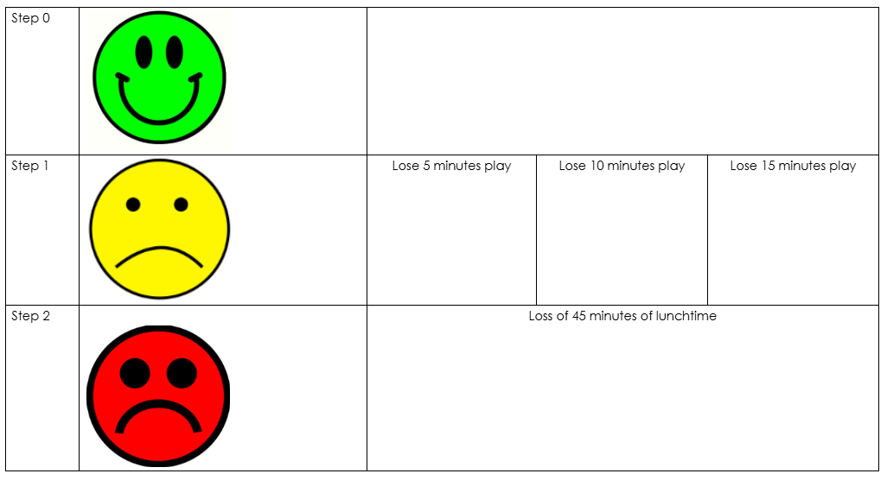
Loss of lunchtime play

Behaviour tracker – Individual
*Please use smiley face or sad face (no straight faces) and initial after each session*
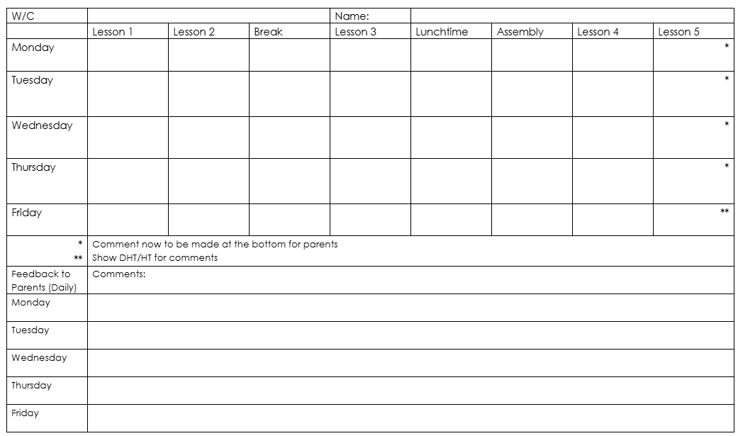
Appendix 4: Emotion coaching

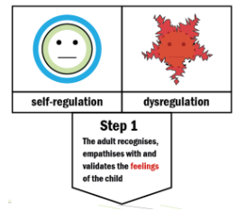

Step 1: Empathise, validate and label

- Recognise all emotions as being natural and normal, and not a matter of choice
- Look for physical and verbal signs of the emotion being felt
- Take on the child’s perspective (attunement, mentalising / mind-mindedness)
- Use words to reflect back the child or young person’s emotion and help them to label the emotion
- Affirm and empathise, allowing the child or young person to calm down through co-regulation
- Provide a narrative for the emotional experience, creating cognitive links through co-learning

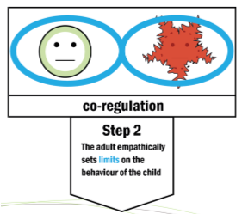

Step 2: Set limits
First co-regulation
- Establish rapport
- Building on attunement with the child or young person
- Mirror neurones then create engagement with the social and emotional brain
- Important that the adult sets the emotional tone – not the adult reflecting back the angry or distressed face of the child, but the child being able to reflect the calm and empathic face of the adult

Then teaching / co-learning
- State the boundary limits of acceptable behaviour
- Make it clear that some behaviours cannot be accepted

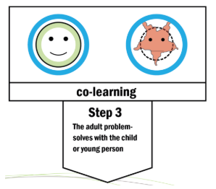

Step 3: Problem-solve with the child
When the child is calm and in a relaxed and rational state…

- Explore the feelings that gave rise to the behaviour, problem, or incident
- Remember that all feelings are acceptable
- We manage our feelings by making choices about how we respond

- Scaffold alternative ideas and actions that could lead to more appropriate and productive outcomes

- Empower the child or young person to believe they can overcome difficulties and manage their own feelings and behaviour

Appendix 5: Structured Conversations

Date:
Attendees:
Explore – Ask what the main issues are as the parent/child sees them. What needs to change?
Focus – Help parents/child clarify key issues and identify priorities. Be explicit. Focus on what needs to change the most or is most important.
Plan – What actions need to happen to address key issues? Set goals/outcomes. Agree actions. By who? By when? (Use plan below)
Review – Summarise key points, clarify next steps/dates. Plan next meeting date.
Next Meeting: at am/pm

Plan
Key Issue | Goal or Outcome  (SMART) | Actions | By who? | By when?
E.g.  Attendance | Improve attendance to above 95% by Oct 26 | - Monthly meetings  - Bring child in if a little unwell, school will send home | NW  Parent | Oct 26

Appendix 6: Positive Handling Form

Name of establishment: Russell Lower School
Child’s name:
Time of incident:
Adults involved:
Other children involved:
Witnesses to incident:
If appropriate, please attach any witness statements.
Day and date of incident: | Place of incident:

Events leading to incident
(What was happening for the child before the incident, what seemed to trigger the behaviour, who else was involved or present.) Triggers?

Behaviour of child
(What behaviour alerted you that the child was struggling to cope?) Early warning signs.

Response from Staff
(Which techniques did you use to attempt to de-escalate the situation? Before restraining the child what was the response from them and others?)
Reassurance
Help Script
Negotiation
Choices
Humour
Planned Ignoring
Give space
Supportive touch
Time out
Consequences
Success reminders
Simple listening
Removing audience
Change of face
Reason for the restraint
(What was the specific risk to the welfare of the child or others?)
Remember: Physical Intervention and Restraint must be 1) Necessary (or believed to be Necessary) to prevent harm and must be
2) Proportionate to the degree of harm which may be caused if there was no intervention made.
Damage to property
Inappropriate sexual behaviour
Bullying
Violent/aggressive behaviour
Impulsive/dangerous behaviour
Racial/Gender/Religious/Learning Disability discrimination
Swearing/Abusive
Reckless disregard for personal safety (e.g. running across busy roads)
Absconding/absenting
Offending behaviour (Criminal damage, theft etc.)
Self-Harm
Carrying/using weaponry
Other (Please specify)

Description of restraint
(What method or type of hold did you use and were there any complications that arose during the restraint?) Help hug – one arm around shoulders with the nearest hand on the nearest shoulder or covering just above elbows Guiding elbows – arms or cupped hands placed just above the elbows to prevent hazardous movements Single elbow – two carers standing/sitting/kneeling alongside each holding the nearest forearm parallel to the ground with the elbow tucked back. The other carer supports the front of the shoulders. Supporting pressure is through the hips to protect backs and heads Double Elbow – one or two carers standing or kneeling alongside the individual passing one arm across the back to hold the furthest forearm. The whole hand hooks over the forearm with the elbow tucked back. The nearest forearm is held with the elbow tucked back. Supporting pressure through hips again) Figure of Four – standing, sitting or kneeling alongside the individual holding underneath the forearm with the outside hand, while nearest hand passes under the arm and over the individual’s forearm to grid the carer’s own wrist

How long did the restraint last?

Conclusion of restraint
(How did the restraint come to an end, and what help and support did you offer to the child?)
Reassurance
Help Script
Negotiation
Choices
Humour
Planned Ignoring
Give space
Supportive touch
Time out
Consequences
Success reminders
Simple listening
Removing audience
Change of face
Staff signature: Date
SLT signature: Date

Part 1 B
(A member of staff not involved in the restraint must fill this in.)
Injuries
Was the child injured? | Yes |  | No |  | If ‘Yes’, what were the injuries?
Was a member of staff injured? | Yes |  | No |  | If ‘Yes’, what were the injuries?
Did someone get medical help? | Yes |  | No
Was first aid given? | Yes |  | No
Was an accident form filled in? | Yes |  | No
Were the police involved? | Yes |  | No |  | If ‘Yes’, please say why, who called and when, and the outcome of their involvement.
Who was told about the restraint?
 | Name of person told |  | Date |  | Time |  | Initials of Informing Staff
Appropriate manager
Relative
Social worker
Witness to the incident
Other

Staff signature:
Date:

Appendix 7: Behaviour Support Plan
Behaviour Support Plan
Name: | Date of plan or review:
Outside Agencies involved:
Key information:

- Record any incidents on ABC to support analysis, planning and prevention – really important to know the ‘A’ and unpick carefully (see below)
- ‘Change of face’ to support staff - Staff encouraged to ask whether they would like to swap
- Call Team Teach trained staff/SLT if needed
- Lots of ‘reasonable adjustments’ are in place. The priority is not currently learning, but regulation

Actions:
Key Issue | Behaviour Goal or Outcome  (SMART) | Strategies for positive behaviour support | Consequences Plan | Actions | By whom? | By when?

ABC:
Date/Time/Place | Activity | Antecedent | Behaviour | Consequence – their result or reaction immediately after the behaviour and response of the adults (not ‘punishment’)
 |  | What happened right before the behaviour that may have triggered it? Be specific. | What the behaviour looked like/resulted in. Be specific.  i.e. X threw a chair but not specifically at anyone | Did they gain attention? Escape a task? Lose something?

Parental Involvement: (Communication book/sticker chart/ABCs home/regular meeting etc.)
Monitoring and Review: (Team meetings/Class meetings/Parent meetings/Outside agency reviews etc.)

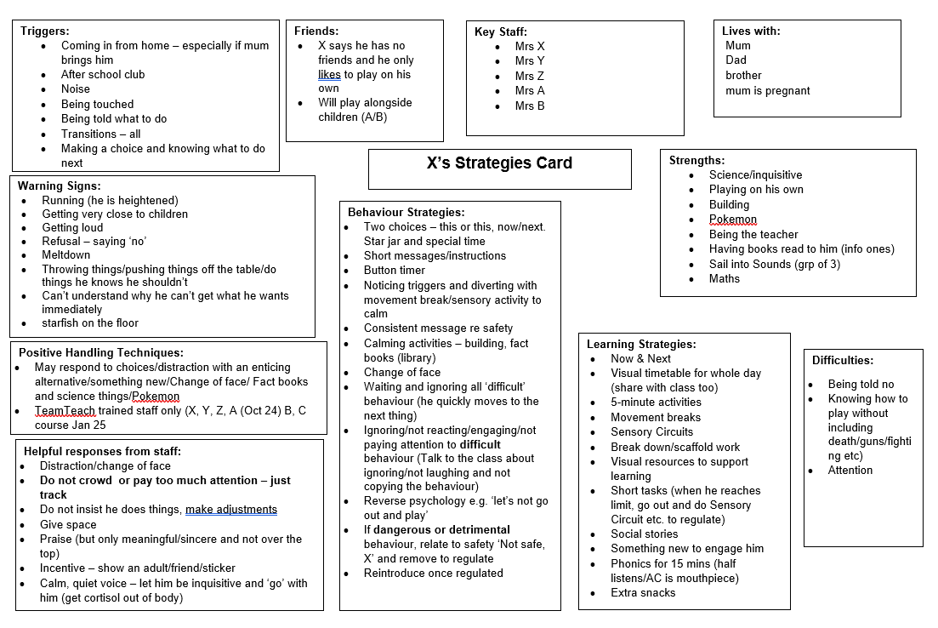
X’s Pupil Passport

Appendix 9: Writing an effective ABC

A - Antecedent:

What happened before?
Record the events, situations, and environmental factors that occurred immediately before the behaviour of interest.
Be specific:
Instead of "something happened," describe "the person was asked to put away toys".
Consider triggers:
Think about potential triggers like changes in routine, environmental factors, or interpersonal conflicts.

B - Behaviour:
Objectively describe: Focus on what was observed, not interpretations of why the person acted that way.
Be detailed: Instead of "was disruptive," write "threw a chair".
Specific actions: Describe the actions of the individual in detail.

C - Consequence:
What happened after? Document the results or reactions that occurred immediately after the behaviour.
Include your response: Record how you reacted to the behaviour.
Consider what was gained or lost: Did the individual gain attention, escape a task, or lose something?
Consequences can be triggers: A consequence can also act as an antecedent for subsequent behaviours.

