Pupil premium strategy statement – Russell Lower School (3 year plan for 2023/2024, 2024/2025, 2025/2026)
This statement details our school’s use of pupil premium funding to help improve the attainment of our disadvantaged pupils.
It outlines our pupil premium strategy, how we intend to spend the funding in this academic year and the outcomes for disadvantaged pupils last academic year.

School overview
Detail | Data
Number of pupils in school | 441
Proportion (%) of pupil premium eligible pupils | 4.7% 21
Academic year/years that our current pupil premium strategy plan covers (3 year plans are recommended) | 2023/2024, 2024/2025, 2025/2026
Date this statement was published | September 2024
Date on which it will be reviewed | July 2025
Statement authorised by | Nicki Walker  Headteacher
Pupil premium lead | Louise Bunney  Deputy Head
Governor / Trustee lead | Sally Whiteside lead for disadvantaged pupils

Funding overview
Detail | Amount
Pupil premium funding allocation this academic year (financial year based on Oct 23 census) | £31,080
Pupil premium funding carried forward from previous years (enter £0 if not applicable) | £0
Total budget for this academic year  If your school is an academy in a trust that pools this funding, state the amount available to your school this academic year | £31,080

Part A: Pupil premium strategy plan

Statement of intent
At Russell Lower School as of 2021-2022 we have adopted the RADY (raising the attainment of disadvantaged youngsters) approach. It is our intent to:
raise expectations;
raise awareness;
raise aspirations;

in order to close gaps between our disadvantaged pupils and their non-disadvantaged peers both in terms of attainment and holistic opportunities and experiences through focusing on equity not equality.

RADY Pledge
Our school pledges to take the following steps as part of the implementation of RADY to provide an equitable approach, resulting in improved outcomes for disadvantaged youngsters:
- An uplift will be applied for all disadvantaged youngsters at the start of the phase of education so that, if all children reach their increased target, attainment will be equalised by the end of the phase of education, and we can diagnose and address gaps in knowledge, skills and understanding at the earliest opportunity
- RADY will form the Golden Thread through the existing school development plan, resulting in all leaders driving RADY through their respective areas which will help to ensure that RADY becomes a sustainable approach that is embedded into the school culture
- We will work to achieve proportional representation for disadvantaged youngsters in all aspects of school life by the end of the first year of implementation so that our disadvantaged youngsters are challenged in lessons and engaging in wider experiences outside of the classroom that will develop their skills to be successful in life
- From the end of 2021-2022 all colleagues within the school will understand what RADY is and be able to articulate what we are doing as a school to increase the attainment of our disadvantaged youngsters.

Research states that disadvantaged pupils have been disproportionately affected by the pandemic. In order to address this our strategy is integral to wider school plans and our SDP ‘golden threads’ for whole school improvement. We understand that by developing evidence-based practices (which we have been focussing on for several years now) that support our disadvantaged pupils we will also be enhancing staff skills and provisions for all pupils.

At Russell Lower high-quality teaching is at the heart of everything we do, with a focus on areas in which disadvantaged pupils require the most support. This is proven to have the greatest impact on closing the disadvantage attainment gap and at the same time will benefit the non-disadvantaged pupils in our school.

We also continue to make use of targeted support for those who are not making good progress, or those who have been disproportionately impacted by the effects of the pandemic. We consider carefully the links between structured small group interventions to classroom teaching and the curriculum and use high quality evidence based provisions to support our pupils.

We are constantly mindful of the wider strategies we use and ensure they relate to the most significant non-academic challenges to success in school, including attendance, behaviour, and social and emotional support, which also may negatively impact upon academic attainment.

We believe accurate early identification of need and knowing our pupils well is key in supporting our disadvantaged pupils to make good progress and achieve high attainment in all subject areas. For this reason, teachers carry out PP passports within the first two weeks of pupils returning to school and appropriate support/provisions are identified and set up by the end of the third week back in September.
We also believe engagement of our PP/vulnerable families is key and continue to develop our communication with these families whilst being mindful to protect these families from any kind of stigmatisation or stereotyping. We invite them to contribute (via Your thoughts questionnaire) to influence the provision their children receive so that it has the greatest impact on raising attainment.

Through robust diagnostic assessment carried out by Phase Leaders, the Inclusion Lead (PP lead), the Deputy Head (PP strategy lead) and the Headteacher supported by LSAs and class teachers during half termly PP meetings/Pupil Progress Meetings (PPMs) we are able to ensure our approach to supporting our disadvantaged pupils is responsive to common challenges and individual needs.

We worked with Challenging Education (Louise Blackburn) during 2021/22 and 2022/23 to implement RADY approaches. We will be continuing with this into 2023/24/25.

Challenges
This details the key challenges to achievement that we have identified among our disadvantaged pupils. These will be our focuses for the next three years (2023/24, 2024/25 and 2025/26).
Challenge number | Detail of challenge
1 | Attendance  Internal monitoring shows that by June 2023 our PP attendance was 94.5% vs non-PP of 95%  (National of 93.7% for all pupils’ years 1 to 6).  June 23 our PP persistent absence (PA) was at 12.9% reducing from 17% in October 22. Non-PP PA was at 10% in June 23 resulting in a gap of -2.9%.  (National of 17.7% for all pupils’ years 1-6)  Although all the figures above are positive in terms of our PP children it has taken considerable work and monitoring to reduce this gap and without the continuation of this we fear it could increase again, particularly the PA %. All evidence indicates that absenteeism negatively impacts attainment and progress.
2 | Attainment  Internal and external assessments and observations indicate that writing and maths attainment among PP pupils is below that of non-PP.  June 23 PP ARE+ Non PP Sum gap Gap with SEND removed for both groups  Reading 88 (87 June 22) 89 -1 +1  Writing 61 (55 June 22) 82 -21 -15  Maths 76 (69 June 22) 87 -11 -4
3 | Lower level of phonics on entry to school  Assessments, observations, and discussions with pupils suggest disadvantaged pupils generally have greater difficulties with phonics on entry to Russell than their peers. This negatively impacts their development as readers.
4 | Language and vocabulary skills  Assessments, observations, and discussions with pupils indicate underdeveloped oral language skills and vocabulary gaps among many disadvantaged pupils. These are evident from Reception through to KS2 and in general, are more prevalent among our disadvantaged pupils than their peers.
5 | Resilience - emotional wellbeing (to include proportional representation)  Our assessments (including SDQs, observations and discussions with pupils and families) indicate that resilience is low in many of our disadvantaged children which has been further impacted by the partial school closures during the COVID-19 pandemic, this is true also for many of our Non-PP pupils.  This lack of resilience towards learning and social factors is significantly impacting the overall progress of our children.  During the academic year 2022/23 31% of the children accessing Pastoral support were disadvantaged.

Intended outcomes
This explains the outcomes we are aiming for by the end of our current strategy plan, and how we will measure whether they have been achieved.
Intended outcome | Success criteria
Improved Attendance  To achieve and sustain improved attendance for all pupils, particularly our disadvantaged children. | Improved and sustained high attendance by 2025/26 demonstrated by:  - Attendance for all to be >97% with no more than a 1% gap between PP and non-PP. 95% year 1, 96% year 2 and 97% year 3  - Persistent absence to be <8% (ideally down to <3%) for all children and close the gap (2.9%) between PP and non-PP PA.
Improved Writing Attainment  Improved writing attainment among disadvantaged pupils from 61% July 23 and narrow the gap of 21%  July 23 no SEN disadvantaged attainment was 75% compared to no SEN other attainment 89%  Gap of 14% | Writing outcomes in 2025/26 show that 85% of disadvantaged pupils meet the expected standard  Writing outcomes in 2025/26 show that 85% of no SEN disadvantaged pupils meet the expected standard with a continued narrowing of the gap.
Improved Maths attainment  Improved maths attainment among disadvantaged pupils from 76% July 23 and narrow the gap of 11%  July 23 no SEN disadvantaged attainment was 87% compared to no SEN other attainment 94%  Gap of 7% | Maths outcomes in 2025/26 show that 85% of disadvantaged pupils meet the expected standard  Maths outcomes in 2025/26 show that 85% of no SEN disadvantaged pupils meet the expected standard with a continued narrowing of the gap.
Improved phonics attainment among disadvantaged pupils. | KS1 phonics outcomes in 2025/26 show that more than 95% of disadvantaged pupils (minus SEND) meet the expected standard.
Improved oral language skills and vocabulary among disadvantaged pupils. | Assessments and observations indicate significantly improved oral language among disadvantaged pupils. This is evident when triangulated with other sources of evidence, including engagement in lessons, book scrutiny and ongoing formative assessment.
Improved Resilience  SDP2 - To build a resilient school community, to ensure children, parents, staff and governors have the skills they need to be successful and thrive. | School has moved from an entirely well-being pastoral model to a resilience model resulting in improved wellbeing by 2025/26 demonstrated by:  - qualitative data from student voice, student and parent surveys and teacher observations demonstrating an improved attitude to all areas but in particular learning  - quantitative data from SDQs/SHEU  - a sustained increase in participation in enrichment activities, particularly among disadvantaged pupils - proportional representation  - Attendance improves further from the position at the end of the year 2022/23 (overall and PA)  - The SHEU survey demonstrates improvements in resilience, as does the well-being governor and staff, child and parent questionnaires  - More children attend the Y4 residential in 2024 without huge intervention from the SLT

Activity in this academic year (2024/25)
This details how we intend to spend our pupil premium funding this academic year to address the challenges listed above. This is linked to the menu of approaches.

Teaching (for example, CPD, recruitment and retention)
Budgeted cost: £10,190
Activity | Evidence that supports this approach | Challenge number(s) addressed and menu of approaches
OFSTED objective SDP3  Continue to develop teachers’ subject knowledge so that they focus specifically on the subject knowledge that curriculum leaders intend children to learn through the introduction of WalkThrus and Instructional Coaching. In order to support accelerated rather than expected progress for our PP children. | Evidence indicates that high quality teaching is the most powerful way for schools to improve pupil attainment, particularly for socio-economically disadvantaged students.  Schools should focus on building teacher knowledge and pedagogical expertise, curriculum development, and the purposeful use of assessment. This could include the selection of high quality curriculum materials or investment in the use of standardised assessments. EEF  Mentoring and coaching can be an important source of support, particularly for early career teachers. Schools should carefully consider the core components that make these strategies effective when developing their approach. EEF | 2, 3, 4  HQT 1, 2, 3
OFSTED objective SDP3  Writing: enhance the writing curriculum through developing teacher pedagogy through specific CPD for the new English Lead (DH) and other members of staff through Hearts For Learning training across the academic year. So that outcomes continue to improve for all children, but particularly in boys and disadvantaged children’s writing. | Supporting continuous and sustained professional development is crucial to developing teacher practice. The content of professional development should be based on the best available evidence and should balance the need to build knowledge, motivate teachers, develop specific techniques, and embed new approaches.  Evidence indicates that high quality teaching is the most important lever schools have to improve pupil attainment, including for disadvantaged pupils. Schools should focus on building teacher knowledge and pedagogical expertise, curriculum development, and the purposeful use of assessment. In some cases, this may include the selection of high-quality curriculum materials, or investment in the use of standardised assessments. EEF | 2,3,4  HQT 1, 2
OFSTED objective SDP1  To introduce a successful validated phonics scheme (Essential Letters and Sounds) into Foundation Stage from September 2024 so that children’s books closely match their current phonics knowledge and they become accurate, fluent readers as quickly as possible.  This will include the use of Phonics Tracker for assessment. | Phonics approaches have a strong evidence base that indicates a positive impact on the accuracy of word reading (though not necessarily comprehension), particularly for disadvantaged pupils:  Phonics | Toolkit Strand | Education Endowment Foundation | EEF | 2,3,4  HQT 1, 2,5

Targeted academic support (for example, tutoring, one-to-one support, structured interventions)
Budgeted cost: £17,000
Activity | Evidence that supports this approach | Challenge number(s) addressed and menu of approaches
OFSTED objective SDP1 Additional high quality phonics sessions targeted at disadvantaged pupils who require further phonics support.  Key focus on year 1 and children in year 2 who did not pass the check last year. | Phonics has a positive impact overall (+5 months) with very extensive evidence and is an important component in the development of early reading skills, particularly for children from disadvantaged backgrounds.  Targeted phonics interventions have been shown to be more effective when delivered as regular sessions over a period up to 12 weeks:  Phonics | Toolkit Strand | Education Endowment Foundation | EEF | 2,3,4,5  TAC 1,2,4
Offer high quality maths, reading, writing and SPaG provisions (SO, tutoring and LSA provisions) in order to narrow the gap between disadvantaged and others in school through accelerated progress. | Targeted academic support can support pupil progress and can be employed to help boost language development, literacy, or numeracy as well as other subject areas. Interventions should be carefully linked to classroom teaching and matched to individual pupils’ specific needs, while not inhibiting their access to the wider curriculum.  - EEF small group tuition +4 months  - 1:1 tuition/small group work and personalised learning results in a +5 months gain EEF  Strategic deployment of teaching assistants is important to ensuring that priority pupils are supported. TAs should be fully prepared for their role in any given lesson or intervention and their input should supplement (rather than replace) high quality provision from the class teacher. | 2,3,4,5  TAS 1, 2, 3, 4
Monitor adaptations (activity and resources) and provisions being made to meet the specific needs of disadvantaged pupils with SEND to ensure that they make more than expected progress as a result of targeted provision (my action plans).  - Pupil passports shared with all staff responsible for pupil learning to ensure a collective understanding of needs. | Disadvantaged pupils with SEND have the greatest need for excellent teaching. Specific approaches to support these pupils may include explicit instruction, cognitive and metacognitive strategies, scaffolding, flexible grouping, and the targeted use of technology. Supporting resources:  • The EEF guidance report on Special Educational Needs in Mainstream Schools includes 5 evidence based recommendations to support pupils with SEND. | 2,3,4  TAS 3

Wider strategies (for example, related to attendance, behaviour, wellbeing)
Budgeted cost: £3,500
Activity | Evidence that supports this approach | Challenge number(s) addressed and menu of approaches
Embed principles of good practice set out in the DfE’s Working Together to Improve School Attendance August 2024.  This will involve continuing to dedicate time to monitor attendance and work with parents to ensure that PP PA reduces from June 2024.  - Teachers to review attendance/punctuality weekly of vulnerable pupils and flag concerns to DHT  - Teachers to proactively engage with parents about attendance/punctuality | Poor attendance at school is linked to poor academic attainment across all stages. Some parental communication approaches and targeted parental engagement interventions show promise in supporting pupil attendance.  Clear evidenced link between attendance and attainment. DfE improving attendance: good practice. | All  WS 2
SDP 2  To become a ‘therapeutic thinking’ (TT) school and adopt and embed the principles to best meet our community’s needs and to continue to build the most resilient community that we can. | Social and emotional skills support effective learning and are linked to positive outcomes later in life. Schools may consider whole-class approaches as well as targeted interventions, monitoring the impact of these choices carefully.  Evidence from the EEF’s Teaching and Learning Toolkit suggests that effective SEL (social emotional learning) can lead to learning gains of +4 months | All  WS 1
To continue to support and encourage parental engagement through:  - an open door policy with the SLT  - embedding the SEND/PP/PS parents café/workshops to support parental engagement  - a range of parent workshops  - offering appropriate extended provision | Levels of parental engagement are consistently associated with improved academic outcomes. Practical approaches, such as supporting shared book reading or tailoring positive communications about learning, can prove actionable for schools.  Parental engagement has a positive impact on average of 4 months’ additional progress.  Supporting resources:  • The EEF Toolkit has a strand on parental engagement.  • The EEF guidance report on ‘Working with Parents to Support Children’s Learning’ offers practical approaches and insights for communicating and supporting parents.  The EEF states ‘Developing a holistic understanding of the needs of pupils, and strategies to support those needs, will require consistent and purposeful engagement with parents and families.’  There is some evidence that providing free, universal, before-school breakfast clubs can benefit pupils, by preparing children for learning or supporting behaviour and school attendance. | All  WS 1,2,4,5,6
Continued focus on proportional representation across the school such as school council, sports leaders, extra-curricular clubs, music lessons etc.  Extracurricular activities, including sports, outdoor activities, and arts and culture - for example, music lessons and school trips.  - Higher % of pupils to hold a school leadership role - Sports Leader/School Council  - Each PPG pupil will be entitled to one extra-curricular club/music lesson per term  - Teachers to monitor and evaluate impact of opportunities and flag to DH  - Residential school trip fully funded for year 4 pupils  - Access to BSC/ASC and holiday club as needed/appropriate | Extracurricular activities are an important part of education in their own right. These approaches may increase engagement in learning but it is important to consider how increased engagement will be translated into improved outcomes.  EEF evidence indicates that when pupils take pride and engage in wider aspects of school life socially, they achieve well as they are more settled.  Improving behaviour in schools  Supporting resources:  - The EEF Toolkit has a strand on arts participation. | All  WS 1,2,3

Total budgeted cost: £30,690

Part B: Review of the previous academic year - 2023/24
Outcomes for disadvantaged pupils
2023/24
Over 2023-2024 there has been some changes with our PP cohort with a couple of children leaving and new children being identified as PP. By the end of the academic year, 26% of our disadvantaged pupils were also on the SEN register. 44% of our PP children were boys with 42% of them being identified as SEND compared to only 20% of PP girls being identified as SEND. This contributed to the difficulty in narrowing gaps for boys.
Improved Attendance
To achieve and sustain improved attendance for all pupils, particularly our disadvantaged children. Attendance for all to be >97% with no more than a 1% gap between PP and non-PP. 95% year 1, 96% year 2 and 97% year 3. Persistent absence to be <8% (ideally down to <3%) for all children and close the gap (2.9%) between PP and non-PP PA.
Whole school attendance continues to be challenging due to lowered immunity and term time holidays. We continue to monitor the attendance of all children very carefully, but specifically PP PA attendance.
 | PP attendance | Non-PP | Gap | PA PP | PA Non-PP | Gap
Summer 23 | 94.5% | 95% | -0.5% | 12.9% | 10% | -2.9%
Summer 24  To 20th June | 94.6% | 96.4% | -1.8% | 18.5% | 3.1% | -15.4%*
Up to 20th June 2024
Whole school: 96.27% (95% 2023)
PP boys: 93.80%
PP girls: 95.16%
PP minus SEND: 94.63
Persistent absence (missing at least 10% of school)
Whole school: 4.03% (improved by 3.78% from Autumn) (10% 2023)
*This is due to 5 children who are falling into the PA bracket. As of 24th June 2 of them are now at 90% and 2 others should get to 90% by the end of the year. All children are being closely monitored/supported by the DH and SAO.
All children are being closely monitored/supported by the DH and SAO.
PP all: 18.5%
PP boys: 25%
PP girls: 13.33%
PP minus SEND: 15.79%

Improved Writing and Maths Attainment
Improved writing attainment among disadvantaged pupils from 61% July 23 and narrow the gap of 21%. Writing outcomes in 2025/26 show that 85% of disadvantaged pupils (minus SEND) meet the expected standard with a continued narrowing of the gap.

Improved maths attainment among disadvantaged pupils from 76% July 23 and narrow the gap of 11%. Maths outcomes in 2025/26 show that 85% of disadvantaged pupils (minus SEND) meet the expected standard with a continued narrowing of the gap.

 | July 2023 |  |  |  |  |  |  | June 2024
 | PP ARE+ | NA KS1 23 | Non PP ARE+ | Gap | PP minus SEND | Non PP minus SEND | Gap | PP ARE+ | NA KS1 24 | Non PP ARE+ | Gap | PP minus SEND | Non PP minus SEND | Gap
Reading | 88% | 54% | 89% | -1% | 95% | 94% | +1 | 78% |  | 92% | -14* | 89% | 97% | -8
Writing | 61% | 44% | 82% | -21% | 75% | 89% | -14 | 63% |  | 81% | -18 | 79% | 89% | -10
Maths | 76% | 56% | 87% | -11% | 89 | 94% | -5 | 70% |  | 88% | -18 | 79% | 94% | -15
Foundation Stage GLD June 23 was 75% (3/4). June 24 67% (2/3), 15% more than National results for 2023
Whole school PP reading ARE+ 78% June 2024, 24% more than National results for 2023.

Whole school PP writing ARE+ 63% June 2024, 19% more than National results for 2023.

Whole school PP maths ARE+ 70% June 2024, 14% more than National results for 2023.

Whole school reading gap between PP and non PP is -14% June 2024, 5% better than National gap of -19% results for 2023.
Reading: Gap has increased due to the addition of a new child and 2 other children moving back in attainment from year 3 to 4 and 1 child moving back from year 1 to 2. Measuring for their starting point ⅓ has not made expected progress.

Whole school writing gap between PP and non PP is -18% June 2024, 3% better than National gap of -21% results for 2023.
Writing: The PP gap has narrowed for writing with both SEND in and removed.

Whole school maths gap between PP and non PP is -18% June 2024, 1% better than National gap of -19% results for 2023.
Maths: Gap has increased due to the addition of a new child and 1 other child moving back in attainment from year 1 to year 2.

Improved phonics attainment among disadvantaged pupils
KS1 phonics outcomes in 2025/26 show that more than 95% of disadvantaged pupils (minus SEND) meet the expected standard.
Year 1 – 97% (89% 2023) of children passed the phonics screening – 75% of PP (75% 2023) children passed. 1 who didn’t is also identified as SEND. 98% (89.5% 2023) of non-PP children passed.
Year 2 retakes – 50% passed (97% 2023) – 100% of PP (100% of PP in 2023) children passed, 44% (96% 2023) of non-PP children passed. Those that didn’t are also identified as SEND.

Improved oral language skills and vocabulary among disadvantaged pupils.
Assessments and observations indicate significantly improved oral language among disadvantaged pupils.
In EYFS Sail Into Sounds sessions have been completed ( 6 x 20 min weekly sessions). Targeted 14 children.
One to one and small group work to support children with processing and the delivery of instructions, make requests, ask questions, receive new information, and interact with peers.
- Targeted reading aloud and book discussion with a child.
- Turn taking games and body sounds (clapping, tapping one 3 fingers on one hand, stamping feet).
- Listening for sounds (letter sounds) and play the beat (musical corner).
- Explicitly extending pupils’ spoken vocabulary.
- The use of structured questioning to develop reading comprehension.
- The use of purposeful, curriculum-focused, dialogue and interaction.
Accreditation will take place in the Autumn 2024 (5.11.24). All children made progress in the following areas: improved listening and attention, following rules/instructions, turn-taking, distinguishing between sounds and learning new vocabulary. 4 children made more than expected progress including the one eligible for PP.
Independent speech and language therapist sessions - 12 children received 1:1 school-funded Speech and language therapy with a trained therapist. Of these, 4 are eligible for PP. 8 are on the SEND register. Targets are personalised. All are making significant progress.
Improved Resilience
SDP2 - To build a resilient school community, to ensure children, parents, staff and governors have the skills they need to be successful and thrive.
School has moved from an entirely well-being pastoral model to a resilience model resulting in improved wellbeing by 2025/26.
- Resilience and well-being group continue to monitor the SDP resilience section and have had good outcomes this year in meeting the objectives
- The resilience and well-being group have met every half term without fail and have been able to maintain visits to both staff and children (pupil voice in the spring) and back up SHEU findings of good well-being amongst the community at Russell
- Russell Recharge now well embedded with evidence of children referring to it themselves and using it at home
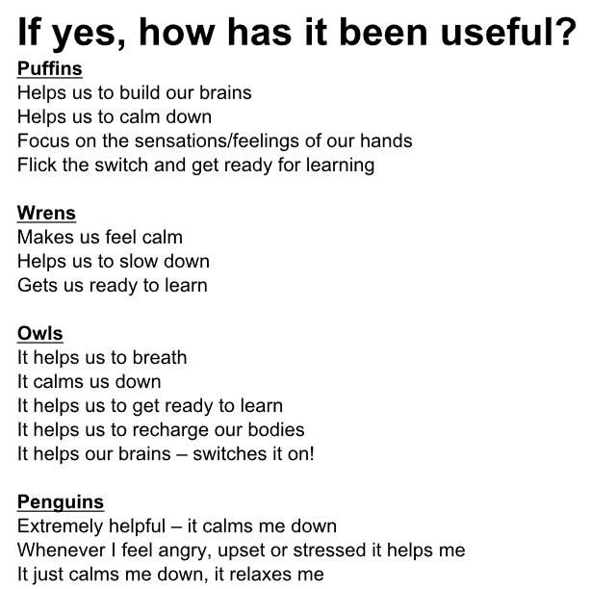
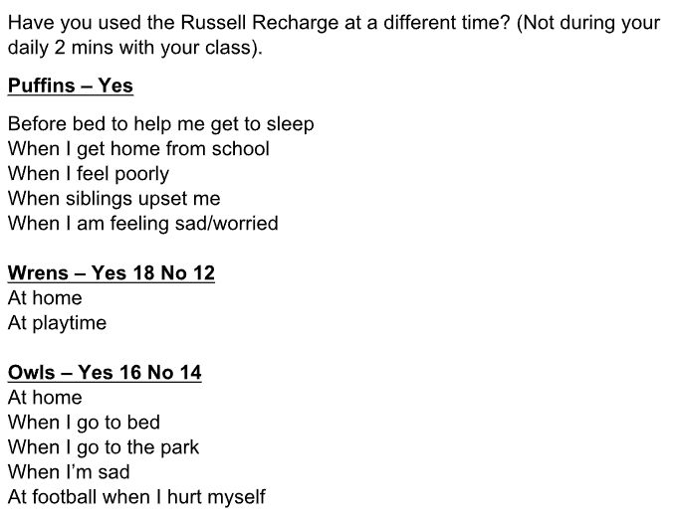
- Proportional representation in clubs/school council etc. is an average of 8% for the school year.
- Parents now working autonomously with KP to support themselves, and then their children through the Positive Intelligence programme
- Final ‘Pod’ meeting took place with KP with all staff reporting high impact from the training and increases in their PQ score - this is tied into PMs for staff
- Successful Residential visit, only one child did not attend due to their own or parent resilience issues
- Inclusion cafe linked to transition supported further building of resilience
- Assemblies continue to be linked to practical strategies that children can use when they face a challenge, rather than having a ‘melt down’
- Attendance continues to be monitored effectively with whole school attendance maintained at over 96% all year, and well above national and CBC in all groups (SEND/PP etc.)
SHEU summary report:
- 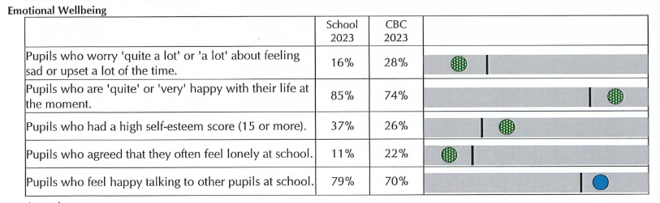

Further information (optional)
Additional activity
The PP strategy has been written with the ‘Using Pupil Premium for School Leaders’ document and the Menu of approaches. These have been referenced in the document using the following codes:
HQT 1

HQT 2

HQT 3
HQT 4

HQT 5
TAS 1

TAS 2

TAS 3

TAS 4

WS 1

WS 2

WS 3
WS 4
WS 5
WS 6

