Bears – Spring 2nd Half Term 2021

Personal Social and Emotional Development  - Circle time games.  - Good to me – activities using puppets/role play.  - Feeling good about myself.  - Understand my feelings, e.g. happy, proud, sad, angry.  - Feeling loved and cared for.  - Value – Happiness.  - Stories about friendship and feelings. | Communication and Language  - Listen attentively.  - Express themselves effectively.  - Show awareness of listeners needs when sharing ideas with others.  - Use language in role play situations – Frozen Castle, Book Shop and Friendship Hotline Centre.  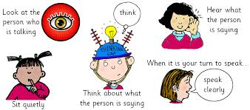  - Use talk to organise, sequence and clarify thinking, ideas, feelings and events. |  | Physical Development  - Use tools effectively – use a knife to make a sandwich for the teddy bears’ picnic.  - Use a single hole punch to punch holes in card for sewing.  - Gymnastics – jumping, sliding, rolling, moving over, on and under apparatus.  - Dance – perform a wide variety of dance actions in time to music and beat patterns; copy repeat and perform simple movement patterns.  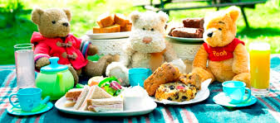
Literacy  - The Runaway Pancake – write a list of ingredients and the method.  - Use the story ‘Chalk’ and other wordless books to inspire storytelling.  - Write inserts for cards.  - Listen to stories about bears, accurately anticipating key events and respond to what they hear with relevant comments and questions.  - Segment sounds in simple words and blend them together.  - Letter sounds and letter names.  - Alphabet songs.  - Write letter sounds, words, captions, lists, labels, sentences and stories.  - Write an invitation to their teddy, inviting them to the teddy bears’ picnic.  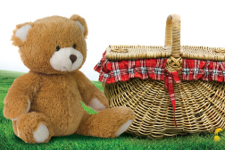 | Mathematics  - Representing 9 and 10, ordering numerals to10, composition of 9 and 10.  - Building, matching and printing with 3D shapes.  - Naming and describing cones, cubes, cuboids, cylinders, spheres and triangular prisms.  - Exploring repeating patterns.  - 10 in the Bed song.  - Counting back from 10, comparing numbers within 10, making 10.  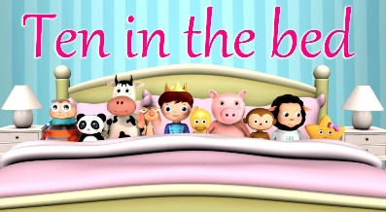 | Understanding the World  - Log in, open 2Simple and 2Paint.  - Create a picture using 2Paint.  - Program a Beebot.  - Investigate the 5 senses.  - Join in celebrations and customs – Pancake Day (Shrove Tuesday), Mothers’ Day and Easter.  - Recognise Christian symbols and talk about new life in nature.  - RE: Why is Easter special for Christians? |  | Expressive Art and Design  - Role-play.  - Music – Our World.  - Sing songs e.g. Goldilocks song, Round and round the garden.  - Hand and finger painting.  - Painting – selecting colours.  - Act out ‘We’re Going on a Bear Hunt’.  - Create repeating patterns on a picnic blanket.

