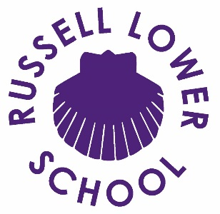

Dear Parents and Carers,
Letter of welcome from the Headteacher
It gives me great pleasure to write to you as the Headteacher of Russell Lower School, and to welcome you to our thriving community.
I joined the school in September 2015 as its new Headteacher having spent most of the previous eighteen years as a teacher (in FS, KS1 and KS2) in educational leadership posts in Milton Keynes and Luton, including both as assistant and deputy head, all with successful OFSTED outcomes, and having undertaken the National Professional Qualification for Headship (NPQH).
Teaching, learning and child development are my absolute passions. I believe education secures freedom, security and choice for our children and that school should be a vibrant, fun, positive community where children love learning, achieving, developing and playing together. In partnership with a strong teaching team and dedicated governing board, we utilise our collective experience, energy, enthusiasm and passion to do everything possible to enable children at Russell Lower School to have the best possible start to their learning journey and school experience.
My mission is to continue to build upon all the incredibly strong practice already in place at Russell (seen by Ofsted in November 2022 and 2016) and develop the governors’ ambitious vision statement even further so that it is an exceptional school.
As a mum of two myself, I know that I generally wanted four things for my children: to be happy, healthy, to be safe and to learn. As the Headteacher I want the very same things for your children and a whole lot more! I actively sought out the Headship at Russell Lower School because of its incredibly strong ethos and culture including its ‘Open Door Policy’, its commitment to real and exciting learning opportunities which leads to not only the development of strong academic skills and abilities but also personal qualities such as confidence, independence, perseverance and respect. The strongest evidence I can give you to demonstrate my total and utter belief and commitment to Russell is that I chose it (quite a few years ago now!) for both of my own children. It was as clear then as it is now, that the highly skilled and talented staff and governors at the school also held the same beliefs and continue to be as committed now to work hard to move Russell from strength to strength.
The only way that we can provide the very best for the children is to work in partnership with parents, carers and the rest of our community. Our ‘Open Door Policy’ means we already have a huge head start on this. We work hard with parents to ensure that all children enjoy school, become confident and independent, excel in their learning and are incredibly proud of their achievements.
I am really excited about working with the whole team here at Russell again this year. Following a £3.9 million pound expansion ‘build’ in 2015 and a full refurbishment in 2016 we have a learning environment to rival anywhere in Bedfordshire. We aim to create a school where every child loves to come and consequently thrives. If I can help in any way, or answer any question, please do not hesitate to ask. I always aim to be as visible as possible: do come and grab me!
Kind Regards
Nicki Walker
Headteacher

