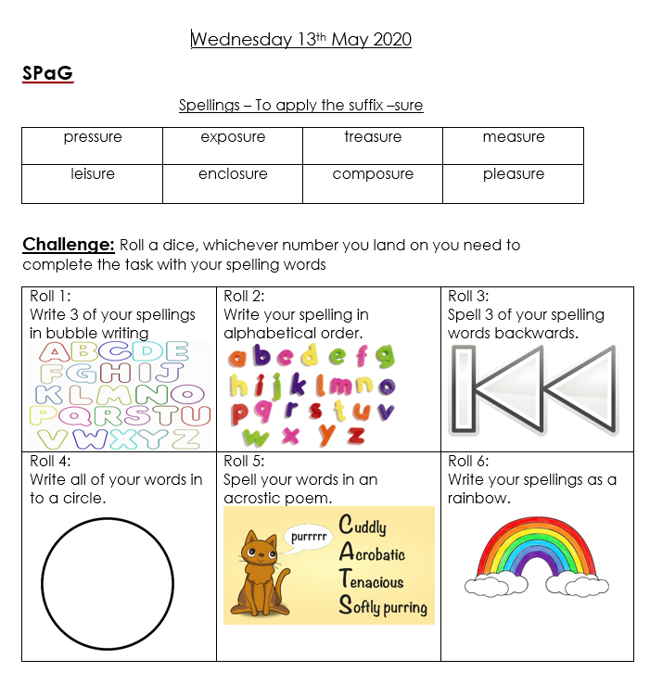

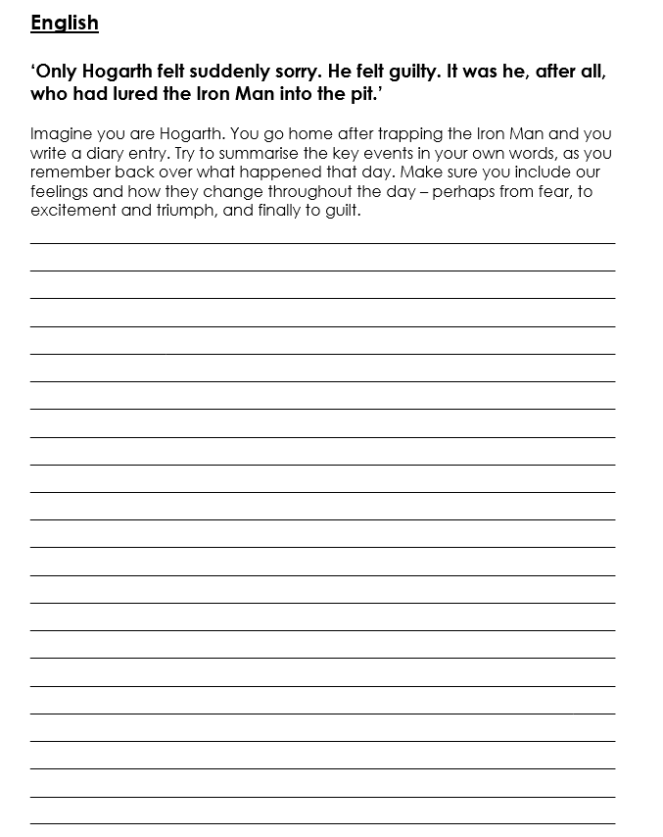

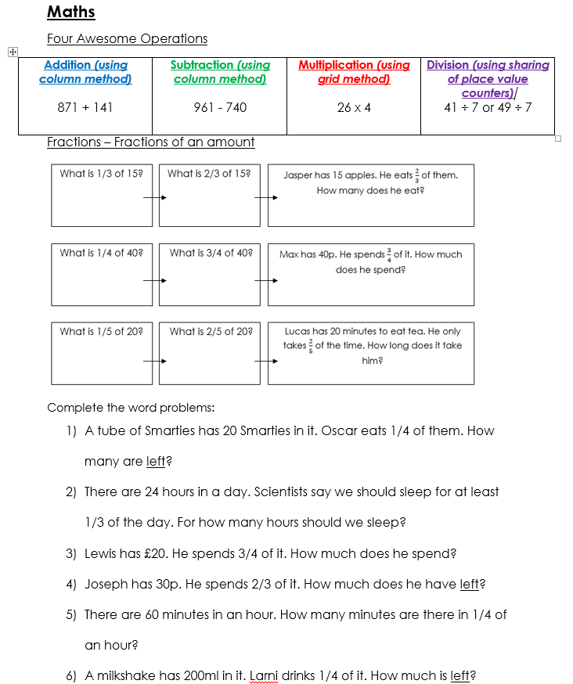

**Challenge questions**

1. A shark chases 244 fish, and eats 3/4 of them – how many does it eat?
2. I am reading a book, which is 55 pages long. I have read 2/5 of it. How many pages have I read?

Can you write word problems for these sums, and then work out the answers?

a) ½ of 126. b) $\frac{1}{3}$ of 27. c) ¼ of 164.

