Wednesday 29th April 2020
English
SPaG
Spellings - The I sound spelt y elsewhere that at the end of the word

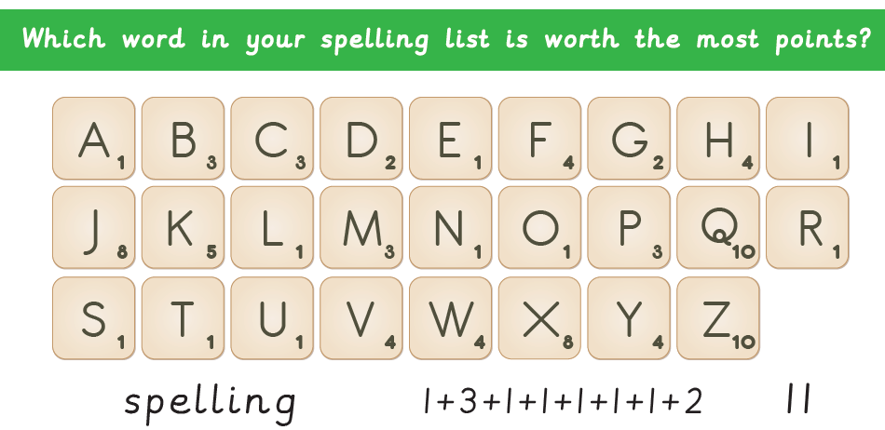
myth
Egypt
gym
pyramid
mystery
symbol
physical
synonym

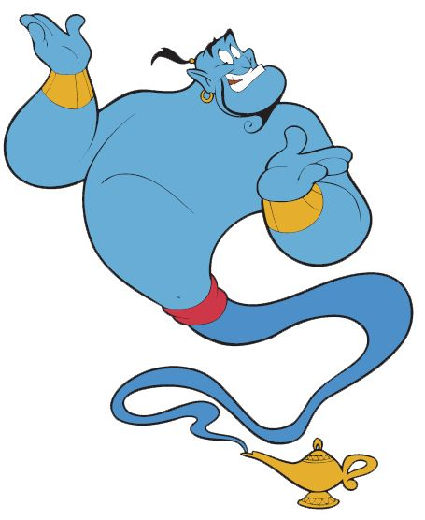
Word of the Day – venture

Definition ____________________________________________
_____________________________________________________
_____________________________________________________
Used it in a sentence: ____________________________________________________
_________________________________________________________________________
Word Class: ____________________________________________________
Synonyms

English – Persuasive Letter – Look at the letter again

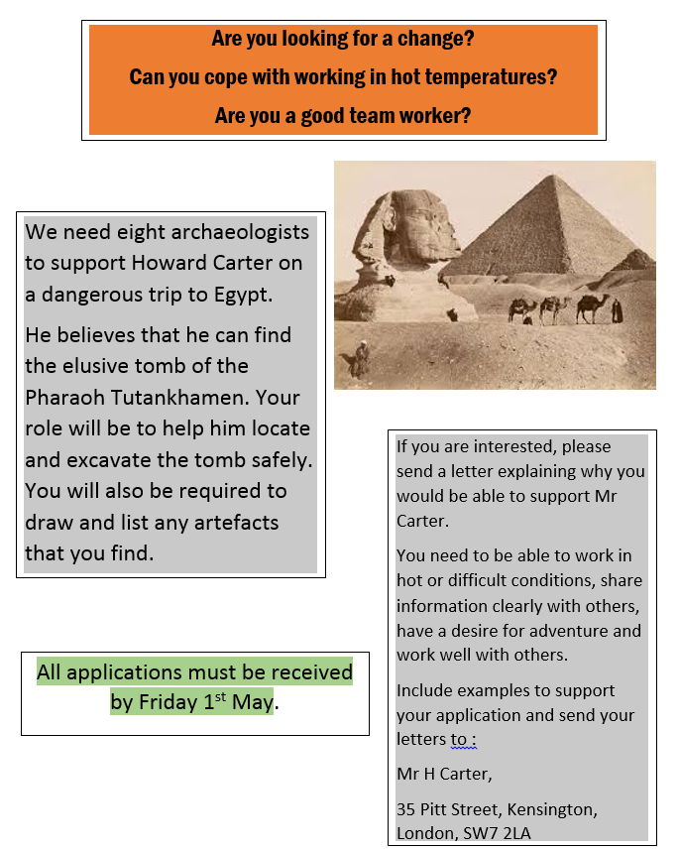

There seems to be four main things to will need to give examples of to persuade Mr Carter to take you on the dig. Draw a chart on a piece of paper like the one below. You can be imaginative as you like and can make up your evidence. I have given an example of the first one below.

Persuade Mr Carter that: | Examples and Evidence
1. Work in difficult conditions | I have been on holiday in a hot country when they were having a heatwave. Even the local people moaned about the heat but I was able to play sport and go for long walks.
2. Share information clearly with others
3. Have a desire for adventure
4. Work well with others.

Maths

- 42 x 3 =
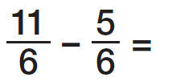

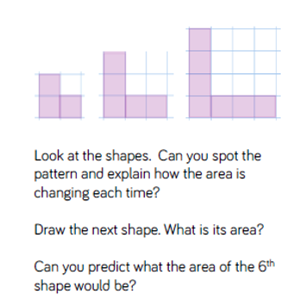
- 1/9 of 45 =
- 4/9 of 45 =
- I have £1.00, I spend 37p, how much change do I receive?
- You receive £5.00 for your birthday from a neighbour. You buy a magasine for £2.75, how much change do you receive?
- Write the words which refer to subtraction: add, take away, times, subtract, multiply, find the difference.
- 246 x 3 =
- Find the difference between 125 and 50.

PSHCE
As lockdown continues, we might start feeling frustrated, anxious and restricted. These feelings can lead to us behaving in funny ways, sometimes we feel like a balloon that’s going to pop!
Write down the things that are making you feel stressed and if you can –talk to someone! Let it out before you burst!
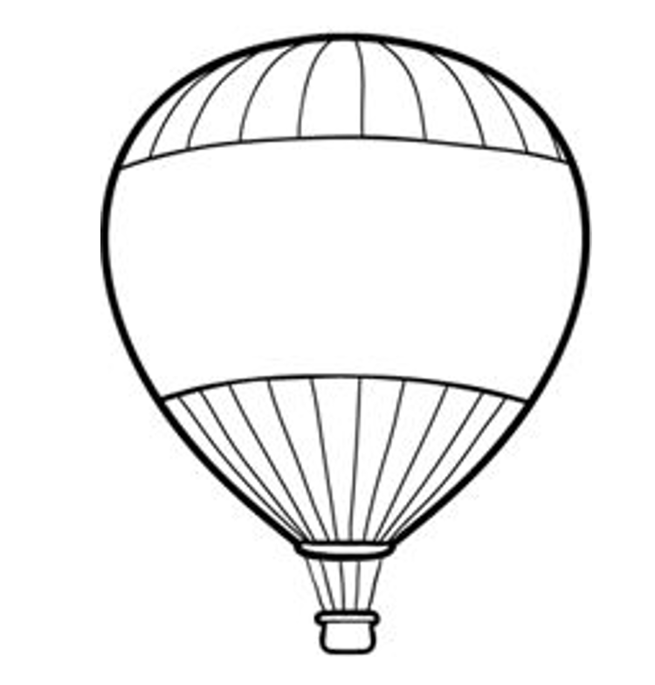
Be K I N D to yourself, you are A M A Z I N G
When you feel trapped, we focus on all the negatives.
Have a look in the mirror or ask someone who loves you, what makes you amazing.
Write them down somewhere safe so you can always look back at them.

