Year 2 Phonics/Spelling Practice – Tuesday 2.6.20.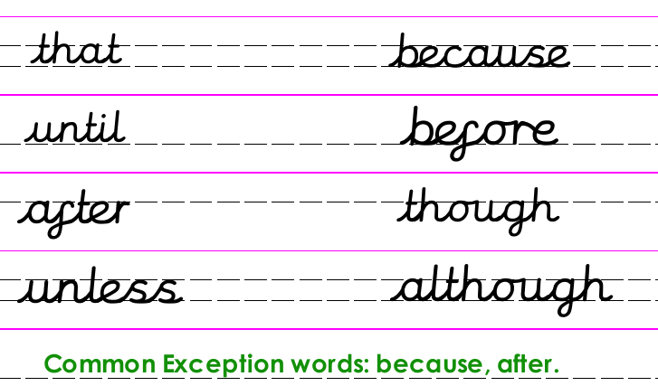
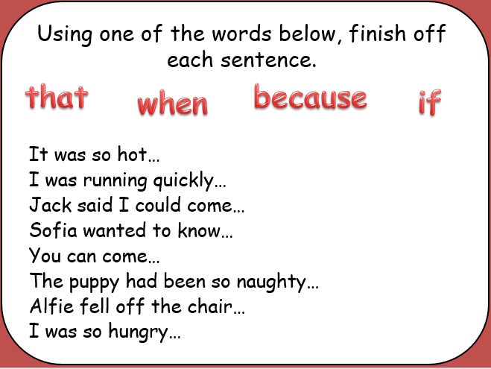
Dictation:
Ask someone to read out the sentence below so that you can write it down – try not to look until after you’ve written it. Check your punctuation and spelling.
It was so hot that I went to the seaside.
Maths 2.6.20
Use Arrays
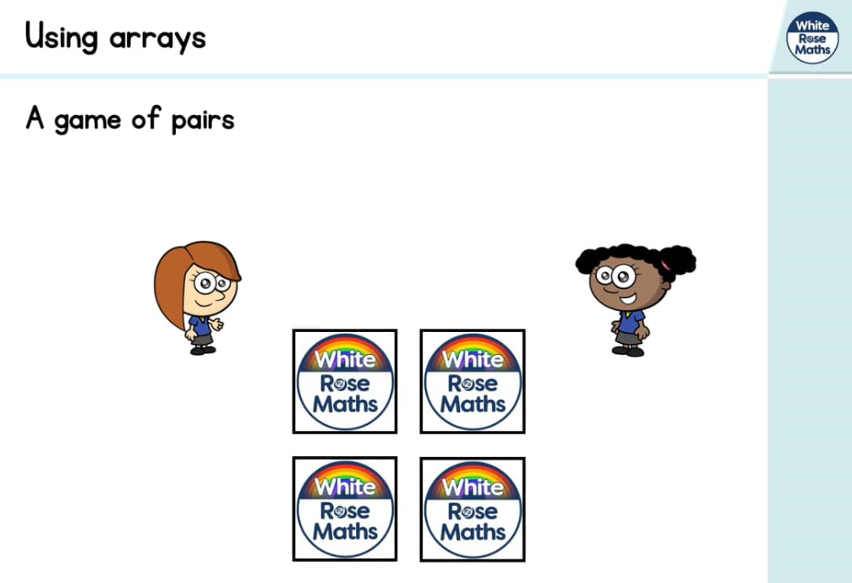
https://whiterosemaths.com/homelearning/year-2/ (Week 5 W/C 18.5.20)

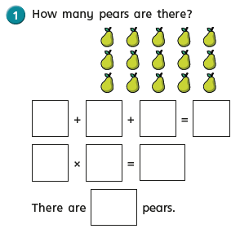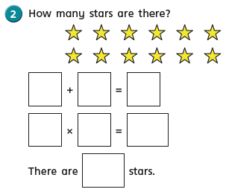
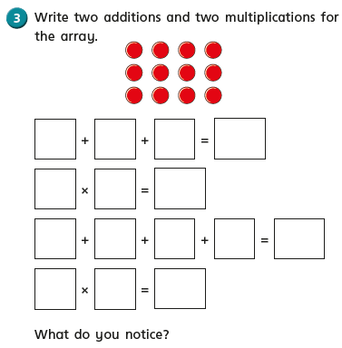
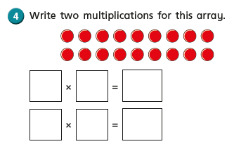

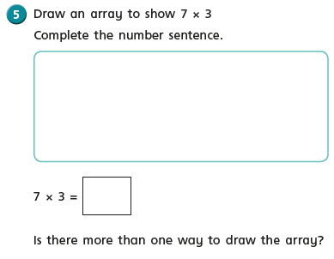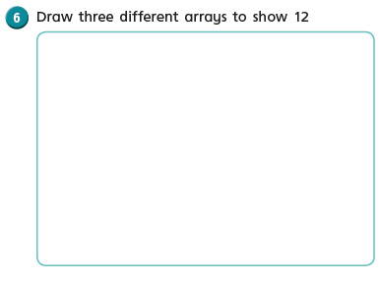
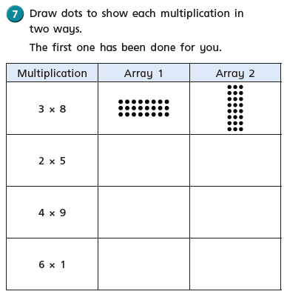
English Tuesday 2nd June 2020

Continue to watch/listen to ‘Wind in the Willows’ if you didn’t manage the whole story yesterday.

https://www.bing.com/videos/search?q=wind+in+the+willows+youtube&FORM=HDRSC3
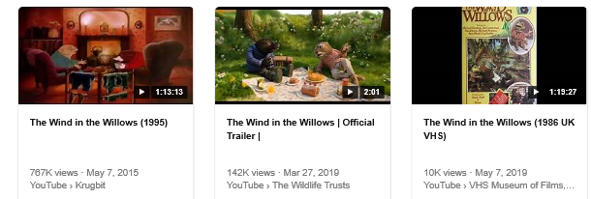

Or you can listen to the story at https://www.bbc.co.uk/sounds/play/p07sny1n

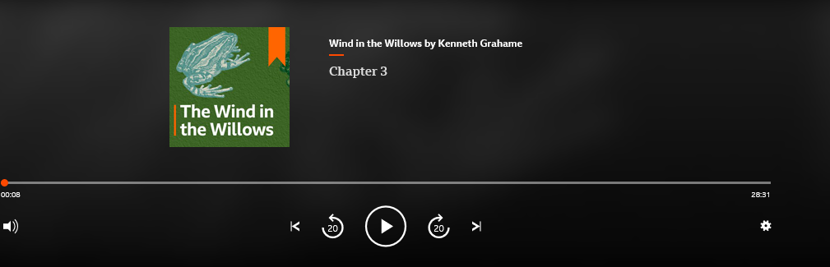

Geography Tuesday 2nd June 2020
WALT understand the Countryside Code.

As you may be aware from the topic web on line and also the work you are doing in English our topic is called ‘Countryside Tales’. I don’t know about you and your families but we have spent so much time during lockdown exploring the countryside around us. With this is mind I think it would be really important for you to learn the ‘Countryside Code’.

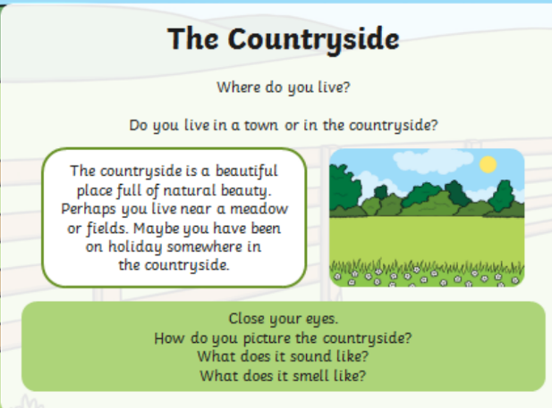
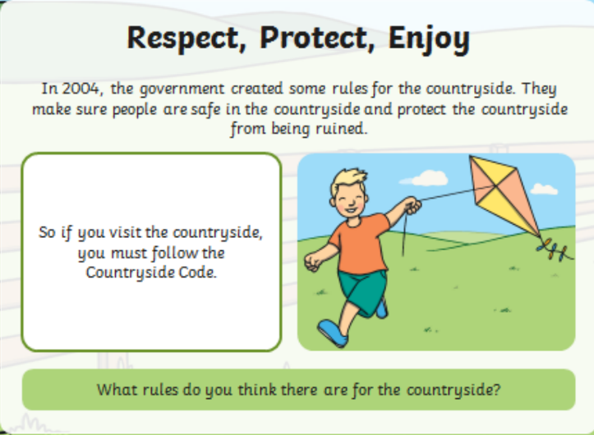
How is this similar to the Russell values?
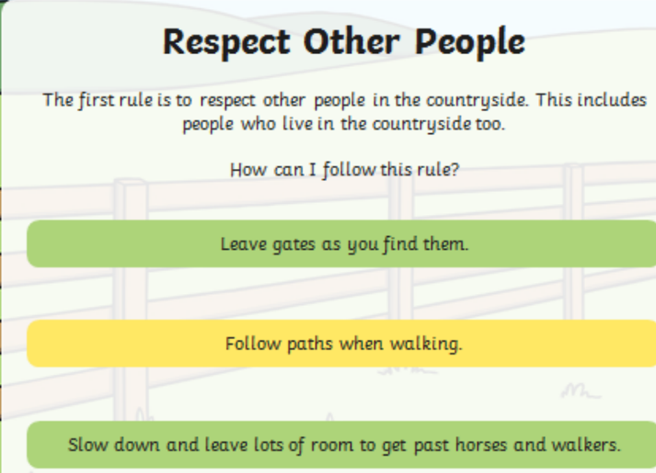

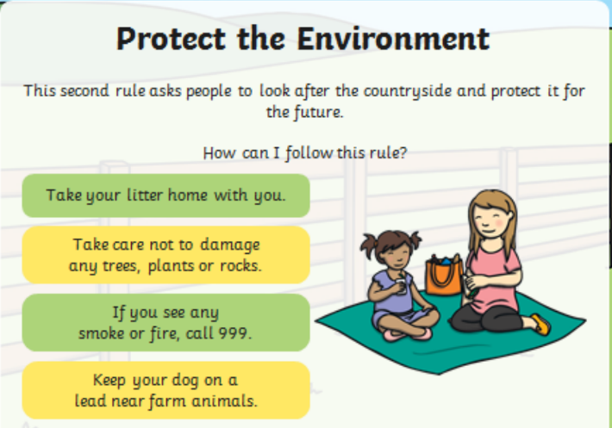

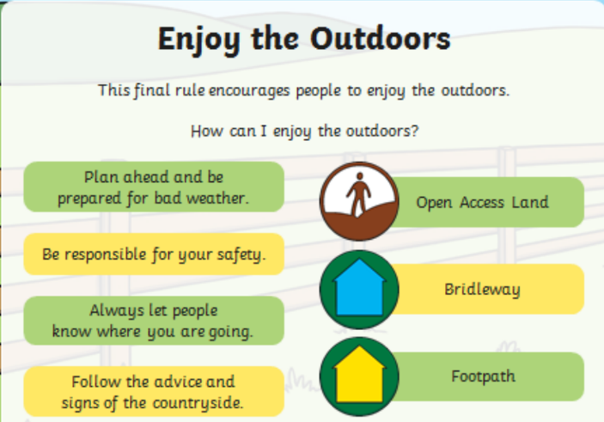

Your task
Can you create a poster with pictures showing some of the ‘Countryside Code’ rules?

