Sports Premium 2016-2017
What is the Sports Premium?
The Government is providing additional funding for the next academic year 2016 to 2017 to improve provision of physical education (PE) and sport in primary schools. This funding has been provided jointly by the Departments for Education, Health and Culture, Media and Sport. This funding is ring-fenced and therefore can only be spent on provision of PE and sport in schools.
Each school will receive £8000, plus £5 for each pupil in years 1 – 6.
The total that Russell Lower will receive this year, is £9185.
Schools must use the funding to make additional and sustainable improvements to the quality of PE and sport they offer.
This means we should use the premium to:
- develop or add to the PE and sport activities that our school already offers
- make improvements now that will benefit pupils joining the school in future years
When considering the spend we kept in mind the five key indicators:
- The engagement of all pupils in regular physical activity – kick starting healthy active lifestyles.
- The profile of PE and sport being raised across the school as a tool for whole school improvement
- Increased confidence, knowledge and skills of all staff in teaching PE and sport
- Broader experience of a range of sports and activities offered to all pupils
- To increase participation levels in competitive sport and healthy activity of pupils.
Possible uses of the funding include:
- hire qualified sports coaches to work with teachers
- provide existing staff with training or resources to help them teach PE and sport more effectively
- introduce new sports or activities and encourage more pupils to take up sport
- support and involve the least active children by running or extending school sports clubs, holiday clubs and Change4Life clubs
- run sport competitions
- increase pupils’ participation in the School Games
- run sports activities with other schools

How do we intend to spend the funding?
At Russell Lower we intend to use the sports premium funding to:
Provision | Estimated Cost | Link to aims of the funding
- Join the Redborne School Sport Partnership (SSP). This provides support for local schools including professional development for teachers and entry into all local school festival and transition events. | £2000 | Continued professional development opportunities  To increase participation levels in competitive sport and healthy activity of pupils.  A range of festivals attended including Paralympic
- Children to take part in sports ambassador training | Included in above cost. | To increase participation levels in competitive sport and healthy activity of pupils.  To increase the engagement of all pupils in regular physical activity.  The profile of PE and sport being raised across the school
- Dance Performance – ‘Where the River Runs’ | £270 | The profile of PE and sport being raised across the school as a tool for whole school improvement  Broader experience of a range of sports and activities offered to all pupils  To increase participation levels in competitive sport and healthy activity of pupils
- PE coordinator to attend PE conference. | £170 | Continued professional development
- Yr4 Bikeability course paid for all who were interested. | £140 | The profile of PE and sport being raised across the school  To increase participation levels in competitive sport and healthy activity of pupils.  Broader experience of a range of sports and activities offered to all pupils
- Scooter rack for storage. | £159 | The engagement of all pupils in regular physical activity – kick starting healthy active lifestyles.
- PE/lunchtime resources for sports ambassadors. | £525.59 | The engagement of all pupils in regular physical activity – kick starting healthy active lifestyles.  The profile of PE and sport being raised across the school as a tool for whole school improvement
- Russell Raiders resources | £500 | The engagement of all pupils in regular physical activity – kick starting healthy active lifestyles.  The profile of PE and sport being raised across the school as a tool for whole school improvement  Increased confidence, knowledge and skills of all staff in teaching PE and sport  Broader experience of a range of sports and activities offered to all pupils  To increase participation levels in competitive sport and healthy activity of pupils.
- Skipping workshop for all children | £482 | The profile of PE and sport being raised across the school  To increase the engagement of all pupils in regular physical activity.  To increase participation levels in competitive sport and healthy activity of pupils.  Increased confidence, knowledge and skills of all staff in teaching PE and sport
- RQT programme for PE Coordinator | £300 | Increased confidence, knowledge and skills of all staff in teaching PE and sport
- PE in the EYFS course for foundation stage teachers. | £80 | Increased confidence, knowledge and skills of all staff in teaching PE and sport
- Triline Fitness Rugby Day for all children. | £150 | Increased confidence, knowledge and skills of all staff in teaching PE and sport The engagement of all pupils in regular physical activity – kick starting healthy active lifestyles.The profile of PE and sport being raised across the school as a tool for whole school improvement  To increase participation levels in competitive sport and healthy activity of pupils
- Outside PE Equipment for Foundation stage | £500 | The engagement of all pupils in regular physical activity – kick starting healthy active lifestyles.  The profile of PE and sport being raised across the school as a tool for whole school improvement  Broader experience of a range of sports and activities offered to all pupils
TOTAL | £5276.59
Carry over | £3908.41 | To be used to develop the outside environment next year

Impact

Point above/pictures | Details | Impact/ Number of participants/statistics
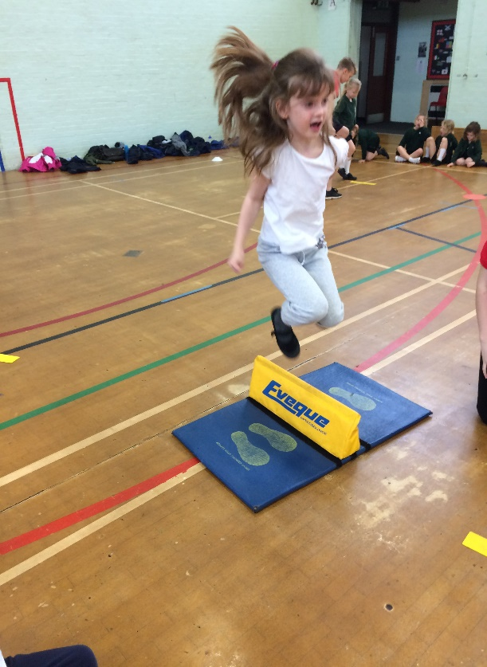  1 | Through RSSP Children are given the opportunity to attend a range of festivals and transition events.  CPD opportunities are also offered throughout the year. 3 staff members due to attend. | Pupils who attend the festivals are awarded a certificate and these are presented in our whole school assemblies in order to raise the profile of PE.  There is a large emphasis placed on the fact that the children are representing their school and to do their best, but the main message portrayed is for the children to enjoy themselves and have fun.  Year 1 – 36  Year 2 – 60  Year 3 – 104 (every child to attend at least 2 events)  Year 4 – 118 (every child to attend at least 2 events)  See Evolve for feedback about each festival/event.  Feedback from staff regarding courses to follow.  Continued professional development opportunities  To increase participation levels in competitive sport and healthy activity of pupils.  A range of festivals attended including Paralympic
2  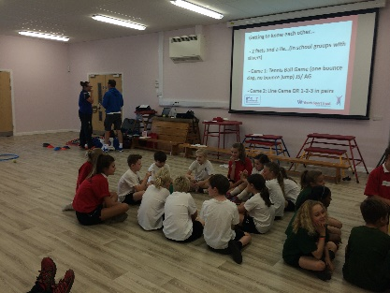 | Through signing up to the RSSP we will gain access to the Leadership Programme where members of the Redborne Partnership will train 10 selected year 4s on how to become good sports leaders. An afternoon will be spent training the selected children. | 100% enjoyed the training  80% thought the training would help them to lead other children in being active at break times. 20% were unsure whether the training would help them.  To increase the engagement of all pupils in regular physical activity.  The profile of PE and sport being raised across the school
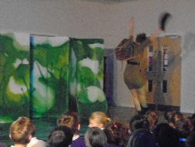  3 | All children we able to experience a live dance performance and take part in a question and answer session. | 78% of students who did not already dance were interested in starting dance lessons after watching. 56% of these children were boys.  The profile of PE and sport being raised across the school as a tool for whole school improvement  Dance clubs offered to children since the dance performance. The uptake of boys at dance clubs is 53% compared to only 30% previously.
4 | PE co-ordinator to attend the PE conference in March 2016. | PE co-ordinator attended the conference and came away with some useful ideas to try within school.
5 | Bikeability for all year 4 children who expressed interest. | Engraining exercise into daily life at school.  Enabling children to safely participate in cycling within school time, encouraging them to cycle to and from school on a daily basis. 100% students enjoyed workshop and passed the training. 90% students said they would now be interested in cycling to school every day and 40% are now going to cycle every day to middle school.
6 Scooter rack for storage | Place for children to store scooters. | To encourage more children to walk and scoot to school every day for the 2017/2018 cohort.
7 PE/lunchtime resources for sports ambassadors | Specific invasion game, bat and ball skills, agility and stamina based equipment. | Ambassador led sports activities for 40 mins every day at lunchtimes.  Encouraging children of all ages to participate in the same sporting activities.
8 Russell Raiders | Coaching qualifications, pitch markings and new goals with the understanding that the coaches will run a ‘get girls scoring goals’ day in the Autumn term (17/18). | Focussed session with football coaches for all children.  Encouraging girls into football, narrowing gender gaps and stereotyping.  Football coaches to coach a session in conjunction with teaching staff to pass across skills and football specific techniques.  Coaches to run a ‘get girls scoring goals’ session to encourage girls to join in weekly football training with the school football team.  Sessions with coaches to encourage children to join the school competitive football team.
9 | Skipping workshop for all children with a boxing focus to get boys into skipping. | 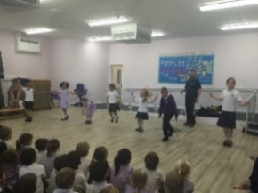  Encouraging 2 minute challenge by all staff showing PE as an essential part of daily life. Personal bests and year group record breakers to be announced in celebrations assemblies each week. 2 minute challenge available every lunch time for all pupils in the school.  Introducing skip2bfit daily 2 minute challenge. Children compete against their personal best times and against other childrens’ personal bests every day.  Teacher participation during the workshop to learn new techniques and increase confidence in teaching skipping and stamina building activities.
10. RQT programme for PE Coordinator | RQT programme for PE Coordinator. | Course focused on leadership skills to enable a class teacher to take on leadership and become the PE coordinator.
11. PE CPD. | Development of staff skill set. | Increased confidence, knowledge and skills of teachers in teaching PE and sport.
12. Triline Fitness Rugby Day for all children. | Rugby workshop for all children. | Teacher participation during workshop to learn new techniques and increase confidence in teaching rugby skills. Whole school participation to get children active and involved in daily physical activity.Ensuring children are playing sport as part of daily life at school. Acheivements from workshop day to be celebrated in assembly.  Coach from local team to encourage/scout children to join a competitive local rugby squad.
13. Outside PE Equipment for Foundation stage | New outside PE equipment to encourage sport within the foundation stage areas. | To encourage pupils to participate in daily physical activity for the 2017/2018 cohort.  Encouraging outdoor Pe equipment as part of daily free choice on top of 2 hours of weekly PE lessons.  Giving children the opportunity to partake in daily sporting activities that are currently not available to them.

Festival participation
Our emphasis is placed on ensuring that as many children participate in as many festivals as possible. We do not focus on sending our ‘best’ children but rather ensuring parity and fairness.
Year | Date | Festival | Number of teams | Outcome
4 | 14.10.16 | Tag rugby | 2 | Non-competitive
4 | 6.10.16 | Year 4 transfer | 2 | Non-competitive
2 | 9.11.16 | Multisports | 2 | Russell one 1st, Russell two 4th
3 | 15.11.16 | Table tennis and table cricket | 4 | 4th, 2X 2nd and 1st
3 | 1.12.16 | Handball | 2 | Non-competitive
2 | 27.1.17 | Virtual competition | 2 | Russell 2 4th  Russell 1 2nd
3 | 5.1.17 | Sportshall athletics | 2 | Non-competitive
4 | 1.3.17 | Swimming | 2 | Russell 1 4th out of 10  Russel 2 2nd out of 7
2 | 3.3.17 | Gym | 2 | Russell 1 5th out of 8  Russell 2 3rd out of 8.
4 | 3.3.17 | Gym | 2 | Russell 1 6th out of 8  Russell 2 8th out of 8
2 | 22.5.17 | Virtual competition | 2
3 | 24.5.17 | Quadkids | 2
4 | 17.5.17 | Kwik Cricket | 2 | All Russell final and through to play-offs for one team
3 | 7.6.17 | Tennis | 2
3&4 | 3.7.17 | Netball | 2
2&3 | 12.7.17 | Cheer/Dance county games | 1
2&3 | 12.7.17 | Cheerleading county games | 1

Clubs
All children have access to our clubs at Russell. However, we do provide some clubs such as tag rugby and kwik cricket for ½ a term specifically to those attending festivals to ensure they are clear on the skills and rules. Our capacity for most clubs is 20. We regard a ¾ or more uptake as good (marked in green).
 |  | Autumn 12 weeks | Spring 10 weeks | Summer 12 weeks
KS1 | Tuesday lunch | Football 13 | Dodgeball 20 Cheerleading 15 | Dance 17
 | Wednesday before school |  |  | 2nd half term tennis 18
 | Wednesday lunch | Gymnastics 21 | Gymnastics 20 | Gymnastics 6
 | Thursday after school | Tag rugby ½ term  Multisports ½ term 11 | Football 12 | Mini Olympics 14
 | Friday lunchtime |  |  | Cheerleading 15
KS2 | Tuesday/Monday after school | Cheerleading 15 | Basketball 11 Cheerleading 15 | Mini Olympics 5
 | Wednesday after school | Handball 7 | Fencing and Archery 12 | Kwik cricket ½ term festival 20  Kwik cricket ½ term 14
 | Thurs lunch | Table tennis 12 | Gymnastics 19 | Gymnastics 6
 | Friday lunchtime |  |  | Cheerleading 15

