Monday 20th April 2020
SPaG
Spellings – To apply the prefix sub
subtotal ________________________________________________________________
subtitle _______________________________________________________________
substitute ________________________________________________________________
subplot ________________________________________________________________
subheading _______________________________________________________________
subdivide ______________________________________________________________
submerged ______________________________________________________________
subtropical _______________________________________________________________
Challenge! Look up the meaning of each of these words in a dictionary so you understand what each word means.
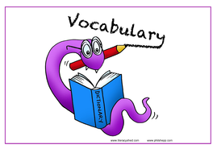
Vocabulary – Word of the Day!
considerate
Definition _______________________________________________
_________________________________________________________
_________________________________________________________
Used it in a sentence: _____________________________________________________
___________________________________________________________________________
Synonyms: _______________________________________________________________________

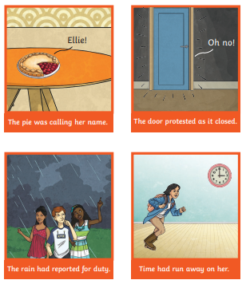
English
Personification
When you give human qualities to an object or animal.
Can you think of any other examples?

https://www.youtube.com/watch?v=afzmwAKUppU
Watch the video clip from Beauty and the Beast. What personification can you identify in the video clip?
Challenge!
Look around an outdoor area. This could be your garden or whilst you are out for a walk. Can you identify anything that you could give a human quality to? Clouds, flowers, leaves, trees, the sun… Write a personification sentence to describe each one you come up with. Can you include an adverb in your sentence?
For example:
The flowers danced gracefully in the breeze.

________________________________________________________________________________________________________________________________________________________________________________________________________________________________________________________________________________________________________________________________________________________________________________________________________
Maths
Four Awesome Operations
Addition (using column method)  521 + 381 | Subtraction (using column method)  600 - 120 | Multiplication (using grid method)  48 x 3 | Division (using sharing of place value counters)  49 ÷ 8
Money
Convert the pounds to pence (and vice-versa) in the table below:
Pounds | Pence
£3 and 24p (£3.24)
 | 225p
£2 and 92p (£2.92)
£1 and 35p (£1.35)
 | 352p
 | 521p
£6 and 16p (£6.16)
£3 and 9p (£3.09)
 | 22p
How Many Ways?
I spend 70p at the shop. I pay with exactly 5 coins.
Which coins do I use?
How many ways are there to make 70p with 5 coins?
Which Answer?
I spend £16.99 at the shop. I pay with a £20 note. How much change am I given?
- £4 and 1p
- £3.01
- £3.1
Now Prove It

Geography
Challenge! Locate as many of these cities as you can!
Birmingham Coventry Canterbury London Bath Cambridge Liverpool
York Newcastle Leeds Bristol Gloucester Manchester
Nottingham Plymouth Norwich
Are there any other locations you can add onto the map of England? You might like to locate Ampthill.
Use the map of England below or you could draw your own if you do not have access to a printer.

