Year 2 Phonics/Spelling Practice – Monday 1.6.20.
This week we are looking are Conjunctions – they are words which join sentences together.

Practise writing your new spelling words each day using your best Russell handwriting.
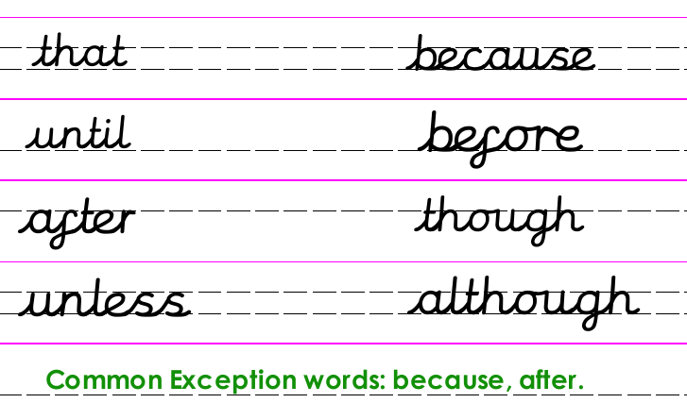
Read this to understand why we use conjunctions.
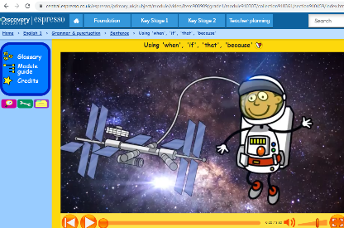
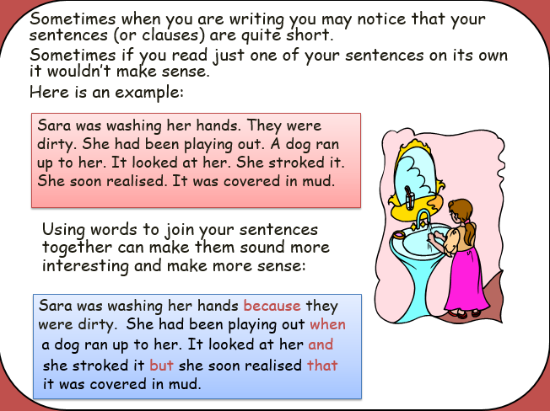
If you have access to Espresso – watch the video at: https://central.espresso.co.uk/espresso/primary_uk/subject/module/video/item908909/grade1/module910307/collection910361/section910459/index.html?source=search-all-all-all-all&source-keywords=subordinating%20conjunctions

Maths 1.6.20
Multiplication sentences using the x symbol
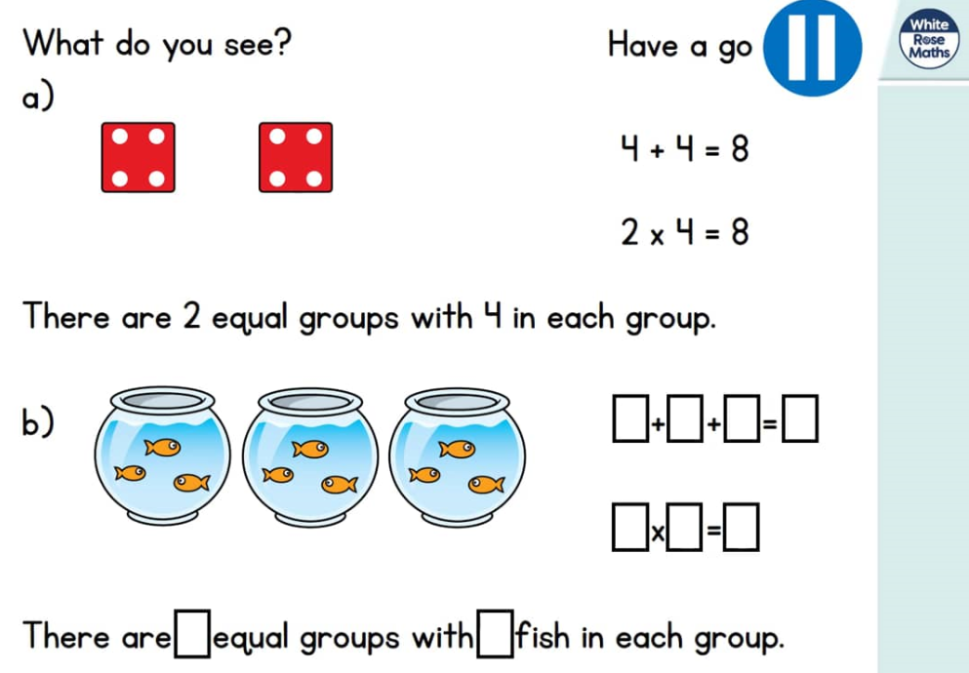
https://whiterosemaths.com/homelearning/year-2/ (Week 5 W/C 18.5.20)
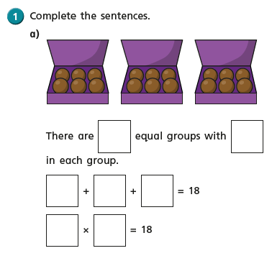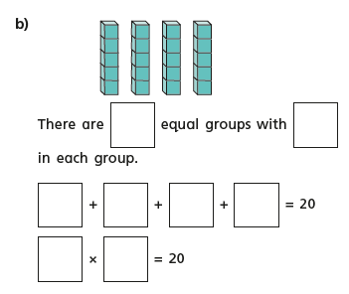
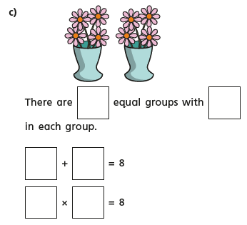
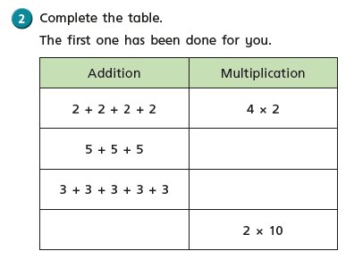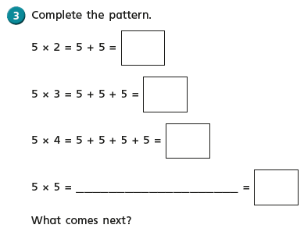
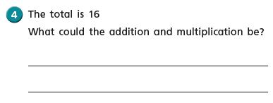
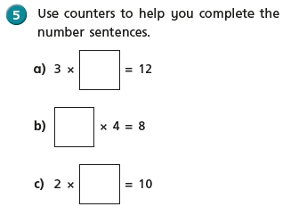

English Monday 1st June 2020
Inspirational quote of the day! 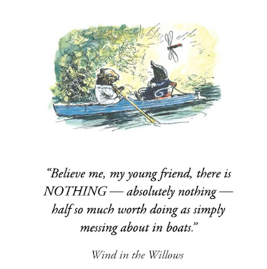
Word of the day – curious

Wow! Today is the first day of our 2nd summer half term, can you believe we have been away for such a long time. It has been great to hear from you all and we enjoy seeing photographs and examples of some of the work you have been doing.
In English this half term we are going to be watching/reading Wind in the Willows by Kenneth Graham. It is a literacy classic and one of my favorite books. I do hope you will all enjoy it as much as we do.

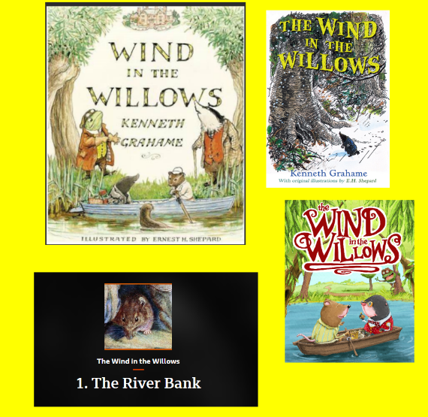

Have a look at these pictures of the book cover.
What do you think the book will be about?
Where do you think the story will be set?
Can you guess who the main characters will be?
Today I am going to set you the wonderful task of watching the film of Wind in The Willows this will probably take you two days at least to watch, as it is about an hour long and I know sometimes you find it hard to concentrate for this amount of time. It is a lovely film and you can watch it on YouTube. You can also listen to the story on the BBC website. Here are the links.

https://www.bing.com/videos/search?q=wind+in+the+willows+youtube&FORM=HDRSC3
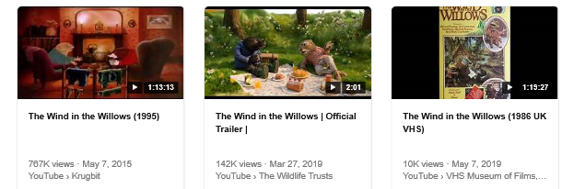

Or you can listen to the story at https://www.bbc.co.uk/sounds/play/p07sny1n

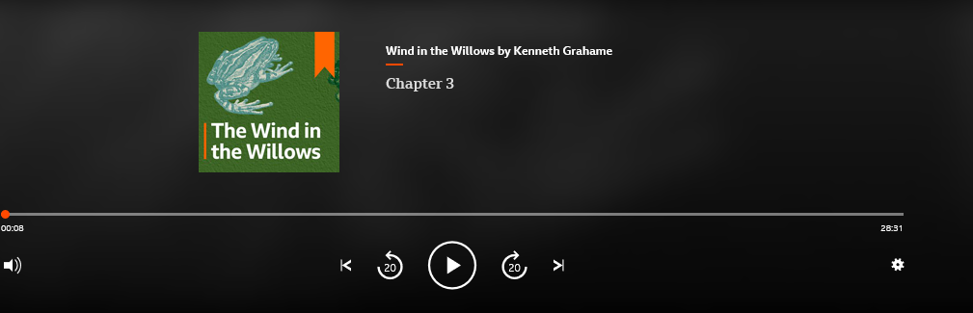

PSHE 1.6.20
WALT: to understand how we can look after our local environment

This week in geography we will be learning about The Countryside Code and how everyone should behave when we are out in the countryside.

What makes our environment a pleasant place to be?
Do we like our belongings to be tidy and organised?
Do we like our parks to be clean and well maintained?
Do we like our classroom to be well resourced and tidy, so we know where to find the things that help us to learn?

Whose responsibility is it to look after all of these places and make them nice environments to be in? It is your parents, teachers, cleaners?
When you next go out for a walk or a bike ride, could you collect some litter and put it in the bin? Could you make sure that you bring any rubbish home with you?

Task:
Design a poster to encourage people to look after their environment. It could be the park, the classroom, your bedroom, your garden…
Make sure that your poster shows a clear, bold message.
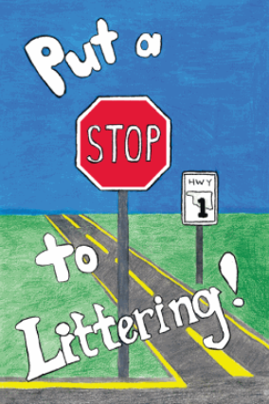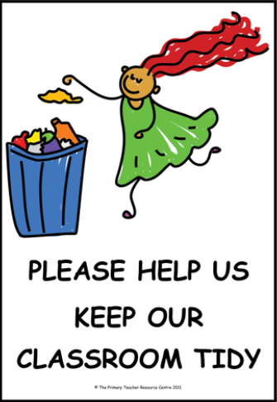

Year 2 Music Summer Term 2 –
Consolidating Year 2 music learning – history of music, musical language.

Week 1
Classical music The term 'Classical music' has come to be known as a term for music that spans the course of hundreds of years, including all Western music from Medieval Church music, to Stravinsky, to the current day. It is music that has been composed by musicians who are trained in notating their compositions so that other musicians can play them. Many people are unaware that Classical music is still being composed today, although it is very different from what was created several hundred years ago. Classical music differs from Pop music because it is not made just to be popular for a short time or just to be a commercial success. It is different from Folk music, which belongs to the people who want to perform it and is passed to future generations by listening and copying. Breadth of listening across ALL genres and styles of music is so important. Children need to understand where music fits into history and to listen to its great composers and musicians. Listening, knowledge and understanding will inform and guide their future listening.
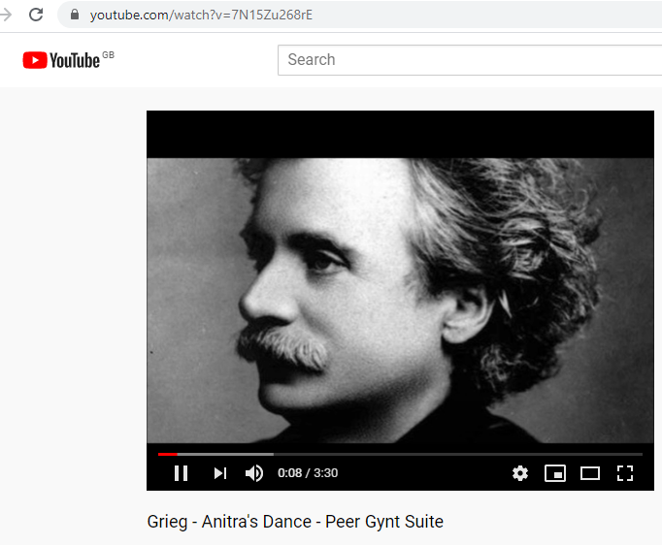
https://www.youtube.com/watch?v=7N15Zu268rE
Listen to this piece of music –
Peer Gynt Suite: Anitra’s Dance by Edvard Grieg written in 1875 - an orchestral composition from the Romantic period. Stand or sit to find the pulse or just listen to the music. In 1874, Henrik Ibsen asked Grieg to write some incidental music for the first performance of the play he had written about the Norwegian hero Peer Gynt. Many of the pieces from this work became very popular.

Discuss the music and what you can hear in it.
What can you hear? instruments, texture, tempo.
How does the music make you feel?
How old do you think this music is?
Does the music tell a story?
Do you like the music?
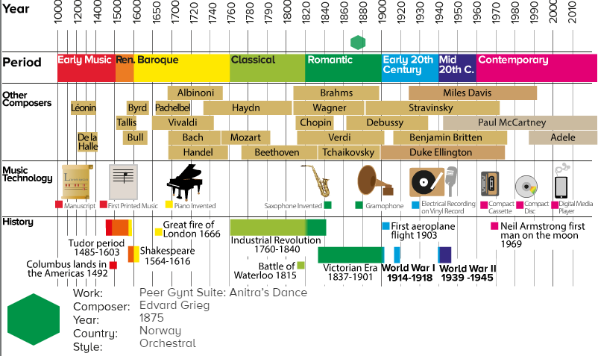
Find the correct period in History on the timeline.

