Year 2 Phonics/Spelling Practice – Tuesday 9.6.20. 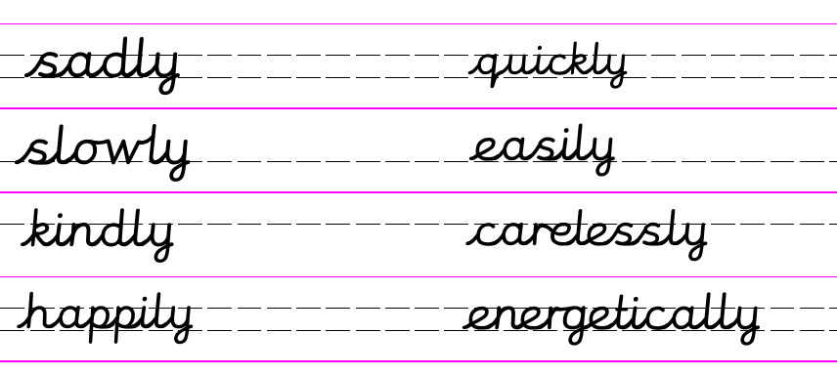
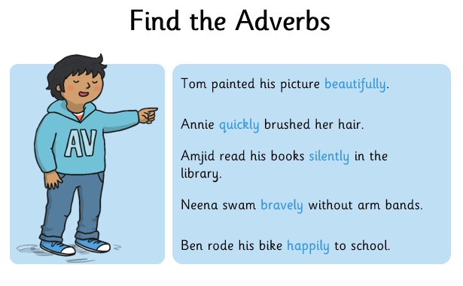
Remember, when the adjective ends in –y already – as it does in words like happy and easy, you change the y for an I before adding on the –ly.
Happy happily easy easily
Dictation:
Ask someone to read out the sentence below so that you can write it down – try not to look until after you’ve written it. Check your punctuation and spelling.
He happily and easily ran quickly around the field.
Now write a sentence of your own – include two adverbs ending in –ly.

Maths 9.6.20
Sharing
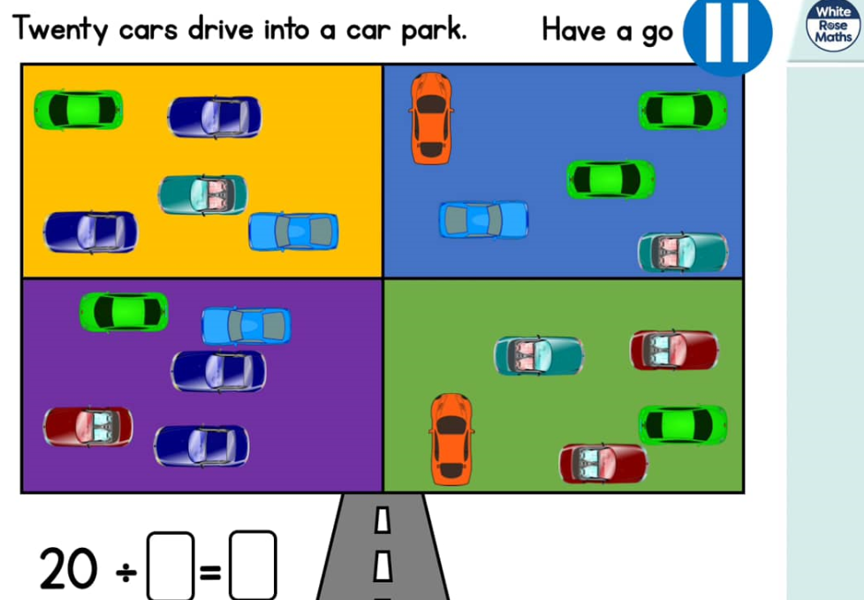
https://whiterosemaths.com/homelearning/year-2/ (Week 6 W/C 1.6.20)
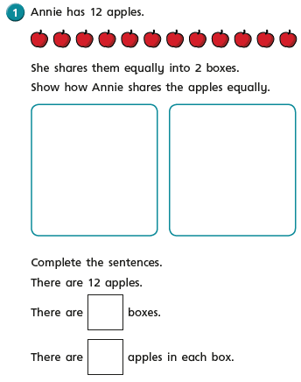
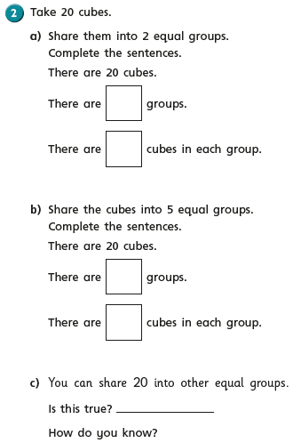

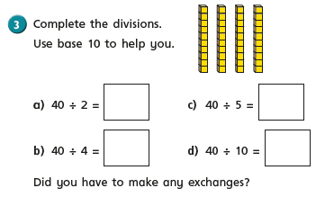
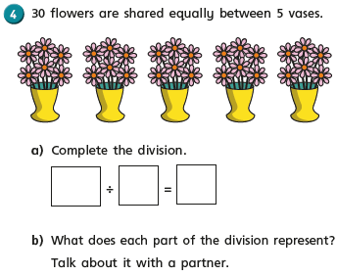
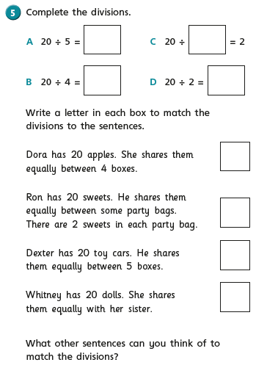

English - Tuesday 9th June 2020
WALT write a description of a scary setting using similes, repetition and metaphors..
WILF I can use repetition to add suspense.
Word of the day repetition/suspense.

Today you will need to go back to the YouTube copy of Wind in the Willows.
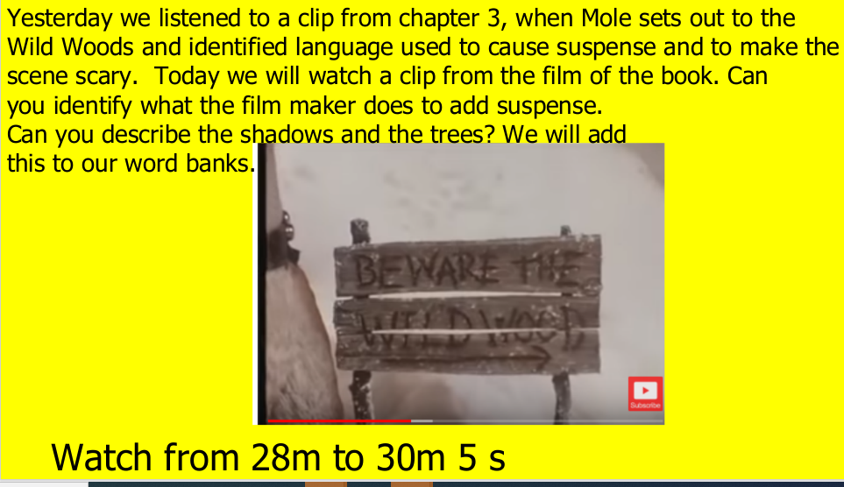

Today we are going to write our own scary settings based on ‘The Wild Woods’. Use the words you have identified from the the film clip and also the words you underlined/looked up yesterday.

I have written a WAGOLl (what a good one looks like) to help you.

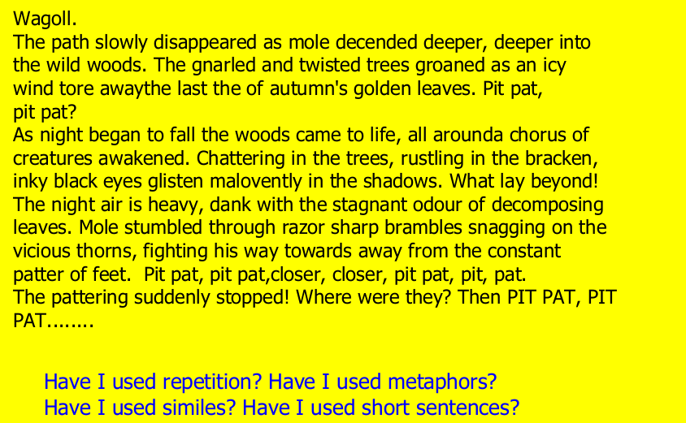

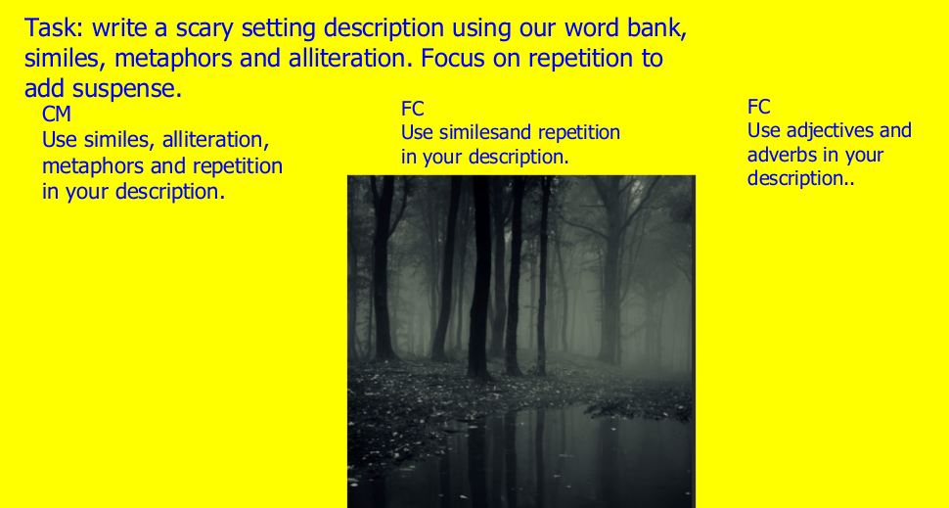

9.6.20 - Geography – Map Skills Part 1
WALT: draw a simple sketch map.
I can name different types of map and at least two key features.
I can begin to compare different types of maps.
I can explain what a sketch map shows.
I can draw a sketch map of my home area.

Today we will be learning how to sketch a map.

Read the information below and then create your own sketch map of the area where you live.

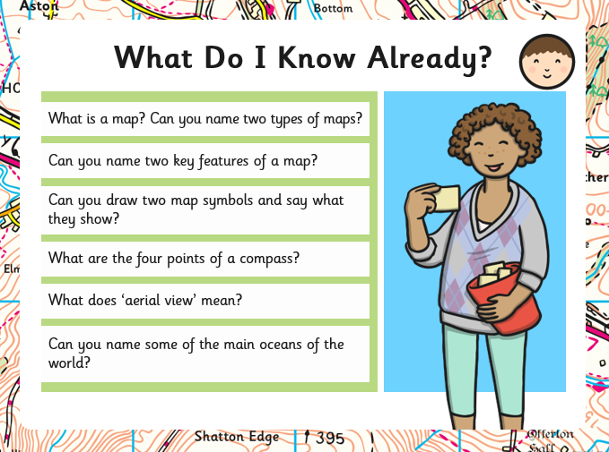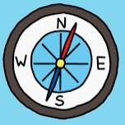
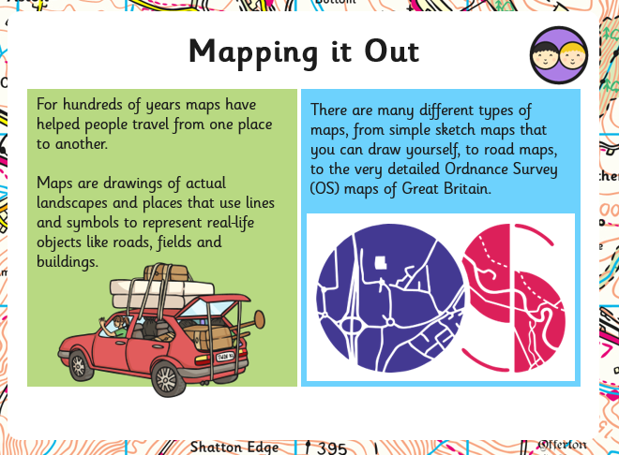
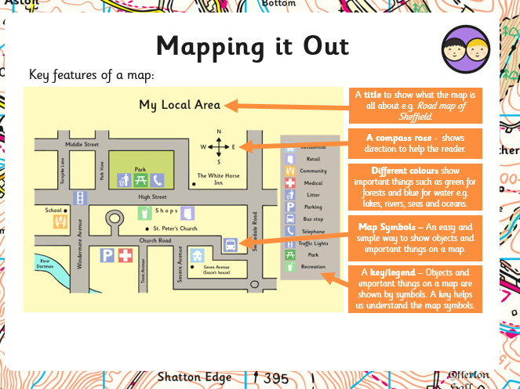
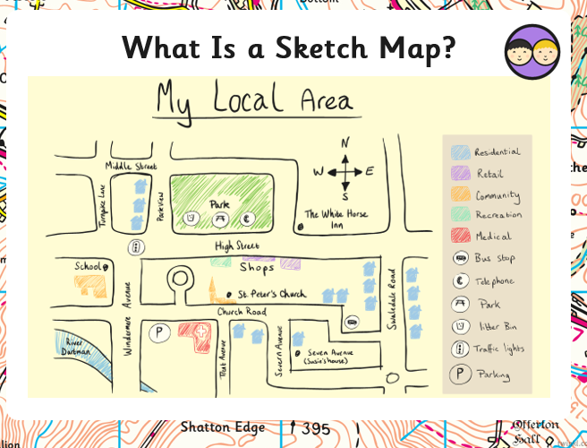

Task:

Draw a detailed map of the area where you live:
Include:
- A Title
- A compass
- Map symbols
- Colours to show different features
- A key

