Monday 11th May 2020 – English
SPaG
Spellings – Suffix - ous
joyous - ___________________________________________________________________
dangerous - ______________________________________________________________
hazardous - _______________________________________________________________
poisonous - _______________________________________________________________
riotous - __________________________________________________________________
mountainous - ____________________________________________________________
momentous - _____________________________________________________________
scandalous - ______________________________________________________________

Look up the meaning of each of these words in a dictionary so you understand what each word means.
Word of the Day – envy

Definition ____________________________________________
_____________________________________________________
_____________________________________________________
Used it in a sentence: ____________________________________________________
_________________________________________________________________________
Word Class: ____________________________________________________
Synonyms

English
Last week we looked at the book called The Egyptian Cinderella.
On Thursday you choose your own traditional tale and used a story map or story board to retell the story.

Today you need to go back to Thursday’s work and give it an Egyptian twist!

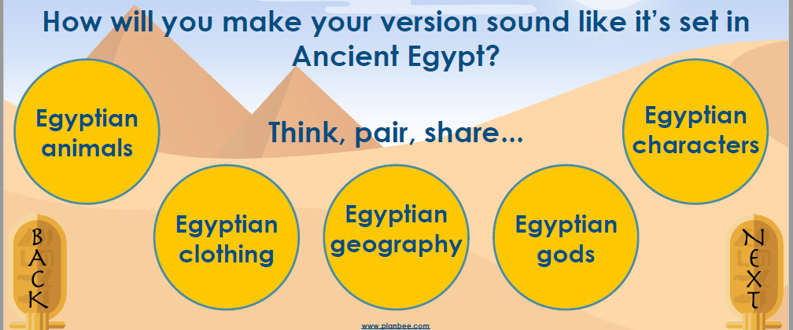

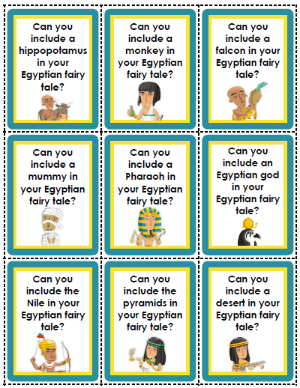
Example – Red Riding robe could be travelling along the Nile to visit her granny. Her mother told her to keep to the bank and not to walk in the shallow parts of the Nile because there are dangerous hippopotamuses.

Here are some helpful pointers

Maths Starter
Write how many thousands, hundreds, tens and ones there are in each of these 3-digit and 4-digit numbers.

1. 398 =

2. 217 =

3. 3709 =

Write the missing numbers or words.

4. 941 __________________________________________

5. _______________ three hundred and twenty-six

6. 534 __________________________________________

Maths Main Lesson – What are decimals?
Watch this song from Supermovers about decimals and fractions.
https://www.bbc.co.uk/teach/supermovers/ks2-maths-decimals-fractions-with-naomi-wilkinson/zf2gt39

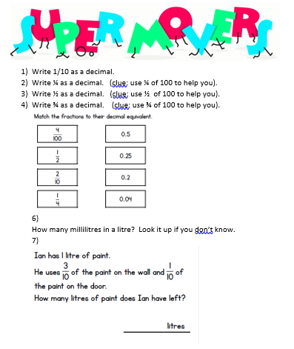

Art and Design
Look carefully at the hieroglyphic alphabet below, can you use it to draw your name? You could add colour to decorate it.
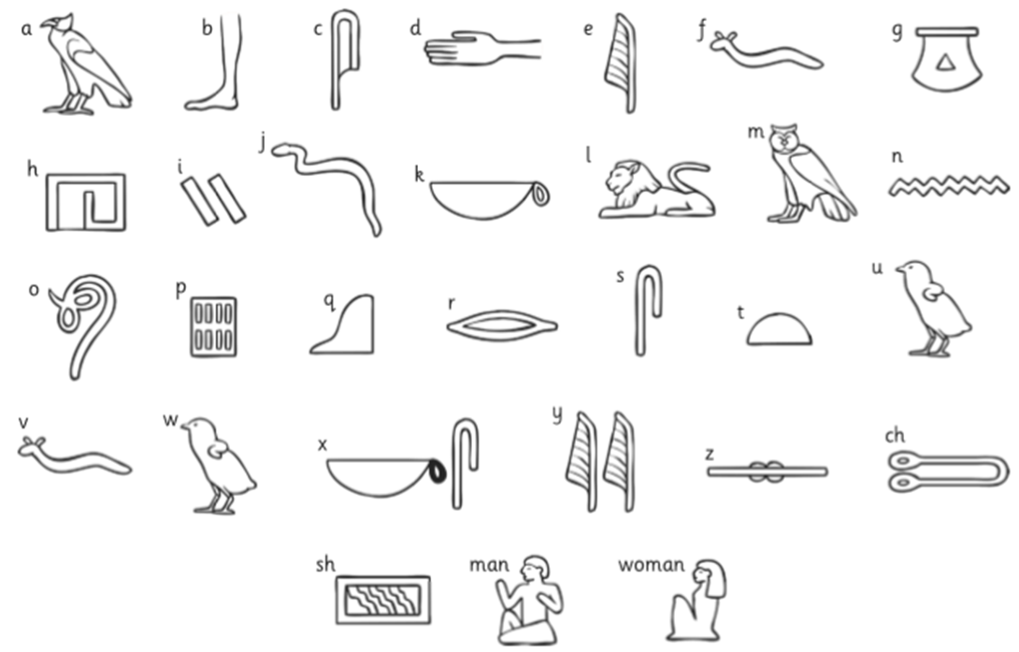

Challenge:
The dot above the letters ‘i’ and ‘j’ ,in the English language, is called a tittle. Which other symbols are used over the top of other letters in different languages?
Just for fun:
Most people find it tricky to explain their emotions and lots find it easier to use emoji’s than words. On average, people use around 30 emoji’s per person per day. So, my question is, do you think emojis are the modern day hieroglyphics? Could you use Emoji’s to tell a story?
