Year 2 Phonics/Spelling Practice – w/c 18.5.20 Monday
This week we are looking at longer words made up from two shorter words.
These are called COMPOUND NOUNS.
ie. football
Can you think of any others?
Practise writing your new spelling words each day using your best Russell handwriting.
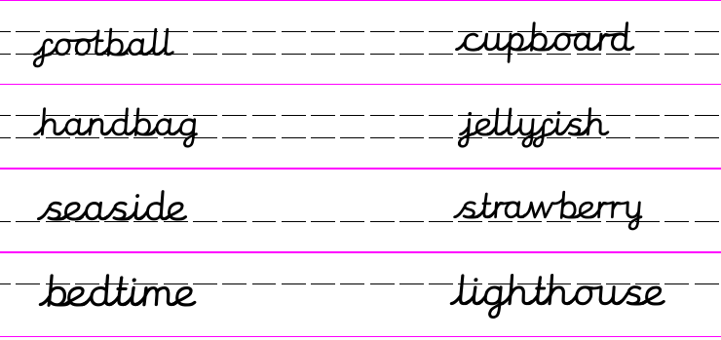
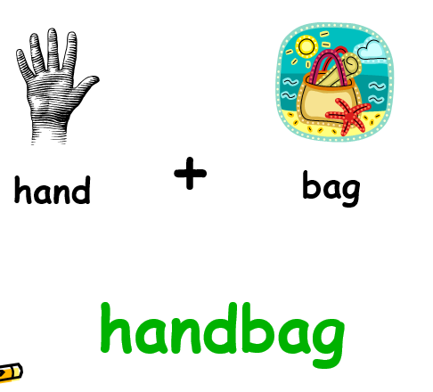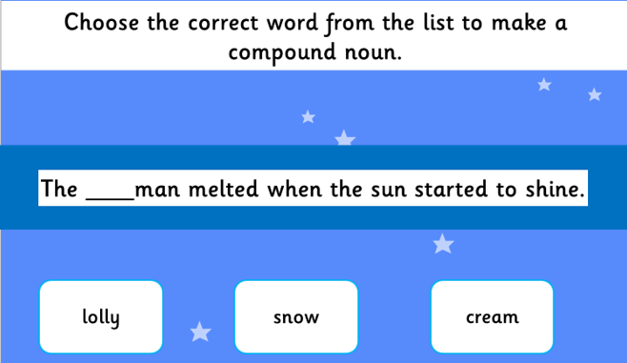
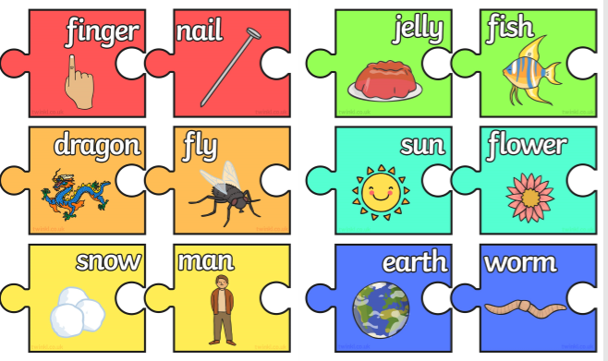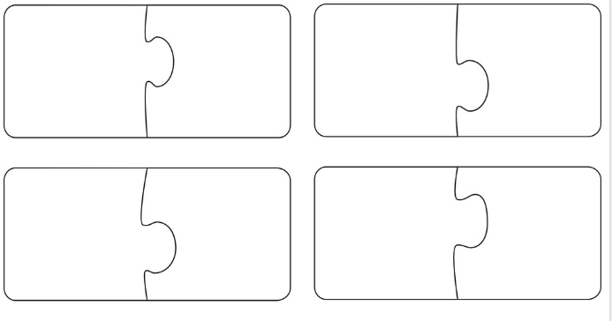
Today’s task: Make up your own jigsaw pieces to show other compound nouns or write the words down in two colours: snowman, dragonfly.
Maths 18.5.20 Adding and subtracting 10s
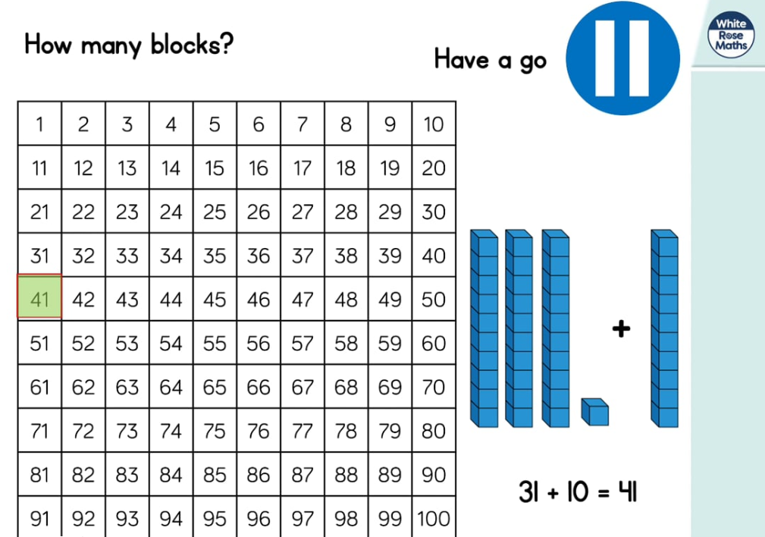
https://whiterosemaths.com/homelearning/year-2/ (week 4 dated w/c 11.5.20 Lesson 1)
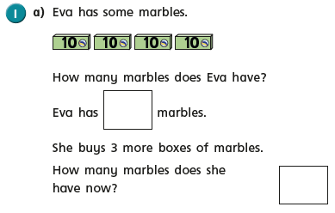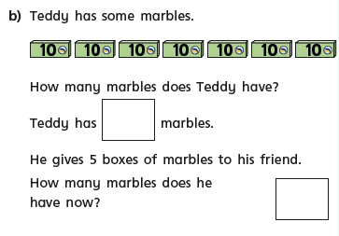
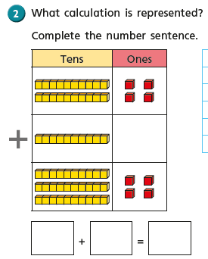
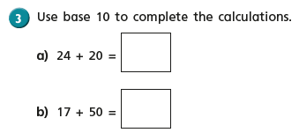

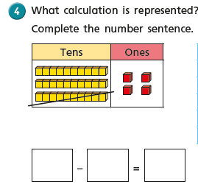
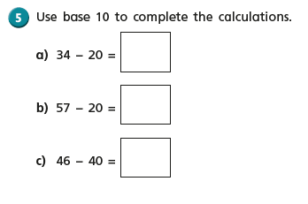

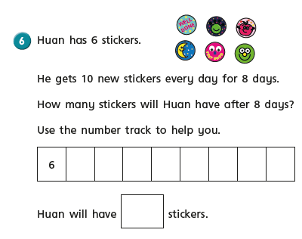
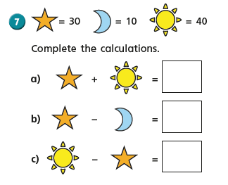
English - Monday 18th^{th} May 2020
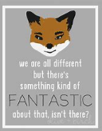
Inspirational quote of the day! Word of the day – suspense.
WALT write a character description about a character from Fantastic Mr Fox.
Welcome to week 5 and we are quickly approaching half term. This week in English we are looking at the story of Fantastic Mr Fox by Roald Dahl. I am so disappointed that we cannot read this story together as it is one of my favourites.

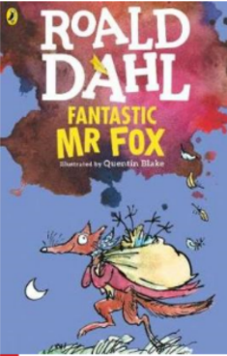
What do you think the story is about?
What clues do we get from the title?
How many other books do you know by Roald Dahl?
What sort of books does he write?
Here is the blurb from the back of the book. Does it make you want to read the story?

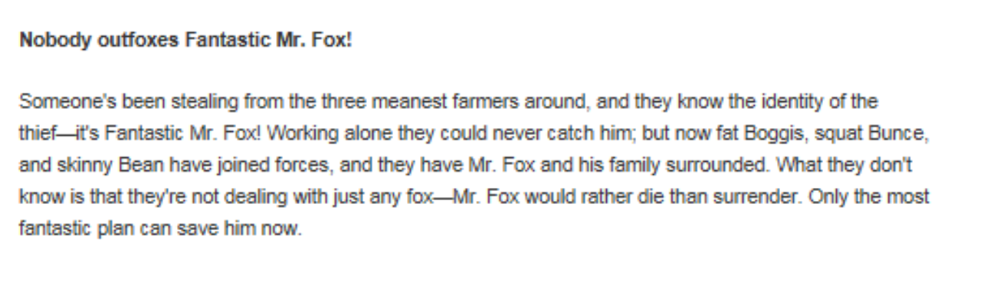

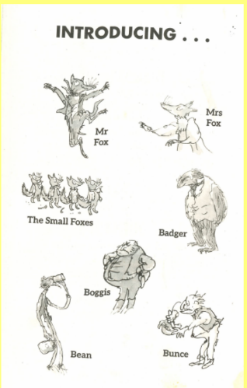
These are the main characters in the story. What do you think they will be like? Why? What can you tell about them from their picture?

I am now going to ask you to read the first few chapters from the story. If you find it too difficult get a grown up to read it to you. Remember to stop them if there are any tricky words you don’t understand or if you have questions about what they have read.

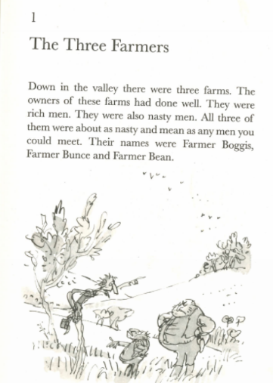
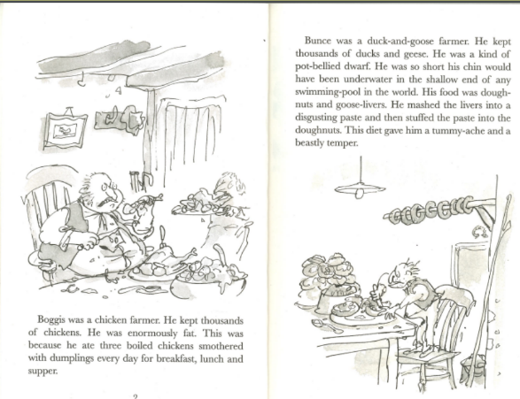

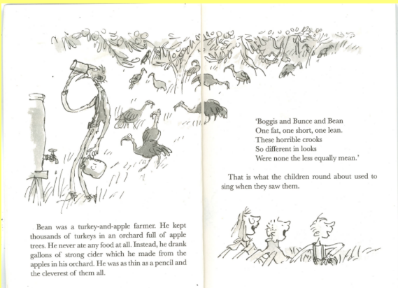

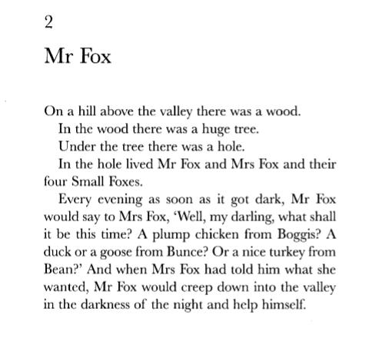
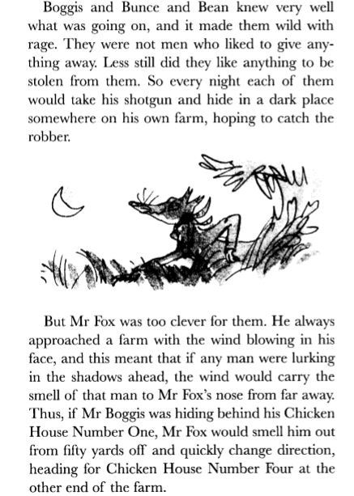

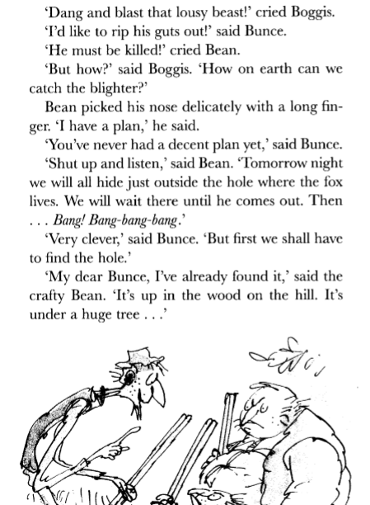

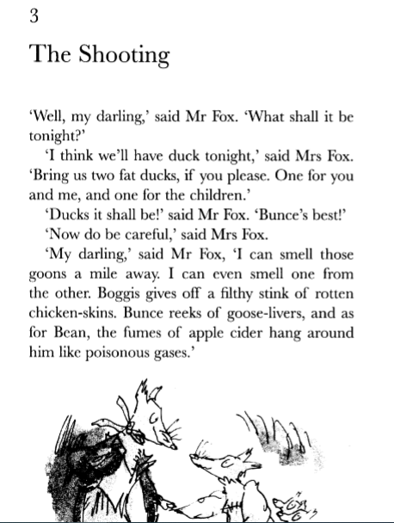

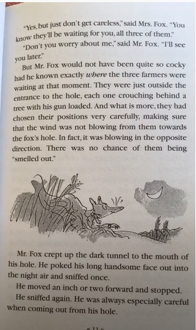

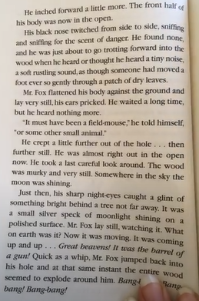
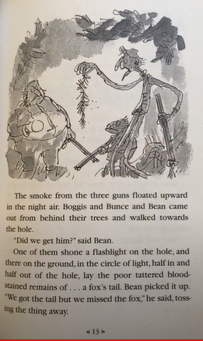
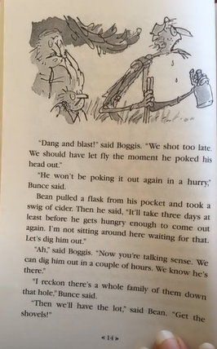

Your task today is to choose one of the characters mentioned so far and to create a character profile of them.

You should include a picture of them. Sentences about their appearance, personality, characteristics and diet.

Have fun.

PSHE 18.5.20
WALT: to describe how it feels when everyone works cooperatively - how it feels to have your needs met by your group/class (helped with work, sharing equipment, listening to others).
Today we are thinking about how we can work together to make a job easier or more enjoyable. We can call this team work, collaborative working and cooperation.
Watch this cute YouTube video to see both humans and animals working together to get the job done https://www.youtube.com/watch?v=K8rXwpXyCWU
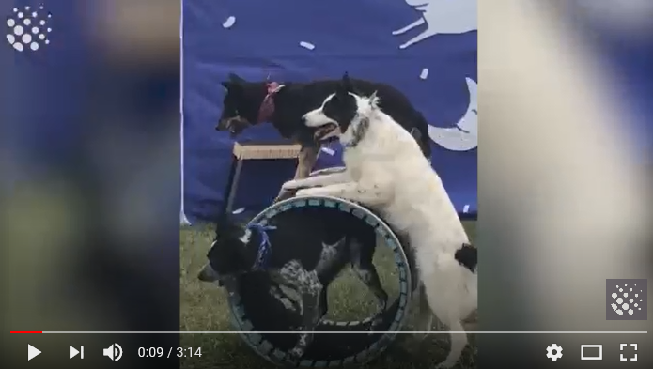
Can you think of a time when you have worked collaboratively either at home or at school to get the job done?
Task: Draw a picture to show when you have worked together either at home, in school or any other place. Write 2 or 3 sentences about how working together make things easier.

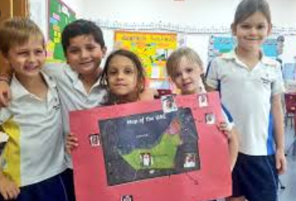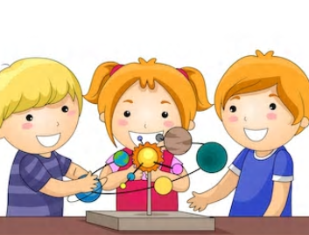
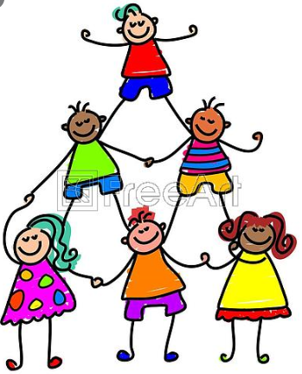
18.5.20 Year 2 Music Summer Term 1 Week 5
FRIENDSHIP SONGS
You might recognise this week’s Friendship song. Do you know which film it’s from?
https://www.youtube.com/watch?v=EcXURC_nNhc (music only with lyrics)
https://www.youtube.com/watch?v=nMN4JZ8crVY (music with video clips from the film Toy Story)
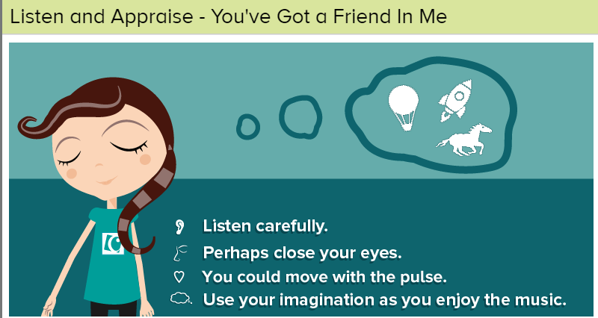
You might see colours, words, pictures, or encounter lots of different feelings. Share some of this with each other after you have listened. Play the music/song. Move to the music or sit down to listen with closed eyes. Perhaps make notes, draw, write down any words that spring to your minds. You might create your own listening map - a visual representation of what you hear. (But you don’t have to!)
● Does this song tell a story? Perhaps the words tell a story or perhaps the music creates a story in your imagination. What is that story?
● What can you hear? Piano, strings, brass, bass, drums, clarinet, saxophones, backing vocals. This is very jazzy.
● How does the music make you feel? Music brings many emotions along with it and often each person feels something different. Perhaps share with each other how the music makes you feel.
● What did you like about the song? It doesn't matter if you like or don't like a song or a piece of music. Think about the reasons why you do or don't.
Fast Facts Information about the song:
● 'You've Got A Friend In Me’ is a song written and first recorded by Randy Newman.
● It was originally written as the theme song for the 1995 Disney/Pixar animated film Toy Story.
● The song has since become the theme song for all its sequels, Toy Story 2 (1999) and Toy Story 3 (2010).
● It is the musical theme throughout all the Toy Story films.
● The song was nominated for many awards.

Year 2 Music Summer Term 1
FRIENDSHIP SONGS

Over the past 5 weeks we have listened to lots of songs about Friendship.
- Did you have a favourite?
- Why did you like it?
- Was it the song that you liked or did you like it because of the instruments used in it or because it was familiar to you?
- Perhaps you liked it because the lyrics (words) meant something to you?

Today, perhaps you (and your grown ups) could look for other songs about Friendship.
Internet Safety - Remember if you are searching the Internet for songs, in order to stay safe you should ask an adult to help you.
If you can’t find any of your own, perhaps try these:
I searched under ‘Disney songs about friendship’ and ‘friendship songs for children’
- Everything by Michael Buble (Lilo and Stitch)
- Lean on Me by Bill Withers
- That’s what friends are for – The Jungle Book
- You’re my best friend by Queen
- The Best of Friends – Disney The Fox and Hounds.

ENJOY LISTENING TO MUSIC……

18.5.20 Music FRIENDSHIP SONGS
You might recognise this week’s Friendship song. Do you know which film it’s from?
https://www.youtube.com/watch?v=EcXURC_nNhc (music only with lyrics)
https://www.youtube.com/watch?v=nMN4JZ8crVY (music with video clips from the film Toy Story)
You might see colours, words, pictures, or encounter lots of different feelings. Share some of this with each other after you have listened. Play the music/song. Move to the music or sit down to listen with closed eyes. Perhaps make notes, draw, write down any words that spring to your minds. You might create your own listening map - a visual representation of what you hear. (But you don’t have to!)
● Does this song tell a story? Perhaps the words tell a story or perhaps the music creates a story in your imagination. What is that story?
● What can you hear? Piano, strings, brass, bass, drums, clarinet, saxophones, backing vocals. This is very jazzy.
● How does the music make you feel? Music brings many emotions along with it and often each person feels something different. Perhaps share with each other how the music makes you feel.
● What did you like about the song? It doesn't matter if you like or don't like a song or a piece of music. Think about the reasons why you do or don't.
Fast Facts Information about the song:
● 'You've Got A Friend In Me’ is a song written and first recorded by Randy Newman.
● It was originally written as the theme song for the 1995 Disney/Pixar animated film Toy Story.
● The song has since become the theme song for all its sequels, Toy Story 2 (1999) and Toy Story 3 (2010).
● It is the musical theme throughout all the Toy Story films.
● The song was nominated for many awards.

