Day 1 - Week Beginning 13th July 2020 – English
SPaG
Words with the k sound spelt with que
mosque - _________________________________________________________________
unique - __________________________________________________________________
antique - _________________________________________________________________
plaque - __________________________________________________________________
cheque - _________________________________________________________________
boutique - ________________________________________________________________
picturesque - ____________________________________________________________
grotesque - _______________________________________________________________

Look up the meaning of each of these words in a dictionary so you understand what each word means.
Word of the Day – nonchalant
Definition ____________________________________________
_____________________________________________________
_____________________________________________________
Used it in a sentence: ____________________________________________________
_________________________________________________________________________
Word Class: ____________________________________________________

Synonyms

English - See loom intro video first. –
Link – https://www.loom.com/share/38225168725242e9a0539db662cc73f2
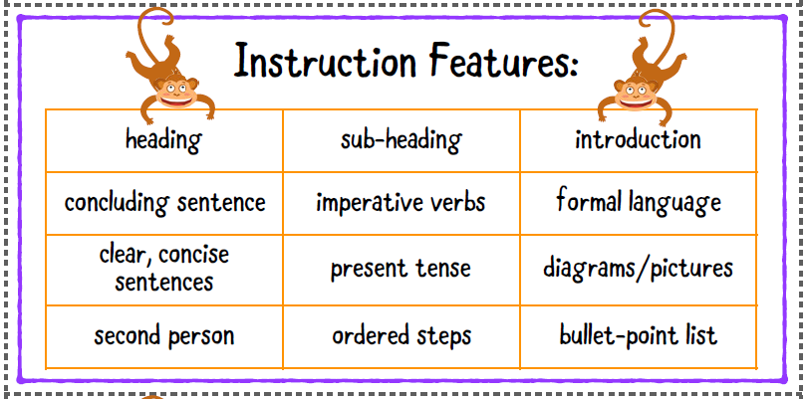
Read The Glass Eye Trick below. Use the Features Card to label all the features of instructions that you can see.

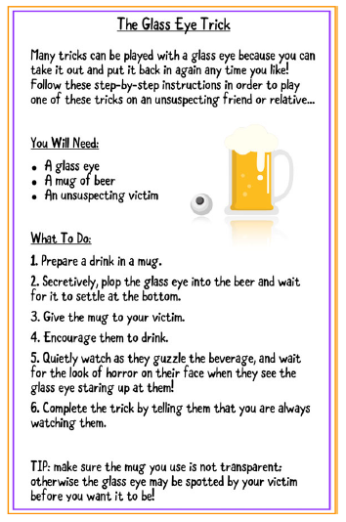

Maths
Day 1 – starter
- 432 + 349
- 543 – 272
- 44 x 8
Watch this video which explains about translations - Corbett maths. Watch the first 2 minutes
https://www.youtube.com/watch?v=8Dtz5fBe7_Q&safe=active
A translation is when we move a point or a shape on a grid, without changing the shape.
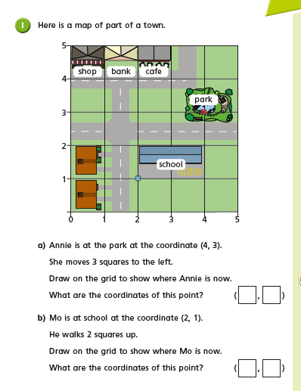
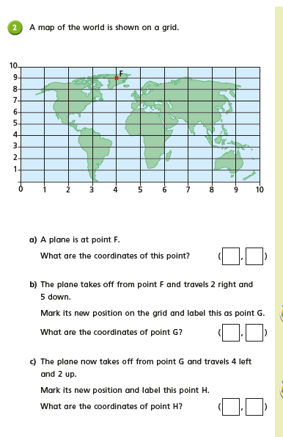

Day 1 Science
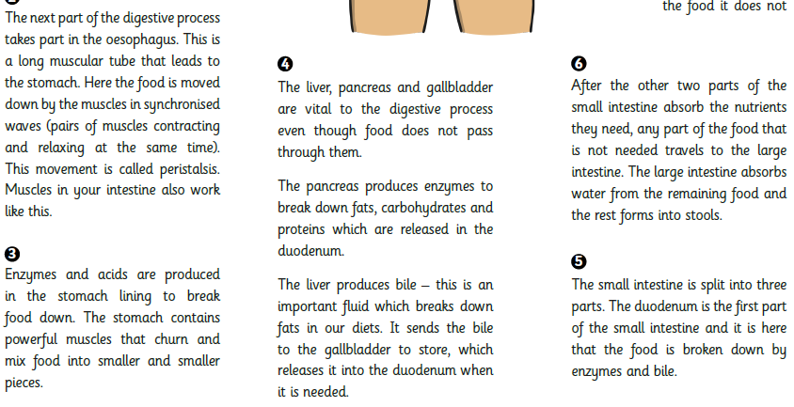
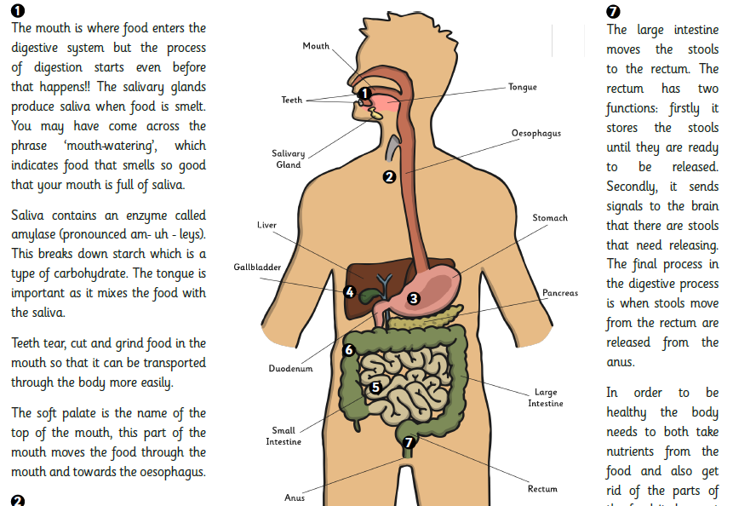
Task: Read the information below about digestion. Use the information to help you label your own picture of the human digestive system and describe the main function of each part. When you are finished you could look back at last week’s picture, which you drew, are there any new organs you have

