Wednesday 22nd April 2020
SPaG
Spellings – To apply the prefix sub
subtotal | subtitle | substitute | subplot
subheading | subdivide | submerged | subtropical

Challenge! Write each of your words. Go over the vowels in a coloured pencil.
subtotal

Challenge! How many syllables are in each of your spelling words? Remember to clap them out! Make your own pairs game by segmenting each word into its syllables.
tal
to
sub

English

Fronted Adverbial Phrases

Adverbial phrases are used to explain where, when or how something happened. Fronted adverbials are ‘fronted’ because they appear at the front of the sentence. Fronted adverbials are single words or phrases at the beginning of a sentence. Commas are needed at the end of a fronted adverbial phrase.

Here are some examples:

Gently, she lifted the sleeping baby. (how)
Last week, I walked to the park. (when)
At the park, I saw lots of families enjoying their walk. (where)

Challenge! Try writing your own sentences using some of these fronted adverbial phrases.
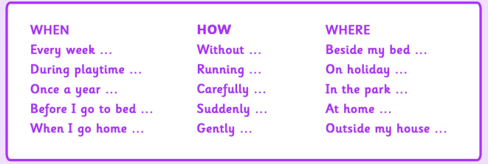

Maths
Four Awesome Operations
Addition (using column method)  714 + 222 | Subtraction (using column method)  239 – 143 | Multiplication (using grid method)  23 x 4 | Division (using sharing of place value counters)  26 ÷ 3
Money
Subtract these money amounts:
Give your answer in pence
- 88p – 45p =
- 34p – 17p =
- 79p – 65p =
- 42p – 39p =
Give your answer in pounds: (In Year 3 we are not expected to subtract decimals so please convert these amounts to pence first BEFORE subtracting)
- £1.75 - £0.61 =
- £5.36 - £2.22 =
- £8.58 - £4.32 =
- £9.99 - £4.44 =
- £6.28 - £4.28 =
- £4.57 - £3.15 =
- £7.25 - £3.52 =
- £9.44 - £7.18 =
- £45.58 - £22.34 =
How much more?
Thomas has £2 and 90p. Benjamin has three times as much money as Thomas.
How much more money does Benjamin have than Thomas?
Rosie has twice as much money as Benjamin. How much more money does Rosie have than Thomas?

Design and Technology
In DT we are going to be creating our own healthy sandwich! What is your favourite sandwich filling? Could you ask the other members of your household what their favourite filling is?

Challenge! Go through some of the food you have at home, can you identify which food group it belongs to? You might like to make a list of all the items you sort. Use the help mat below to help you!

For example, in my kitchen I have a loaf of bread which belongs in the carbohydrate good group.
