Tuesday 9th June 2020
English
SPaG
Spellings – Words with a zhuh ending spelt sure
Practise your spellings – try making a fortune teller to help practise the words.
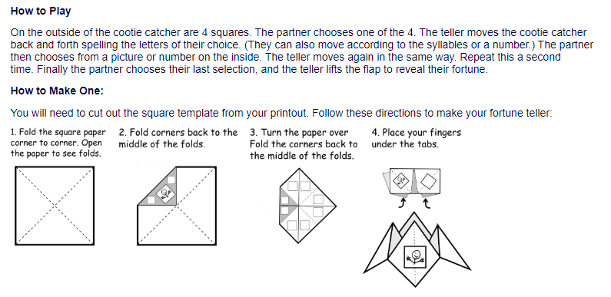
unsure
leisure
measure
closure
treasure
pleasure
composure
enclosure

Word of the Day – Orchard

Definition ____________________________________________
_____________________________________________________
_____________________________________________________
Used it in a sentence: ____________________________________________________
_________________________________________________________________________
Word Class: ____________________________________________________
Synonyms

English - Watch this video which will explain what an explanation text is.
https://www.bbc.co.uk/programmes/p02lr49p
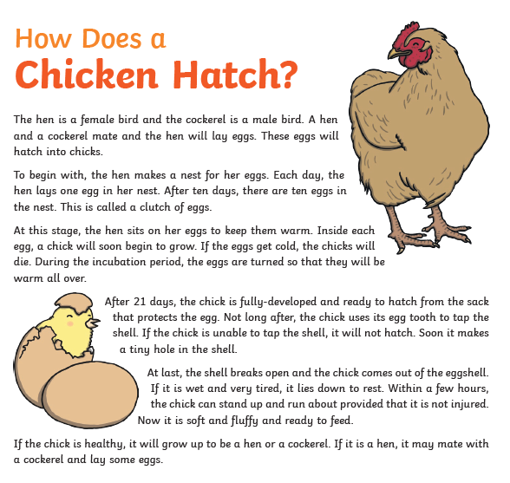
Your task is to look at the text below and see what features on the checklist can be found. Are there any missing?
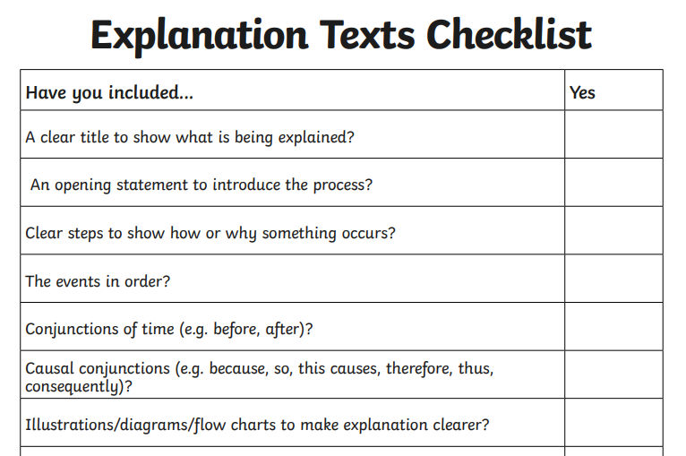

Maths
Starter
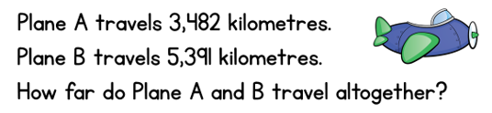
Watch the children make amounts of money with this video. https://www.bbc.co.uk/bitesize/clips/zgyb9j6
Is 100p equivalent to £1.00? Is 500p equivalent to £5.00? Yes of course they are. Which is greater £5.07 or £5.70, why?
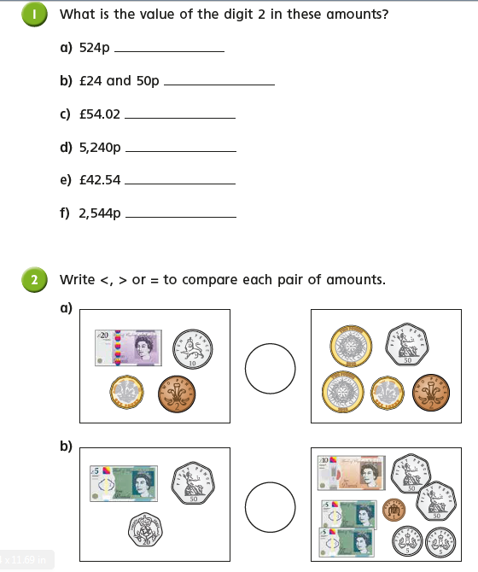

PSHCE (the world around us)
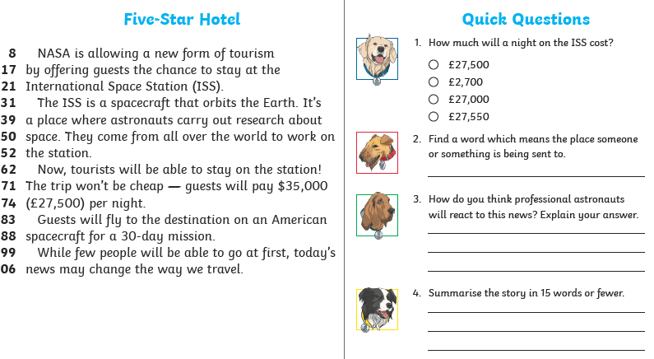
Challenge: Find out about the international space station, where is it? What is it? What are the names of the astronauts who are on the ISS now?

