NOVEMBER NEWSLETTER
November 2021
Dear Parents/Carers,
Welcome to our November newsletter. These newsletters are sent out on a monthly basis to keep you informed about what is happening in school. If you ever want to contribute an ‘article’ or suggest information that should be on the newsletters, I would be delighted to hear about them.
Please note events that are underlined and in italics are new since the previous newsletter.
Sunday 14th November – Remembrance Service starting at St Andrew’s at 10am, finishing at the Cenotaph
Monday 15th November – Road Safety week, Anti-bullying week (Odd sock day to celebrate ‘One Kind World), Rotary Shoebox appeal assembly, 6:30pm Curriculum, Learning and Standards Governors’ meeting, SHEU Survey in Y4 (letter to Y4 parents will follow)
Tuesday 16th November – Rescheduled Y3 Seed Collection Visit to Ampthill Park (am)
Wednesday 17th November – Year 4, Year 3 and Foundation Stage Hinduism Workshops,
Thursday 18th November - 9:30am – New Intake Meeting (5)
Friday 19th November – Children in Need Day (see below) and Rotakids Bake Sale on the field from 3:30pm – bring in some money and buy a sweet treat after school from our Rotakids
Monday 22nd November – possible flu immunisations – TBC
Wednesday 24th November – Foundation Stage Maths Workshop for parents 9:15 – 10am, KS1 and KS2 Maths Workshop for parents 2:30 – 3:15pm, (socially distanced, main school hall – please see below and sign up via the 2 second Google Form)
Monday 29th November – Santa Challenge begins in school, Full Governors’ meeting at 6:30pm
Wednesday 1st December – Year 4 Archery festival (TBC), Foundation Stage Nativity to nursery children and Swan Class parents at 9:30am (more details to follow)
Thursday 2nd December – New Intake Meeting (4) at 9:30am
Saturday 4th December – all weekend - St Andrew’s Christmas Tree Festival
Monday 6th December – 9:30am – Foundation Stage Nativity to Dove parents (more details to follow)
Tuesday 7th December – 2:45pm – Foundation Stage Nativity to Swift parents (more details to follow) Y4 Samba Performances to parents (Woodpecker Class at 9:30, Starling Class at 10:30 and Kingfisher Class at 11:45) (more details to follow), 5:30pm PTA join the Ampthill Lions Christmas Float around Russell
Wednesday 8th December – 9:30am Year 2 Performance to Greenfinch parents, Christmas Lunch Day
Thursday 9th December - 9:30am Year 2 Performance to Penguin parents, 2:30pm Year 2 Performance to Robin parents
Friday 10th December – Christmas Jumper Day and Activity Morning, PTA ‘Elfridges’ and Father Christmas visit (TBC)
Monday 13th December – Year 2 Theatre trip (morning)
Thursday 15th December – Year 1 Theatre trip Year 3 Theatre Trip (am), Foundation Stage Theatre trip (pm)
Friday 16th December – Year 3 Theatre trip Year 4 Theatre Trip (am) and Year 4 Theatre Trip Year 1 Theatre Trip(pm)

CHRISTMAS HOLIDAY MONDAY 20TH DECEMBER – MONDAY 3RD JANUARY 2022

Tuesday 4th January 2022 – All children return to school – NO INSET Day, Ice skating event in school (more information to follow)
Wednesday 5th January 2022 – Ice skating event continues (more information to follow)
Thursday 6th January – 9am and 2:45pm – Parent Volunteers in School Induction sessions, Year 3 swimming (more information to follow)

Please see the school website for more dates beyond this
More detailed information on the above events will follow in due course

Covid update
Thank you for all your continued support with managing the Covid-19 risk in the community. We are continuing to limit the impact on the children’s education between us. Thank you for your on-going vigilance. Please find attached the latest flowchart from CBC for your information.

Parking and drop-off and collections:
Following several complaints from our neighbours and other parents, can I please remind everyone not to block residents drives, or park on pavements. By parking on pavements, we force many pedestrians (especially those with buggies or wheelchairs) onto the road. As you can imagine, this is incredibly dangerous.
In addition, can we please request that as the weather gets colder you do not wait in cars with the engine running? As Year 4 found out on their ‘climate walks’, this pollutes the air around school significantly, which of course we then all breathe in. Thank you in advance.

Attendance:
Now, more than ever, every single morning and afternoon of your child attending school is vital. Children lose confidence and feel behind their peers incredibly quickly. We are seeing an enormous rise in the requests for term time holidays. Please can we ask you to try, wherever humanly possible, to avoid this. We really want to be able to support children to ‘catch up’ lost learning whenever possible. In addition, please make every possible effort to get siblings to school if only one child is unwell. Thank you for your support.

Inappropriate viewing:
Please can we ask for your support in protecting children from inappropriate viewing? Sadly, many of our children are re-enacting really quite nasty and frightening ‘games’ and ‘chants’ that they are seeing/hearing from games such as Fortnite and programmes such a ‘Squid Games’. These have ratings as old as ‘15’ and are having a detrimental effect on children’s play and well-being at school. Thank you in anticipation.

Kitchen/Caterlink update:
Thank you for your patience whilst we experienced some supply and staffing issues earlier in the term. I am delighted to report that these issues have been resolved now and the children are delighted with their school meals again. Thank you again for your support and understanding.

Children in Need – Friday 19th November
This year’s theme is ‘Together we can’ – very apt! We will be supporting this charity and encouraging children to wear ‘spotty accessories’ (please note: children should still wear school uniform, but may opt for a spotty hairband, tights, socks, face paint, scarves, CIN ‘ears’ etc.). If you would like to donate to this very worthy cause, please do so via Parent Pay using this link. Thank you. https://app.parentpay.com/ParentPayShop/Foc/Default.aspx?shopid=3876

Christmas Events:
Sadly, some Christmas events will be different again this year, but we have tried our best to adapt and carry on. Due to recent CBC guidance, we are unable to hold any events that bring significant numbers of parents into school/together, so unfortunately, we cannot hold a Christmas Fayre, Breakfast Morning or KS2 Church service this year. However, the run up to Christmas at Russell this year will still include lots of festivities:

- Christmas Activity Morning/Christmas Jumper Day – 10th December – please send the children to school in their favourite Christmas jumper and enjoy a festive morning of ‘crafty’ Christmas activities, PTA ‘Elfridges’ and Santa Visit (TBC with more details to follow). Donations will be collected for Save the Children via this Just Giving page: https://christmas.savethechildren.org.uk/fundraising/cjd210002098
- Children are welcome to exchange Christmas Cards within their classes, but there will not be a school wide postal box again this year – sorry!
- Christmas parties – we will continue to have parties in our classes, but will just ask for one ‘treat snack’ to be brought in to be eaten instead of sharing party food. More information to follow from the teachers.
- Christmas lunch with teachers and crackers; fun and music – 8th December – menus home soon!
- Christmas Theatre trips will take place in year group ‘bubbles’ (please note the change of day for some year groups above) – more details to follow
- Christmas Nativity and Year 2 Performances will go ahead with one performance for each class. We will have to limit each performance to one adult per child to enable social distancing (without which, we cannot go ahead at all!). I do understand what a difficult choice this will be (and how disappointing), but it is the only way we can carry on with an ‘in person’ event. You are more than welcome to film these, provided they are for your own personal use only. (Please do not post on social media).

Maths Workshops – Wednesday 24th November – Foundation Stage 9:15 – 10am, Years 1 – 4, 2:30 – 3:15pm (main hall):
Would you like to find out more about how we teach Maths at school and how you can better support your child? Please come along to our Parent Workshops to find out more. To comply with social distancing requirements please sign up in advance by completing the appropriate Google Form:
Foundation Stage 9:15 – 10am 24/11/21 https://forms.gle/Ky9PuMEXzgt3f2dD9
Years 1 to 4, 2:30 – 3:15pm 24/11/21 https://forms.gle/HhQLfi1BZysnsyuc8

PTA updates:
Well done to everyone who took part in the PTA Pumpkin trail over half term. Lots of families and children took part, with Jensen in Wren Class being the lucky winner of first prize! Well done Jensen – you cracked all the clues!
Are you starting your Christmas shopping? A reminder that if you shop at smile.amazon.co.uk then Amazon will donate 0.5% of the net purchase to the PTA. Just select Russell Lower School PTA and remember to shop on Amazon Smile to support the PTA.
Christmas Wreath Making event – there is still space on the Wednesday 8th December session. Contact pta@russell-lower.co.uk if you want to know more about this creative, fun and sociable Christmas event.

Coming soon:
A new bike and scooter shelter in the KS1 playground (you may well have noticed that the old one is now very much past its best!)

Community Events:

Christmas Tree Festival and Christingle Service
St Andrews Church is delighted to announce that the Christmas Tree
Festival is back for 2021!
This year’s event will be on
Saturday 4th December 10.00 am – 4.30pm
&
Sunday 5th December 11.00am – 4.00pm
Christingle service from 4.30pm on Sunday all are welcome.
Special guests
Natalie &amp; Jeremy, Sloop Groggy Dogs, Ampthill Town Band,
Ampthill Choral Society
There will be live music & story tellers throughout the event
Refreshments will be available, with gift & produce stalls and a raffle.
Entry £2.50 if you are over 14 years of age. If you are under 14 you can
come in free! There is no charge for entry during services.
www.ampthilltrees.com

School admissions to Foundation Stage in September 2022 and Middle Schools:
We have been incredibly popular again this year, and even our FIFTH open day, which was added due to the fourth being over-subscribed, is now full! Please do make your application if you have a child due to start lower school or middle school in September. Thank you.

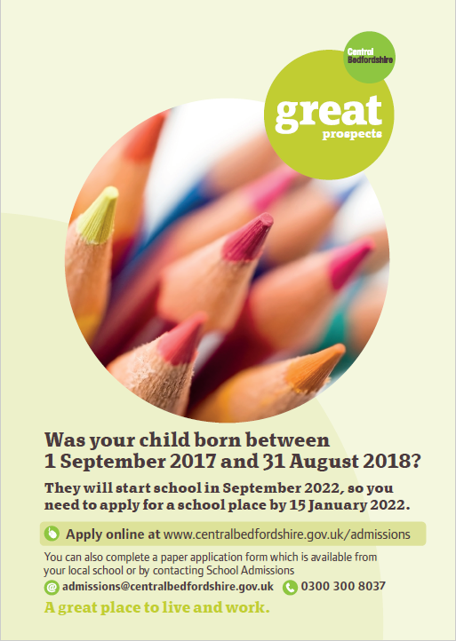
It’s that time of year again!

Children born between 01/09/17 and 31/08/18 are due to start school in September 2022.

Parents/ carers need to make an application to CBC by 15 January 2022, even if their child attends a nursery/pre-school on the school site.

All the information you will need regarding your Starting School 2022 application is available on the CBC website.

Please bear in mind that applications for Middle School are also needed within the same timescales i.e before 15th January 2022.

School admissions | Central Bedfordshire Council

And finally
Thank you for taking the time to read this newsletter. Have a wonderful weekend.
Many thanks and kind regards,
Nicki Walker
Headteacher

