Sports Premium 2018-2019
What is the Sports Premium?
The Government is providing additional funding for the next academic year 2018 to 2019 to improve provision of physical education (PE) and sport in primary schools. This funding has been provided jointly by the Departments for Education, Health and Culture, Media and Sport. This funding is ring-fenced and therefore can only be spent on provision of PE and sport in schools.
Each school will receive £16,000, plus £10 for each pupil in years 1 – 6.
The total that Russell Lower will receive this year, is £18,960
Schools must use the funding to make additional and sustainable improvements to the quality of PE and sport they offer.
This means we should use the premium to:
- develop or add to the PE and sport activities that our school already offers
- make improvements now that will benefit pupils joining the school in future years
The Impact of this Funding to Date
- The DfE vision for Primary PE and Sport Premium is that “all pupils leaving primary school will be physically literate and have the knowledge, skills and motivation necessary to equip them for a healthy, active lifestyle and lifelong participation in physical activity and sport”. To achieve self-sustaining improvement in the quality of PE and sport in our school we need to demonstrate how we are achieving this against the following indicators: -
- The engagement of all pupils in regular physical activity - the Chief Medical Officer guidelines recommend that all children and young people aged 5 to 18 engage in at least 60 minutes of physical activity a day, of which 30 minutes should be in school
- The profile of PE and sport being raised across the school as a tool for whole school improvement
- Increased confidence, knowledge and skills of all staff in teaching PE and sport
- Broader experience of a range of sports and activities offered to all pupils
- To increase participation levels in competitive sport and healthy activity of pupils.
Possible uses of the funding include:
- hire qualified sports coaches to work with teachers
- provide existing staff with training or resources to help them teach PE and sport more effectively
- introduce new sports or activities and encourage more pupils to take up sport
- support and involve the least active children by running or extending school sports clubs, holiday clubs and Change4Life clubs
- run sport competitions
- increase pupils’ participation in the School Games
- run sports activities with other schools

How do we intend to spend the funding?
At Russell Lower we intend to use the sports premium funding to:
Objective | Estimated Cost  Actual cost | Link to 5 indicators
- Join the Redborne School Sport Partnership (SSP). This provides support for local schools including professional development for teachers and entry into all local school festival and transition events. | £2,900  £2,900 | Increased confidence, knowledge and skills of all staff in teaching PE and sport  To increase participation levels in competitive sport and healthy activity of pupils.  A range of festivals attended including Paralympic  The engagement of all pupils in regular physical activity.  The profile of PE and sport being raised across the school as a tool for whole school improvement
- Children to take part in sports ambassador training.  Sports Ambassadors to lead lunchtime games for all pupils on rotation throughout the week. | Included in above cost. | To increase participation levels in competitive sport and healthy activity of pupils.  To increase the engagement of all pupils in regular physical activity.  The profile of PE and sport being raised across the school
- Upskill staff through whole school CPD opportunities. 1 day of dance with lunch CPD,1 day of gym with lunch CPD and 1 day of judo with CPD. | Included in above cost. | The profile of PE and sport being raised across the school as a tool for whole school improvement  Increased confidence, knowledge and skills of all staff in teaching PE and sport
- All pupils to be offered new sport experiences. | Included in above cost | The engagement of all pupils in regular physical activity.  The profile of PE and sport being raised across the school as a tool for whole school improvement  Broader experience of a range of sports and activities offered to all pupils
- YST membership at level 2 | Included in above cost | The engagement of all pupils in regular physical activity  The profile of PE and sport being raised across the school as a tool for whole school improvement  Increased confidence, knowledge and skills of all staff in teaching PE and sport  Broader experience of a range of sports and activities offered to all pupils  To increase participation levels in competitive sport and healthy activity of pupils.
- Specialist PE CPD for coordinator. | £150  £60 – sports premium spend/active 30:30  £160 – PE conference  £300 – MDSA training  £120 – UQT coaching | Increased confidence, knowledge and skills of all staff in teaching PE and sport
- Yr4 Bikeability course for all who were interested. | (£70 for 4 sessions of 12, 1 session funded by RSSP)  £280  £290 | The profile of PE and sport being raised across the school  To increase participation levels in competitive sport and healthy activity of pupils.  Broader experience of a range of sports and activities offered to all pupils
- Scoot sessions for KS1 | (£70 for ½ day of 3-4 sessions of 10 each)  £280  £280 | The profile of PE and sport being raised across the school  To increase participation levels in competitive sport and healthy activity of pupils.  Broader experience of a range of sports and activities offered to all pupils
- Purchase festival jackets so children to feel proud to play competitive sport for their school. | £500  Not purchased | The profile of PE and sport being raised across the school as a tool for whole school improvement
- Purchase PE/lunchtime resources | £3,000  Lunch £864.37  PE £659.16  PE hub £370  Sports leaders caps £46.45  Storage for lunchtime play equipment £925.40 | The engagement of all pupils in regular physical activity.  Increased confidence, knowledge and skills of all staff in teaching PE and sport
- Funds towards Russell Raiders resources (school football team) | £400 | The engagement of all pupils in regular physical activity – kick starting healthy active lifestyles.  The profile of PE and sport being raised across the school as a tool for whole school improvement  Broader experience of a range of sports and activities offered to all pupils  To increase participation levels in competitive sport and healthy activity of pupils.
- Swimming lessons for year 3 (non-curriculum requirement).  To include sessions and transport. | £1000  £1,483.50 | The engagement of all pupils in regular physical activity.  The profile of PE and sport being raised across the school as a tool for whole school improvement  Broader experience of a range of sports and activities offered to all pupils  To increase participation levels in competitive sport and healthy activity of pupils.
- Each class to have their own raised bed to grow vegetables. | £1000  £47.64 for plants  £118.95 resources | To increase participation levels in competitive sport and healthy activity of pupils.
- To further develop and enhance the outside space around school promoting physical activity throughout the school day. | £6,000  £4,589 | The engagement of all pupils in regular physical activity  The profile of PE and sport being raised across the school as a tool for whole school improvement  Broader experience of a range of sports and activities offered to all pupils  To increase participation levels in competitive sport and healthy activity of pupils.
- To develop and enhance resilience and behaviour through activity and an inspirational sports person | £875 | The profile of PE and sport being raised across the school as a tool for whole school improvement
- Increase activity of children in KS2 | £150  £80 | To increase participation levels in competitive sport and healthy activity of pupils.
Estimated Expenditure | £15,695
Actual Expenditure | £14,569.47
Total sports premium | £19,090 (309)

£4520.53 to be carried over to the Autumn term to be used to fund an outdoor gym with 2019-2020 premium.
Impact

Point above | Key actions | Anticipated outcome – green if achieved Impact | Sustainability/next steps for 2019-2020
1 | Through RSSP Children are given the opportunity to attend a range of festivals and transition events.  CPD opportunities are also offered throughout the year. 3 staff members due to attend.  To enter all sports competitions through Redborne School partnership with both A and B teams and request additional due to the size of the school (3 form entry). | Pupils to be more active, healthier and engaged in sports activities.  We have signed up for all events with over the max number of teams available.  All children in year 4 to attend a transition event and 1 additional event  All children in year 3 to attend at least one event  All children in year 2 to attend at least one event.  12 children from Year 1 (gifted and able) to attend an event  Pupils who attend the festivals to be awarded a certificate, presented in our whole school assemblies in order to raise the profile of PE.  There is a large emphasis placed on the fact that the children are representing their school and to do their best, but the main message portrayed is for the children to enjoy themselves and have fun. – see end of document for details.  See Evolve for feedback about each festival/event.  CPD to be disseminated. | Children experience interschool sports festivals and therefore will be more confident to put themselves forward for these in the future.  CDP is disseminated to other staff members.  To allocate funding to be part of RSSP if needed in the future.
2 | Through signing up to the RSSP we will gain access to the Leadership Programme where members of the Redborne Partnership will train 10 selected year 4s on how to become good sports leaders. An afternoon (Autumn term) will be spent training the selected children and a follow up session in the Summer term. | All the sports ambassadors to enjoy the training and feel it has developed their skill set to enable them to work with and initiate sports activities with pupils in all year groups of the school. Sports ambassadors to lead sports activities during lunchtimes on all playgrounds. – 87.5% enjoyed it, 12.5% (1 child) neither enjoyed or not, 100% felt it would help them to lead others.  Additional training session held in Summer 2 which involved the sports leaders working with a year 1 class.  Sports leaders also helped with the running of FS and KS1 sports day  Rest of pupils from FS to KS2 to be more motivated to join in with physical activity at lunch time.  Use of the personal challenge from Autumn 2 in order to target a wider selection of children. | Children to disseminate skills further down the school. Year 4 sports ambassadors to begin training (taster sessions) year 3 children in the Summer term.
3. | Highly skilled coaches to teach one session alongside staff and then offer lunchtime/twilight CPD to share new techniques and planning strategies (Street dance, gymnastics) | Staff to have updated planning, teaching and learning techniques to use when teaching specific sports. Staff to be confident in their own ability.  Children to be motivated in joining more sports clubs both inside and outside of school and enjoy the sessions.  Gym – 100% felt confident after the training, 100% enjoyed the training, 75% felt it was valuable 25% felt the Q&A was too short.  Dance - all staff’s confidence increased after the training, 100% enjoyed the training, 80% felt it was valuable 20% felt it needed to be longer or more frequent. | Staff to feel confident in their delivery of a range of PE areas.
4. | All pupils to be offered new sport experiences. | Children to be motivated in joining more sports clubs both inside and outside of school.  Clubs average a take up of 23 children – many clubs were at max capacity throughout the year. See end of document for clubs offered. | To continue to offer these types of clubs as extra-curricular.
5. | YST Membership at level 2:  Level 2 Includes  YST Quality Mark: online self-review tool  Active 30:30 Tri  Power of enrichment  Two sets of Skills2Play/Sport resource card packs  School open day place | Access to online resources, topical updates, exclusive offers, discounts and priority access to YST National PE & School Sport Awards & National Programmes – used for resources and staff training  Nationally recognised badge of excellence for PE and school sport.  A simple resource that will enable us to map 30 minutes of daily movement across the school week.  A digital guide to help practitioners evidence and advocate the role of purposeful extra-curricular sport as a vehicle for development.  Choice of two packs from the Skills2Play range.  Share best practice with like-minded practitioners. | Use this membership to upskill current staff/PE lead and further raise the profile of PE/sport within school.  Consider the impact of this and whether we need Level 2.
6. | PE co-ordinator to attend the PE conference in March 2018.  To have highly skilled staff teaching PE within our school.  To learn new techniques and find out about new local initiatives. | Increased confidence and understanding of PE lead.  To develop PE skills.  To find out more around how to improve and develop PE within Russell.  Sports Premium spend/active 30:30 course - Increased confidence around the sports premium impact report. Valuable opportunity for networking and sharing effective ideas for spend. The session delivered on action 30:30 was disseminated during a SDM on 18.3.19.  PE conference – ‘Learning outside the classroom’. Very good and attendee has since been thinking about ways to incorporate the outside inside her classroom e.g. introduction of the indoor plants for the children to care for and the African land snails. I'm not sure it would be very easy to roll out into the school as it was all about how to landscape the outside space to have forested areas etc... Introduction of a bug hotel to FS outside area - it also inspired attendee to go to the forest school training on 24.6.19.  MDSA training – only 3 feedback forms completed  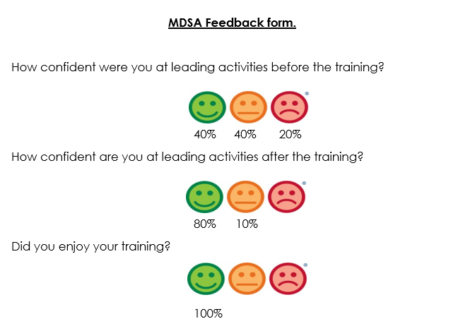  UQT coaching - I have found it really beneficial. It’s been really great to observe how he teaches and then I put it into practise. Even basic things like how to put them into groups thinking about the different abilities. | To disseminate back to rest of teaching staff. – SDM held  To feedback to the rest of the school on new ways of spending sports premium, new clubs and initiatives that we could get involved with.  To provide this again next year as there were only a few sessions arranged due to the busy half term.
7. | To teach year 4 children to ride their bicycles safely  Bikeability for all year 4 children who expressed interest.  To offer to all children as an opt out rather than opt in. | At Level 1 new riders learn to control and master their bikes in a space away from traffic such as a playground or closed car park.  At Level 1 you can:  prepare yourself and your bike for cycling  get on and off your bike without help  start off, pedal and stop with control  pedal along, use gears and avoid objects  look all around and behind, and control the bike  share space with pedestrians and other cyclists  Children are able to use their bikes safely outside school. Children are able to bike to Middle School.  60% of the year group took part this year  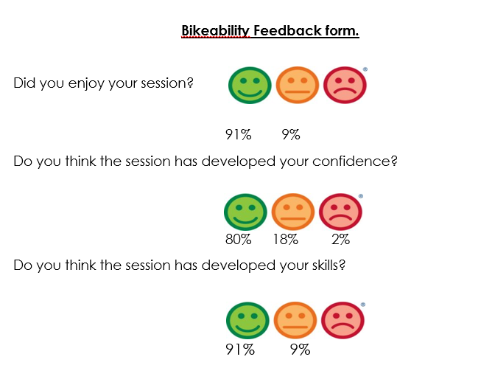 | To budget for in future years if needed.
8. | KS1 Scootability  To teach KS1 children to manage their scooters safely. For all KS1 children who express interest.  To offer to all children as an opt out rather than opt in. | The aim of this programme is to use the scooters as a fun and active way to revise  and reinforce basic pedestrian safety messages. The key safety messages are  equally relevant to younger children and to older children who walk or scoot  independently to school, to the local shops or around where they live.  All year 1 and 2 children took part apart from 1 child as parents stated they did not want to do it.  Year 1  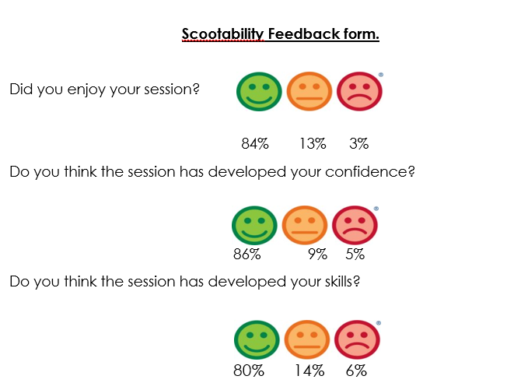  Year 2  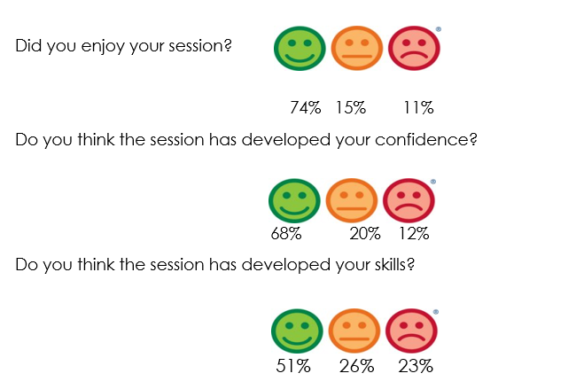  Some children fed back that the instructor was strict and shouty – this will be fed back to the company. | To budget in future years if needed.
9. | To buy a set of sports jackets which the children will wear over their PE kits when attending competitive sports festivals. | Children are more engaged in competitive sports. Children to have pride in their school and a sense of team spirit.  Not completed this year. Whole school do now have purple PE shirts which makes them more easily identifiable. | To replace as and when needed.
10 | To ensure the sports resources within the school are up to date and conducive to learning and development both within and outside of curriculum time. | Staff feel confident in delivering sessions and have the resources available to do this to a high standard.  91% said they find the new planning useful, the remaining 11% (FS) said they have no experience of it (Autumn term). FS have begun using the PE hub over the Spring and Summer term and plan to continue with this moving forward.  100% said the new planning has supported confidence  Children enjoy playtimes and are fully engaged in a range of activities.  Children are able to engage in physical activity inside and outside. | For staff confidence to be developed through the use of PE hub planning.  Ensure children are taught about the safe handling of and respect for all new equipment within school.
11. | Money given to our school football team in order to assist with purchasing new equipment. | Russell Raiders team and volunteers to feel valued and supported by the school.
12. | Non-curriculum swimming lessons for year 3. | Year 3 to attend non-curriculum swimming sessions in the Summer term. As the feeder middle school does not require swimming lessons we feel it is important to cover this in both year 3 and 4 in order to give our children the basic water skills needed.  All children in year 3 attended these sessions.  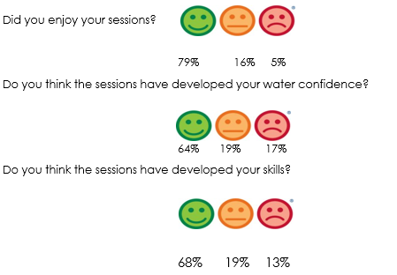 | Children will have experience in the water before their curriculum requirement in year 4.  Children will maintain/develop these skills through their life.
13 | Each class to have their own raised bed to grow vegetables.  To arrange for a gardener to come in and speak to the children about growing their own food. | To purchase a vegetable bed/planter for each class so they are able to grown simple vegetables such as potatoes, carrots and onions. They will then be able to use this produce in healthy eating lessons.  Children to understand more around the growing of fresh food.  https://schoolgardening.rhs.org.uk/about-us  https://www.rocketgardens.co.uk/growing-veg-school/  Year 1 - Over the weeks, through growing our fruit and veg. we have covered these areas through PSHCE time so far:  - Science - what a plant needs to grow in order to keep healthy and compared this with what we need as humans/children to grow and be healthy.  - PSHCE - how to care for a living thing... taking the time and responsibility to do this.  - how to 'home grow' in order to not used preservatives/pesticides/unnecessary packing for fresh and healthy food with more nutritional value..  - how gardening is healthy for you as you are outdoors in the fresh air and completing physical exercise - great for mental and physical wellbeing.  - Economic Wellbeing - cheaper to 'grow your own' and not take the costs that buying from a shop incurs - e.g. importation/transportation/packaging/renting the shop premises/paying the employees - cashiers etc.  - ECO Friendliness - less packaging, no transportation, therefore fuel use or costs.  Year 3 - The veg patch supports some of the learning we have completed this year:  * realising the importance of eating a healthy balanced diet (Science)  * how having a healthy lifestyle can benefit our mental health as well as our physical health (PSHE).  * early farming and growing food (Stone Age - History)  We are soon going to be preparing our own healthy meals in our DT learning and are going to use the ingredients we have grown in our veg patch which I am sure they will love and will further aid their understanding of healthy eating.  Year 4 - the children have been out several times, identified the veg and seen that slugs and caterpillars eat them. We have discussed healthy eating and the requirements of a plant to grow where the whole year was very responsive. We just need some serious growing now.  If we can get them earlier next time we will see more growth and harvest beans | Small budget each year for new seeds/plug plants.
14. | To further develop and enhance the outside space around school. | Children to be more physically active throughout the school day and feel proud of their environment.  £4,589 towards the astroturfing of the KS1 area to offer additional space during playtimes regardless of the weather. | Maintenance of this will be built into the main school budget.  Remaining money to be added to next year’s premium to purchase outdoor gym equipment.
15. | To develop and enhance resilience and behaviour through activity and an inspirational sports person through enrichments days for KS2 and whole school assemblies delivered by Mike Mullen  - To introduce some basic knowledge around growth and fixed mind set  - To introduce some catch phrases to implement when faced with learning challenges in class  - Behaviour workshop around a metaphor called ‘Drains and Radiators’ and realising some people can drain our potential while others are more supportive and positive to be around (radiators). Drains and radiators is used to help us understand how to adjust our communication and create a supportive environment / friendship group.  - Resilience workshop revolves around the notion of overcoming the word ‘Can’t’. It uses inspiration from role models who have faced adversity but let it fuel their drive and belief to overcome obstacles in life. The pupils then face difficult team tasks which they have to repeat until successful, using the inspiration from the role models to persevere until successful. | Children to further develop skills around these areas. Children to learn to improve their habits, confidence and reactions to challenges.  Staff feedback:  100% felt the outcomes were achieved  100% felt the children enjoyed the sessions  100% felt the sessions were a valuable experience  100% felt the sessions will have a lasting impact on their class/your teaching | Staff to reinforce skills and key messages to children.  Consider the used of Mike again in future years for workshops.
16. | Increase activity of children in KS2  - Activity questionnaire to be completed by all KS2 children to determine levels of activity both within and outside of school | Less active children to take part in an extra-curricular club free of charge. This will hopefully encourage them to take part in others moving forwards.  In KS2 only 10/162 children reported in the Autumn term to have not attended a club. By the end of the year only 3 had still not attended a club (in school). | Complete these questionnaires at the beginning of each year to gage the number of least active children and target them into joining a club.  Ensure that staff maintain a focus on active 30:30 across the curriculum.

Festival participation
Our emphasis is placed on ensuring that as many children participate in as many festivals as possible. We do not focus on sending our ‘best’ children but rather ensuring parity and fairness.
Year | Date | Festival | Number of teams | Outcome
4 | Oct | Tag rugby | 2 (20) | Festival cancelled due to weather
3 | Oct | Football | 2 (12) | Festival – now March
3 and 4 | Nov | Inclusive table cricket | 2 (16) | Development  Values for honesty and passion
2 | Nov | Multiskills | 3 (36) | Non-competitive 2nd and 3rd out of 6
4 changed to year 3 | Dec | Sports hall athletics | 2 (24) | Pathway 13th and 14th out of 16 – many other teams year 4
2 | Jan | Multiskills | 2 (24) | Non-competitive
3 | Feb | Gym | 1 (6) | Pathway – withdrew due to snow
2 | Feb | Gym | 1 (6) | Pathway – withdrew due to snow
4 | Feb/March | Swimming | 1 (12) Team 1 (25m+) – 8 (3 girls) Team 2 (10-15m) – 4 | Development  Team 1 2nd  Team 2 1st
4 | Feb/March | Transition | 4 (48) | Non-competitive
3 | March | Dance | 1 (10) | Non-competitive
4 | April | Quadkids | 3 (24) | Pathway
4 | May | Transition | 4 (48) | Non-competitive
4 | May | Kwik Cricket | 2 (20) | Pathway - Russell 1 second, Russell 2  County finals 3rd place
1 and 2 | June/July | Multiskills | 2 (24) | Non-competitive
3 | June | Tennis | 2 (24) | Festival – cancelled due to rain
3&4 | July | Netball | 2 (18) | Development – we entered this in a non-competitive nature due to the make-up of our teams and sending more boys.  Team 1:  Drew 3 and lost 1  Team 2:  Won 2 and drew 1
2 | July | Football | 2 (12) | Festival – cancelled by RSSP

Clubs
Festivals |  |  | Autumn 1 6 weeks 10th Sept – 19th Oct | Autumn 2 7 weeks  30th Oct – 17th Dec | Spring 1 5 weeks  7th Jan – 8th Feb | Spring 2 7 weeks  18th Feb – 5th April | Summer 1 5 weeks 23rd April – 24th May | Summer 2 6 weeks 3rd June – 12th July
KS1 | Wednesday lunch |  | Gymnastics - 30 | Gymnastics | Gymnastics | Gymnastics | Gymnastics | Gymnastics
 | Thursday after school |  | Street dance | Yr2 Multi skills | Multi sports | Multi sports | Summer sports | Summer sports
 | Friday lunch |  | Dodgeball - 30 | Dodgeball | Archery | Ball skills (2 football, 2 rugby, 2 tennis) | Dodgeball | Tennis
School staff clubs |  |  |  |  | Gym club for festival children Miss C (6)
Festivals |  |  |  | Nov – Yr2 multi skills | Feb – yr2 gym (P) |  |  | June – yr1/2 multi skills  July – yr2 football
KS2 | Monday after school |  | Yr4 Tag rugby for festival children (20) | Yr3/4Table cricket for festival children (16) plus 4 | Yr4 Sportshall athletics for festival children (24) | Yr 4 Quad kids for festival children (24) | Yr4 Kwik cricket for festival children (20) | Ball skills
 | Wednesday after school |  | Yr3 football for festival children (12) plus (8) | Tag rugby | Dodgeball | Ball skills (2 football, 2 rugby, 2 tennis) | Ball skills (2 cricket, 2 tennis, 2 rounds) (6 sessions) | Kwik cricket
 | Thurs lunch |  | Gymnastics | Gymnastics | Gymnastics | Gymnastics | Gymnastics | Gymnastics
School staff clubs |  |  |  |  | Yr3 Gym club for festival children Miss C (6) | Yr3 Dance club for festival children Mrs H (10) |  | Netball club for festival children Miss B, W and T (18)
Festivals |  |  | Oct – yr4 tag rugby  Oct – yr3 football | Nov – yr3/4 SEND table cricket (D) | Jan - yr4 sportshall athletics (P)  Feb – yr3 gym (P) | Feb/March – yr4 swimming (D)  Feb/March – yr4 transition  March – yr3 dance  April – yr4 quad kids (P) | May – yr4 transition  May – yr4 kwik cricket (P) | June – yr3 tennis  July – yr3 netball (D)
20 is generally the max for a club

Possible Next Steps for the use of the Sports Premium for 2019-2020 from staff and children

- Use of premium for some outdoor gym equipment for KS2 children.

