Year 2 Phonics/Spelling Practice – Wednesday 1.7.20.
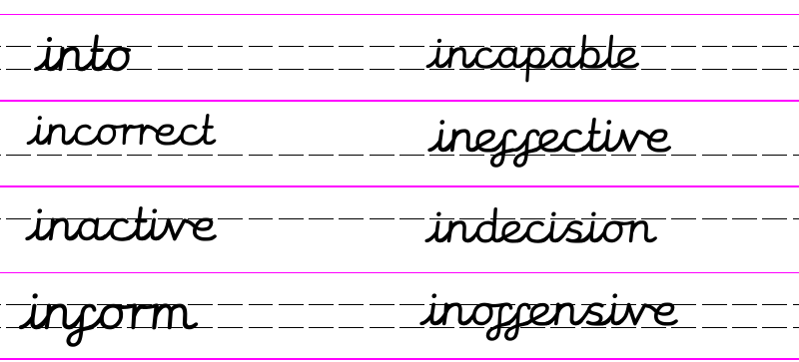
Practise: Quick write - Set a timer for 2 minutes – how many in- words can you write down before the timer finishes?
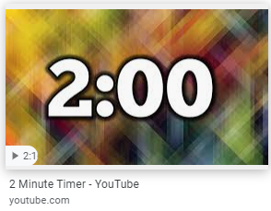

____________________________________________________________________________________________________________________________________________________________________________________________________________________________________________________________________________________________________________________________________________________________
Perhaps try again and see if you can beat your score! Remember to check afterwards to see if you spelled them correctly.
Dictation:
Ask someone to read out the sentence to you.
I can inform you that a cat is incapable of barking.

Maths 1.7.20
Four operations with Lengths
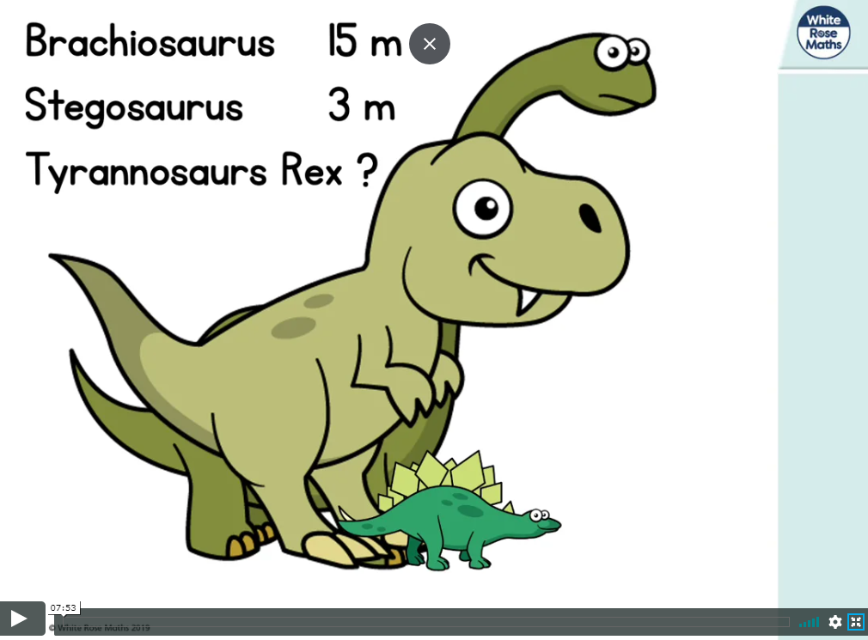
https://whiterosemaths.com/homelearning/year-2/ (week 9 w/c 22.6.20)
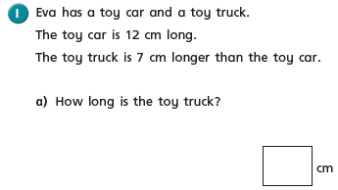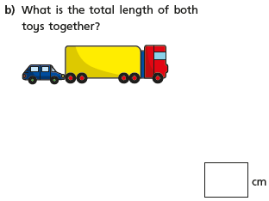
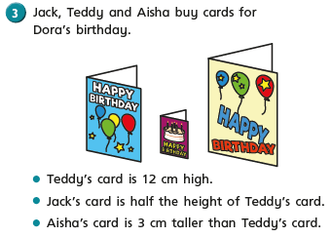
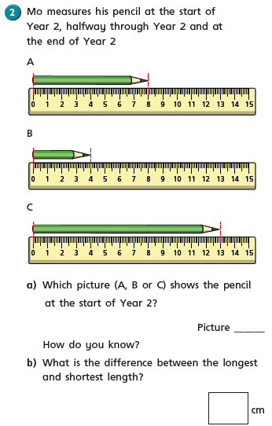
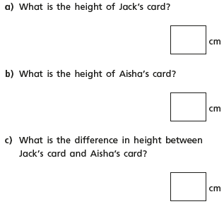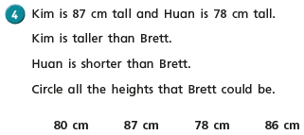

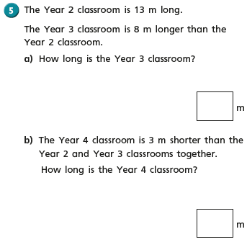

English - Wednesday 1st July
Fact of the day: July was named in honour of Julius Caesar in 44bc. Previously it had been called Quintilis, which means fifth month in..

Wow we are now in July! It is heartbreaking that you are not in school and it really is not a nice feeling for your teachers. This time of year is normally so busy and we are getting ready with all the transition for your new classes. I also love July, normally we would be getting ready for the summer holidays. My birthday is in July, so it is also a very special time for me. I have found lots of facts about July so will probably continue with July facts this week.

Let’s read some more of our story.
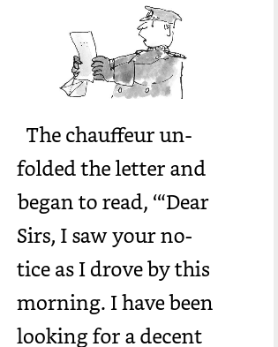

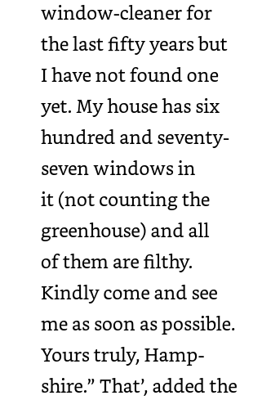
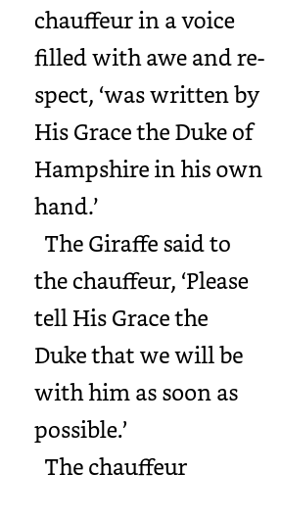
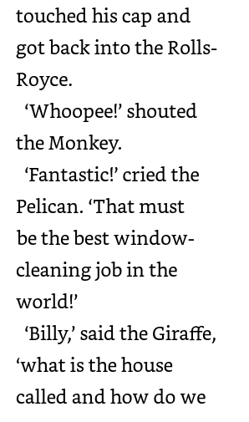k
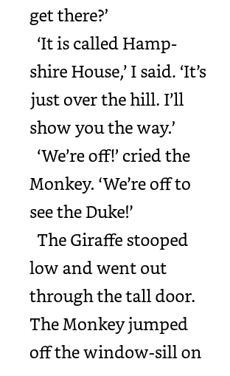
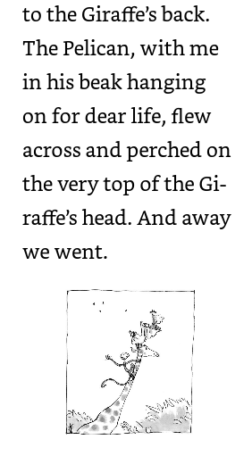
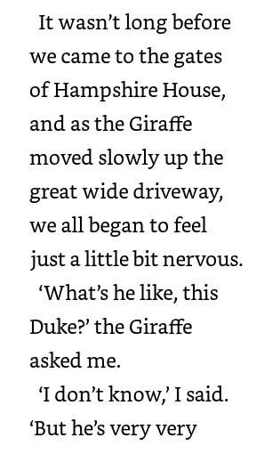
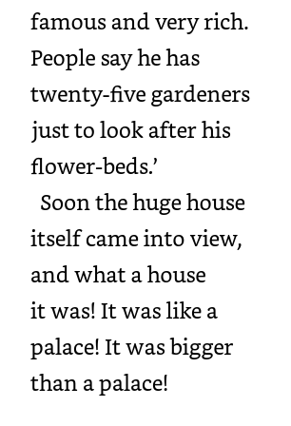
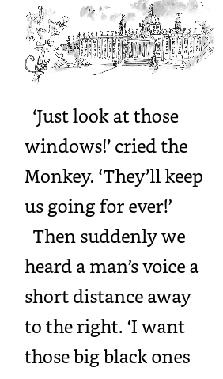

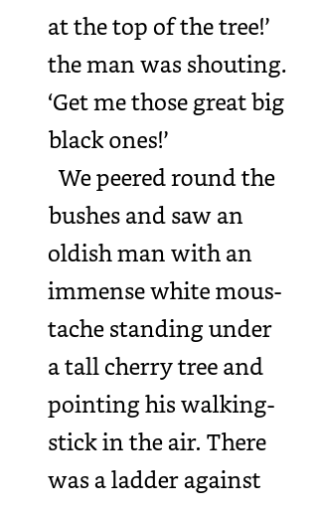
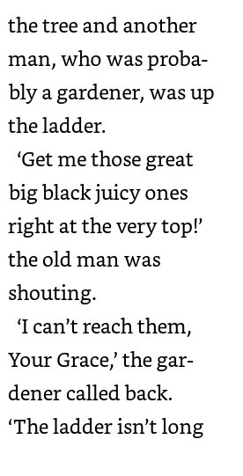
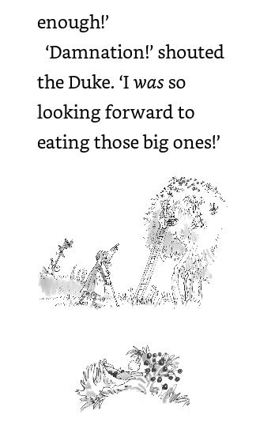

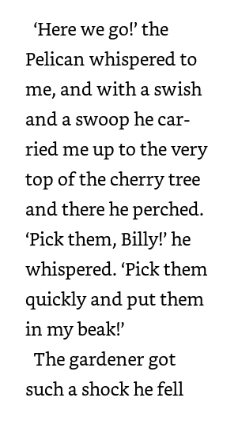
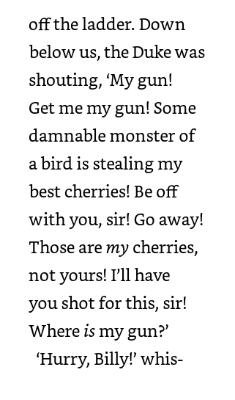
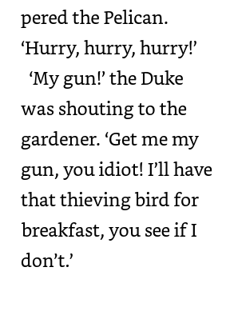
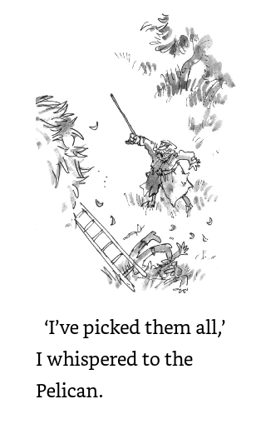
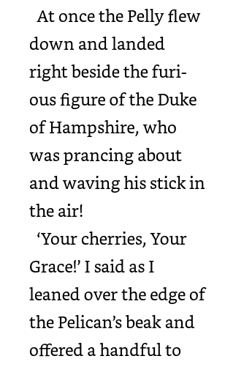

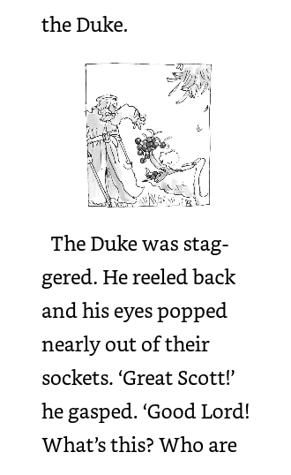
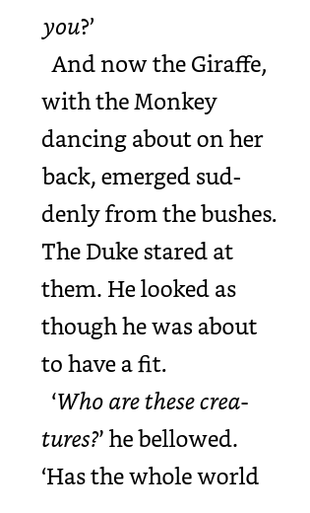
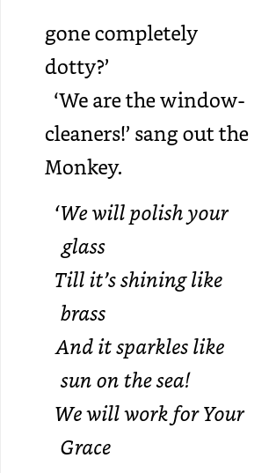

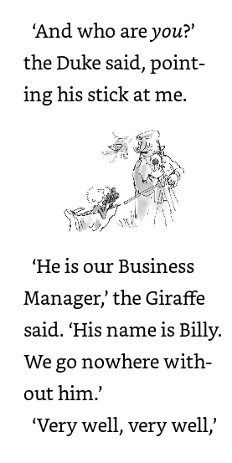

Wow that was a lot of reading today! Well done.

Today we are going to answer some questions about the text just read. This will help with our understanding of the text we have read.

Task:
All…..
Page 12
And now the Giraffe, with the Monkey dancing about on her back, emerged suddenly from the bushes.
The Duke stared at them. He looked as though he was about to have a fit.’

‘Who are these creatures?’ he bellowed. ‘Has the whole world gone completely dotty?’

Which word is closest in meaning to the word ‘emerged’?
Tick one
appeared
shook
drank
ate

Which word is closest in meaning to the word ‘bellowed’?
Tick one
whispered
sang
shouted
jumped

Challenge 1 Find a word that you don’t know very well and answer the following questions.

I think the word ………………. means............................................................................
because I found these clues in the text......................................................................
The clues tell me ........................................................................................................

Challenge 2
Read page 11 and find other tricky words, explain what you think they mean and how you know.

Wednesday 1st July 2020 – CONTINUED FROM LAST WEEK
RE - WALT understand what is the good news that Christians believe Jesus brings.
WILF That you can write about the good news that you would like to hear.
Jesus would travel with his twelve disciples across the land bringing people the ‘good news’. The good news was often stories that taught a lesson about how to life our lives. These are called parables. We have looked at parables in our R.E lessons on school. Can you remember any of them?
We had the story of ‘The Good Samaritan’. This story told us how we should help all people regardless of their beliefs. There is the story of ‘The Lost Sheep’. The shepherd didn’t give up on that sheep did he? He made sure each and every one of his flock was safe.

You have all been at home keeping safe but are desperately waiting for some good news that you can come back to school Today I want you to imagine this dreadful disease has gone away and that things are finally getting back to normal. The children of Russell Lower School have returned to school, the restaurants and cafes in Ampthill are open. Children can now play at the park and have playdates with all their friends. You can even have birthday parties!
I would like you to create the front page of a newspaper, telling the people of Ampthill the ‘good news’.

Don’t forget to give your newspaper a name. e.g. ‘Ampthill Gazette,’ or ‘The Daily Gossip’, ‘The Good News’
Make sure you have an eye catching heading e.g. ‘Guess who’s back!’ ‘Russell Returns’, ‘Back to the past’ ‘Normality Rules Ok’.

Add pictures, subheadings. Make your writing interesting by using adjectives, nouns, verbs and adverbs.
I look forward to your reading your reports and who knows by the time you have finished them they may well be the ‘good news’ we are all waiting for.
I think this is a big task, so I would like you to take two weeks on this task.

