Year 2 Phonics/Spelling Practice – Friday 5.6.20.
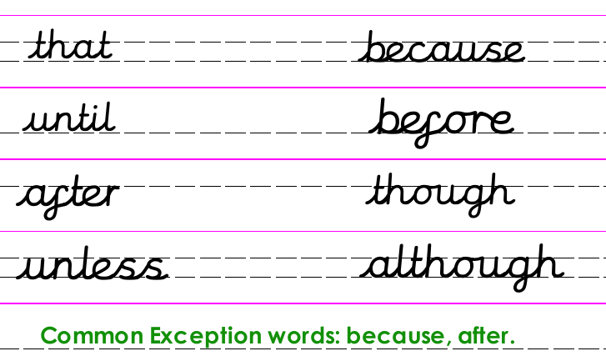
Two of our conjunctions this week are also Year 2 common exception words: after, because.
The word ‘after’ sounds like it contains the ‘ar’ sound but it is spelt with an ‘a’. Some people will pronounce it as ‘a’ depending on where they live or come from in England.
Lots of other Year 2 common exception words contain this spelling too!

We need to learn to spell them all before the end of Year 2!
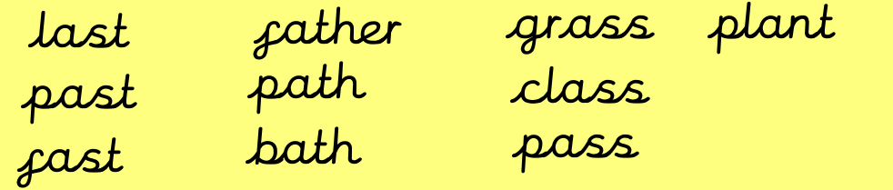
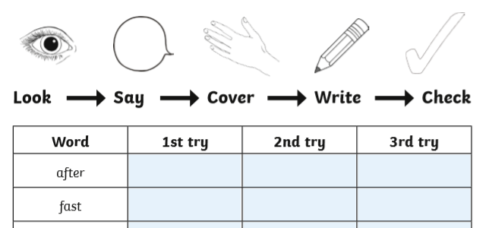
Practise writing these words using Look – Say – Cover – Write –Check.

Pick the correct word to go in each sentence:
We went to the park _______________ school.
A __________________usually has leaves and a stem.
Cows like to eat the lush, green __________________ .
I was muddy after football so I had a ____________________ .
There are 23 children in my _________________ at school.
Can you make up your own sentences for three of the other words on the list?
Maths 5.6.20
Use ‘Hit the Button’ to practise X2, X5, X10.
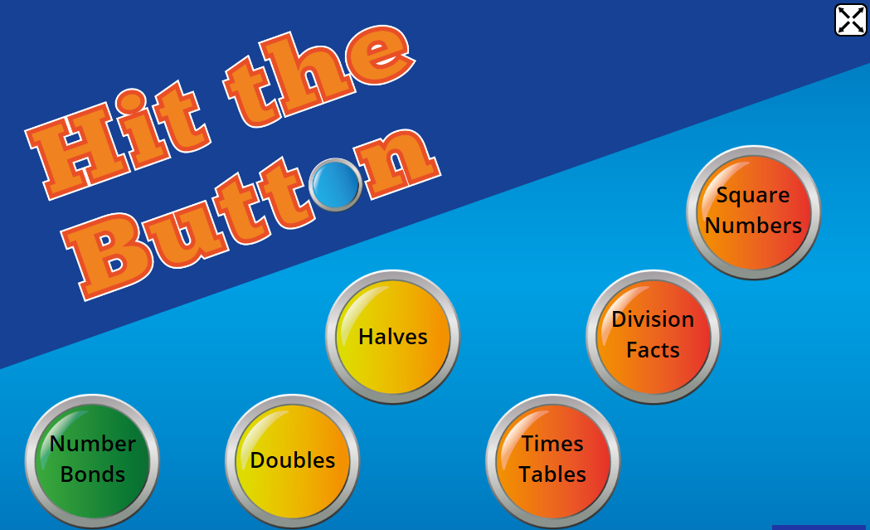
https://www.topmarks.co.uk/maths-games/hit-the-button

1 x 5 = | 3 x 5 =
7 x 5 = | 2 x 2 =
6 x 2 = | 8 x 2 =
6 x 10 = | 8 x 10 =
4 x 5 = | 2 x 5 =
6 x 5 = | 1 x 2 =
5 x 2 = | 7 x 2 =
5 x 10 = | 7 x 10 =
9 x 5 = | 11 x 5 =
12 x 5 = | 12 x 2 =
9 x 2 = | 11 x 2 =
11 x 1 0 = | 9 x 10 =
12 x 10 = | 0 x 5 =
2 x 10 = | 12 x 2 =
10 x 2 = | 9 x 5 =
10 x 5 = | 4 x 2 =
English Friday 5th June 2020

The story ‘The Wind in the Willows’ is set on the bank of a river. Can you Google rivers and see if it is possible to watch a clip of a river, moving, gurgling, and meandering along. Even better would you be able to visit a lake and watch how it moves, how it sounds, what you can see there, birds, trees, and insects.

When you have done this can you write as many words as possible to describe it.

Can you identify which types of words you have used e.g. adjectives, verbs, adverbs?

Science 5.6.20
WALT: to understand what plants need to thrive
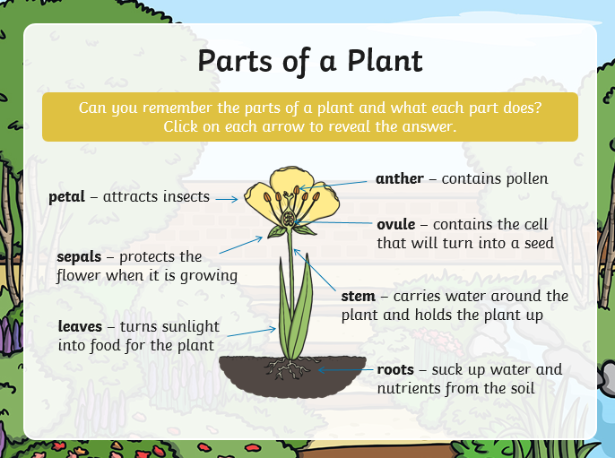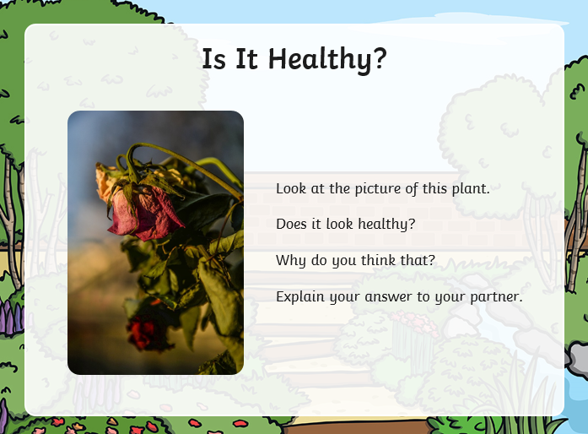
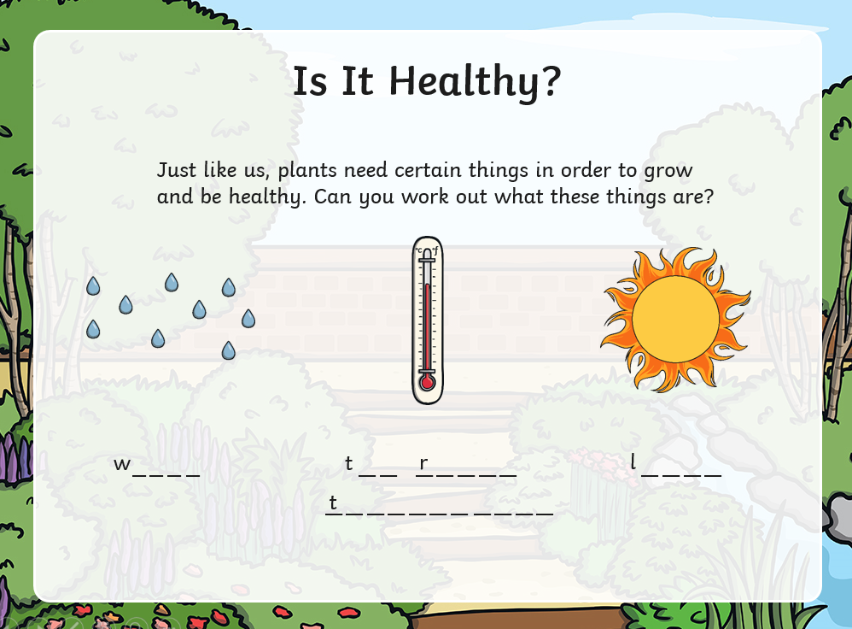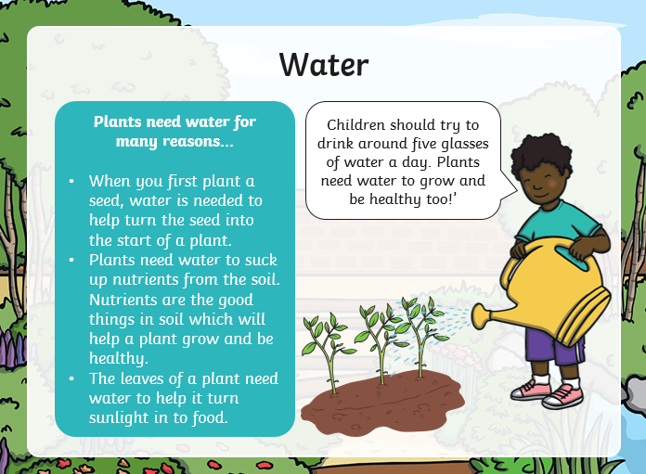
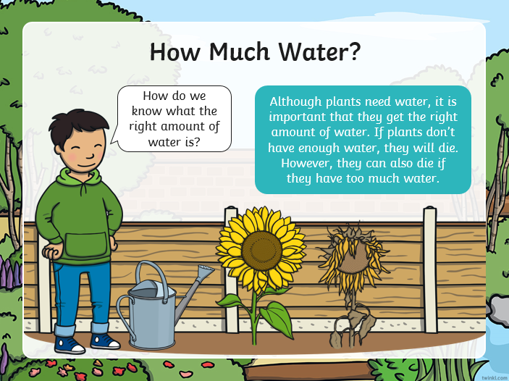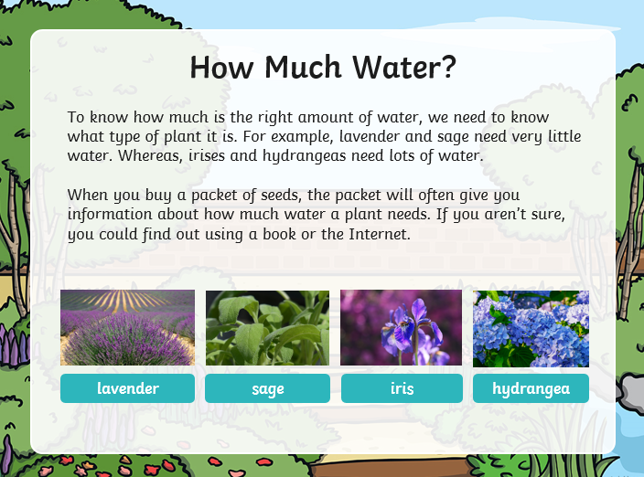
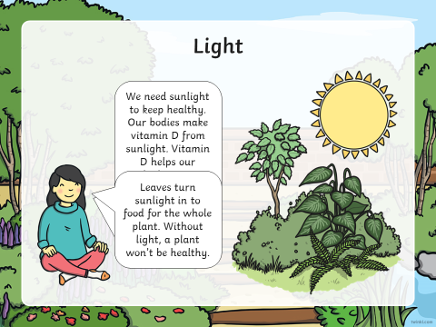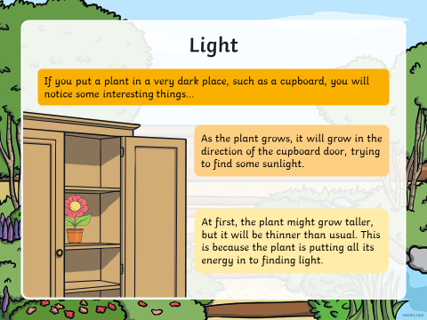
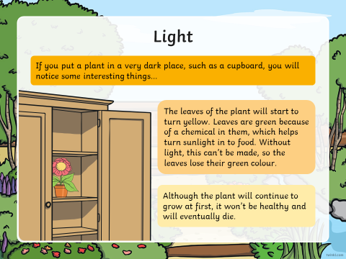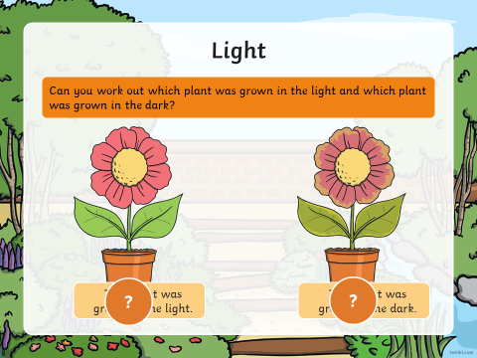
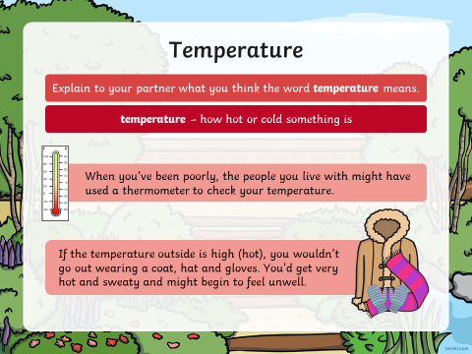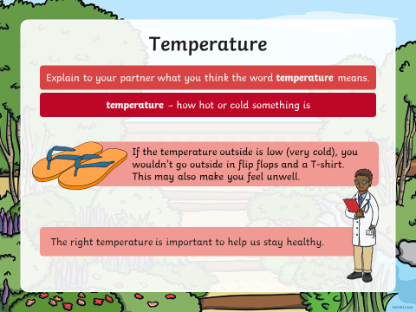
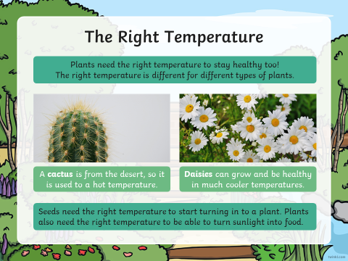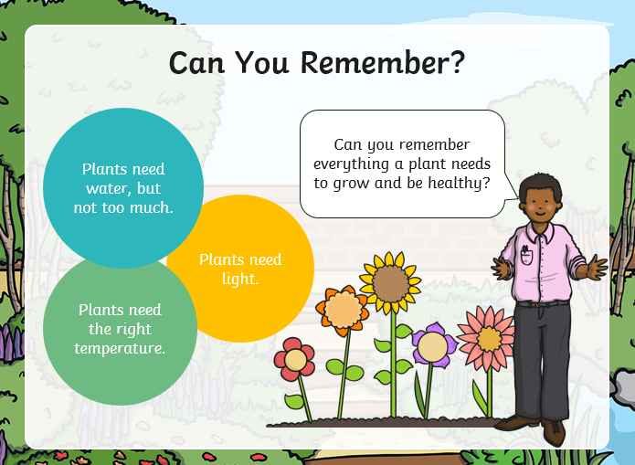
Task:
