15th December 2020

Dear Parents and Carers,

As we approach the last few days of this term, I wanted to write, once again, to thank you for all your support this term in working tirelessly with us to keep the school community safe, and bubbles open. It continues to be an incredibly challenging time for us all, and without your vigilance and willingness to work in partnership with us for the good of the whole community, we would have lost far more school days to Covid this term than we have. Thankfully, we have been able to keep this incredibly low at Russell – thank you.

Below, I want to update you on:
- The national changes to the isolation period – reducing it from 14 days to 10 days
- A Flowchart for parents
- Arrangements for reporting cases over the Christmas holiday period
- What to think about before returning in January

- Change in isolation period from 14 days to 10 days

As you may well know, from Monday 14th, the government has changed its advice around isolation from requiring 14 days isolation to 10 days of isolation.

In its simplest form:

If you are a 'close contact' of someone with Covid 19, or test positive for Covid 19 you are required to isolate for 10 days from:

1) Day of Contact with positive person
2) Day of first Covid symptoms
3) Day the positive Covid test was taken (not the day you receive the result)

...whichever of these 3 is first, counts as 'Day Zero'

You then count forward to day 10 and return on day 11.

You must still isolate if anyone in your household has Covid symptoms or takes a Covid test. It is all very complex so JUST ASK IF YOU ARE IN ANY DOUBT.
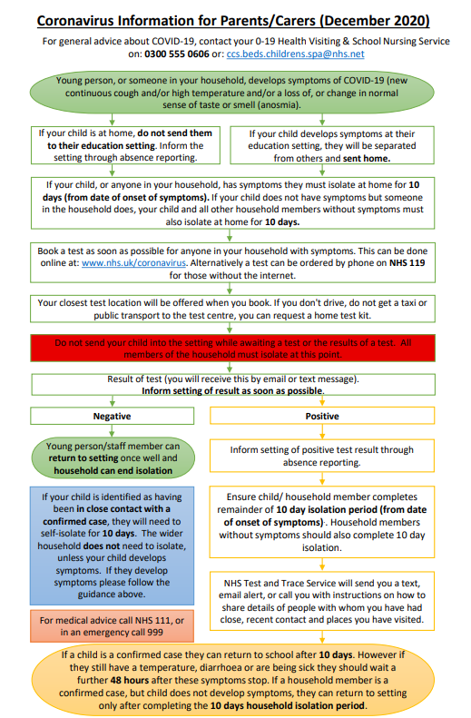
2 UPDATED
FLOW CHART

- Reporting a Covid Positive result for a child that attends Russell during the Christmas holidays:

- If your child (who attends Russell) develops Covid symptoms within 48 hours of being in school (Saturday 19th or Sunday 20th December assuming they were at school to the end of term) AND subsequently tests positive, please inform us via the office@ email address for contact tracing purposes

Please do continue to check your emails from school AT LEAST UNTIL MONDAY 21st DECEMBER as we may need to contact you to notify you that your child has been a close contact of a positive case in their bubble. Unfortunately, if this was the case, your child would need to isolate for 10 days

- If a child who attends Russell tests positive on or after Monday 21st December, as it is more than 48 hours since your child attended school, there is no requirement to inform us, but again, please follow the NHS Test and Trace process

- If a member or your household who is not a child a Russell tests positive we do not need to know at school, but please follow the NHS Test and Trace process

Get the latest NHS information and advice about all aspects of Coronavirus (Covid-19) here: https://www.nhs.uk/conditions/coronavirus-covid-19/

- What to think about before returning in January

We will all have difficult choices over whether to mix with others during the Christmas period, but this certainly will increase the risks for our return to school. As you can imagine, my wish is to keep Russell as free from Covid as it is humanly possible to be. To this end could you please:
- continue to keep your child off of school if they, or anyone in your household has Covid symptoms (a high temperature over 37.8 degrees, a new, continuous cough , a loss of or change in normal sense of taste or smell), or is awaiting the result of a Covid test when we are due to return to school on TUESDAY 5th JANUARY (Monday 4th is an INSET day so children are unable to attend school on this day)
- continue to arrive on site on time (no more than a few minutes early for your staggered start/finish time) and with only one adult per child please
- continue to keep to the 2m social distancing requirements around the site, and wear a face covering if you can
- leave the site quickly after collecting/dropping your child; please do not gather in groups to chat before/after school
- do not allow the children to play on the equipment before or after school - it will have been thoroughly cleaned (between bubbles) and we may not realise that we then need to do it again
We will always contact you if we plan to change anything about the re-opening of school in the new year. Please assume everything is back as usual on Tuesday 5th January, unless you hear otherwise via email. Please do not email into school to check this – our email system will collapse! Please note: it is imperative that you keep your email contacts up to date for this purpose. If you need to update us, please email in your new contact to: office@russell-lower.co.uk

If you are struggling over the Christmas period

Please find attached the CBC contacts list for a whole range of support services that can help with you everything from food to finances over the Christmas period.

Thank you and final Christmas message from Russell Lower…

Thank you for all your on-going support this term, and all our wonderful and very generous Christmas gifts. Thank you! It has been incredibly challenging and we couldn’t have got through it without you. We are all hoping for a ‘Whole New World’ and brighter times ahead in 2021…please see our Christmas Whole School Christmas message which was sent out with this letter.

Can we please also remind you of the importance of not sharing this link with anyone else, such as extended family and friends, or posting it on social media, in order to safeguard the children. It is for your own personal use only.
From everyone here at Russell Lower School, we wish you a very Merry Christmas and a happy, healthy, safe 2021.

Many thanks and kind regards,
Nicki Walker
Headteacher

