SEPTEMBER NEWSLETTER
19th September 2020

Dear Parents/Carers,

Welcome to our first newsletter of the new school year. These newsletters are sent out on a monthly basis to keep you informed about what is happening in school. If you ever want to contribute an ‘article’ or suggest information that should be on the newsletters, I would be delighted to hear about them.
The children have been telling me all about their incredible summer holidays and appear to be enjoying being back in school with their new teachers and friends. Everyone is looking very settled and learning has already begun at quite a pace!
As you know, we had a very challenging first week back, with our first positive Covid-19 test result and the very sad (but necessary) closure of our first bubble. Since then, I am delighted to say we have not had any further positive cases or closures and we are very much hoping to be operating with a full school again by Wednesday next week. I must take this opportunity to thank you all, and especially parents and children in Goldfinch Class, for your incredible on-going support, understanding and calm approach. Together we can face this challenge!
As things are so ‘up in the air’ at the moment (to put it mildly), we will be taking each half term at a time. Please note events that are underlined and in italics are new since the previous newsletter.
Monday 21st September – Walk/Bike/Scoot or park and stride to school week
Tuesday 22nd September – Phonics for Y1 and Y2 parents (virtual – presentation link will be sent home to all parents in Y1 and Y2)
Thursday 24th September – New Intake Meeting (Sept 2021 starters) 9:30am (field)
Thursday 1st October – FS reading and writing workshop for Foundation Stage Parents 9:15 – 10:30am (virtual presentation link will be sent home to all parents in YR/FS) and New Intake Meeting (Sept 2021 starters) 2pm (field)
Monday 5th October – Zoom Harvest Assembly
Monday 12th October – Parents’ Evening 4:30pm to 7pm, Finance and Resources Governors meeting at 6:30pm (will be telephone/virtual – more details to follow)
Tuesday 13th October – Parents’ Evening 3:45pm to 6:30pm (will be telephone/virtual – more details to follow)
Wednesday 14th October – New Intake Meeting (Sept 2021 starters) at 9:30am (field)
Friday 23rd October – School breaks up for half term

Half term – 26/10 – 30/10 – Premier Sport Holiday Club
Monday 2nd November – INSET DAY – School CLOSED to children
Tuesday 3rd November – Children return to school following the half term break

Please see the school website for more dates beyond this
More detailed information on the above events will follow in due course
A warm welcome to our new children and families:
We are delighted to welcome so many new children and families to Russell Lower School this year. We pride ourselves on being approachable, supportive and professional, and strive to build strong relationships with children and parents. It is this partnership which makes Russell Lower School unique. Please do not ever hesitate to contact any of us if you have the slightest concern or query – we will always do our very best to help – even in these very challenging times! I cannot believe how well you children are settling already, especially considering the very minimal transition work that was possible! They are a real credit to you all.
Please always begin by contacting your child’s class teacher using the class email. They are the person who is most likely to be able to help you. If you still need to speak to someone, you can then approach the Phase Leader (using their class email – classes below). Phase Leaders are very experienced teachers with additional leadership responsibility. Hopefully any queries will have been successfully resolved by our Phase Leaders, but you can still always speak to our Office Manager, Mrs Sue Summerfield, Mrs Bunney (Deputy Head) or myself (Mrs Walker – Headteacher). We aim to be out and about every morning (and as many evenings as we can), but you can also email (office@russell-lower.co.uk) or telephone the school (01525 755664)
In addition, we have our pastoral support team: Mrs Vanessa Halsey, Mrs Caroline Hunt and Miss Becky Thompson. This is a very experienced team who can offer or sign post support for ‘non-academic’ issues. These may be emotional issues, attendance issues, health issues (we would sign post you to other professionals), family breakdown, bereavement, sleep issues, home behaviour issues etc. In fact, anything that is adversely affecting your family and therefore your child. Do not hesitate to contact them via our school office or at: pastoralsupport@russell-lower.co.uk

Staff Structure 2020/21:
Foundation Stage
Swan Class: Mrs Ruth Brown (Phase Leader for Foundation Stage)
Dove Class: Mrs Jacqui Peace
Swift Class: Mrs Chelsea Moore
Year 1
Owl Class: Mrs Katherine Milligan
Puffin Class: Mrs Becky Cox
Wren Class: Mrs Emma Jochacy - Mon, Tues, Wed, and Mrs Emma Rogers - Thurs and Fri
Year 2
Greenfinch Class: Mrs Caroline Johnson
Penguin Class: Miss Inci Sensoy
Robin Class: Mrs Zoe Hitchings (Phase Leader for KS1 – Year 1 and 2)
Year 3
Blackbird Class: Mr Callum Syrett
Nightingale Class: Miss Becky Thompson
Goldfinch Class: Miss Rachel Walker
Year 4
Woodpecker Class: Miss Clara Rawlings
Starling Class: Mrs Helena Moffat
Kingfisher Class: Mrs Dawn Tuck (Phase Leader for KS2 – Year 3 and 4)

Higher Level Teaching Assistants: Mrs Sam Connolly, Miss Joanne Meyern and Miss Anna Leece (Maternity leave)
Sports Coaches: Mr Josh Norman and Mr Aaron Keech
Pastoral Support: Mrs Vanessa Halsey, Mrs Caroline Hunt and Miss Becky Thompson (pastoralsupport@russell-lower.co.uk)
Switch On Intervention: Mrs Melissa Wolf
Inclusion Lead (SENDCO): Mrs Sarah Knight (send@russell-lower.co.uk)
Office Manager: Mrs Sue Summerfield
Finance Administrator: Mrs Karen Appleby
Office Administrator: Mrs Sarah Bremner
Aviary Before and After School Club Manager: Mrs Tracey Baker
Aviary Before and After School Club Deputy: Mrs Natalie Fraser
Site Agent: Mr Martin Clarke
Chair of Governors: Mrs Nicolette Ford
Headteacher: Mrs Nicki Walker
Deputy Headteacher/Safeguarding Lead: Mrs Louise Bunney
Safeguarding Governor: Mrs Keith Redman-Henry
HUGE thank you:
Thank you so much for the many, generous gifts and messages left in the foyer at the end of last academic year. It really meant a lot to have your support. Thank you. In addition, you may remember that many of you also contributed to a ‘contactless’ gift by contributing to the school bank account to buy books for the children. I am delighted (and amazed at your generosity!) to say that we had almost £600 of donations which we have already placed a book order for. Thank you SO much!

Summer Challenge Deadline:
Thank you to the huge numbers of you who have already handed in your completed summer challenges. They look really impressive! It is clear you had a very busy and productive summer. Can we please request that all entries are back by Wednesday 23rd September at the latest so that we can purchase the correct number of prizes? Unfortunately, we will be unable to provided prizes for entries that arrive after the deadline. Thank you so much.
Term Dates 21/22:
Term dates for 21/22 are now out and attached. Please note this is NOT this academic year. Our current and future term dates are on the school website (under the ‘About Us’ tab).
Free School Meals ‘Census’ Day:
You will be aware that school budgets are getting increasingly ‘squeezed’ by the government, and one way we can maintain our budget is by making sure we are using what the government currently provide. Universal Infant Free School Meals are currently made available to children in FS, Y1 and Y2. From Y3, parents are asked to pay for school meals. In order to keep this free lunch facility, we have a ‘Census Day’ to check our use. This day is Thursday 1st October. If our percentage of meals eaten on that day is high it results in more money coming into the school budget. This is crucial in maintaining current standards. Please support us by encouraging your child to have a school dinner on that Thursday (we have changed the menu to make it as attractive as possible to as many as possible and Mrs Summerfield will be sending you a separate letter to give you this information). With your support we can make sure Russell continues to receive the highest possible percentage of the available money so the children continue to benefit. Thank you.
Sharing Assemblies:
Sadly, we are currently unable to offer sharing assemblies. We will review this ‘offer’ later in the year.
Music Lessons:
These will be resuming at Russell in a socially distanced and Covid-secure way next week. There are currently some spaces available for some of our musical instrument lessons with peripatetic teachers from Central Bedfordshire’s Inspiring Music. Lessons are offered for flute, fife, violin, viola, piano (on-line), guitar, cello, brass instruments and drums. If you are interested in your child learning an instrument and would like more details please contact the school office. Please be aware that there is an additional fee for peripatetic lessons.
Uniform:
Please ensure all uniform, including shoes, coats and PE kit, is clearly marked with your child’s name. May we also ask you to conform to our uniform regulations set out below:

Trousers, shorts, skorts, skirts and pinafores – grey
Dresses – purple
Polo shirts/Shirts – white
Cardigans, jumpers and sweatshirts – purple/logo
Socks and tights should be white, grey or black. All footwear should be flat and sensible for running around and sitting on the carpet. Boots are permitted provided they are not ‘snow’ boots or similar. All footwear should be black. Suitable school style sandals, i.e. with no open toes and backs may be worn but tights or socks must be worn (either ankle or knee-length). Trainers are not part of the daily school uniform.
P.E kit
The clothing does not need to be a particular brand. No part of the daily school uniform should be used for P.E. Children should have in school the following:
- A purple school logoed PE t-shirt - for both indoor and outdoor use
- A pair of black shorts/skort – for indoor and warmer months use
- A pair of black jogging bottoms – for outdoor use
- A black PE jumper – for both indoor and outdoor use
- A pair of trainers - for outdoor use
- A pair of plimsolls - for inside use

Please note that jewellery, nail varnish and tattoos should not be worn and hair products and accessories should be used sparingly. Please note that ‘unnatural’ hair styles and colours are not allowed in school. For pierced ears only studs should be worn. All ear-rings should be removed for PE. Although we do not recommend ears to be newly pierced during term time, any child who is unable to remove their ear-rings for PE should come to school on PE days with the ear-rings covered by tape.

Medical Conditions and Absence from School:
In order to keep our records up-to-date please notify the school office of any changes to your child’s medical condition. Please return any medications that we should have in school to the school office. Please notify the school office on the first day of any absence.
Medication in School:
We can only administer medication prescribed by your child’s GP that requires a dose during the school day. Please note a consent form giving permission for our trained staff to administer such medication should be completed at the school office. All medication should be stored with the school office – this includes asthma inhalers.
If your child has asthma, please do attend regular review meetings with your child’s doctor and ask them to give you a Care Plan. This will really help school meet your child’s medical needs.
Please note any analgesic medicines such as Calpol or Nurofen cannot be administered by staff. Should your child require such medication during the school day we would deem that they are unfit for school. In addition, please be aware that we will not be sending home First Aid notes for every minor bump or scratch. However, we will continue to notify you of anything more significant and of all significant head ‘bumps’.
Flu Vaccination:
As you may be aware the NHS has announced that all children will be offered the flu vaccination in the form of a nasal spray. Shortly you will be receiving an information pack. We will need completed consent forms returned in advance. We will send you more information as we have it.
Covid-19 and deciding whether to send my child to school:
Earlier this week we circulated our flowchart (below) to support you in deciding whether to send you child to school. It is also attached again with this email. Please refer to this as you first port of call for advice. We will update it and issue a new one if the guidance changes (as it is constantly doing at the moment!). Thank you for your support. We have never needed your support more!

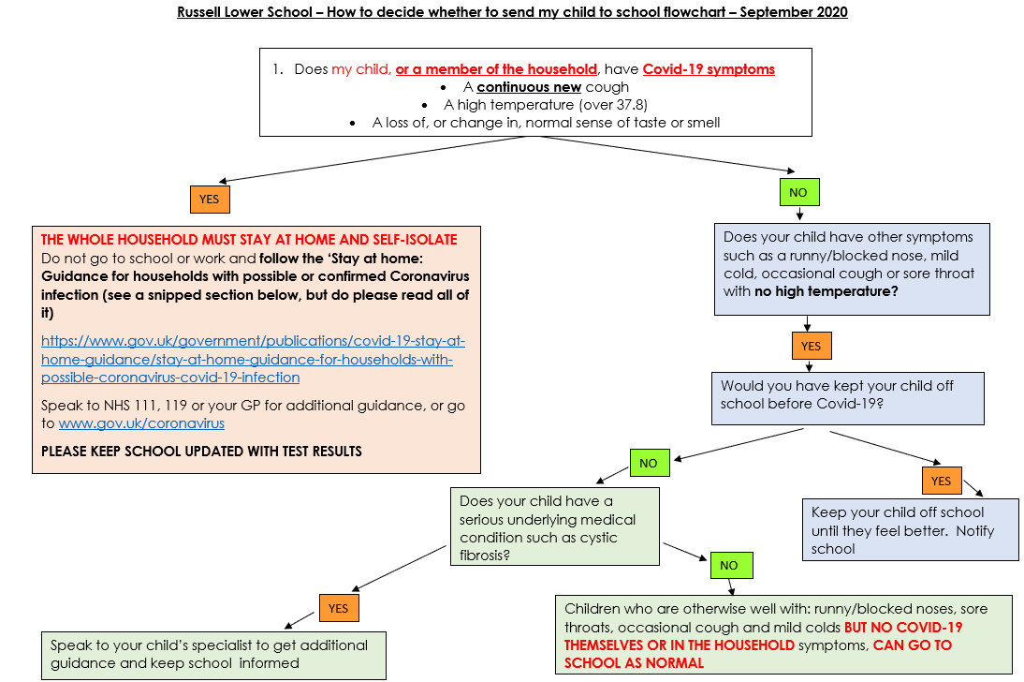
Please go to: https://www.gov.uk/government/publications/covid-19-stay-at-home-guidance/stay-at-home-guidance-for-households-with-possible-coronavirus-covid-19-infection for more information from the government

Also, see the attached: Returning to Primary School – What parents need to know leaflet
Contact details:
You will be aware that we may need to contact you at very short notice if we have to close a bubble (class) due to a positive Covid-19 test result. We will contact you via email and mobile phone text alert so PLEASE ENSURE WE HAVE UP-TO-DATE MOBILE NUMBERS AND EMAIL ADDRESSES SO THAT WE CAN WORK TOGETHER TO KEEP OUR CHILDREN SAFE. Thank you. Please notify changes in writing via the office@russell-lower.co.uk and not the class email address.

E-Safety and supervision of internet use:
Please can we remind all parents of the importance of ensuring that you supervise your child’s online usage and of the age restrictions for various social media platforms (the recommended age for a TikTok account/Fortnite is 12+ years old). Please remain vigilant to try and ensure your child remains safe when using mobile devices, including when they should seek help or discuss any concerns/incidents.
This is even more important than ever when we may see children at home even doing their school work on-line. Please supervise your children in their use of all technology and platforms, even for educational purposes. Even whilst we have had a class at home this week, we had an incident in the ‘message’ section of Loom in which one child ‘impersonated’ another. You can imagine how this could quickly escalate without intervention. Thank you for all your support.
ParentZone has a wealth of information, including factsheets about different social media platforms. You may find their website useful.

Snacks:
Thank you for sending your child to school with one healthy snack per day. Please can we remind you that the children only have 10 minutes or so to eat their snack so please don’t send an entire fruit bowl! Please also be reminded of our snack policy (in FS New Starter Booklet):
As part of a government initiative towards healthy eating all children in Foundation Stage are provided with a piece of fruit daily. As the scheme is aimed to add an additional piece of fruit each day rather than replace a snack, we distribute the fruit at morning breaktime each day.
In the interest of healthy eating and dental care, children are allowed to bring one snack a day into school to eat during the afternoon - this should be fruit, chopped vegetables or cheese. Chocolate bars, chocolate biscuits, sweets and crisps are not allowed. Please do not send any snacks containing nuts as we have children in school who have nut allergies (Anaphylaxis).

Collection/Drop off of Children:
As you know, keeping everyone safe is our primary purpose above all else at the moment. Please DO NOT arrive on site more than a few minutes early to drop off or collect your children. The system we have set up works well when everyone observes this, but causes crowding if it is not. Please do use the ‘waiting area’ (Zone 1 in the Foundation Stage playground by the trim trail) if the queues for the classroom doors are simply too busy, or a different class is still dismissing their children. This will allow us all to socially distance and observe a 2 metre gap. Please can we also ask you to avoid blocking gates so that people can enter and leave the site quickly and safely. I know we will all get quicker and slicker with time, and I really appreciate your support and patience in the meantime. Thank you.
If your child is collected by anyone other than their parents, could you please ensure that your child’s new Class Teacher is made aware of this. Any changes to the normal collection arrangement of your child should also be notified. As your child’s wellbeing and safety is paramount, no child will be released without prior parental consent of any changes, or if anyone under the age of 16 comes to collect them. Should your child need to be collected during the course of the school day please can you ensure your child is signed out at the school office? Thank you
School crossing patrol (SCP):
Please see the following message from CBC: I am writing to you today to ask if you could please remind parents and children to abide by social distancing rules and the rule of 6 around the school crossing patrol officers. We understand that this is the responsibility of the parents and/or children, however we have received some complaints from members of the public stating that parents are not abiding by the rule of 6 around the SCPs. Please help to keep the SCP staff safe and stay 2 metres away from them please. Thank you
School Website:
Please use the school website: www.russell-lower.co.uk as a good source of information and for diary dates. If you still have any queries please do not hesitate to contact the school office on Tel: 01525 755664 or email: office@russell-lower.co.uk
Both the PTA and the School have Facebook pages for further information. Please be aware that only the school office and school Facebook page can answer questions about school. The PTA Facebook page is purely for PTA events and information. Any class-related issues can be directed to the class email address in the format classname@russell-lower.co.uk e.g. robinclass@russell-lower.co.uk
Administration:
Please be aware that all letters and reply slips and correspondence should go in children’s book bags and to the classrooms for teachers each day and not directly to the office. Office staff make collections from classrooms each day. Only medication, reporting of absence or early collection and Aviary Club enquiries should go via the school office via email or telephone please. This helps keep processes as effective and efficient as possible for everyone. Thank you in anticipation of your support.
School Admissions for September 2021:
Central Bedfordshire have now opened the school admissions process for children starting school for the first time in September 2021. Ampthill and the surrounding area is growing quickly and we were incredibly popular again this year (practically filling all 90 places very early on), so please make sure you make your application early so that you do not miss out on a place at your preferred school. You have until 15th January to apply for a place. The dates/times of our New Intake meetings can be found at the beginning of this letter.
Please note that you also have to apply for your child’s Middle School place if they are currently in Year 4, this is not automatic. The deadline for this is also 15th January and can be done through the Central Bedfordshire Admissions website.
Supporting learning at home:
Thank you for your support with the numerous ways you support your child’s learning at home. Your support is invaluable.
Over the next few days (or already) we will be providing you with some information that we hope you will find useful:
- Theme webs for each year group to show you what children will be learning this term
- Home learning letters to explain what ‘homework’ children will be asked to complete in each class and other ways you can support learning from home. This will also detail when it is due in. Thank you for your support with this
- Year 4 Multiplication check information letter and how you can support your child in preparation

Of course, do come and ask if you have any queries at all about your child’s learning before the October Parent’s Evenings (which will either be via Google Chat/Zoom or telephone this year).

If your child’s bubble (class) has to self-isolate, we will of course write to you and explain how Remote Learning will work. Fingers crossed we don’t need that too often!
Thank you for taking the time to read this (very long – sorry) first newsletter. I really do appreciate how much information you are having to assimilate at the moment. We continue to really value working in partnership with you to ensure your children are safe, happy and progressing well in these unusual times.
Have a lovely, safe weekend.
Yours sincerely,
Mrs. N. Walker
Headteacher

