Thursday 4th March 2021
Keeping in Touch - 7
Dear Parents and Carers,
Return to School and HUGE thank you:
We have almost made it! Just one more full day of remote learning to go. I am sure you are all as desperate to get the children back to school as we are to see them! We would like to thank you all for your incredible support, patience, resilience and hard work with remote learning this term. You have been phenomenal – thank you SO much. We know from your feedback that the live lessons and Google Classroom have been a brilliant support (and probably the best that could possibly be done in the circumstances), but that there simply is no substitute to being in school. We cannot wait to welcome you all back on Monday!
As you know, we will be continuing with ALL our Covid secure measures as the pandemic is by no means over. Please continue to support us in these.

Staggered starts and finishes will need to continue. These will be the same as they were before Christmas. A reminder of these is below. Please use the appropriate gate, face coverings and maintain 2m social distancing at all times. This will continue to keep us all safe and avoid any bubble closures.

Timings - staggered starts and finishes

Gate | 8.40am – 3.10pm | 8.50am – 3.20pm | 9.00am – 3.30pm
FS | Greenfinch | Owls, Dove | Swift, Wren
Main Queens Road | Penguin, Swan | Puffin | Robin
KS 2/Field/A&F Motors | Blackbird, Starling | Goldfinch, Nightingale | Woodpecker, Kingfisher

As previously, please do not send your child into school if they, or anyone in your household, has Covid symptoms, or is awaiting Covid test results.
Testing:

Staff will continue to conduct twice weekly tests to ensure they are safe to be at school. Primary aged children will NOT need to do any testing at school or at home, unless you as a parent decided to do this. However, as you may have read in the press, anyone living in a household with primary age children can get access to tests that they can use regularly at home if they choose too. At the moment information on this is limited, but we do know that schools will NOT be supplying these test kits to parents. Parents will need to source these for themselves, and at the moment we understand this to be possible in the following ways:
https://www.gov.uk/guidance/rapid-lateral-flow-testing-for-households-and-bubbles-of-school-pupils-and-staff?utm_source=1%20March%202021%20C19&utm_medium=Daily%20Email%20C19&utm_campaign=DfE%20C19
If you do choose to do this and anyone in your household should ever test positive using a lateral flow device, please immediately isolate as a household, do not come to school, and follow additional advice from Test and Trace (usually this is to get a confirmatory PCR test). Thank you.
Other local information about testing from CBC:
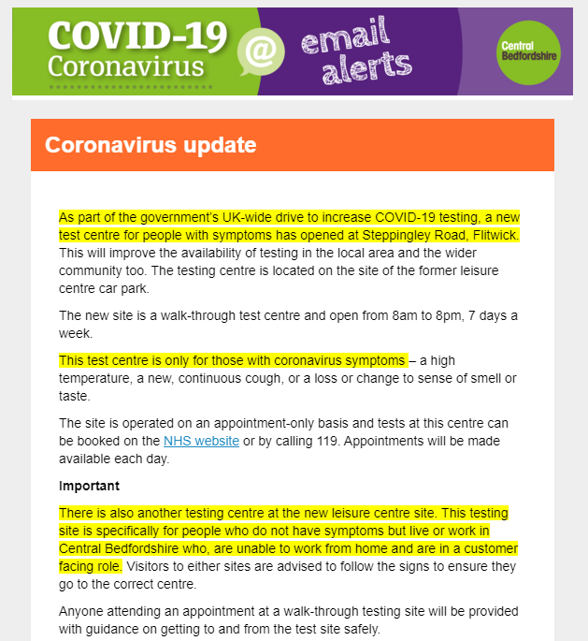
As your thoughts are now turning to school, you will experience a mix of emotions – both excited and nervous are completely normal!
We are SO excited and ready to welcome the children back to school, and to support them (and you) as they get back into a familiar school routine. We anticipate this will be a breeze for some parents and children (and very welcomed) and really traumatic and anxiety-inducing for others. We understand all these perspectives and will do everything we can to help support both children and parents. Please try not to overly worry (although it is the most natural thing in the world!): we are ready and waiting.

I want to reassure you that we remain absolutely committed to school being a safe and happy place, with a strong, caring and inclusive community where strong academic and personal progress and achievement is made. We are proud of all our collective achievements during this challenging time so far, and extremely grateful for our wonderfully supportive school community.

In order for school to have a calm, orderly and safe start back, can we please remind you of the following:

Please ensure that you:
- Know the time your child needs to start and finish (staggered) school and which gates to use, and be prompt, without being early or late. Please only send one adult and leave the site quickly (even if your child is distressed. This is quite normal and we will ensure they are ‘scooped up’ quickly and supported)
- Do not try to have conversations with staff or other adults on site. This will lead to potential social distancing concerns and safety issues
- Full attendance and school uniform is expected again now please. Only keep your child away from school if they are unwell or showing any Covid-19 symptoms
- Reassure your child (and yourself), it will be just like it was before Christmas – they’ve just had an extra long break! All their familiar adults will be there with them in the classroom
- Get your child back into a good sleep routine (if they are out of it)
- Make sure your child has what they need for each day, and that you are up and organised early on Monday to make Day 1 calm (getting lots ready on Sunday evening might help)
- Are not to be tempted to linger on site to chat to other parents or allow children to play on equipment. The equipment will have been cleaned ready for the next ‘bubble’ and this could contaminate it again
- Please call the school office (01525 755664) or email instead of speaking directly to the school staff (either office@ or class@ email addresses). We can pass messages on quickly
- Some queuing will be inevitable; please observe the social distancing rules when this is necessary
- Please leave plenty of time to find parking spaces around the school site, and either park and stride, walk/scoot or bike to school wherever possible. It will be busier than it has been for months around the school gates, please take care and keep your distance
- Please make sure your child is washing their hands JUST before they leave the house in the morning, and as soon as they come home in the afternoon/evening

If you feel that your child will struggle with separation/anxiety or both, it may help to read the following on our website: https://www.russell-lower.co.uk/website/promoting_positive_wellbeing_-_separation_anxiety_/485862 There are resources here too. As always, please do shout if you feel you, or your child needs additional support.

When we all work together, we are confident your children will be safe and happy as they return to school.

Year 4 Walking to and from school alone:

Usually, after Easter our Year 4 children are invited (via their parents giving consent) to walk to and from school independently in preparation for Middle school. Following careful consideration of all the risks, we have decided that this will be delayed this year until after May half term.
The reasons for this are very simply:
1) Children have lost over half a term of 'experience' of walking to/from school with their parents - this is vital for parents to 'train' their children in road/stranger safety etc.
2) Social Distancing will still be absolutely key in the next half a term, with government restrictions still in place. We will not be able to encourage children to mix with other bubble children to walk to and from school as they might otherwise have done.
3) A delay will give us time to cover more 'road safety' aspects with children in school in the build up to May half term, rather than trying to 'cram' it in at the same time as settle children back before Easter. Again, thank you in advance for your support.

Home Schooling – Heaven or Hell?

You may have seen in the latest Oracle (March 21), there was an article by one of our parents, Linda Armstrong. It is a fantastic reflective piece, looking back over the remote learning time from a parents’ perspective. I thoroughly recommend it! I am also delighted that Linda gave Russell a ‘shout out’ and concluded that it was ‘heaven’. We will pay you later Linda! Thank you for your kind words.

CBC Remote Learning Survey:

Please find below a request for information from CBC Council. If you would like to tell them about your experiences of Russell’s Remote Learning offer then please do follow the link to complete the survey. Thank you.

Parental survey – home learning
The COVID-19 pandemic and periods of lockdown have been challenging for us all and we want to find out how the resulting home learning has impacted children.
Our Children’s Services team has produced a survey for parents that will help us understand more about how children in Central Bedfordshire have coped during the latest lockdown.
The survey will run until 11 March 2021 and we would really value input from as many people as possible, therefore, we’re asking you to help us by sharing the link with parents:
https://centralbedfordshire.researchfeedback.net/s.asp?k=161280053394

PTA forthcoming plans:
I just wanted to let you know that our wonderful PTA have been busy planning some Easter events for us all to enjoy – yet again supporting us with lovely things to do whilst the restrictions still apply! Just to whet your appetite (more information to follow), these are likely to include:
- Easter Hunt with treat (in school at the end of term)
- Easter Holiday Scavenger Hunt for whole families
- Virtual Family Quiz Show with Skittleman during the holiday
I would like to send a very big thank you in advance to all the PTA members for planning these amazing, fun activities for the whole community. We are all very appreciative.
World Book Day:
Thank you for your wonderful support today. We had a brilliant day with lots of fun and laughter (and that was just the adults!!). We hope you enjoyed (right word?!) watching The Masked Reader stories and trying to guess the adults reading (we had far too much fun making these too – Russell staff really do need to get out soon!). Amongst other things, we really enjoyed making chalk, reading the book ‘Chalk’ and dressing up in our favourite costumes. Thank you for being such great fun everyone. On a serious note, most of you know me well enough by now to know that if asked the question: ‘What is the one thing I need to do as a parent to support my child’s academic progress AND well-being?’, I will always answer ‘have a daily bedtime story routine’. This develops vocabulary, English skills, understanding of story language and structure, creates opportunity to discuss, debate and give opinions, as well as creating a special, precious and much-needed 1:1 time between you and your child. There is no better time than World Book Day to establish this as a favourite routine. I can highly recommend it.
Key dates:
- This evening - Thursday 4th March – 6 – 7:30pm – NHS Stress and Well-being workshop for parents (Virtual).
- Monday 8th March – All children back to school (following the same pattern as before Christmas), Finance and Resources Governors’ meeting at 6:30pm
- Friday 12th March – Design an egg competition begins (separate letter and email to follow)
- Thursday 19th March – Red Nose Day – This year’s theme is ‘Share a Smile’. Get your best jokes ready for a joke themed day! (Separate letter and email to follow)
- Friday 26th March – Easter Activity Morning in school (sadly, without parents), Easter Hunt (in school), Break up for Easter holiday at 3:30pm

Getting back to school:

As we get the children back to school we will be re-checking their book levels for reading etc. Please just bear with us to get these (and other things) updated as it may take a few days to get everyone back to going home with the correct book level etc. Thank you again in advance.

In the meantime, please do not hesitate to get in touch if you have any queries, and a HUGE thank you for your on-going support and patience.

I will continue to update you as necessary, as well as returning to the more usual monthly newsletter later this month.
We are REALLY looking forward to welcoming you ALL back to school on Monday. There might even be a special visitor in the playground to say hello – keep your eyes peeled!
We can’t wait to see you all again on Monday

Many thanks and kind regards,
Nicki Walker
Headteacher

