Year 2 Phonics/Spelling Practice – Tuesday 16.6.20.
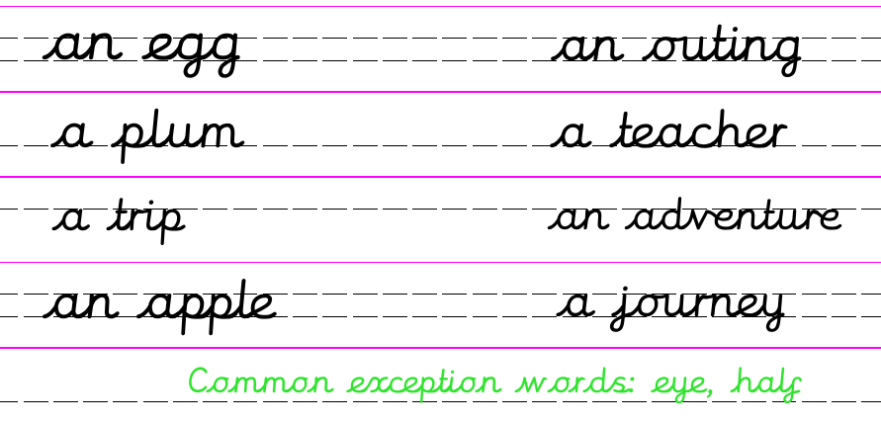
Yesterday we learned a simple rule to help us know when to use ‘a’ or ‘an’.
Can you remember the rule?
But there are exceptions to this rule. An exception is a case when something different happens:
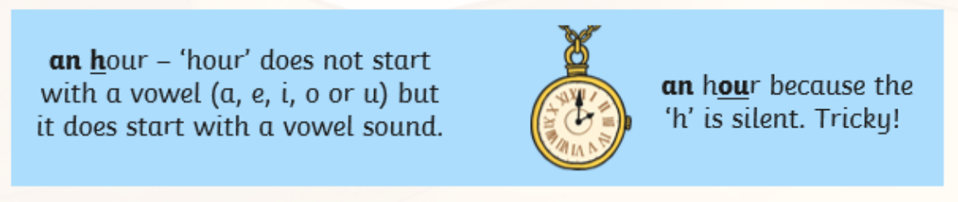
Other similar words are: honest, honour, honourable.
Eg. The walk will take half an hour.
It was an honour to get a gold certificate.
Write down the examples of exceptions for today which start with ‘h’ where it sounds like /ow/ or /o/ instead of /h/.

Dictation:
Ask someone to read out the sentence below so that you can write it down – try not to look until after you’ve written it. Check your punctuation and spelling.
It was an honour to wait an hour for my medal.

Maths 16.6.20
Non-Unit Fractions
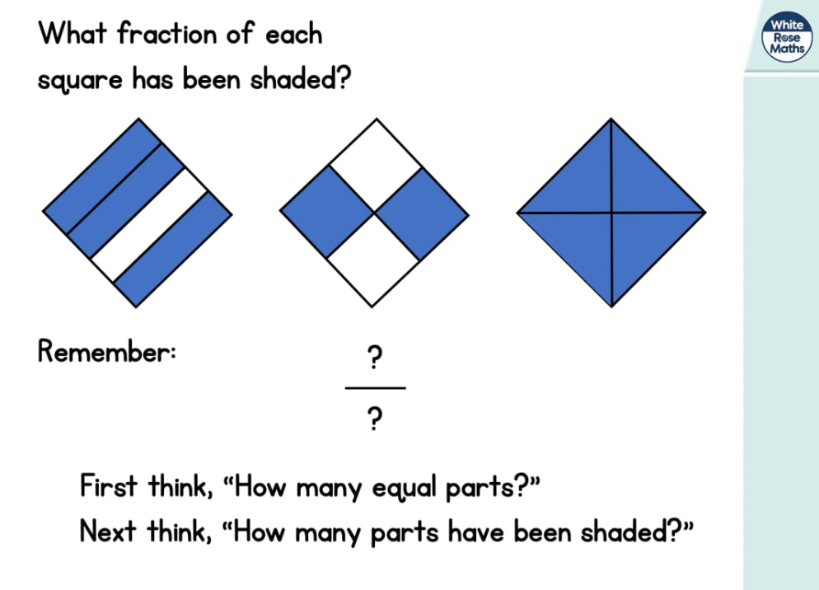
https://whiterosemaths.com/homelearning/year-2/ (Week 7 W/C 8.6.20)
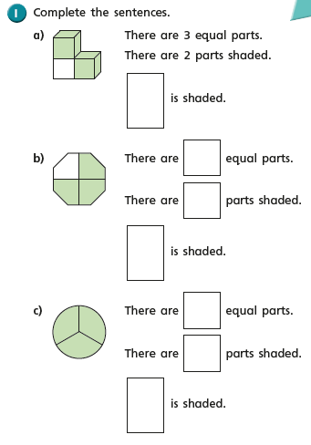
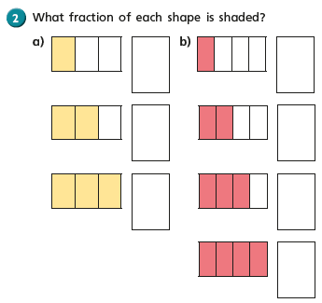
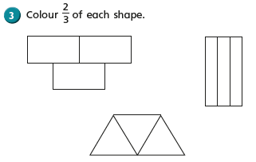

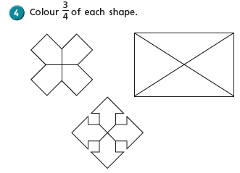
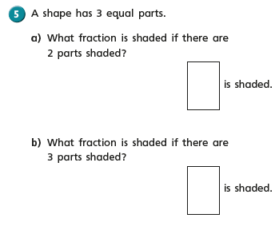
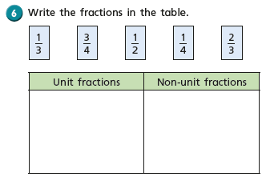
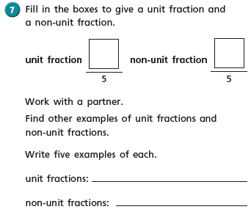

Tuesday 16th June 2020
WALT identify homophones.
Words of the day colonel and kernel.
How did you get on with yesterday’s work. How many of you drew a picture of what Billy could see through the windows.
I imagined something like this:

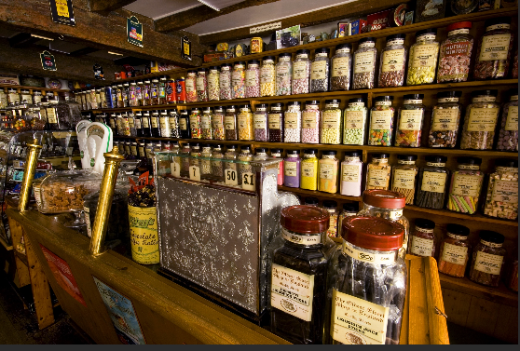

Jars and jars of every single sweet in the world going!
Today we are going to look at some of the text in more detail.
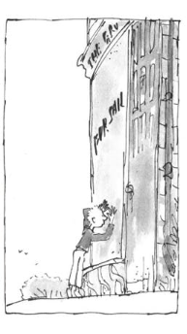
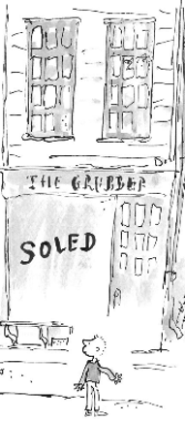

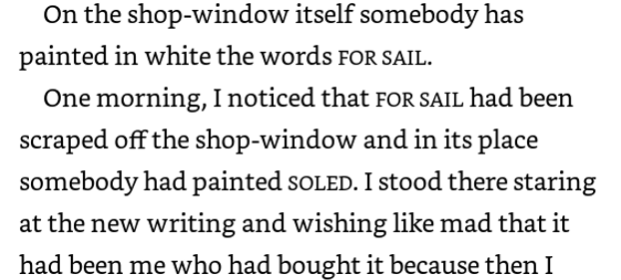

Hmm, who can notice something strange about the writing on the shop window?
For sail and Soled?

Yes they are spelt wrong but they are both still words. What should they say? How do you
Spell them?
What does sail mean?
What does soled mean?

What sort of person do you think wrote these words incorrectly? A child? An adult? Who else could have? Think of the title to our story?

We call words that sound the same but that have different meanings homophones.

Your task today is to think of as many homophones as possible.

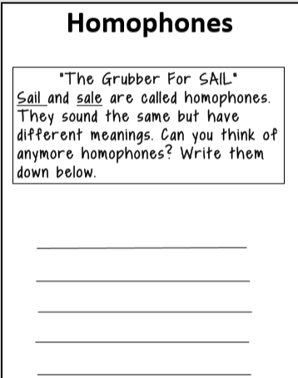

16.6.20 - Geography – Map Skills Lesson 2:
WALT: use compass directions to move around a map.
WALT: plan a route in the local area.

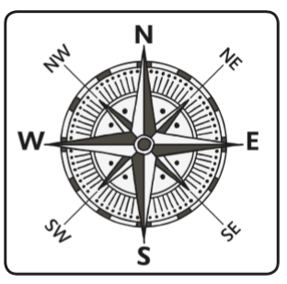
What can you remember about compass directions?
- What are the four points of a compass?
- What do we use a compass for?
- Who might use a compass?

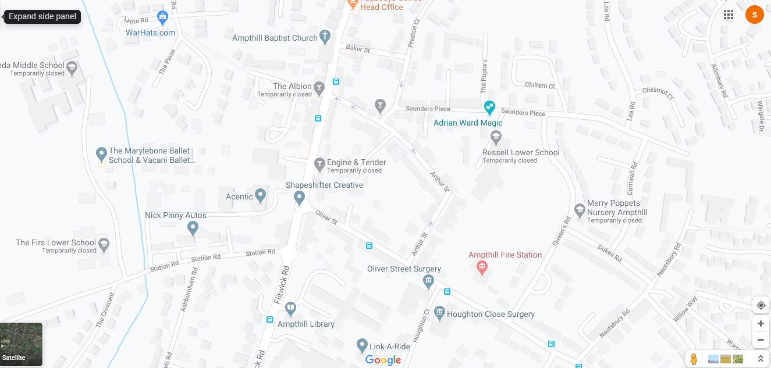
This is a map of the area around school.
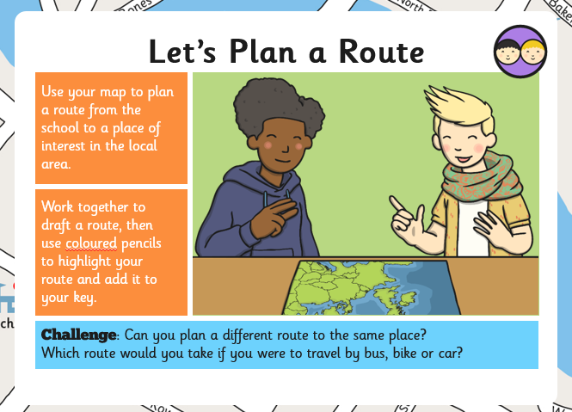

Task: Describe your route to someone else.

