Year 3 - Home Learning Pack
Hello wonderful Year 3’s,
Here are some actives to keep you busy. We cannot wait to see what you do!
From the Year 3 Team

Maths
Times Tables
- Please get your child to go on Times Table Rock Stars (accessed through computer, tablet or phone), play in the garage, and complete regular sound checks.
- The accounts for Times Table Rock Stars have recently been created and will follow the format below:
Username: The first three letters of your child’s first name and then the first three letters of your child’s surname.
Password: black, gold or night depending on the class.
Times Tables Games
Fizz Buzz
Choose ‘fizz’ for multiples of a number (e.g. 3), and ‘buzz’ for multiples of another number (e.g. 5). Starting with 1, players take it in turns to say the next number. However, each time a multiple of 3 or 5 is reached, the player must say ‘fizz’ or ‘buzz’ instead of the number. If the number is a multiple of both 3 and 5, the player must say ‘fizzbuzz’.
For example: one, two, fizz, four, buzz, seven, eight, fizz, buzz, eleven, fizz, thirteen, fourteen, fizzbuzz
You could try other multiples or adding another multiple for a more complex game.
Times Table Tennis
Choose a times table to focus on. Take it in turns to say the next number in the times table sequence. You could pretend to serve and pass a tennis ball between you or use a real one.
Times Table Corners
Label different areas/corners of your garden with 2, 5 and 10. Shout out a number. If the number is a multiple of 2, 5 or 10, your child must go to the matching area.
Fastest Times Tables Facts
Choose a times table to focus on and have a competition to see who can write down the times tables facts the fastest. You can decide whether to write the number sentences out in full (e.g. 1 × 2 = 2, 2 × 2 = 4, 3 × 2 = 6 ) or just the numbers (e.g. 2, 4, 6).
Times Tables Snap and Matching Cards
Create a set of cards with separate times table facts and answers. Challenge your child to find the matching cards in a game of snap. Alternatively, place the cards face down and take it in turns to turn over two cards. If the cards match, the player keeps the cards. If they don’t match, turn the cards back over and the next player takes their turn.
Four Awesome Operations

3 6 x 4 =
5 0 9 - 2 9 0 =
6 3 3 + 2 6 6 =
4 8 ÷ 6 =
3 4 x 8 =
6 0 1 - 2 4 4 =
2 6 8 + 3 4 9 =
5 8 4 - 2 3 2 =
3 2 ÷ 5 =
4 6 x 5 =
4 2 4 + 5 2 2 =
English
Writing Task
Use a range of descriptive and figurative language to write a diary entry in the role of Stone Age boy?
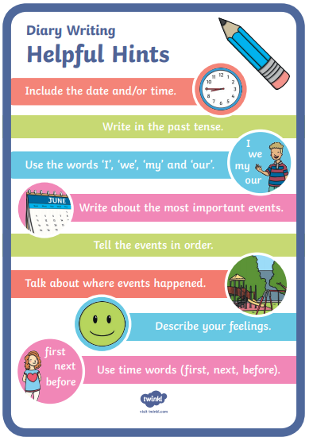
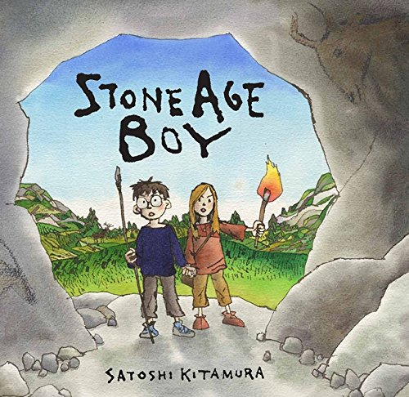
Can you use:
- A range of adjectives, verbs and adverbs
- Fronted adverbial phrases
- Similes
- Metaphors
- Personification
- Alliteration
__________________________________________________________________________________________________________________________________________________________________________________________________________________________________________________________________________________________________________________________________________________________________________________________________________________________________________________________________________________________________________________________________________________________________________________________________________________________________________________________________________________________________________________________________________________________________________________________________________________________________________________________________________________________________________________________________________________________________________________________________________________________________________________________________________________________________________________________________________________________________________________________________________________________________________________________________________________________________________________________________________________________________________________________________________________________________________________________________________________________________________________________________________________________________________________________________________________________________________________________________________________________________________________________________________________________________________________________________________________________________________________________________
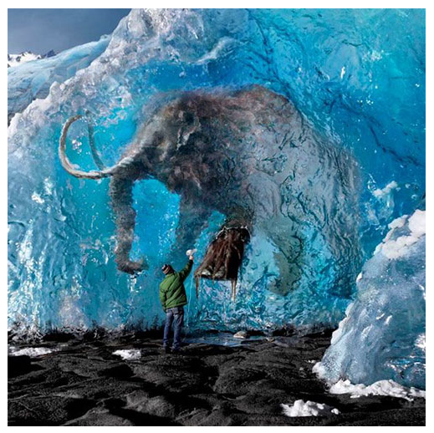
VIPERS Comprehension

Infer
What do you think the man is thinking?
________________________________________________________________________________________________________________________________________________________________________________________________________________________________________________________________________________________

How do you think the man discovered the woolly mammoth?
________________________________________________________________________________________________________________________________________________________________________________________________________________________________
_____________________________________________________________________
Theme
Geography
So far this term we have learnt all about Extreme Earth! This has included work on Mountains, Volcanoes and Earthquakes.
Challenge! Design an earthquake proof building.
Things to think about: Shape – what shapes could prevent the buildings from twisting? Walls – what could you use to strengthen your walls? Base – how could you make your building more stable? How could your building absorb the shock waves? Other – think about how you could protect your building’s windows, gas and electricity supply.
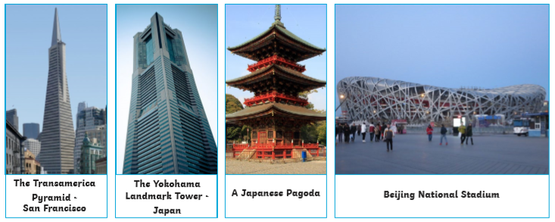

Science
Challenge! Write a definition of the three types of rock:
Igneous rocks are ………………………………………………………………………… ……………………………………………………………………………………………………………………………………………………………………………………………………..
Sedimentary rocks are …………………………………………………………………… ……………………………………………………………………………………………………………………………………………………………………………………………………..
Metamorphic rocks are …………………………………………………………………… ……………………………………………………………………………………………………………………………………………………………………………………………………..

Challenge! Sort these rocks underneath the correct heading.
Permeable | Impermeable | More Durable
High Density | Low Density | Less Durable
