Year 2 Phonics/Spelling Practice – w/c 20.4.20 Day 5
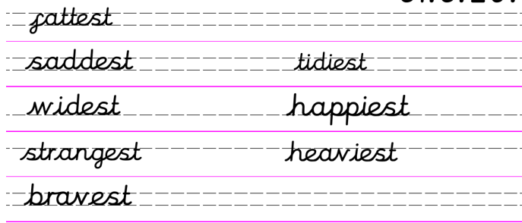

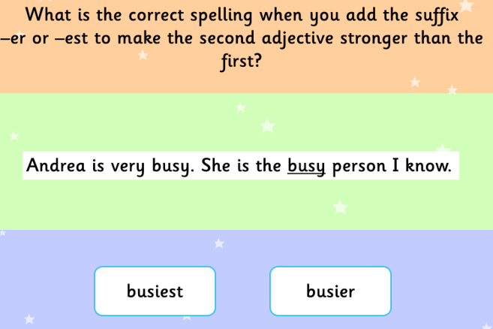
Now write 3 sentences of your own using the words you have learned this week:

English 24.4.20
Today we are going to read another story by Eric Carle. As you listen I want you to think about things that are the same and things that are different between the two stories. As we do at school I suggest you listen once then listen again and jot down any things that are the same or different.
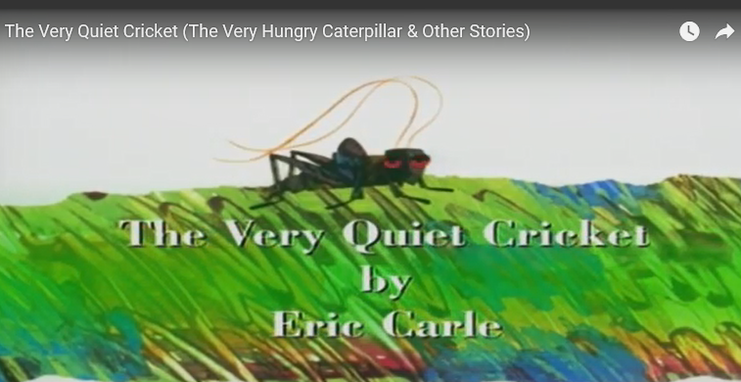 https://www.bing.com/videos/search?q=the+very+quiet+cricket&FORM=HDRSC3

I hope you enjoyed both stories but which one did you prefer? Why?
We are now going to do some more grammar. We have looked at some contractions in class and you are now beginning to use them. Read the following sheets and then can you make your own contraction caterpillar like in the picture?
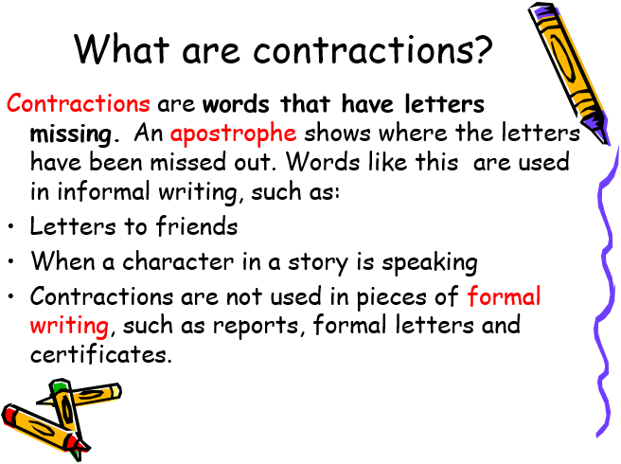

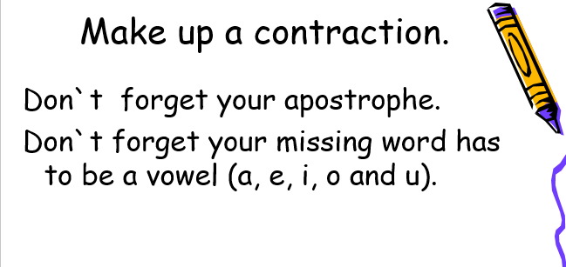

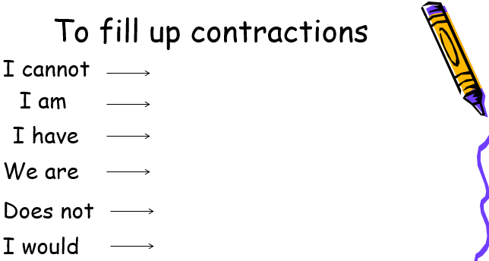

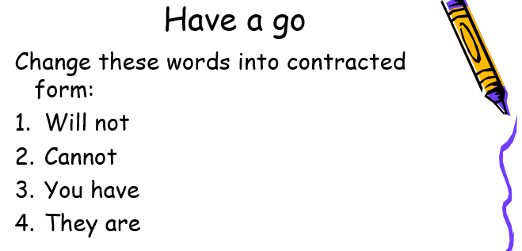

Task
Can you make your own Contraction Caterpillar?
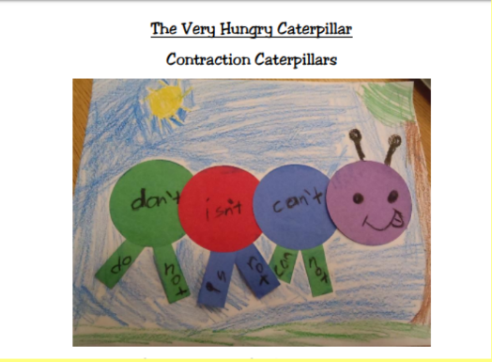

I hope you have enjoyed our English lessons this week. I am missing you all so much but hope we will all be back together in year 2 soon. Keep safe and have a wonderful weekend. Be good.

Maths 24.4.20
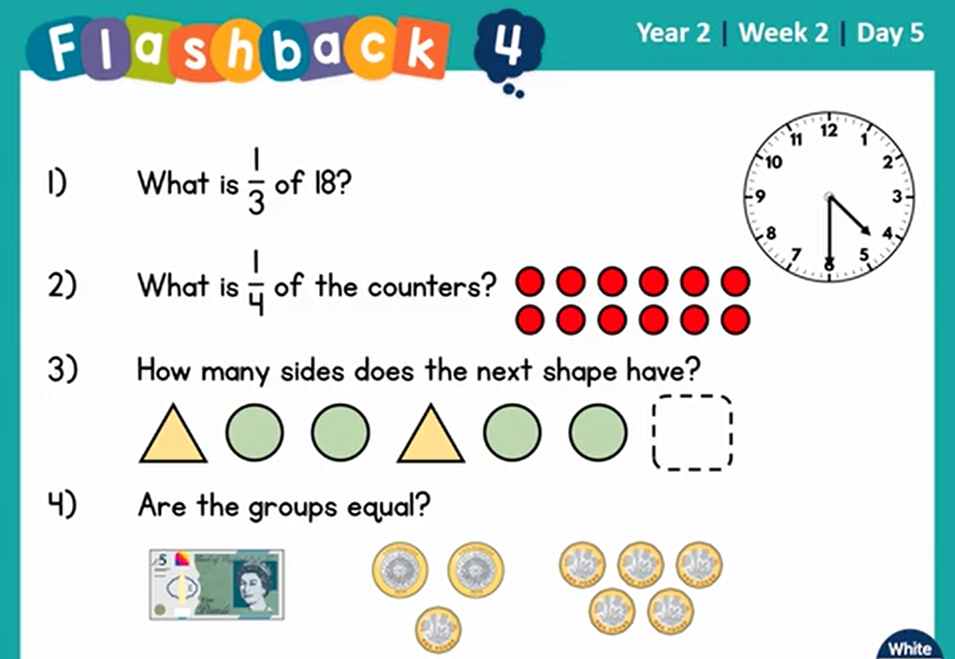

Which shapes are half shaded? Can you draw some 2-d shapes of your own and shade exactly half?
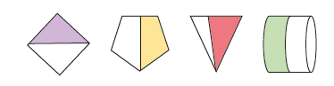

Can you find these fractions of 20? Could you use 20 pennies, pencils, stones to help you?
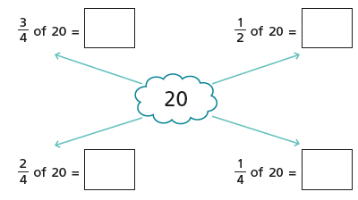

24.4.20 –Science Living Things and Their Habitats.
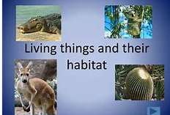
WALT understand what a habitat is.
WILF that you can create a habitat suitable for living things.
Key vocabulary: habitat, variety, community, funghi
Today is the first day of our new science topic – Living Things and Their Habitats. In this topic we are going to explore and compare the difference between things that are living, dead and things that have never been alive. We will be identifying that most living things live in habitats which they are suited to and we will be able to describe how different habitats provide for the basic needs of different kinds of animals and plants. You will learn to identify and name a variety of plants and animals in their habitats, including micro-habitats and be able to describe how animals obtain their food from plants and other animals.
The first thing we need to do is make sure we all know what a habitat is. A habitat is the home of an animal or a plant. Almost every place on Earth – from the hottest desert to the coldest ice pack – is a habitat for some kinds of animals and plants. Most habitats include a community of animals and plants along with water, oxygen, soil or sand and rocks.
We are going to kick off our new topic by creating a habitat at home for creatures to live in. I suggest we make a wood pile as it is an easy habitat to make but I know some of you are very creative and may prefer to make a bug hotel or even a bird feeder to encourate animals in to your gardens.
How to make a Wood Pile.
A wood pile is a great way to encourage wildlife to visit your garden and set up home there. Dead wood provides shelter and food for a number of creatures including woodlice, spiders, slugs, beetles, frogs and slow worms.
Creating a wood pile is easy. Look out for pieces of wood such as logs, fallen branches and twigs. Try to use wood from a variety of tree species. Gather them up and pile them in a reasonably damp and shady area. Add some dead leaves to the pile too.
Once you have made the pile you must leave it alone. Allow the wood to rot as this provides food for slugs and snails which will then attract birds and hedgehogs into your garden. You may find some interesting fungi appear! It won’t take long for wildlife to make a home in your wood pile!

Here’s one, I have made at my house.

