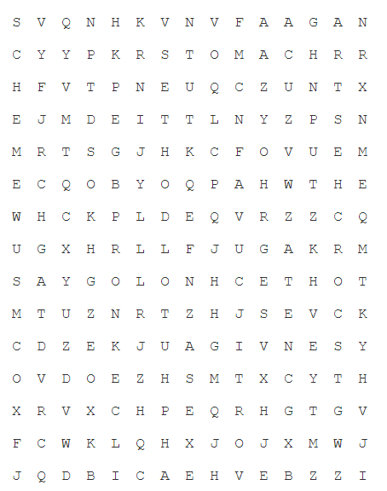
Friday 26th June 2020
SPaG
Words with the k sound spelt ch
echo
chorus
character
scheme
chemist
stomach
orchestra
technology

Word of the Day – arrest

Definition ____________________________________________
_____________________________________________________
_____________________________________________________
Used it in a sentence: ____________________________________________________
_________________________________________________________________________
Word Class: ____________________________________________________
Synonyms

English
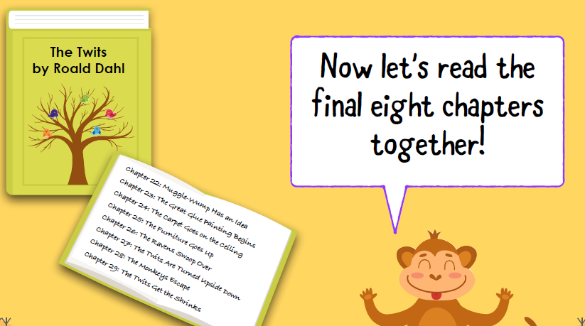

Task – Below are some question and answer cards. Cut them up and then mix them up. Afterwards can you put the questions back with the answers.
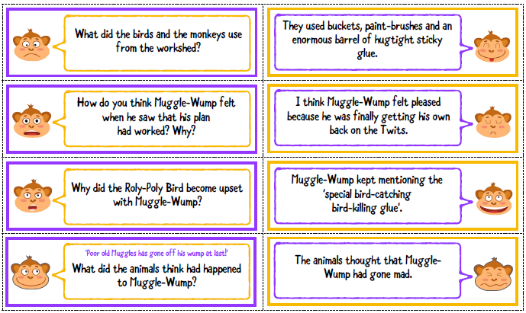

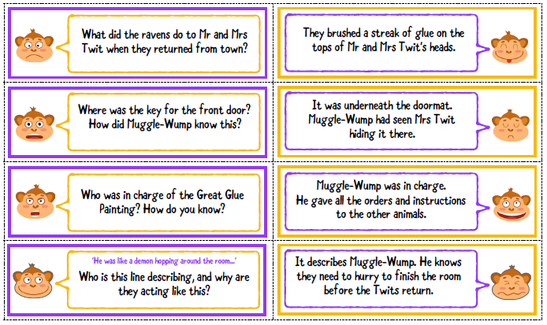

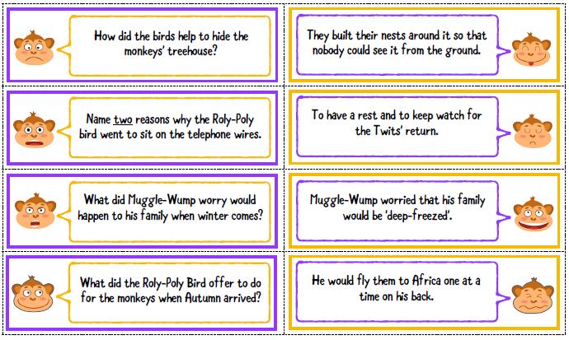

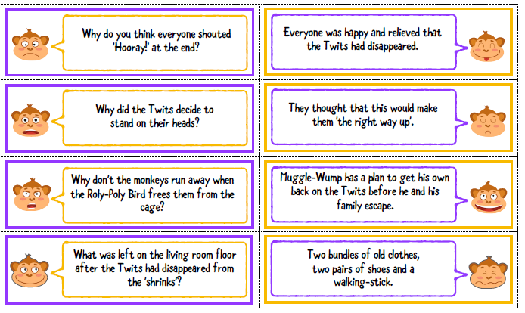

Maths
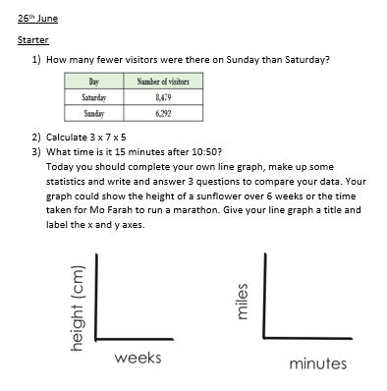

PSHCE
What positives have come from lockdown?
Lockdown is a difficult time when we may feel that the things we love and enjoy have been taken away from us. For example we are unable to go to school, see out friends and family, take part in after-school activities or visit our favourite places.
During this difficult time, you may have learnt new skills, discovered new talents and found more of your special qualities. These positives need to be captured and celebrated.
Take some time to think about what positives being in lockdown has taught us. You could display your answers around your home somewhere you can see them and be proud of them each day. If you are having a difficult day, looking back at your answers will help you feel proud and positive about yourself.
- What new skills have I learnt (can you make lunch by yourself?)
- What new talents have I discovered? (Have you learned to draw?)
- What special qualities have I discovered? (Patience? Resilience? Motivation?)
