Monday 1st June 2020 – English
SPaG
Spellings – Suffix ly
happily - __________________________________________________________________
angrily - ___________________________________________________________________
gently - ___________________________________________________________________
simply - ___________________________________________________________________
humbly - __________________________________________________________________
nobly - ____________________________________________________________________
frantically - ______________________________________________________________
dramatically - ____________________________________________________________

Look up the meaning of each of these words in a dictionary so you understand what each word means.
Word of the Day – desire

Definition ____________________________________________
_____________________________________________________
_____________________________________________________
Used it in a sentence: ____________________________________________________
_________________________________________________________________________
Word Class: ____________________________________________________
Synonyms

English
What did you enjoy most over half term? Today we would like you to write a recount of some of the things you did over half term.
But first let's find out from Michael Rosen how to write a super recount.

https://www.bbc.co.uk/teach/class-clips-video/english-ks1-ks2-how-to-write-a-recount/z7dg92p
If you don’t have access to a printer you can use your own paper to write your recount.

Maths Starter
- Round 3.7 to the nearest whole number.
- Round 5.2 to the nearest whole number.

Maths Main Lesson
We now have access to some great new videos. Remind yourself about equivalent fractions by watching this video.
https://vimeo.com/418154458
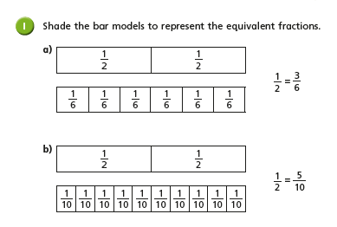
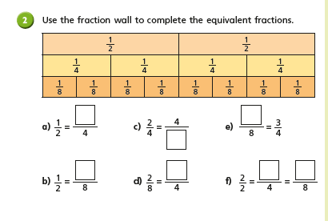

Science
Look at the picture below, what do you think these things all have in common?

_________________________________________________________________________________
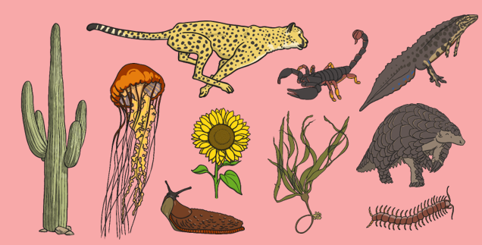
All of these images are of living things. Sometimes we call them ‘organisms’. Even though they might be very different from each other, all of these organisms share certain characteristics. All living things do certain things to stay alive. These are called life processes. All animals, including humans, do these things. Plants do too, although they do them in different ways.
Find out what the 7 life processes are and write about them below. Use the clues below to help you.

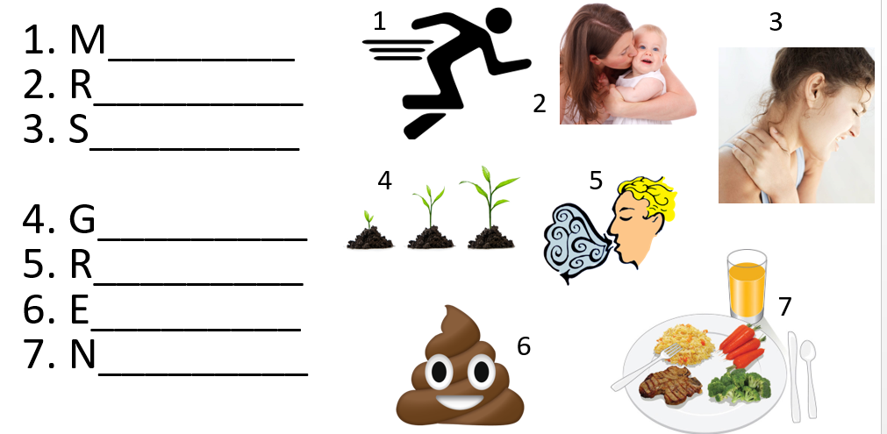
Challenge: Could you make up a song about the life process to help you remember them?

