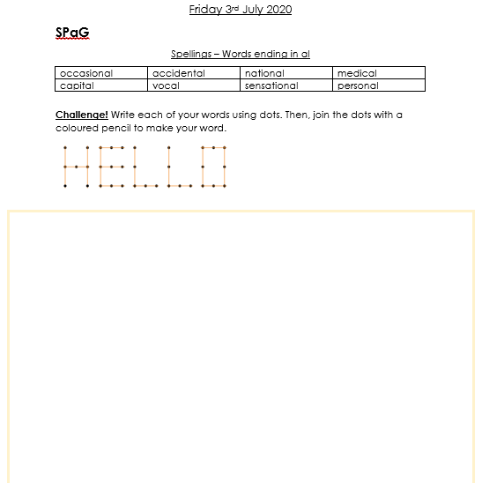

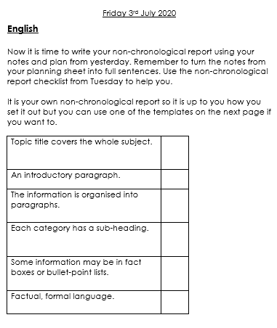

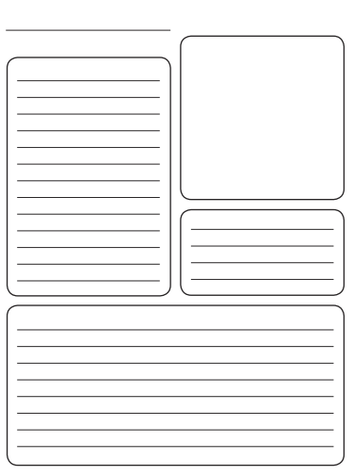

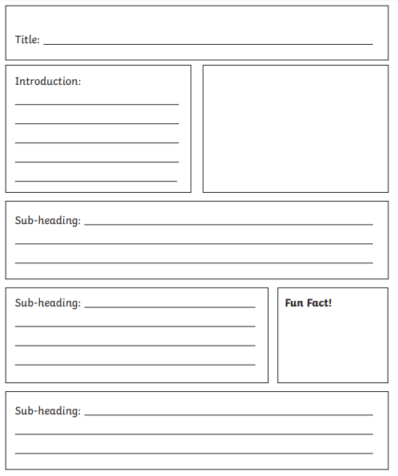

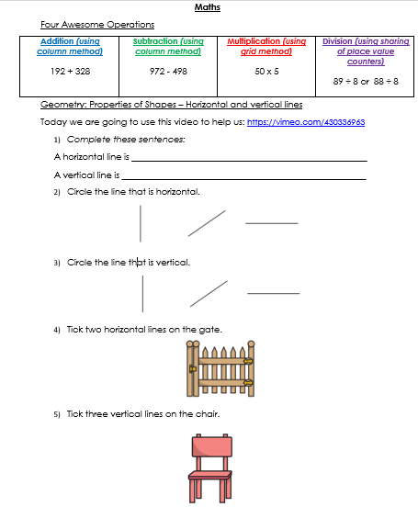

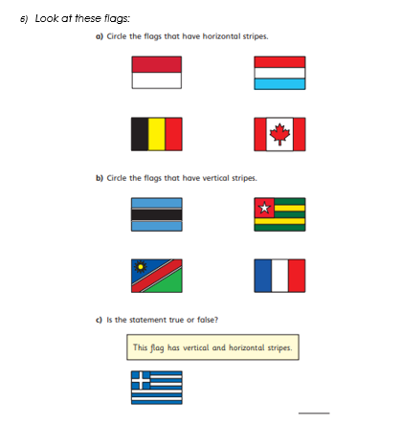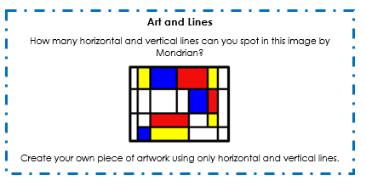

**PE**

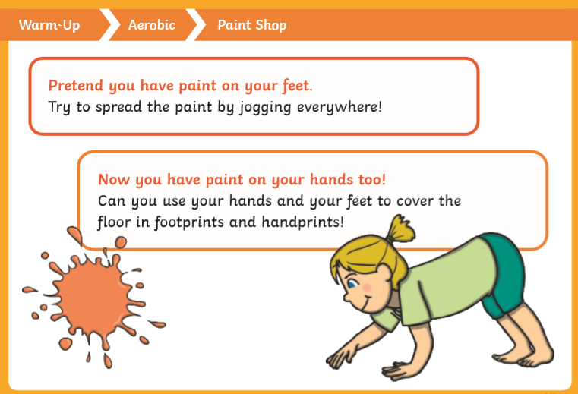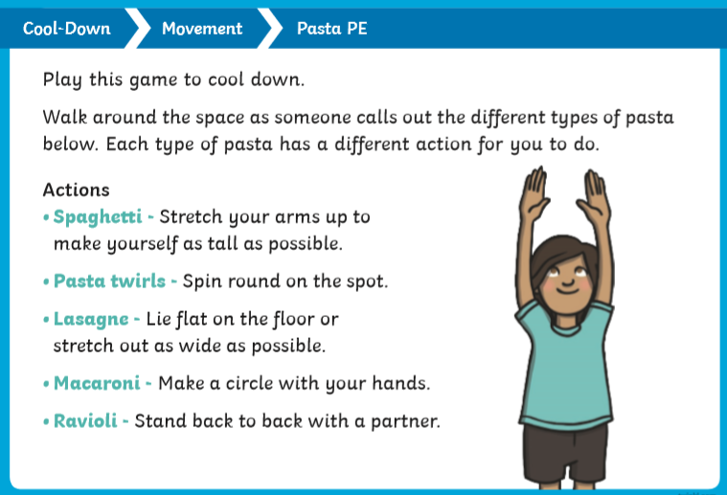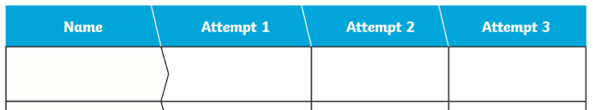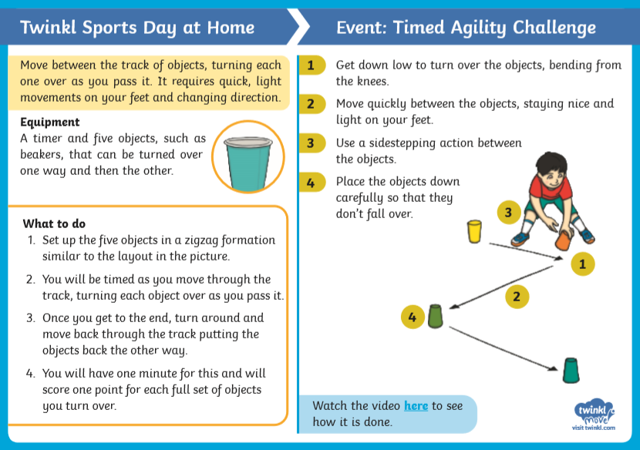

**Video Link:** [**https://www.youtube.com/watch?v=5xGu3UbnLmE&list=PLemcx8qcUKRzIBw9bbY9hFB6RFbvbjrBK&index=4&t=0s**](https://www.youtube.com/watch?v=5xGu3UbnLmE&list=PLemcx8qcUKRzIBw9bbY9hFB6RFbvbjrBK&index=4&t=0s)

You might like to create a score sheet like the one below.